GYS202J全液压单钢轮振动压路机
GYS202J FULL HYDRAULIC SINGLE DRUM VIBRATORY ROLLER
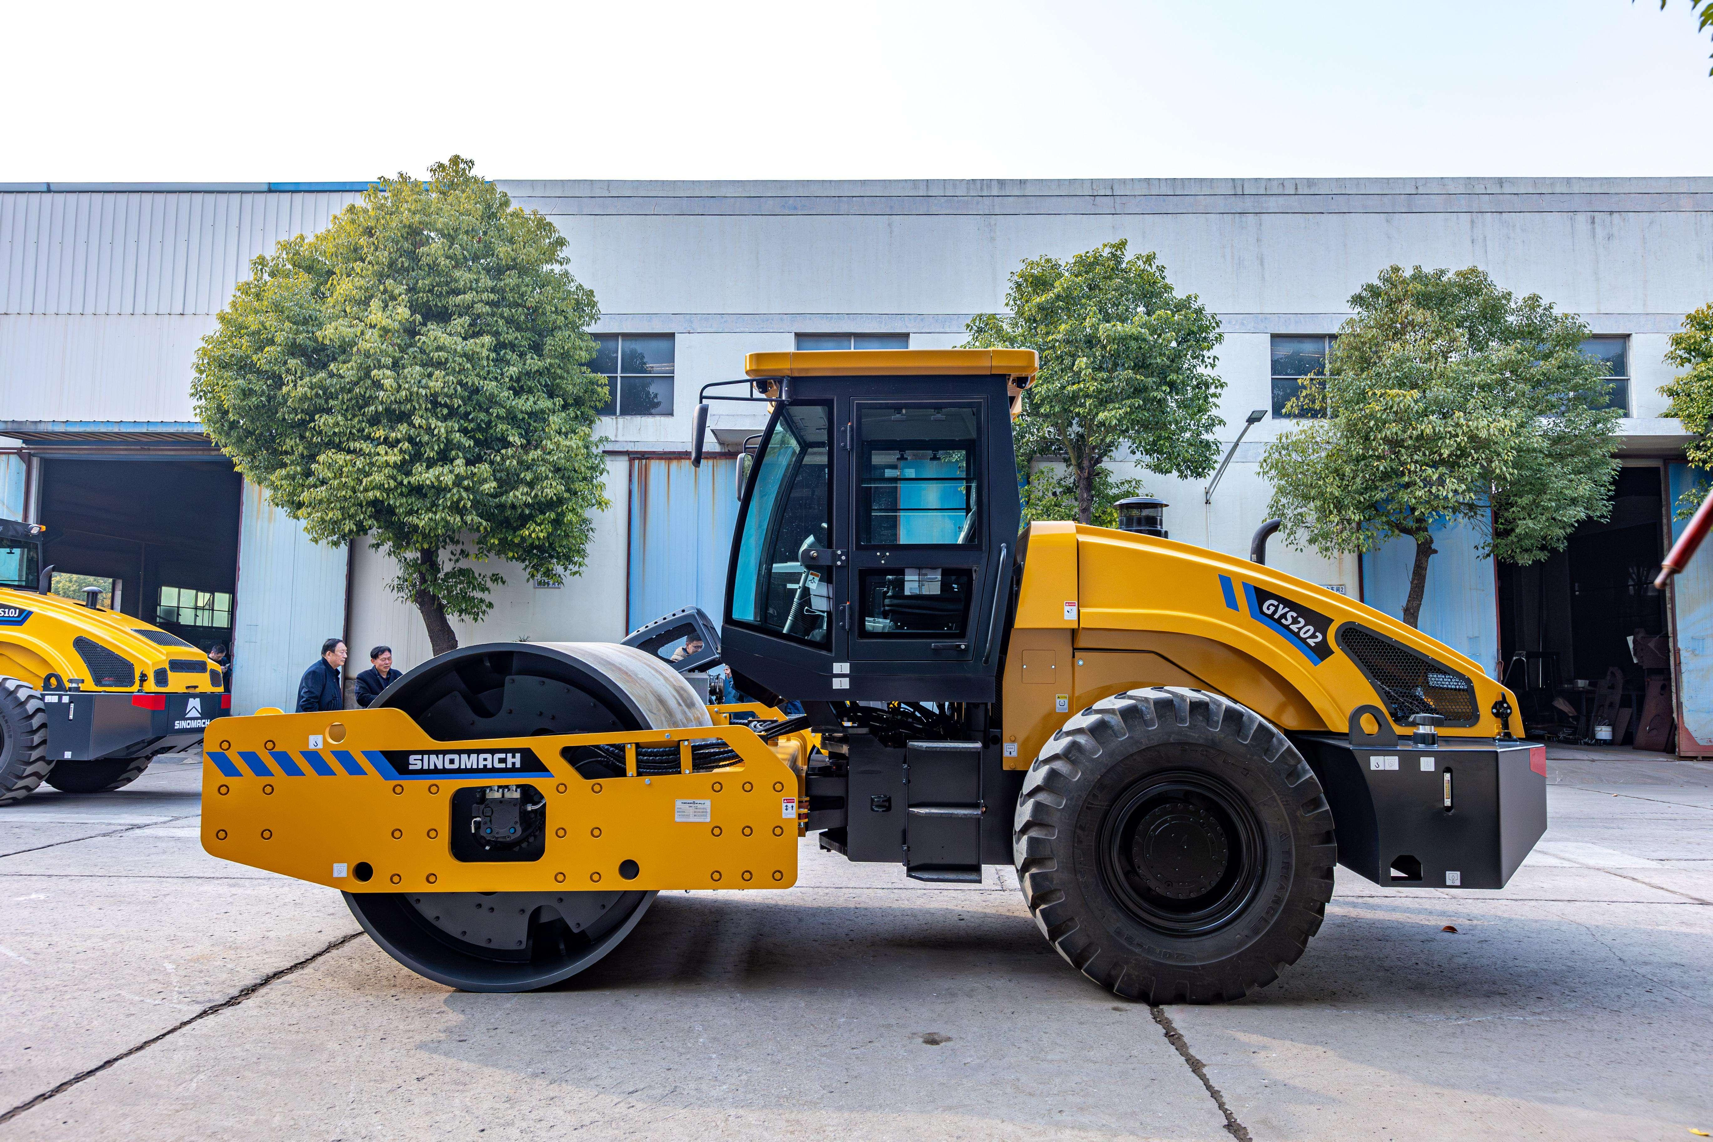
主要性能特点：Main characteristic
1.液压前后轮驱动，两档无级变速，爬坡能力强。
Fully hydraulic drive, two speeds, continuously variable.
2.液压振动，双频双幅，电控延时起振。
Hydraulic vibration, dual-frequency double amplitude, electronically controlled delayed vibration.
3.液压转向，铰接式车架，转向灵活
Hydraulic steering, articulated frame, flexible steering.
4.液压行走制动，电控钳盘停车制动
Hydraulic service brake, electronically controlled caliper disk parking brake.
5.后机罩可大角度翻起，方便维修保养
Engine hood can be flipped up at a wide angle for easy maintenance.
6.主要液压元件采用国外知名品牌
The main hydraulic components adopt foreign famous brands.
7.标配驾驶室，可选装空调
Standard cabin with optional A/C.

规格型号：GYS202J全液压单钢轮振动压路机
MODEL：GYS202J FULL HYDRAULIC SINGLE DRUM VIBRATORY ROLLER
主要技术参数 Main parameter
1、工作质量 Operating mass | 20000kg
2、外形尺寸 Overall dimensions
总长 Length | 6360 mm
总宽 Width | 2300 mm
总高 Height | 3100 mm
最小离地间隙 Min. ground clearance | 450 mm
轴距 Wheel base | 3150 mm
3、发动机 Engine
生产商 Manufacturer | WEICHAI
型号 Model | WP6G190E22（Ⅱ）
额定功率 Rated power | 140 kW
额定转速 Rated speed | 2200 r/min
冷却型式 Cooling type | Water cooled
4、工作装置 Working equipment
振动轮直径 Diameter of drum | 1600 mm
压实宽度 Width of compaction | 2130 mm
静线载荷 Static line pressure | 575 N.m
名义振幅 Vibratory amplitude | 1.9/0.9 mm
振动频率 Vibratory frequency | 28/32 Hz
激振力 Centrifugal force | 385/260 kN
5、行走系统 Walking system
前进 Forward speed | 0-4/0-5.5/0-6.5/0-11 km/h
后退 Reverse speed | 0-4/0-5.5/0-6.5/0-11 km/h
最大爬坡能力 Gradeability | 40%
最小转弯半径 Min. turning radius | 6500 mm
轮胎规格 Tyre model | 20.5-25

主要配置说明 Main configuration
Item | Model | Q’ty | Manufacturer
Engine | WP6G190E22  Optional MEE Ⅲ | 1 | WEICHAI
Travel pump | HPV105 | 1 | LINDE
Front travel motor | HMV075 | 1 | LINDE
Rear travel motor | HMV105 | 1 | LINDE
Vibration pump | HPV055 | 1 | LINDE
Vibration motor | HMF055 | 1 | LINDE

