724H MOTOR GRADER SPECIFICATIONS

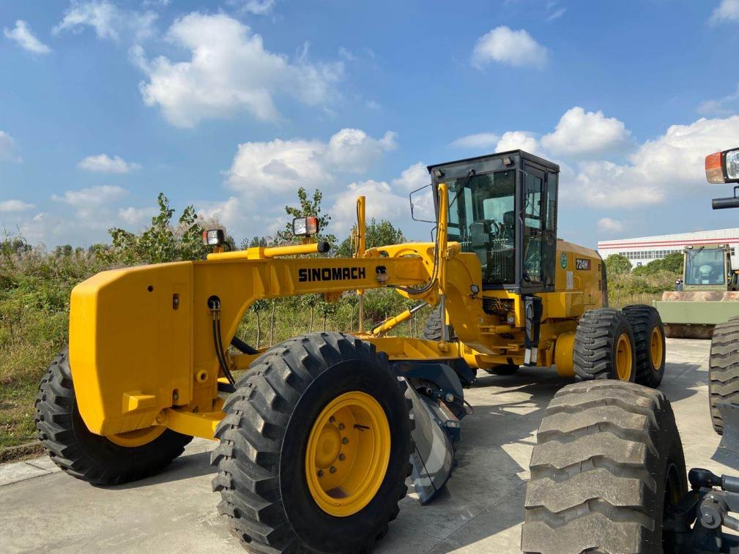
- Equipped withCummins6CTA8.3-C240 engine
- Sing-handle electro-hydraulic controlled power-shift T/M, 6forward &3reverse shifts makes operation easy and convenient
- Hydraulic lock, auto lock/unlock NO-SPIN differential ensures stability and powerful traction
- Ideal axel load allocation provides excellent stability while cutting hard surface
- Serviceable, efficient hydraulic system enables every part to be fully used
- Box-typed frame and advanced T/M enable it to complete heavy-duty work
- A wide working range is accomplished through flexible blade suspension system and articulated frame

Overall Dimension整机尺寸
1 | Length总长 |  |  |  |  |  |  |  |  |  |  |  |  |  | 9980mm
2 | Width总宽 |  |  |  |  |  |  |  |  |  |  |  |  |  | 2830mm
3 | Height(To the top of the cab)总高（到驾驶室顶部） |  |  |  |  |  |  |  |  |  |  |  |  |  | 3630mm
4 | Wheel base轴距 |  |  |  |  |  |  |  |  |  |  |  |  |  | 6900mm
5 | Tread轮距 |  |  |  |  |  |  |  |  |  |  |  |  |  | 2580(mm)
Main Technical Specification主要技术参数
1 | Operating weight操作重量 |  |  |  |  |  |  |  |  |  |  |  |  | 18000kg
2 | Blade length 刀板长度 |  |  |  |  |  |  |  |  |  |  |  |  | 4420mm
3 | Blade height刀板高度 |  |  |  |  |  |  |  |  |  |  |  |  | 580mm
4 | Shovel Blade thickness 铲刃板厚度 |  |  |  |  |  |  |  |  |  |  |  |  | 20mm
5 | Traveling speed(Km/h)，6 forward and 3 reverse行驶速度，前六后三
 | (1)forward前进 |  |  |  |  |  |  |  |  | 4.96/8.55/11.3/19.32/24.25/40
 | (2) reverse后退 |  |  |  |  |  |  |  |  | 4.96/11.3/23
Diesel engine发动机
1 | Model型号 |  |  |  |  | Cummins6CTA8.3-C240 engine
2 | Type型式 |  |  |  |  | Direct injection. Turbocharged. Water cooling  直喷、增压、水冷
3 | Rated output额定功率 |  |  |  |  |  | 179 kW
4 | Rated speed额定转速 |  |  |  |  |  | 2200(r/min)
5 | Max. Torque最大扭矩 |  |  |  |  |  | 1028(N.m)/(1500r/min)
Transmission case变速箱
1 | Model型号 |  |  |  | 6WG200（ZF）
2 | Type形式 |  |  |  | power shift, single-shift lever, netural-shift lock device  动力换挡、单手柄、中位自锁
3 | Gear shift position档位 |  |  |  | 6 Forward and 3 reverse gears  前六后三
Axle and Tire桥和轮胎
1 |  |  | Max. drawing force 最大牵引力 |  |  |  |  | 103KN
2 |  |  | Size of tire轮胎型号 |  |  |  |  | 20.5-25-16PR L-2 (standard) 标配
Working Device Hydraulic System工作液压系统
1 |  | Model of oil pump(include steering pump)  油泵型号(双联泵) |  |  |  |  |  |  |  |  |  | CBGj1032/1032
2 |  | System pressure系统压力 |  |  |  |  |  |  |  |  |  | 17.5MPa
3 |  | Model of distribution valve多路阀型号 |  |  |  |  |  |  |  |  |  | HUSCO 5000
4 |  | Model of oil motor回转马达型号 |  |  |  |  |  |  |  |  |  | 604-0663
Steering System转向系统
1 | Type型号 |  |  | Fore Tiredeflexion前轮偏摆式转向
2 | Model of steering gear转向器型号 |  |  |  |  |  |  |  |  |  | BZZ5-E160BG-1+FKB-3020C
3 | System pressure系统压力 |  |  |  |  |  |  |  |  |  | 16MPa
Brake System制动系统
1 | Type of traveling brake  行车制动系统型式 |  |  |  |  |  |  |  | Hydraulic and inner-expanding brake  全液压内涨蹄式制动
2 | Model of brake pump制动泵型号 |  |  |  |  |  |  |  | CBGj1032/1032
3 | System pressure系统压力 |  |  |  |  |  |  |  | 10MPa
4 | Type of parking brake停车制动型式 |  |  |  |  |  |  |  | Mechanical and inner-expanding brake  机械式内涨蹄式制动器
Oil Capacity用油量
Fuel(diesel)燃油箱 |  |  |  |  |  |  |  |  |  |  |  |  | 515L
Engine lubricating oil发动机机油 |  |  |  |  |  |  |  |  |  |  |  |  | 28L
Oil for converter and gear box变速箱 |  |  |  |  |  |  |  |  |  |  |  |  | 28L
Oil for hydraulic system液压系统 |  |  |  |  |  |  |  |  |  |  |  |  | 90L
Oil for driving rear axles后桥 |  |  |  |  |  |  |  |  |  |  |  |  | 80L
Tandem box 平衡箱 |  |  |  |  |  |  |  |  |  |  |  |  | 165L×2

3、724H平地机标准配置表
Standard configuration table for Motor Grader 724H
序号  NO. | 名称  Item | 型号  Model | 厂家  Manufacturer | 产地  Origin
1 | 发动机  Engine | 6CTA8.3-C240 | 东风康明斯  Cummins | 中国  China
2 | 变速箱  Transmission | 6WG200 | ZF | 中国  China
3 | 驱动桥  Axle | 18MRD-X243JC | 美驰  Meritor | 中国  China
4 | 轮胎  Tire | 20.5-25-16PR | 徐轮或前进  Triangle | 中国  China
5 | 工作液压油泵:  Working Pump | CBGj1032/1032 | 济南  JiNan | 中国  China
6 | 转向装置  Steering System | BZZ5-E160BG-1+FKB-3020C | 镇江液压件厂  ZhenJiang | 中国  China
7 | 回转马达  Rotary motor | 604-0663 | 伊顿  EATON | 中国  CHINA
8 | 多路阀  Valve | 5000 | HUSCO | 美国  USA

