735T MOTOR GRADER SPECIFICATIONS

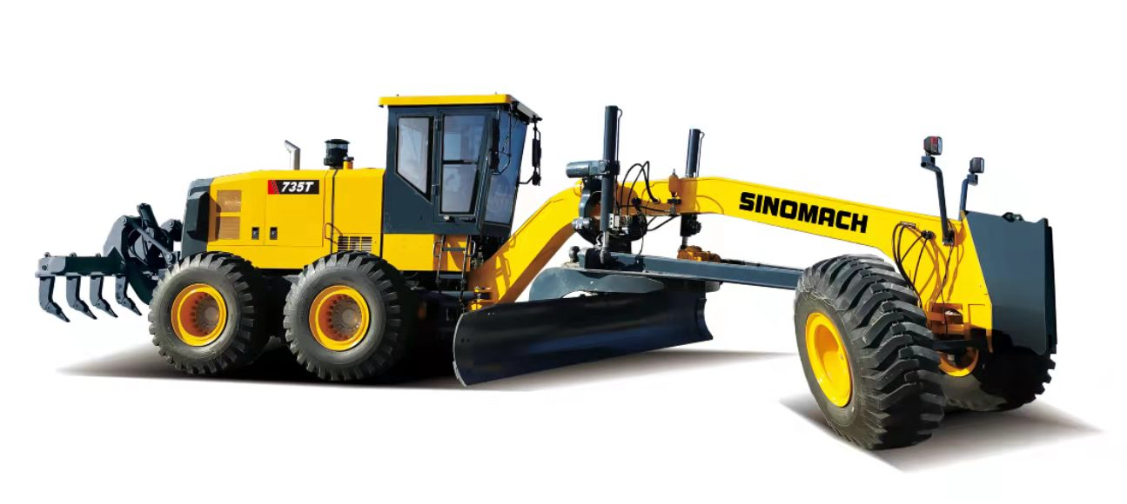
- Equipped with reliable Cummins QSM11-C360 engine
- Sing-handle electro-hydraulic controlled power-shift T/M, 6 forward & 3reverse shifts makes operation easy and convenient
- Hydraulic lock, auto lock/unlock NO-SPIN differential ensures stability and powerful traction
- Ideal axel load allocation provides excellent stability while cutting hard surface
- Serviceable, efficient hydraulic system enables every part to be fully used
- Box-typed frame and advanced T/M enable it to complete heavy-duty work
- A wide working range is accomplished through flexible blade suspension system and articulated frame

Overall Dimension整机尺寸
1 | Length总长 |  |  |  |  |  |  | 12500mm
2 | Width总宽 |  |  |  |  |  |  | 3300mm
3 | Height(To the top of the cab)总高（到驾驶室顶部） |  |  |  |  |  |  | 3700mm
4 | Wheel base轴距 |  |  |  |  |  |  | 7760mm
5 | Tread轮距 |  |  |  |  |  |  | 2650mm
6 | Min. turning radius 最小转弯半径 |  |  |  |  |  |  | 9000mm
Main Technical Specification主要技术参数
1 | Operating weight操作重量 |  |  |  |  |  | 28000kg
2 | Blade length 刀板长度 |  |  |  |  |  | 4920mm
3 | Blade height刀板高度 |  |  |  |  |  | 695mm
4 | Blade width 刀板厚度 |  |  |  |  |  | 25mm
5 | Max. lift above ground 最大提升高度 |  |  |  |  |  | 515mm
6 | Max. grading depth 最大切削深度 |  |  |  |  |  | 735mm
7 | Max. shoulder reach outside rear tire 铲刀最大侧伸距离 |  |  |  |  |  | 2260mm（L）/1950mm（R）
8 | Traveling speed(Km/h)，6 forward and 3 reverse行驶速度，前六后三
 | (1) forward前进 |  |  |  |  | 5.4/8.2/12.7/19.3/27.5/41 km/h
 | (2) reverse后退 |  |  |  |  | 5.4/12.7/27.5 km/h
Diesel engine发动机
1 | Model型号 | Cummins QSM11-C360  康明斯QSM11-C360发动机
2 | Type型式 | EFI,turbocharger,air-to-aircooling,temperature control independent cooling system  电喷、涡轮增压、空空中冷；温控独立散热系统
3 | Rated output额定功率 | 268(kW)
4 | Rated speed额定转速 | 2100(r/min)
5 | Max. Torque最大扭矩 | 1830(N.m)/(1400r/min)
Transmission case变速箱
1 | Model型号 |  | 6WG310 （ZF technology）
2 | Type型式 |  | electro-hydraulic controlled power shift single handle operation，automatic transmission  电液控制动力换档、自动变速箱，单手柄操作
3 | Gear shift position  档位数 |  | 6 Forward and 3 reverse gears  前六后三
Axle and Tire桥和轮胎
1 | Max.drawing force 最大牵引力 |  |  | 144kN
2 | Size of tire轮胎型号 |  |  | 18.00-25-28PR
Working Device Hydraulic System工作液压系统
1 | Model of oil pump油泵型号 |  |  |  |  | 丹佛斯 FRR074BLS2520-3S1N2A1
2 | System pressure系统压力 |  |  |  |  | 25MPa
3 | Model of distribution valve多路阀型号 |  |  |  |  | Walvoil DRFC22132 DPX100/5  Walvoil DRFC22133 DPX100/5
4 | Model of oil motor回转马达型号 |  |  |  |  | Eaton 604-1113
Steering System转向系统
1 | Type型式 |  |  |  |  | ForeTiredeflexion前轮偏摆式转向
2 | Model of steering gear转向器型号 |  |  |  |  | Eaton Xcel45-320
3 | System pressure系统压力 |  |  |  |  | 16MPa
Brake System制动系统
1 | Type of traveling brake 行车制动系统型式 |  |  |  | Full Hydraulic Wet Brakes全液压湿式制动
2 | Model of brake pump制动泵型号 |  |  |  | 泊姆克HPT2-35/HPT1-20/9
3 | System pressure系统压力 |  |  |  | 6.9MPa
4 | Type of parking brake停车制动型式 |  |  |  | Hydraulically Operated Disc Brake  液压操纵盘式制动
Oil Capacity用油量
1 | Fuel(diesel)燃油箱 |  |  |  |  | 540L
2 | Engine lubricating oil发动机机油 |  |  |  |  | 28L
3 | Oil for converter and gear box变速箱 |  |  |  |  | 35-40L
4 | Oil for hydraulic system液压系统 |  | 200L
5 | Oil for driving rear axles后桥 |  | 35L
6 | Tandem box 平衡箱 |  | 2*60L

3、735T平地机标准配置表
Standard configuration table for Motor Grader 735T
序号  NO. | 名称  Item | 型号  Model | 厂家Manufacturer | 产地  Origin
1 | 发动机  Engine | QSM11-C360 | 康明斯  Cummins | 中国  China
2 | 变速箱  Transmission | 6WG310 | 采埃孚  ZF | 德国  GER
3 | 驱动桥  Axle | 19MRW-X245E | 美驰  XZmeritor | 中国  China
4 | 轮胎  Tire | 18.00-25-28PR | 轮胎 | 中国  China
5 | 工作液压油泵:  Working Pump | FRR074BLS2520-3S1N2A1 | 丹佛斯  Danfoss | 丹麦  Denmark
6 | 转向器  Steering Gear | Xcel45-320 | 伊顿  Eaton | 美国  USA
7 | 回转马达  Rotary motor | 604-1113 | 伊顿  Eaton | 美国  USA
8 | 差速器:  Differential | NO-SPIN | 美驰  XZmeritor | 中国  China
9 | 多路阀  Valve | DRFC22132 DPX100/5  DRFC22133 DPX100/5 | 沃尔福  Walvoil | 意大利  Italy
10 | 空调  Air conditioner | TY50D02 | 徐州天一  Tianyi | 中国  China

