732T-5 MOTOR GRADER
Front wheel auxiliary drive configuration and parameters
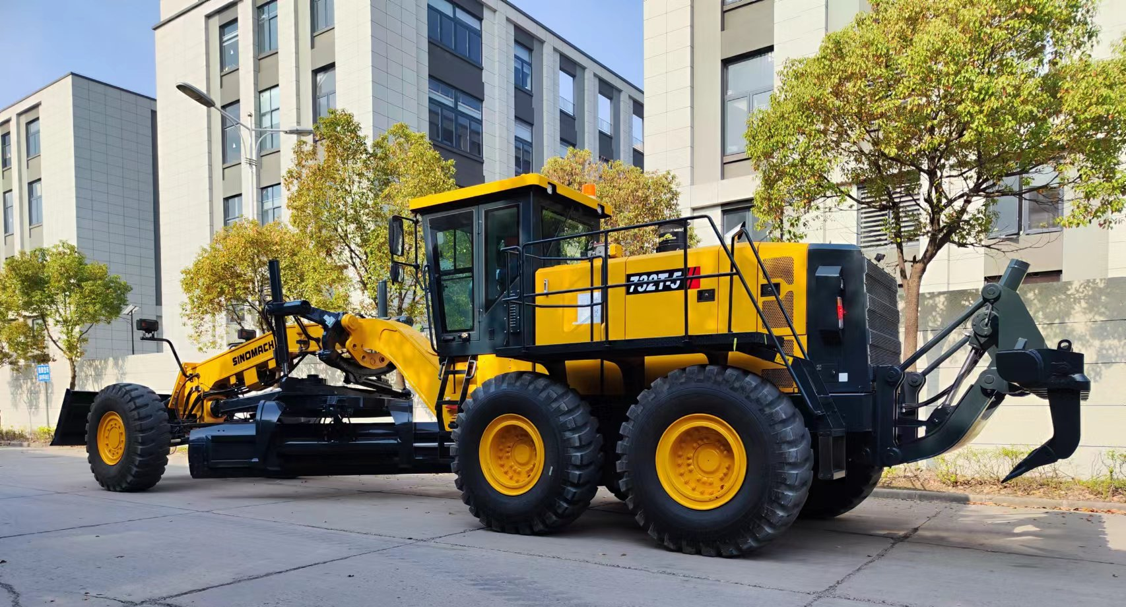
- Equipped with reliable Cummins QSM11-C330 engine
- Sing-handle electro-hydraulic controlled power-shift T/M, 6 forward & 3reverse shifts makes operation easy and convenient
- Hydraulic lock, auto lock/unlock NO-SPIN differential ensures stability and powerful traction
- Hydraulic system: dual handle electric control load sensitive system
- Steering system: fully hydraulic front wheel steering, articulated steering
- Service braking: fully hydraulic wet braking
- Parking brake: hydraulic operated disc brake

Overall Dimension整机尺寸
1 | Length总长 |  |  |  |  |  |  |  |  |  | 12750mm
2 | Width总宽 |  |  |  |  |  |  |  |  |  | 3300mm
3 | Height(To the top of the cab)总高（到驾驶室顶部） |  |  |  |  |  |  |  |  |  | 3700mm
4 | Wheel base轴距 |  |  |  |  |  |  |  |  |  | 8010mm
5 | Tread轮距 |  |  |  |  |  |  |  |  |  | 2650mm
6 | Min. turning radius 最小转弯半径 |  |  |  |  |  |  |  |  |  | 9000mm
Main Technical Specification主要技术参数
1 | Operating weight操作重量 |  |  |  |  |  |  |  |  | 30000kg
2 | Blade length 刀板长度 |  |  |  |  |  |  |  |  | 4620mm
3 | Blade height刀板高度 |  |  |  |  |  |  |  |  | 695mm
4 | Blade width 刀板厚度 |  |  |  |  |  |  |  |  | 25mm
5 | Max. lift above ground 最大提升高度 |  |  |  |  |  |  |  |  | 515mm
6 | Max. grading depth 最大切削深度 |  |  |  |  |  |  |  |  | 735mm
7 | Max. shoulder reach outside rear tire 铲刀最大侧伸距离 |  |  |  |  |  |  |  |  | 2260mm(R)/1950mm(L)
8 | Maximum inclination angle 最大倾斜角 |  |  |  |  |  |  |  |  | 65 °
9 | Cutting angle adjustment range切削角调整范围 |  |  |  |  |  |  |  |  | 23-73 °
10 | Max. swing angle of the front axle: 前桥最大摆动角 |  |  |  |  |  |  |  |  | 15 °
11 | Max. inclination angle of front wheel 前轮最大倾斜角 |  |  |  |  |  |  |  |  | 17 °
12 | Max. front wheel steering angle 前轮最大转向角 |  |  |  |  |  |  |  |  | 49 °
13 | Max. turning angle of articulation 铰接最大转向角 |  |  |  |  |  |  |  |  | 25 °
14 | Traveling speed(km/h)，6 forward and 3 reverse行驶速度，前六后三
 | (1) forward前进 |  |  |  |  |  |  | 5.5、8.6、13.3、20.3、29、43
 | (2) reverse后退 |  |  |  |  |  |  | 5.5、13.3、29
Diesel engine发动机
1 | Model型号 |  |  |  |  |  |  |  |  | Cummins QSM11-C330  康明斯QSM11-C330发动机
2 | Type型式 |  |  |  |  |  |  |  |  | EFI,turbocharger,air-to-aircooling;temperaturecontrolindependentcoolingsystem  电喷、涡轮增压、空空中冷；温控独立散热系统
3 | Rated output额定功率 |  |  |  |  |  |  |  |  | 246(kW)
4 | Rated speed额定转速 |  |  |  |  |  |  |  |  | 2100(r/min)
5 | Max. Torque最大扭矩 |  |  |  |  |  |  |  |  | 1674(N.m)/(1400r/min)
Transmission case变速箱
1 | Model型号 |  |  |  |  |  |  |  |  |  |  | ZF 6WG260
2 | Type型式:电液控制动力换档、自动变速箱，单手柄操作 |  |  |  |  |  |  |  |  |  |  | electro-hydraulic controlled power shift single handle operation，automatic transmission
3 | Gear shift position  档位数 |  |  |  |  |  |  |  |  |  |  | 6 Forward and 3 reverse gears  前六后三
Axle and Tire桥和轮胎 Rear axle balance box:Meritor
1 |  |  |  | Max. drawing force（f=0.73）最大牵引力 |  |  | 200kN
2 |  |  |  | Size of tire轮胎型号 |  |  | 18.00-25-28PR
Working Device Hydraulic System工作液压系统
1 |  | Model of oil pump油泵型号 |  |  |  |  |  |  | 丹佛斯FRR074BLS2520-3S1N2A1
2 |  | System pressure系统压力 |  |  |  |  |  |  | 25MPa
3 |  | Model of distribution valve多路阀型号 |  |  |  |  |  |  | Walvoil DRFC22132 DPX100/5  Walvoil DRFC22133 DPX100/5
4 |  | Model of oil motor回转马达型号 |  |  |  |  |  |  | Eaton 604-1113
Steering System转向系统
1 | Type型式 |  |  |  |  |  | Fore Tire deflexion前轮偏摆式转向
2 | Model of steering gear转向器型号 |  |  |  |  |  | Eaton Xcel45-320
3 | System pressure系统压力 |  |  |  |  |  | 16MPa
Brake System制动系统
1 | Type of traveling brak额行车制动系统型式 |  |  |  |  | Full Hydraulic Wet Brakes全液压湿式制动
2 | Model of brake pump制动泵型号 |  |  |  |  | 泊姆克HPT3-50/HPT1-22/9
3 | System pressure系统压力 |  |  |  |  | 6.9MPa
4 | Type of parking brake停车制动型式 |  |  |  |  | Hydraulically Operated Disc Brake  液压操纵盘式制动
Front wheel auxiliary drive system前轮辅助驱动系统
1 |  |  | Model of front wheel drive pump  前驱油泵型号 |  | 驱动泵FRR090CLS2620--3S1C2A1
2 |  |  | Model of front wheel drive motor  前驱马达型号 |  | 左前轮马达4073601313  右前轮马达4073601213

