GKM65P矿用自卸车
GKM65P Mine Dump Truck

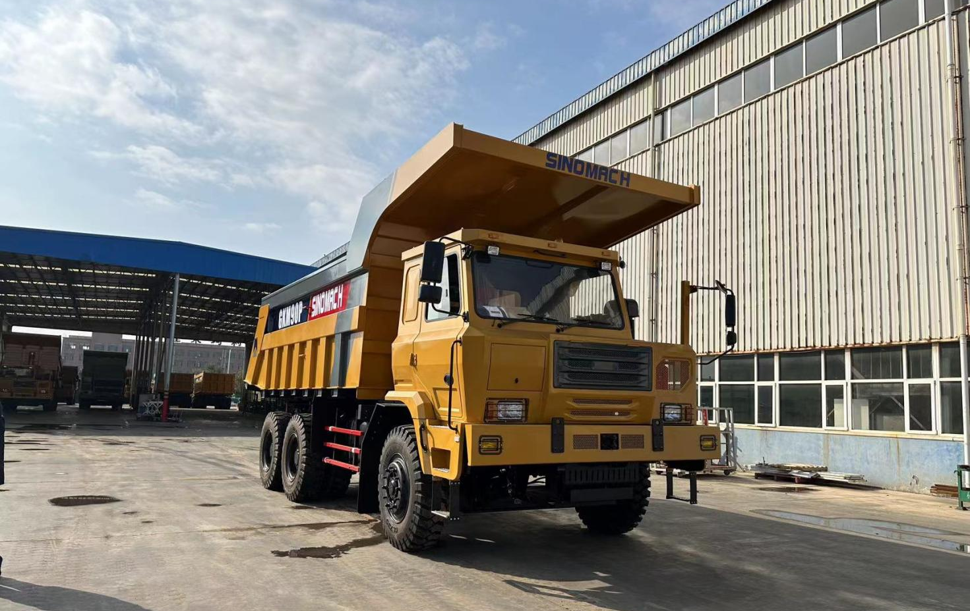

GKM65P Off-road mining dump truck
型号 Type | GKM65P
驾驶室 Driving cab： | 可翻转式宽体偏置驾驶室  Reversible wide-body offset cab
发动机Engine Type/ Horsepower:： | WEICHAI 380马力国三
变速箱  Transmission Type: | FAST 7DS220 Manual (without liquid retardation)
转向器  Steering Engine: | 液压助力Hydraulic power
前/后车桥  Front/rear axle: | 13T 前桥 / 25T 铸钢双级减速中后桥  13T front axle/ 25T casting dual reduction tandem axle
车架  Frame:： | 焊接式刚性箱型车架 450*130  Welded rigid cube type frame 450*130
上装描述  Description: | 底板 16mm 边板 12mm、前举、海沃 Hyva 油缸、方箱  Bottom 16mm, side 12mm, front hoisting, Hyva cylinder, square box  货厢内尺寸（mm）Inner dimension of body：5600*2850*1550
轮胎Tyre: | 14.00R25 Mining Tubed Wire Tire矿用有内胎钢丝胎轮胎  14.00-25 Mining Tubed Bias Tire 矿用有内胎斜交胎
悬挂  Front/rear suspension: | 钢板弹簧 Steel plate springs
制动系统  Breaking system: | 瑞立  SORL system
其他  Others: | 三级沙尘空滤、排气制动、大箱底板加热、排石器、底盘防护、电瓶防护、油箱防护、挡泥板、LED侧灯和尾灯、电子空调  Triple sand air filter, exhaust brake, heated big box floor, stone evacuator, chassis protection, battery protection, fuel tank protection, fenders, LED side and tail lights, electronic air conditioning
整车质量  Curb Weight(kg): | 23000
额定载质量  Rated load(kg): | 40000
总质量  Rated total weight(kg): | 63000
外形尺寸  Overall Dimension(mm): | 8700*3000*3700
最小离地间隙  Min ground clearance(mm): | 380
最小转弯半径  Min turning radius(m): | ≤12
最大爬坡度  Max gradeability(%): | 30
轴距  Axle base(mm): | 3650+1560
油箱  Oil tank Capacity(L): | 400L
货箱容积  Body Capacity: | 25m³

