Fuel-powered multi-functional cleaning sweeper
- summary ：
The fuel-powered multifunctional cleaning sweeper is an innovative road sweeper system, comprising a vehicle body, engine, hydraulic system, electronic control system, and modular operation system. This model enables rapid switching between multiple functions without additional tools, including vacuum sweeping, winter operation, and snow removal. All components—engine, hydraulic parts, and electrical components—are sourced from internationally renowned brands.
The vehicle features reliable quality. It comes standard with an independent enclosed cab, integrated climate control, and ergonomic airbags, significantly enhancing driver comfort. The articulated body design reduces turning radius, while the hydraulic power steering and automatic hydraulic braking system ensure agile handling and improved safety. With mature technology and superior performance, this product is widely applicable to urban streets, sidewalks, non-motorized lanes, pedestrian zones, squares, parks, green spaces, and parking lots, delivering excellent performance and high operational efficiency.
It is easy to control and low in operation cost.

II. Core Advantages:


The articulated linkage mechanism enhances operational flexibility, while the modular body structure and compact design...
The mechanism makes the machine easy to drive in narrow road and space.

30 horsepower and four-wheel drive

The engine's power comes from an imported YAMAHA engine, paired with the brand's proprietary closed-wheel-drive system.
The technique ensures rational distribution of traction and propulsion forces, enabling effortless operation under various working conditions.

The concept of "quick switching" is adopted, with optimized body structure and hydraulic quick-change devices, enabling the switching of various functional components within four minutes. The operation is simple and efficient, enhancing the customer's return on investment.

With a featherweight body and lightweight construction, this vehicle is the ideal choice for sanitation operations, leaving no traces behind after completing tasks.

Reliable performance comes from powerful performance
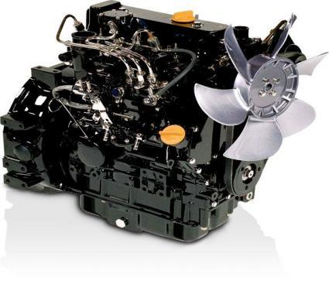
The product features a high-performance imported YAMA diesel engine, compact in size yet delivering 26.6KW of power with fuel efficiency.
Far below the general industry standard.
The modular quick-installation system ensures rapid switching of accessory functions, with the product featuring multifunctionality (cleaning, snow sweeping, and snow pushing).
Cleaning width: 1600 mm
1. Vacuum suction and sweeping function (second brush)
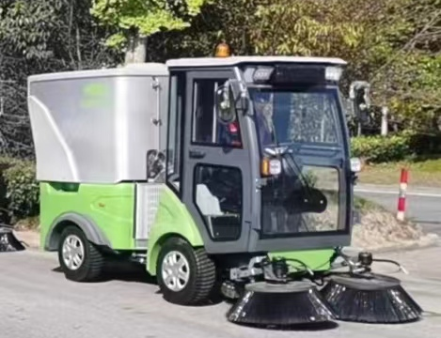

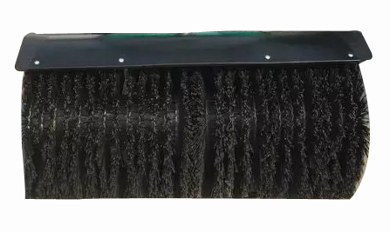
Snow removal feature
1. Sweeping width ≥1200 mm
2. Brush rotation speed: ≥200 rpm
3. The diameter of the brush is ≥500 mm
4. Number of brushes: 2 integrated roller brushes
5. Snow removal depth: 0–200 mm
6. Snow removal capacity: 10,000–12,000 m²/h

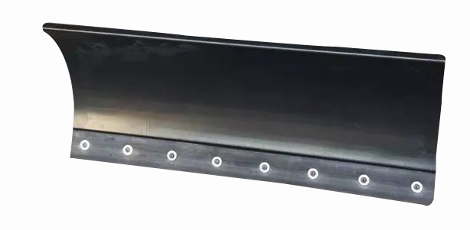
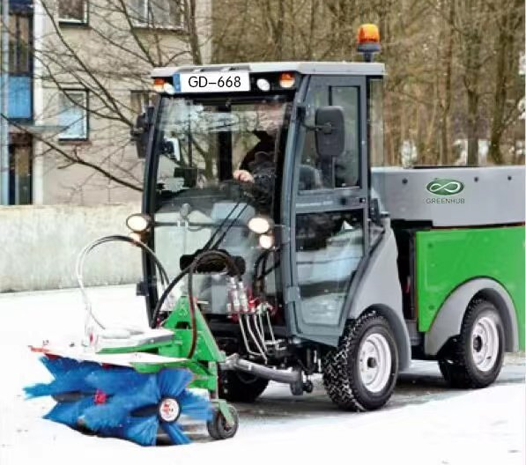

Push Snow
1. Width: 1200 mm
2. Pushing shovel working height: 520 mm

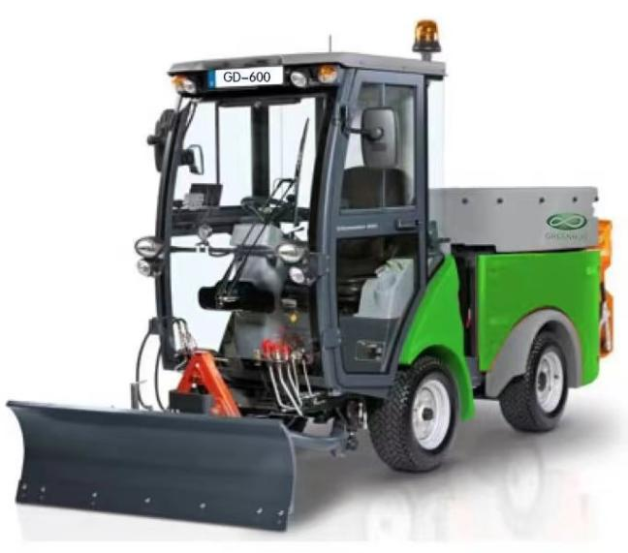

3. The articulated body structure, combined with the telescopic left and right steering cylinders, ensures agile handling and reduces the turning radius.
The turning radius is 1.95m, which enhances the maneuverability of the vehicle.

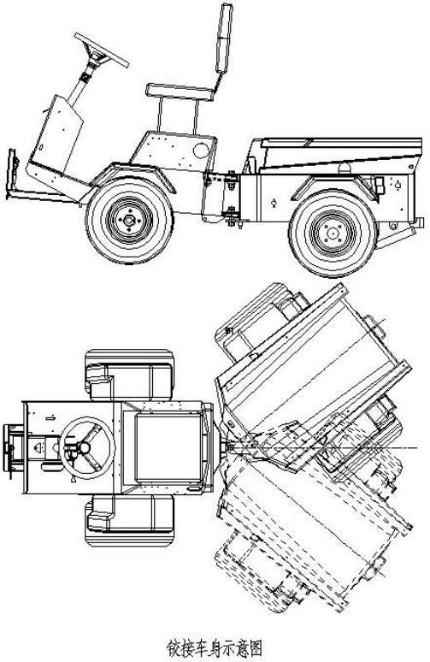

The articulated body design reduces the turning radius, enhancing maneuverability.
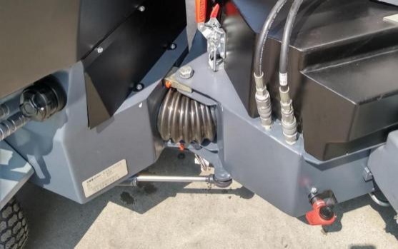
III. Technical Parameters
Fuel-powered multi-functional cleaning sweeper
engine type | 3TNV88-BDFFC
engine power/rev | 26.6kw/3000rpm
transition velocity | 16km/h
working speed | 0- 10km/h
Cleaning width | 1.65m
Scan diameter | ≧750mm
Maximum inhalable particle size (equivalent diameter) | 80mm
work efficiency | 18000m2/h
volume of dust control tank | 200L
bin capacity | 650L
angle of discharge | 45°
dump height | 1250mm
maximum gradability | 20°
minimum ground clearance | 135mm
cleaning rate | 97%
tread | 965mm (front wheels) + 990mm (rear wheels)
wheel base | 1460mm
turning radius | 1950mm
diesel tank capacity | ≧50L
Snow removal width (mm) | 1200
Scan count (items) | 2
Clear snow depth (mm) | 0-240
Snow removal capacity (m2/h) | 10000-12000
Snow removal width (mm) | 1200
Pile pusher height (mm) | 520
Dimensions (length x width x height) | 3650X1650X2200

