TITLE | Swing Bed Billing Requirements
TODAY’S DATE | December 11, 2020
SECTION | ☒Organization Wide  ☐Emergency Department  ☐Inpatient ☐Ambulatory  ☐Nursing ☐Medical staff [physicians and advance care practitioners]

APPLICABLE LOCATIONS | ☐All Bozeman Health locations  ☒Bozeman Health Deaconess Hospital  ☒Big Sky Medical Center  ☐Belgrade Clinic + UrgentCare  ☐Hillcrest Senior Living  ☐b2 UrgentCare ☐b2 MicroCare

CONTRIBUTORS | Colleen Croghan, Katie Hess, Dawn Rhodes
APPROVED BY | Incident Command
APPROVAL DATE | December 11, 2020

PURPOSE:
To outline the swing bed billing requirements for Bozeman Deaconess and Big Sky Medical Center during the Public Health Emergency (PHE) under the blanket swing bed waiver.

POLICY/PROTOCOL:
The COVID-19 blanket swing bed waiver allows for Bozeman Deaconess and Big Sky Medical Center to provide swing bed services and bill for these services according to the CMS billing guide. Bozeman Deaconess and Big Sky Medical Center must have a plan to discharge swing bed patients as soon as practicable. These patients are no longer acute but are unable to find placement in a skilled nursing facility.

Patient care staff (nursing, case management or UR) will notify patient access staff when an acute care patient needs to be discharged and readmitted as a swing bed patient.

Patient access staff will perform the discharge procedure within the electronic health record, and readmit the patient into the swing bed status. Typically the patient will not be moved to another room unless the facility is experiencing a surge situation as a result of the PHE. Please see ONE CHART TRAINING INPATIENT/OUTPATIENT TIP SHEET: Admit to Swingbed Process – Patient Access for details on Epic tips.

CHARGE TABLE:
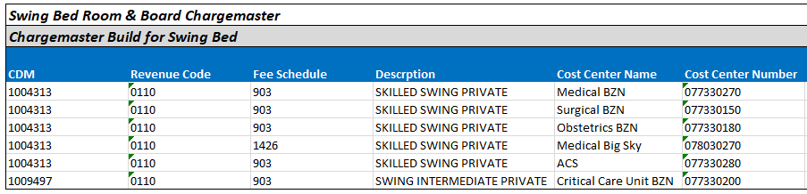
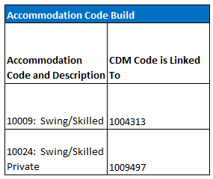

BILLING GUIDELINE: Primary insurance will be billed first. For specific billing details for the BACS refer to that specific SOP. This applies to Bozeman Health Deaconess Hospital and Big Sky Medical Center during the approved waiver period only. See future SOP for Big Sky Medical Center standard Swing Bed billing requirements.

Bill Types
- 180- Non-covered Stay
- 181- Admit to Discharge claim
- 182- 1st sequential
- 183- Cont sequential
- 184- Discharge

Billing Frequency
Monthly or upon discharge

Condition Codes
- DR- Disaster Related, reported for all swing beds services provided by either Deaconess Hospital or Big Sky Medical Center; this will bypass the 3 day qualifying stay edit as well as other applicable edits
- 04- Medicare Advantage beneficiary
- 40- Same day transfer
- 55- SNF bed not available
- 56- Medical appropriateness
  - Used to override the edit that denies a claim because the service dates are more than 30 days past the qualifying hospital stay and the delayed services were predictable at the time of admission.
- 57- SNF readmission
  - Must be used in conjunction with occurrence span code 78 to indicate prior SNF days when admission is within 30 days of discharge from Medicare but more than 30 days from the qualifying hospital stay
- 58- Terminated Medicare Advantage Enrollee

Occurrence Codes
- 21- Utilization Review (UR) notice received
- 22- Date active care ended and would equal the through date on the claims as all days after would be billed as no-pay/demand bill (only add when beneficiary drops below skilled level of care)
- 50- Assessment Reference Date (ARD)

Occurrence Span Codes
- 74- Leave of Absence (LOA) if applicable
- 78- SNF prior stay dates if applicable

Revenue Codes
- 12X- Room and board
- 18X- LOA if applicable
- 42X- Physical Therapy if applicable
- 43X- Occupational Therapy if applicable
- 44X- Speech Therapy if applicable
- 30X- If any lab billed
- Any other ancillary service

Value codes
- 09- Co-Insurance amount if applicable for specific year
Case Management staff will be responsible for completing the MDS (multiple data sheet) and will submit electronically through State approved software. The MDS completion will generate a Patient Driven Payment Model (PDPM) score that will be communicated to Patient Financial Services via predetermined email group in order to add the score to the claim. This applies only to Bozeman Deaconess Hospital and NOT Big Sky Medical Center.

NOTES:
OTHER POLICIES/PROTOCOLS TO REFERENCE:
CMS 1135 Blanket Waiver: Expanded Ability for Hospitals to Offer Long-term Care Services (“Swing-Beds”) for Patients Who do not Require Acute Care but do meet the Skilled Nursing Facility (SNF) Level of Care Criteria

SCOPE:
We anticipate these adjustment to be temporary and reserve the right to revise or discontinue these adjustments with or without notice depending on the current understanding and/or business needs of Bozeman Health relating to COVID-19.

