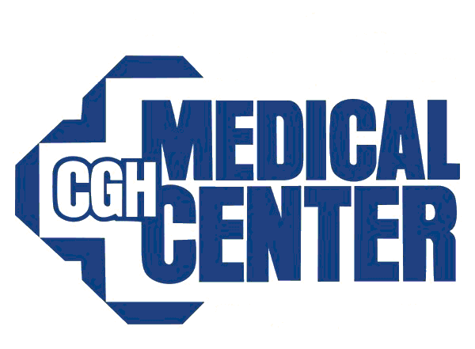 | CGH Board of Directors  Planning Committee  20 July 2017
Call to Order and Attendees | A meeting of the CGH Board of Directors Planning Committee was called to order by John Van Osdol at 18:01 on Thursday, 20 July 2017. Present were John Van Osdol, Dana McCoy, Tim Zollinger, Bob Hewes, John Larson, Don Stindt, Dacia Dennis, Mary Ellen Wilkinson, Carolyn Spencer, Nancy Rasmussen, Dr. Jeff LeMay, and DeAnne White. Excused Absence was Bill Burke and Roger Wait. Unexcused absence was Heather Sotelo. Also present were seven (7) staff members of CGH Medical Center.
Approval of Previous Minutes | The minutes of the 22 March 2017 meeting were approved as written. A MOTION WAS MADE BY JOHN LARSON AND SECONDED BY NANCY RASMUSSEN TO APPROVE THE MINUTES AS PRESENTED.
OLD BUSINESS
Marketing | Dana gave a presentation on the Market Share Update. Core Market – S/RF, Primary Market – surrounding area, second market – beyond the primary service area. Calendar Year 2016 – Primary Core – 4461 admissions. Since 1996 our core market share has declined to 67% in 2016. The transition to admitting patients as observation patients vs. inpatients has an impact on our total number of calculated admissions. Most of our business is outpatient.  Resource Distribution – Budget – 28% advertising – general, 11% main clinic, 9% service lines, 10% satellite, 5% digital website, 18% Healthlines, 12% Directories, 4% Misc, 3% promo items.  Video Production – Types of videos at CGH – 1. Education/awareness, 2. Quarterly education videos, 3. Physician Videos, 4. Growing Healthier videos, 5. Promotional/”Feel good”, 6. Professional. Four more of the professional videos featuring CGH staff members are being created and will be released soon. YouTube stats were reviewed. Matt discussed the process he utilizes to create and edit videos that are released on YouTube and utilized for public and employee education.
Recruitment/Clinic Update | CURRENT SEARCHES  Family Medicine (if local ties)  Gastroenterology  Hospitalist  Internal Medicine (traditional or outpatient only)  Interventional Cardiology  Neurology  Ophthalmology  Pathology  Pulmonology/Sleep Med  OB/GYN  RECENT AND UPCOMING START DATES  Bryan Kemker, ENT, started June 1, 2017  Rita Hart, Pediatrics, started June 19, 2017  Ethan Brooks, Orthopedic Surgery PA, started June 23rd, 2017  George Nelson, CRNA, started July 10, 2017  Jenny Eide, NP Cardiology, August 1, 2017  Dr. Ashlea Canady, General Surgery, August 7, 2017  Theresa Krueger, NP Wound Care, September, 2017  Abdullah Altayeh, Pulmonology/Critical Care, September 11, 2017  Niall Cooper, CRNA, September 25, 2017  Angela Stralow, NP, Dr. Wolf, seeing patients October 2017  Chloe (Etzler) Payne, Dermatology, starts October 2017  Dr. Stees is back and is practicing. Biopsying and treating skin cancer.  Departures  Stephen Berns, Pathologist, departed May 31, 2017  John Exner, Dermatology, retired end of June  Mark Schmelzel, General Surgery, July 26th retirement  Sharath Reniguntala, Family Medicine, leaving end of September  Jen Vance, PA, (Dr. Luckey), leaving end of September
Facilities/Master Plan Update | Cindy reviewed the 2E blueprints and did an overview of the project. The project finish board was shared with the committee. Some of the major changes will be an addition of a public restroom and upgrades to the plumbing and HVAC systems. We will be adding a bariatric patient care room and two secure rooms for behavioral health patients. This project will take approximately one year. The drawings have been submitted to the State for approval.  Downtown Clinic project will be completed in 4 phases. The 1st phase will be to move marketing and foundation staff to 2600 North Locust in the suite currently being used by Hospice. Dr. Luckey and his NP will be moved adjacent to Ready Care. This will allow Ready Care and Dr. Luckey to work together to treat overflow patients at peak times. We are currently working through the upper floor plan. The second floor will house Diabetes Education Center, VA space, Dr. Blazquez, and Dr. Dang’s practices along with expansion for the future. We will be standardizing exam rooms and upgrading them. We will also have a complete upgrade of the HVAC systems for the clinic which will require significant renovation to improve comfort for staff and patients in the space.  MRI – The new MRI space will be built in the shell space on the north side of Diagnostic Imaging. North shell space will be used. This will prevent us from having to rent a mobile unit which are difficult to manage for patients and staff. This will open up radiology for square footage for future projects. A rendering was shown of this new area. This new machine will be very quiet and has a wider bore for people with claustrophobia.  We are working on designing a hybrid operating room to house vascular imaging equipment in addition to the room being able to perform as a regular OR room. We are looking to seek approval for this project in the fall.  We are currently working on the master plan and early next year we will start to design space to allow us to phase the master plan and convert to approval of multiple stages and projects.  Land was purchased for the new Rock Falls Clinic. The land is off Dixon Avenue by Rastede’s Dental Clinic. It is 2.8 acres. Finance gave approval this week for this project and will go to the Board this week. Once we have approval we will start working with the architects. We hope to break ground in the Spring. Our goal is to be in by the he end of 2018. The size of the clinic will be between 6500-7500 sq. feet. The Mayor is very happy that we are going to be in RF.
NEW BUSINESS
Illinois Budget Impact Update | The budget was passed at the end of July. The State owes 3.5 billion dollars and there was nothing in the budget to address past debts. They pay CGH 5% each month. It means (to CGH) between hospital and clinic that they owe us 15.4 million dollars which is 40% of accounts receivable. It is about 15% of our business. It takes about ½ a year to collect from the State. Coventry is our biggest payor and Cigna is second. We do expect some of the debt to be paid down in the next few months.
Next Meeting Date | The next meeting will be October 12, 2017 at 1800.
Adjournment | There being no further business the meeting was adjourned at 1857 p.m.

Beth Lancaster John VanOsdol
Recording Secretary Chairman

