**AUTHORIZATION AGREEMENT FOR DIRECT PAYMENT**

**ACH DEBIT AUTHORIZATION FORM**

This is an authorization between MercyCare Health Plans and _____________________________________ (Policy Holder’s Name or Account Holder); hereafter called Company/Member, to initiate debits/withdrawal from: **(Select One)**

Checking Account Savings Account

Indicated at the depository financial institution named below: hereafter called DEPOSITORY, and to debit the same account for the monthly premium payment that is your responsibility. Furthermore, Company/Member hereby authorizes MercyCare Health Plans in the case of a clerical error to initiate credit entries to our account and the Depository to credit the same to such account. Company/Member acknowledges that the origination of ACH transactions to our account must comply with the provisions of U. S. Law.

Company/Member understands that if the funds are not available in my account, and ACH is returned to MercyCare Health Plans as NSF there can be an additional NSF Fee applied.

ACH processing begins on the 10th of the each month and may conclude in that following week.

Depository Name (Bank name):_______________________________ Name on Bank Account: ______________________________

Checking Account Number: ____________________________________ Bank Routing Number: _______________________________

This authorization is to remain in full force and effect until MercyCare Health Plans has received written notification from Company/Member of its termination by the first day of the month the ACH is scheduled to be processed in, afford MercyCare Health Plans and Depository a reasonable opportunity to act on notification.

Signature: _________________________________________ 2nd Signature (if applicable): ___________________________________

Print Name: _______________________________________ 2nd Print Name (if applicable): ________________________________

Date: __________________ Date: __________________

Address: ______________________________________ City: ___________________ State: _______ Zip Code: _______________

**MercyCare Health Plans Name, Account Number of Policy Holder: ______________________________________________**

Please return completed form to:

Please attach a voided check

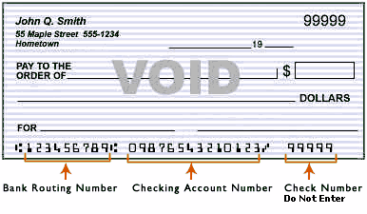

MercyCare Health Plans

Finance Department – ACH

PO BOX 550

Janesville WI, 53547