**November 2020 Bulletin**

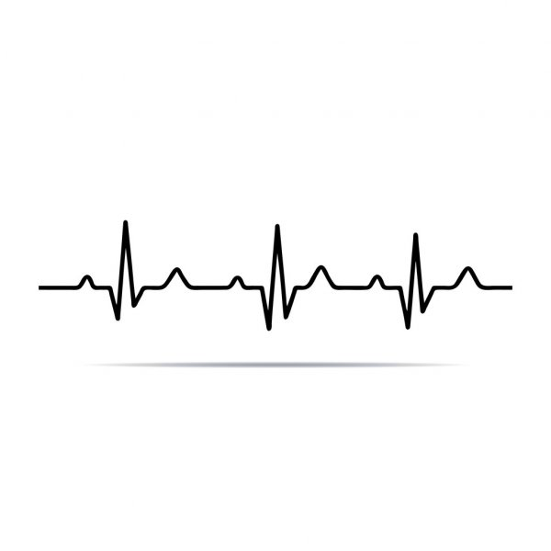

What are the benefits of Cardiac Rehabilitation after a cardiac event?

(i.e. MI, Valve surgery, CABG, Cardiac stents, CHF)

*Reduce your overall risk of future heart problems, and risk of dying from a Heart Attack

*Decrease pain and the need for medicines to treat heart or chest pain

*Decrease the chance that you’ll have to return to the ER with a heart problem

* Improve your overall health by decreasing risk factors for heart problems

*Improve quality of life by increasing strength, stamina and endurance

* Decrease anxiety and depression thru exercise and education

* Improve healthy diet choices and diet changes to decrease a future Heart problem

Hummus

30 oz. canned, low sodium garbanzo beans-drained, rinsed

½ cup lemon juice

2 tsp. minced garlic (from jar, use less if fresh)

1 Tbsp. EVOO (extra virgin olive oil)

¼ tsp. paprika

½ tsp. dried parsley

Directions:

Place all ingredients in a blender or food processor and blend until smooth. Serve with fresh veggie slices or sticks as a dip.

Calories 126/serving, Protein 6g/serving, Fiber 4g/serving

**Recipe**

Lakeside Heart Center

177 West 4th St

Oswego, NY. 13126

(315) 343-1378

Oswegohealth.org

**Lakeside Heart Center is dedicated to the prevention and treatment of heart disease. The program is certified by the American Association of Cardiovascular and Pulmonary Rehabilitation.**

**Please ask your Healthcare provider for more information about Cardiac Rehab.**