“If You Can Dream It You Can Do It”
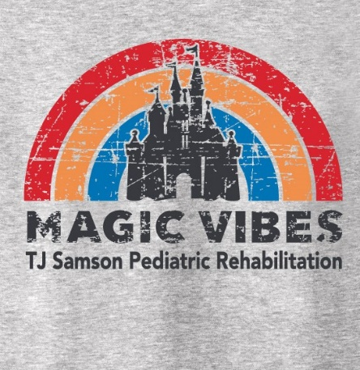
C.A.M.P. TJ KIDS
TJ Samson Rehabilitation Department
Children Always Making Progress

Schedule: June 14, 15, 16, & 17 - TUESDAY through FRIDAY
Location: HIGHLAND ELEMENTARY
It is time to get ready for our 23rd annual C.A.M.P. T.J. KIDS. This year we are excited to see everyone in person we will practice social distancing and follow recommended CDC guidance. We will have a morning group and afternoon group. Each class will have activities planned around theme. Your child will be working on fine/gross motor skills, strength, endurance, coordination, handwriting, social skills, art communication and self-esteem, while having fun!
This experience is coordinated
by T.J. Samson Rehabilitation Department.
To be eligible to attend camp, the participant must receive therapy services (OT, PT, or SLP,) in a clinic, school system or other setting and be 3 years old.
Registration Fee is $50
Registration Deadline: May 16 the (Space is Limited)
Go to www.tjsamson.org, click on Rehabilitation services to download and print the camper packet. Print and return completed packets to:
ATTN: TJ Samson Discovery Academy Team
T.J. Samson Outpatient Rehabilitation Services
Address: 310 North L Rogers Wells Blvd Glasgow KY 42141
email us at stsmith@tjsamson.org or phone # 270-659-5660

