Place Orders
- Select a patient from the Open Census, click
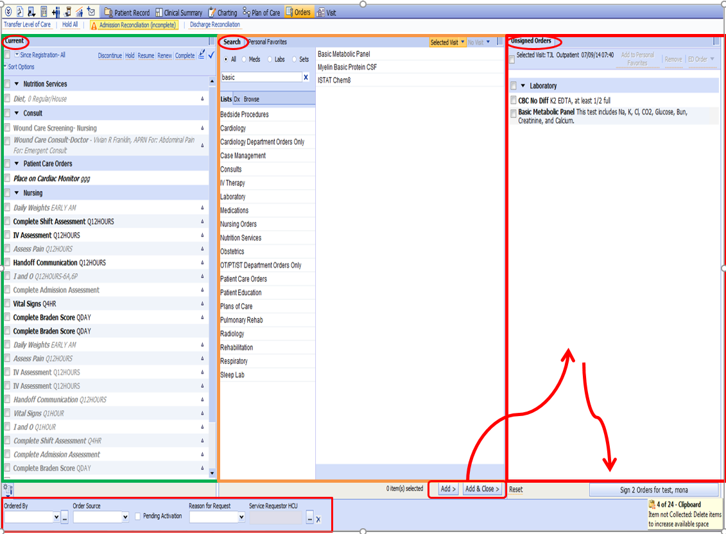
Unsigned Orders
Search

Current Orders
There are 3 sections in Orders. Current Orders section lists the current orders for a patient. Search Section is where you locate orders to add. The Unsigned Orders section is where orders that are not saved reside to allow you to make changes to them before you activate them.
- In Search box, Start typing first few letter on what you wish to order.
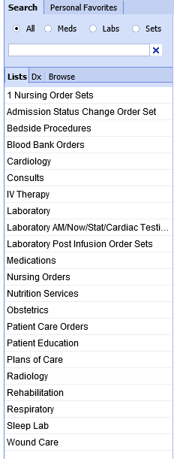
Most Common list
- The Order Date and Time defaults the current date and time into the order detail form(s) and do not need be entered in the Session Details.

Order Detail Forms
After you select the order(s), the order detail forms display if all required fields are not completed. Complete the order detail fields as appropriate. Orders may go directly to the Unsigned Orders. You can click on the order name from the Unsigned Orders to launch the order detail form and review or update the fields.

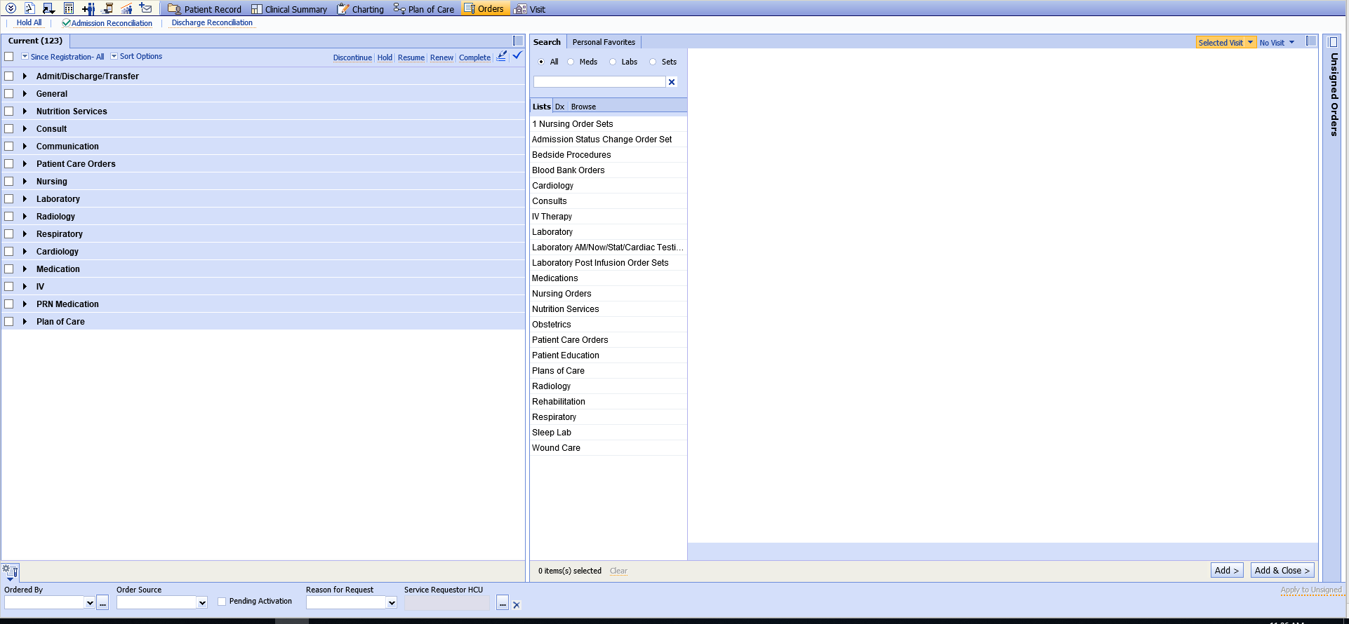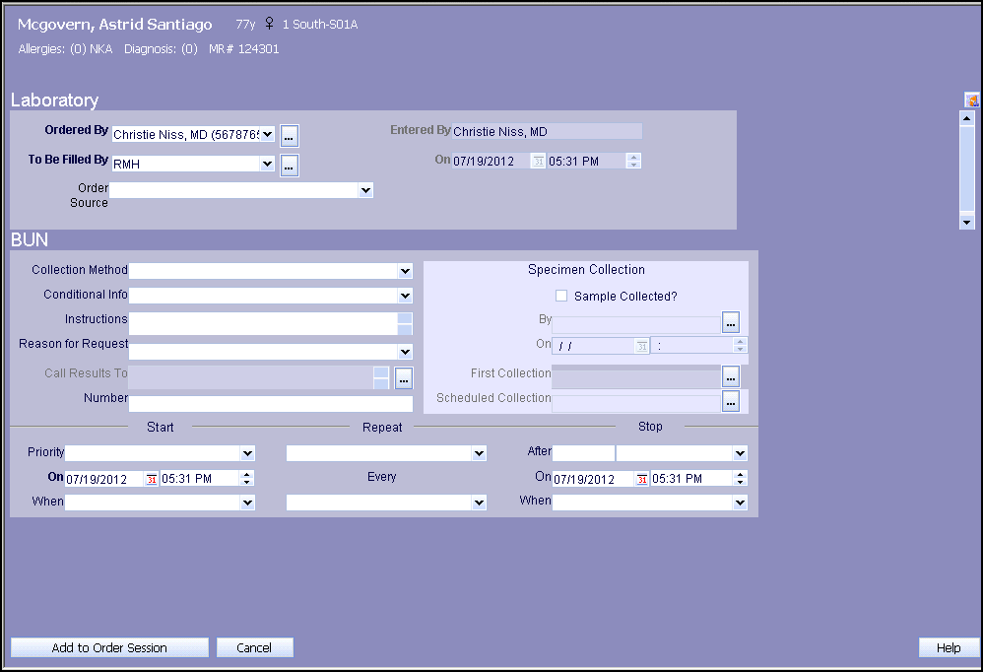Click to save the orders.
Current Orders Menu Options
In the Current Orders section, click on the name of an order and the following menu options display:
Details | View the order detail form
Revise | To change order details
Result | View the result for this order
History | View any changes that have been made to the order
Revise Status | You might not be using this option.

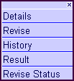

Current Orders Indicators
Icon | Order Status
 | Complete
 | Not Complete
 | Active
 | Suspend
 | Discontinued, cancel, Invalid
 | In Progress

