

Tribhuvan University
Faculty of Humanities and Social Science
Orchid International College

A PROJECT REPORT
ON
INVENTORY MANAGEMENT SYSTEM USING
K-MEANS CLUSTERING FOR CUSTOMER SEGMENTATION
Submitted to
Department of Computer Application
Orchid International College

In partial fulfillment of the requirements for the Bachelors in Computer Application

Submitted by
Nishant Chaudhary (93902070)
November 2025

Under the Supervision of
Sulav Dahal

Tribhuvan University
Faculty of Humanities and Social Science
Orchid International College

SUPERVISOR’S RECOMMENDATION
I hereby recommend that this project prepared under my supervision by Nishant Chaudhary entitled “Inventory Management System using K-means Clustering for Customer Segmentation” in partial fulfillment of the requirements for the degree of Bachelor of Computer Application is recommended for the final evaluation.

SIGNATURE
Sulav Dahal
SUPERVISOR
Faculty of Humanities and Social Science
Bijayachowk, Gaushala, Kathmandu

Tribhuvan University
Faculty of Humanities and Social Science
Orchid International College

LETTER OF APPROVAL
This is to certify that this project prepared by Nishant Chaudhary entitled “Inventory Management System using K-means Clustering for Customer Segmentation” in partial fulfillment of the requirements for the degree of Bachelor in Computer Application has been evaluated. In our opinion it is satisfactory in the scope and quality as a project for the required degree.
Signature of Supervisor  _____________________  Mr. Sulav Dahal  Department of IT  Orchid International College | Signature of HOD/ Coordinator  ___________________  Mr. Dhiraj Kumar Jha  Head of Department  Department of IT
Signature of Internal Examiner  _____________________  Shrilata Wagle  Full-time Faculty  Orchid International College | Signature of External Examiner  ___________________

ABSTRACT
Inventory Management System using K-means Clustering for Customer Segmentation was developed to streamline business operations, enhance inventory visibility, and support data-driven decision-making. The system featured modules for dealer management, inventory tracking, purchase handling, invoice generation, party ledger creation, and customer record management. Customer segmentation was enabled through the K-means clustering algorithm, allowing intelligent grouping and analysis. Dynamic dashboards provided real-time insights into stock levels, transactions, and performance metrics, while a media center ensured efficient asset organization.
The platform was built using FastAPI, Next.js, and MongoDB, with RESTful APIs facilitating secure and efficient communication between services. The result was a responsive, modular, and user-friendly solution capable of managing inventory, financial records, and customer relationships effectively at scale.

Keywords: Inventory Control & Management System, FastAPI, Next.js, MongoDB, REST API, K-means Clustering

ACKNOWLEDGEMENT
I sincerely express my heartfelt gratitude to everyone who supported me throughout the completion of this project. I extend special thanks to Er. Dhiraj Kumar Jha for his invaluable guidance, constructive feedback, and continuous encouragement, which greatly contributed to the successful execution of this work. I am deeply grateful to my family for their constant love, motivation, and belief in me, and to my friends and college mates for their support, cooperation, and meaningful discussions during various stages of this project. I would also like to acknowledge the college library for providing essential resources and a conducive environment for research. To all who contributed directly or indirectly, I offer my sincere appreciation.
Nishant Chaudhary (93902070)

TABLE OF CONTENT
SUPERVISOR’S RECOMMENDATION i
LETTER OF APPROVAL ii
ABSTRACT ……………………………………………………………………………...iii
ACKNOWLEDGEMENT iv
TABLE OF CONTENT v
LIST OF FIGURES vii
LIST OF TABLES viii
LIST OF ABBREVIATION ix
Chapter 1: Introduction 1
1.1 Introduction 1
1.2 Problem Statement 1
1.3 Objectives 1
1.4 Scope and limitation 2
1.4.1 Scope of System 2
1.4.2 Limitation of Existing System 2
1.5 Development Methodology 2
1.6 Report Organization 3
Chapter 2: Background Study and Literature Review 4
2.1 Background Study 4
2.2 Literature Review 4
Chapter 3: System Analysis and Design 5
3.1 System Analysis 5
3.1.1 Requirement Analysis 5
3.1.2 Feasibility Study 7
3.1.3 Object Modeling 8
3.1.4 Dynamic Modeling 9
3.1.5 Process Modelling 11
3.2 System Design 14
3.2.1 Sequence Diagram 14
3.2.2 Component Diagram 16
3.2.3 Deployment Diagram 17
3.3 Algorithm Details 19
Chapter 4: Implementation and Testing 23
4.1 Implementation 23
4.1.1 Tools Used 23
4.1.2 Implementation Detail of Modules 24
4.2 Testing 26
4.2.1 Test Cases for Unit Testing 26
4.2.2 Test Cases for System Testing 27
Chapter 5: Conclusion and Future Recommendation 29
5.1 Conclusion 29
5.2 Future Enhancement 29
REFERENCES 30
APPENDICES 31

LIST OF FIGURES
Figure 1.1 Agile Methodology 3
Figure 3.1 Use case diagram 6
Figure 3.2 Gantt Chart 8
Figure 3.3 Class Diagram of Inventory Management System using K-means Clustering for Customer Segmentation 9
Figure 3.4 Sequence Diagram 10
Figure 3.5 Activity Diagram 12
Figure 3.6 Refined Sequence Diagram 14
Figure 3.7 Component Diagram 16
Figure 3.8 Deployment Diagram 17
Figure 3.9 Working Mechanism of K means Clustering 19
Figure 3.10 Elbow Curve for k Selection 22

LIST OF TABLES
Table 4.2 Test Case 001 – Admin Login Module 26
Table 4.3 Test Case 001 Dealer Creation 27
Table 4.4 Test Case 002 - Add Product 28

LIST OF ABBREVIATION
API : Application Programming Interface
CSS : Cascading Style Sheets
DB : Database
HTML : Hypertext Markup Language
JS : JavaScript
JWT : JSON Web Token
MERN : MongoDB, Express.js, React, Node.js
REST : Representational State Transfer
SWR : Stale While Revalidate
TC : Test Case
UI : User Interface
UX : User Experience
VCS : Version Control System

Introduction

Introduction
The Inventory Management System using K-means Clustering for Customer Segmentation is a comprehensive solution designed to manage products, stock levels, dealers, and financial records efficiently. It enables model-based product tracking, category classification, purchase management, invoice generation, and party ledger maintenance. A centralized media center allows image reuse, and customer data is analyzed using the K-means clustering algorithm for effective segmentation. Built with FastAPI, Next.js, and MongoDB, the system provides real-time dashboards, reports, and search functionalities, ensuring smooth inventory operations and informed business decisions.

Problem Statement
Businesses often face challenges in managing inventory efficiently, tracking stock levels, maintaining accurate dealer and customer records, and monitoring financial transactions. Manual or fragmented systems lead to errors, stock-outs, overstocking, delayed invoicing, and difficulty in analyzing customer behavior. There is a need for a unified system that can streamline product management, automate stock updates, handle dealer and party ledgers, and provide real-time insights through dashboards and reports. Additionally, leveraging data analytics, such as customer segmentation, can help businesses make informed decisions and optimize operations.

Objectives
The objectives of the proposed system are:
- To efficiently manage dealer information, including company details, contact persons, payment terms, and transaction history.
- To maintain accurate and up-to-date records of stock supplied by each dealer, ensuring seamless inventory tracking.
- To automate party ledger management, tracking dues, payments, and outstanding balances for dealers.
- To streamline purchase and invoice generation processes linked to dealer transactions.

Scope and limitation
This section defines the boundaries of the Inventory Management System using K-means Clustering for Customer Segmentation, outlining its key functionalities in inventory and dealer management. It also highlights the system’s constraints, such as reliance on manual entries and limited support for multi-branch operations.

Scope of System
The Inventory Management System using K-means Clustering for Customer Segmentation is designed to efficiently manage products, stock levels, dealers, and financial records within a business. It covers dealer management, model-based product tracking, category classification, purchase handling, invoice generation, and party ledger maintenance. The system also includes a centralized media center for image management and implements customer segmentation using the K-means clustering algorithm. Real-time dashboards and reports provide insights into stock status, financial transactions, and dealer performance, supporting data-driven decision-making and streamlined inventory operations.

Limitation of Existing System
- Certain financial transactions require manual entry.
- Analytical features are limited to basic clustering; no advanced forecasting.
- System performance depends on accurate and consistent data entry.
- Supports only a single organizational framework; no multi-branch synchronization.

Development Methodology
The Inventory Management System using K-means Clustering for Customer Segmentation was developed using the Agile methodology, emphasizing iterative development, continuous feedback, and incremental improvements. The system was built in phases, starting with requirement gathering, followed by system analysis, design, implementation, testing, and deployment. FastAPI was used for backend development, Next.js for the frontend, and MongoDB for the database, ensuring a modular, scalable, and maintainable architecture. This approach allowed for flexibility in incorporating changes, efficient progress tracking, and timely resolution of issues throughout the project lifecycle.
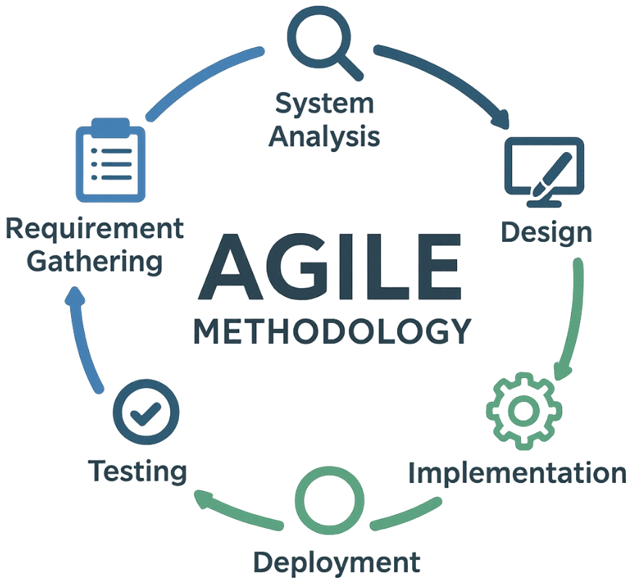
Figure 1.1 Agile Methodology

Report Organization
This report is organized into five chapters:
- Chapter 1 – Introduction: Overview of the project, objectives, scope, and limitations.
- Chapter 2 – Background Study: Analysis of existing systems and their pros and cons.
- Chapter 3 – System Analysis and Design: Requirement analysis, feasibility study, and system design.
- Chapter 4 – Implementation and Testing: System implementation, testing, and debugging details.
- Chapter 5 – Conclusion and Future Work: Summary, limitations, and potential enhancements.

Background Study and Literature Review

Background Study
Inventory management is a key function in businesses, ensuring optimal stock levels, smooth operations, and effective management of dealers and customers. It involves processes such as tracking stock, managing purchases, maintaining ledgers, and analyzing customer and product data. Traditional manual methods or basic software often result in errors, stock discrepancies, delayed invoicing, and inefficient transaction tracking. Advanced inventory management systems aim to automate these processes, providing real-time updates, accurate stock control, and data-driven insights.
The Inventory Management System builds on these concepts by integrating dealer management, model-based product tracking, category classification, purchase and invoice handling, party ledger maintenance, and customer segmentation using K-means clustering. This ensures a unified, scalable, and user-friendly platform that improves operational efficiency, minimizes errors, and supports informed business decisions.

Literature Review
Several studies and projects have contributed to the development of effective inventory management systems. Multi-agent based inventory systems demonstrate how agent autonomy and cooperation can streamline inventory control, reduce stock levels, and enable seamless coordination among enterprises [1]. These ideas inspired the automated stock and dealer management features in the system, minimizing manual errors and improving workflow.
Web-based inventory systems emphasize centralized management, accessibility, and operational efficiency [2]. This influenced the development of a responsive, user-friendly interface in the system using FastAPI and Next.js, enabling efficient real-time stock management. The K-means clustering algorithm, widely applied in data segmentation and analysis, guided the design of system’s customer segmentation feature, helping categorize customers for better decision-making and targeted management [3].
Additionally, integrating invoicing with analytics in small and micro enterprises demonstrates the importance of automated invoice generation, sales tracking, and financial management [4]. This informed the ledger and invoice modules in the system, ensuring accurate tracking of dues, payments, and financial summaries.

System Analysis and Design

System Analysis
System analysis focuses on understanding the requirements, processes, and functionalities needed for the Inventory Management System using K-means Clustering for Customer Segmentation It identifies what the system should do, how it should perform, and the constraints under which it will operate.

Requirement Analysis
Both functional and non-functional requirements were carefully examined and documented to serve as a foundation for system design and implementation. Requirements are generally split into two types:
- Functional Requirements
- Non-Functional Requirements
- Functional Requirements
Functional requirements define the specific behaviors and functions of the system. The key functional requirements of SYSTEM include:
- Dealer Management – Add, update, and delete dealer information; track dealer transactions and generate party ledger.
- Product Management – Add new products or update stock for existing models; manage product categories and specifications.
- Stock Management – Maintain real-time stock levels, track stock history, and generate low-stock alerts.
- Media Center – Upload, reuse, and manage product images with tagging and usage tracking.
- Purchase & Invoice Management – Record purchases, generate invoices, and track payments.
- Customer Management & Segmentation – Store customer data and perform segmentation using K-means clustering.
- Reporting & Dashboard – Provide stock summaries, financial metrics, and activity reports.

- Non-Functional Requirements
Non-functional requirements define how the system performs and constraints under which it operates. For system, they include:
- Performance – Real-time updates for stock and ledger entries.
- Scalability – Ability to handle increasing products, dealers, and customers.
- Security – Secure API endpoints with Rate limiting, caching, token-based authentication.
- Reliability – System uptime, error handling, and data integrity.
- Usability – Intuitive and responsive web interface for ease of operation.
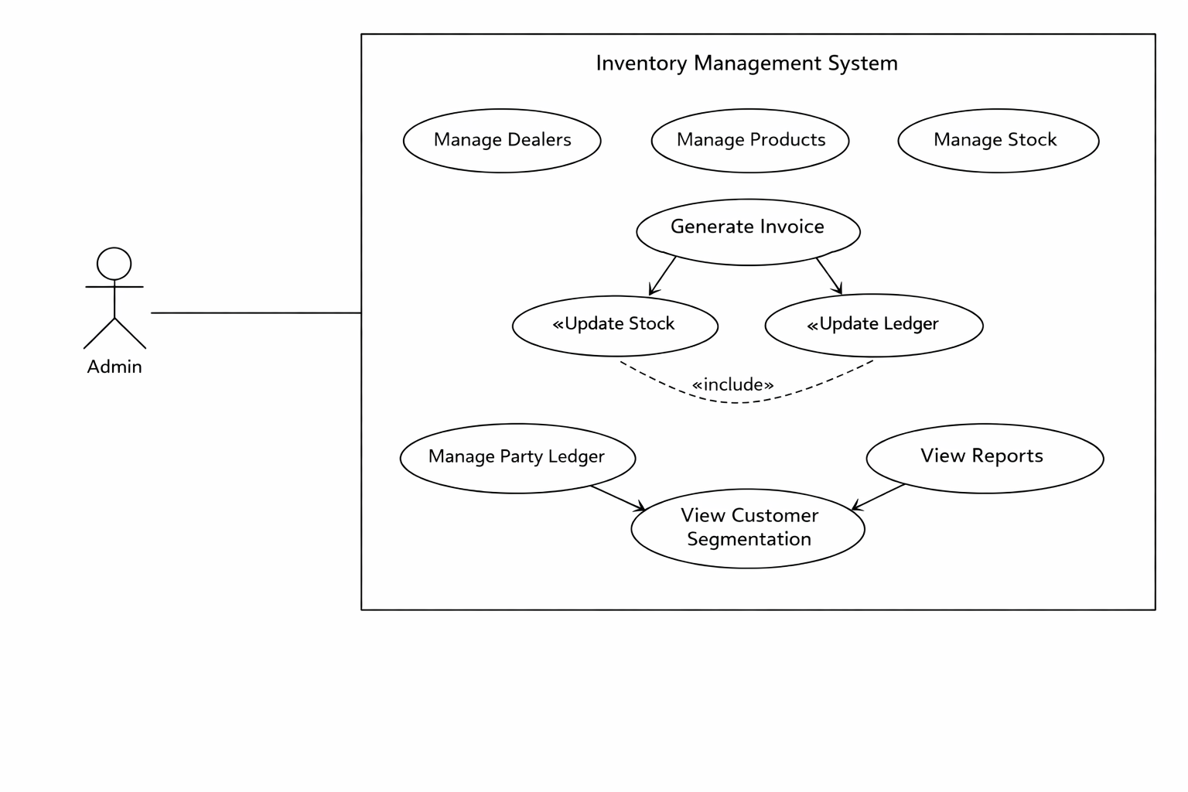
Figure 3.1 Use case diagram

The admin interacts with the system to manage all core aspects of inventory operations.
- Starting with dealer management, the admin maintains dealer records and transactions.
- Stock management ensures that product levels are always updated and monitored.
- Through sales and invoice management, the admin can create invoices and track sales seamlessly.
- Customer data is stored and analyzed via customer management and segmentation, improving decision-making with clustering techniques.
- Finally, ledger management ensures financial integrity by tracking dues, payments, and outstanding balances.

Feasibility Study
- Technical Feasibility
The system is technically feasible because it uses modern, widely adopted technologies:
- Backend: FastAPI (lightweight, scalable, and high-performance Python framework).
- Frontend: Next.js (React-based, providing server-side rendering and optimized performance).
- Database: MongoDB (flexible schema design suitable for product and stock management).
- Deployment: Containerized using docker, ensuring flawless deployments to cloud platforms.
- Operational Feasibility
The system addresses real business problems faced by Inventory Management System using K-means Clustering for Customer Segmentation, such as:
- Managing dealer and supplier records.
- Tracking stock levels with model-based product management.
- Maintaining financial records through a party ledger.
- Reducing manual errors in invoice generation and stock updates.
- Providing real-time insights through dashboards and reports.

- Economic Feasibility
- Development Costs: Minimized by using open-source frameworks (FastAPI, Next.js, MongoDB).
- Infrastructure Costs: Controlled through cloud deployment on Google Cloud with scalable plans.
- Maintenance Costs: Reduced due to modular design and reusable components (e.g., Media Center).
- Schedule Feasibility
The system was developed using the Agile methodology, ensuring timely progress and flexibility:
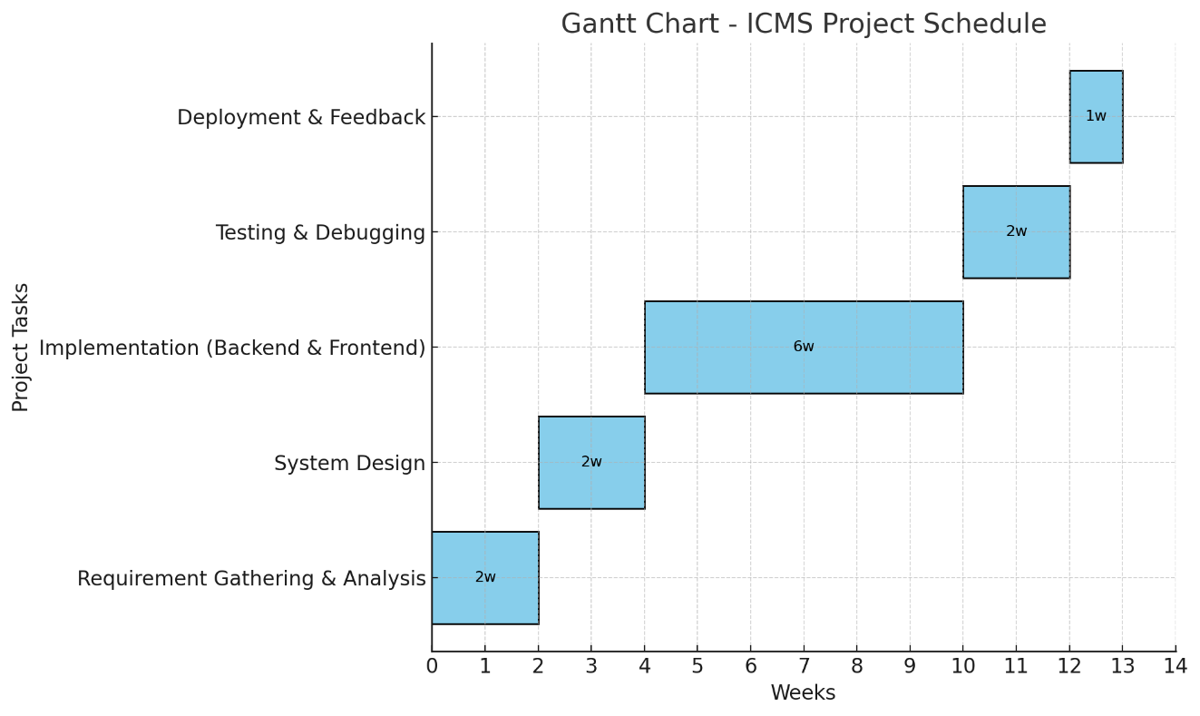
Figure 3.2 Gantt Chart
- Requirement Gathering & Analysis → 2 weeks
- System Design → 2 weeks
- Implementation (Backend & Frontend) → 6 weeks
- Testing & Debugging → 2 weeks
- Deployment & Feedback → 1 week

Object Modeling
The class diagram of the system represents the core entities of the inventory and dealer management system and how they interact. The Dealer class stores information about suppliers, including their name, phone number, GST number, and payment terms. Each dealer can supply multiple products, represented by the Product class, which contains details like model number, dealer price, and stock levels. Products are grouped into categories, managed by the Category class, such as TVs, Mobiles, or Refrigerators, allowing the system to organize items efficiently. Financial transactions with dealers are tracked using the Ledger class, which records dues, payments, and invoice references, and each dealer can have multiple ledger entries. Product images or media are handled by the Media class, and a many-to-many relationship exists between products and media, meaning a product can have multiple images, and a single image can be associated with multiple products. Overall, this class diagram defines the structural blueprint of the system, showing how dealers, products, categories, financial records, and media interconnect.
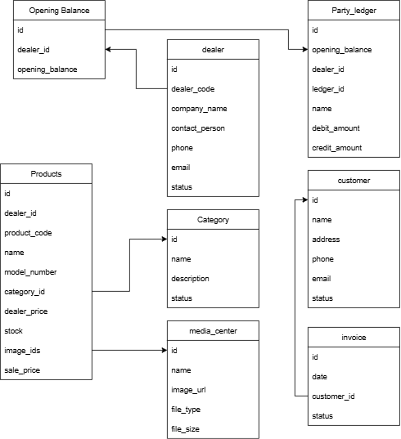
Figure 3.3 Class Diagram of Inventory Management System using K-means Clustering for Customer Segmentation

Dynamic Modeling
Figure 3: Class Diagram
3.1.4 Dynamic Modeling
Dynamic modeling refers to the process of creating a representation of a system that
captures how it changes over time. This involves understanding the behavior of a system
through its interactions and the flow of information or resources, typically using various
modeling techniques to depict dynamic aspects such as processes, events, and states. Here
are some key points about dynamic modeling:
Dynamic modeling refers to the process of creating a representation of a system that
captures how it changes over time. This involves understanding the behavior of a system
through its interactions and the flow of information or resources, typically using various
modeling techniques to depict dynamic aspects such as processes, events, and states. Here
are some key points about dynamic modeling:
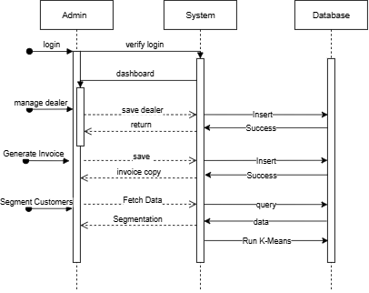
Figure 3.4 Sequence Diagram
The sequence diagram for the Inventory Management System using K-means Clustering for Customer Segmentation illustrates how the single administrator interacts with the system and how the system communicates with the underlying database to perform different operations. The diagram highlights the step-by-step workflow of requests, processing, and responses.
Login Process
- The Admin initiates the login by sending credentials to the system.
- The system verifies the credentials by querying the database.
- Upon successful authentication, the system provides the Admin with access to the dashboard.
Inventory Management
- When the Admin adds a new product, the request is sent to the system.
- The system forwards the product details to the database for storage.
- Once the operation is successful, the system responds back with an updated product list to the Admin.
Dealer Management
- The Admin can add or manage dealers by sending dealer information.
- The system saves these details into the database.
- A confirmation is sent back, and the updated dealer list is shown to the Admin.
Invoice Generation
- The Admin creates invoices for transactions.
- The system stores invoice records in the database.
- The Admin receives a copy of the generated invoice for reference.
Customer Segmentation
- To analyze customer behavior, the Admin requests segmentation.
- The system fetches customer data from the database and applies the K-means clustering algorithm.
- Segmentation results are then presented to the Admin for insights.
Reports and Analytics
- The Admin requests reports on stock levels, sales, or dealers.
- The system queries the database and processes the required data.
- The generated report is displayed to the Admin in a simplified format.

Process Modelling
Process modelling is a crucial step in system design as it visually represents the flow of activities, decisions, and interactions within a system. In the case of the system, activity diagrams are used to model how the administrator interacts with different system modules, from login to logout. These diagrams capture the dynamic behavior of the system and provide a clear understanding of sequential and parallel workflows.
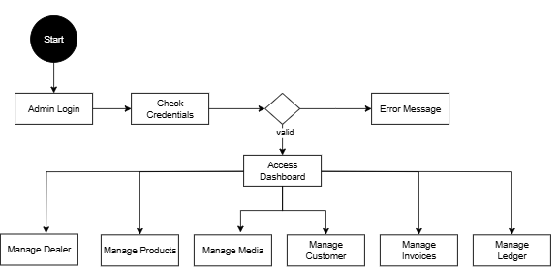
Figure 3.5 Activity Diagram
Process modeling represents the flow of activities and decisions within the Inventory Management System using K-means Clustering for Customer Segmentation. It focuses on how the system behaves dynamically in response to administrator actions, from authentication to operational tasks and reporting. Activity diagrams are used to visually and logically describe this workflow.
The process begins when the Admin accesses the system and enters login credentials. The system validates the credentials against stored records. If the credentials are invalid, the system displays an error message and requests re-entry. Upon successful authentication, the Admin is redirected to the dashboard, which serves as the central control panel for all system operations.
From the dashboard, the Admin can initiate multiple processes such as dealer management, product and stock management, invoice generation, ledger management, customer analysis, and report viewing. In dealer management, the Admin can add, update, or delete dealer records, which are then stored in the database. Product and stock management allows the Admin to create or update product details, assign categories, and maintain real-time stock levels.
When generating an invoice, the system follows a dependent workflow. After the Admin selects products and customer details, the system automatically updates stock quantities and creates corresponding ledger entries. This ensures data consistency between inventory records and financial transactions. The Admin is then able to view or download the generated invoice.
For analytical operations, the Admin can request reports or customer segmentation insights. The system retrieves relevant customer data from the database and internally applies the K-means clustering algorithm to group customers based on purchasing behavior. The resulting segments are presented in a readable and meaningful format on the dashboard. The Admin does not directly interact with the algorithm; instead, the system handles the computation and displays the outcome.
Each activity provides feedback to the Admin in the form of confirmations, updated tables, or visual reports. The process concludes when the Admin logs out of the system, ensuring secure termination of the session. Overall, the process model demonstrates a structured and efficient flow of operations, ensuring seamless interaction between inventory management, financial tracking, and analytical reporting.

System Design
System design defines the overall structure, interactions, and deployment of the Inventory Management System using K-means Clustering for Customer Segmentation. It transforms the requirements into well-structured models and diagrams that represent the functional, behavioral, and physical aspects of the system. The design phase ensures that all modules, components, and workflows are properly visualized for accurate implementation.

Sequence Diagram
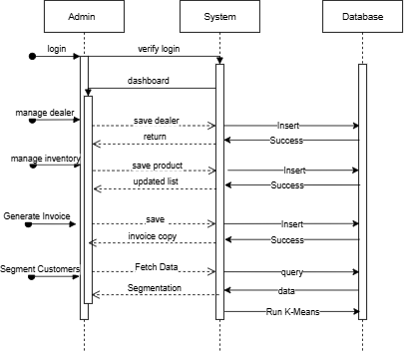
Figure 3.6 Refined Sequence Diagram
The refined sequence diagram for the system provides a detailed view of the interactions between the Admin (actor), the System (controller), and the Database (data store). It ensures that all major operations are covered with precise workflows.

Login Authentication
- The Admin enters credentials.
- The System validates credentials by checking with the secret stored.
- If valid, the Admin is redirected to the dashboard; otherwise, an error is shown.
Inventory Management
- Admin requests to add or update a product.
- The System receives the request and forwards it to the Database.
- Once saved, the System confirms success and shows the updated inventory list to the Admin.
Dealer Management
- Admin submits dealer details for creation or modification.
- The System processes the request and updates the Database.
- Confirmation and updated dealer records are displayed back to the Admin.
Invoice Generation
- Admin initiates invoice creation by selecting customer and product details.
- The System generates an invoice, stores it in the Database, and retrieves a copy.
- The finalized invoice is displayed to the Admin.
Customer Segmentation (K-means Analytics)
- Admin requests customer segmentation.
- The System fetches customer data from the Database.
- K-means clustering algorithm is applied to categorize customers into groups.
- Results are returned and displayed as segmented clusters.
Reporting & Ledger Management
- Admin requests a report (e.g., sales, stock levels, dealer activity).
- The System queries the Database and processes the data.
- A structured report or ledger is generated and displayed.

Component Diagram
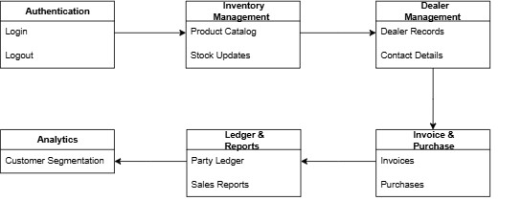
Figure 3.7 Component Diagram
The component diagram illustrates the high-level architectural structure of the Inventory Management System using K-means Clustering for Customer Segmentation. It represents the major software components of the system and shows how they interact to deliver complete functionality. This diagram helps in understanding the separation of responsibilities among different system layers.
The User Interface component represents the frontend of the system, developed using Next.js. It provides all interactive screens such as login, dashboard, dealer management, product management, invoice generation, reports, and customer segmentation views. The Admin interacts with the system exclusively through this component, which sends requests to the backend and displays responses in a user-friendly manner.
The Application Controller component acts as the communication layer between the frontend and backend services. It handles incoming requests from the User Interface, performs request validation, and routes them to appropriate backend services. This component ensures secure and structured communication using RESTful APIs.
The Business Logic or Service component contains the core functionality of the system. It implements rules and operations related to dealer management, product and stock handling, invoice generation, ledger maintenance, reporting, and customer segmentation. The K-means clustering algorithm is implemented within this layer as an internal service, ensuring that analytical processing remains hidden from the user interface and is executed automatically when required.
The Data Access component is responsible for interacting with the database. It manages all create, read, update, and delete (CRUD) operations for products, dealers, ledger entries, invoices, and customer records. MongoDB is used as the database, providing flexible schema design and efficient data storage for inventory-related information.
Additionally, the Media Management component handles product images and other media assets. This component integrates with Cloudinary to store, retrieve, and optimize media files. It allows multiple products to reuse the same images while maintaining efficient storage and fast delivery.
The interaction between these components follows a layered architecture. The User Interface communicates only with the Application Controller, which then interacts with the Business Logic and Data Access components. Direct access to the database from the frontend is restricted, ensuring better security, maintainability, and scalability. This component-based design enables modular development, easier testing, and future system enhancements.

Deployment Diagram
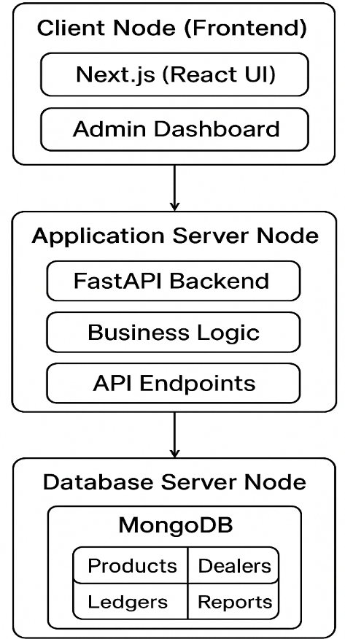
Figure 3.8 Deployment Diagram
This deployment diagram represents a three-tier architecture for the Inventory Management System using K-means Clustering for Customer Segmentation. Each node (box) corresponds to a hardware or server environment, and inside each node are the software components deployed on it. The arrows show communication paths between these nodes.
Client Node (Frontend)
- Contains the Next.js (React UI) and the Admin Dashboard.
- This is the entry point where users and administrators interact with the system.
- The frontend communicates with the backend using HTTPS REST API calls, ensuring secure communication.
Application Server Node
- Hosts the FastAPI Backend, which contains the Business Logic and API Endpoints.
- This is the core of the system where requests from the frontend are processed, business rules are applied, and data is prepared for users.
- The application server communicates with the database to fetch and update records as needed.
Database Server Node
- Runs MongoDB, which stores persistent data.
- Collections include Products, Dealers, Ledgers, and Reports, covering all critical aspects of the inventory and dealer management system.
- The database is accessed only by the application server, not directly by the client, ensuring data security.
Communication Flow
- The Client Node → Application Server communication happens via HTTPS REST API calls.
- The Application Server → Database Server communication happens through a database connection (MongoDB driver).

Algorithm Details
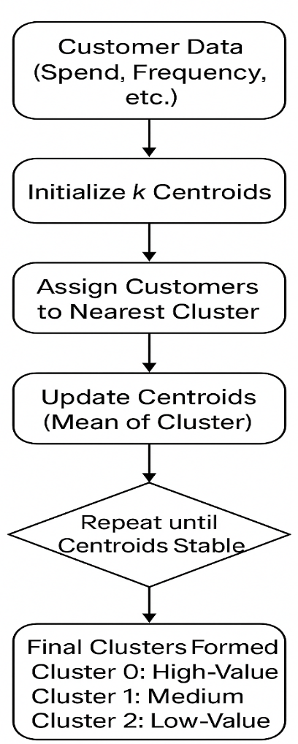
Figure 3.9 Working Mechanism of K means Clustering
This System’s Customer Segmentation employs an exclusive version of the K-Means clustering technique for autonomously categorizing consumers according to their shopping habits. The objective is to assist businesses in identifying trends within their purchasing behavior for making informed strategic choices regarding marketing efforts, customer retention initiatives, and financial transactions.
Starting off involves collecting organized data points related to every client's spending habits, including overall total spend, number of completed invoices, average order value, and recency of purchase. The current focus of the system in cluster analysis involves examining only total spending and number of invoices as they effectively reflect key aspects of customer worthiness and interaction levels.
After preparing the data, the algorithm categorizes every client into one out of three groups initially set as k equals 3. Often these groups signify categories like high-value repeat customers, moderate-value regular customers, and low-spend occasional buyers. Following the clustering procedure, each client receives an integer-based cluster identifier (e. g. , 0 for VIPs, 1 for Active customers) subsequently translated into understandable descriptive terms like "High Value Champions" or "Active Growing Clients”.
The K-means method undergoes successive adjustments for optimization. Firstly, it employs the K-Means++ method to randomly select k starting points called centroids. These initial positions aim to distribute data evenly across clusters effectively. Every client receives an immediate placement near its closest representative within the data's spatial framework. Following completion of this task cycle, new centers are determined through an average calculation of customer locations within every group formed. The task—repetitive update process persists till cluster centers settle down, indicating successful clustering completion. A distinct hierarchical arrangement emerges which facilitates precise strategic planning by businesses.
In this framework, employing k equals three aligns well with practical application insights. Retail customer profiling usually focuses on categorizing shoppers into three distinct groups based on their spending habits: frequent spenders who make many purchases, average consumers who occasionally shop, and infrequent purchasers. Ensuring clarity in segmentation by having three distinct groups guarantees it is both useful for action and consistent with typical business strategies while preventing overcomplicated classifications.
Mathematical Formulation of K-Means Clustering
K-Means clustering is an unsupervised algorithm that groups customers into a fixed number of clusters (k) based on similarity in their purchasing behavior. Each customer is represented using numerical values derived from transaction history.
Let the dataset contain n customers, represented as:
X = {x1, x2, x3, ..., xn}
Each customer xi is defined by two features:
xi = (Si, Ii)
where:
Si = total spending of customer i
Ii = total number of invoices of customer i

Distance Calculation
The similarity between a customer and a cluster center is measured using Euclidean distance:
Distance (xi, cj) = √ [(Si − Sj)² + (Ii − Ij)²]
where:
cj = centroid of cluster j
Sj and Ij are the centroid values of spending and invoice count.
Cluster Assignment
Each customer is assigned to the cluster whose centroid is closest based on minimum distance:
Customer xi belongs to cluster j if:
Distance (xi, cj) is minimum among all clusters.
Centroid Update
After assigning customers to clusters, new centroid values are calculated using the average of customers in that cluster:
New centroid (Sj, Ij) = (average spending of customers in cluster j,
average invoice count of customers in cluster j)
Stopping Condition
The algorithm repeats the assignment and centroid update steps until:
- Cluster assignments no longer change, or
- Centroid values remain stable, or
- Maximum iterations are reached.
Cluster Interpretation
In this system, k is selected as 3 using the Elbow Method, resulting in:
- Cluster 1: High-value frequent customers
- Cluster 2: Medium-value regular customers
- Cluster 3: Low-value occasional customers
Each customer is labeled with a cluster ID and stored in the database for reporting and analysis.
Determining the Value of k
Determining an appropriate value for k in the K-Means clustering algorithm is essential for forming meaningful customer groups. In this system, the selection process is guided by the Elbow Method, a standard evaluation technique that examines how clustering performance changes as the number of clusters increases. The Elbow Method focuses on inertia, which is the total squared distance between each data point and its assigned centroid. As the number of clusters grows, inertia decreases because the data is divided into more specific groups. However, this improvement does not continue at the same rate.
By conceptually observing inertia across increasing values of k, a pattern becomes clear. The decrease in inertia from k equal to 2 to k equal to 3 is relatively large, showing that introducing a third cluster adds meaningful separation in customer behavior. When moving from k equal to 3 to k equal to 4, the reduction becomes noticeably smaller. This point where the rate of improvement slows is known as the elbow. It indicates that additional clusters provide limited benefit and may lead to unnecessary fragmentation.
Based on this evaluation process, k equal to 3 corresponds to the elbow position and represents a balanced choice that maintains both clustering quality and practical interpretability for customer segmentation in the System.
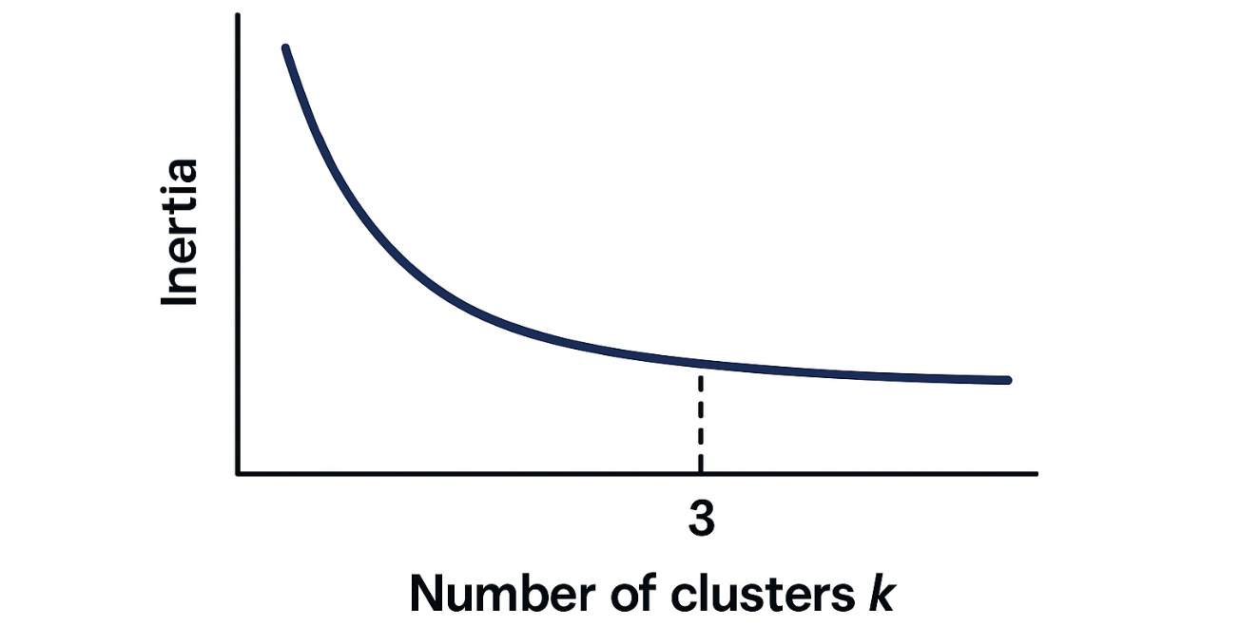
Figure 3.10 Elbow Curve for k Selection

Implementation and Testing

Implementation
The system was developed using the Agile development methodology, ensuring iterative progress and continuous feedback throughout the project lifecycle. Development was carried out in short sprints, where features were planned, implemented, tested, and refined incrementally. This allowed for flexibility in adapting to evolving requirements and faster resolution of issues. Key modules such as authentication, product and dealer management, ledger handling, customer segmentation service, and reporting—were built and improved step by step. Regular testing and review ensured that each component met performance, scalability, and usability standards. This iterative approach ultimately led to a more robust, user-centered solution aligned with project goals.

Tools Used
The following tools and technologies were used for the design, development, and deployment of the system:
- Next.js: A React-based framework used for building the frontend interface and admin dashboard. It provides server-side rendering, API routes, and static site generation, which contribute to performance optimization, SEO-friendliness, and flexible deployment.
- FastAPI (Python): A modern, high-performance web framework for building the backend services. It was used to implement business logic, REST API endpoints, and integration with the database. Its speed and built-in validation made backend development efficient and reliable.
- MongoDB: A NoSQL database used for storing structured and semi-structured data, such as product information, dealer records, ledger transactions, and customer segmentation results. Its flexibility and scalability made it suitable for handling growing business data.
- Cloudinary: A cloud-based media management service used to store and deliver images, product photos, and other media assets. It provides efficient image optimization, transformations, and CDN delivery to improve frontend performance.
- Google Cloud Platform (GCP): Used for hosting and deploying the system. GCP services ensured scalability, reliability, and security of the application in production, supporting both the backend and frontend deployments.

Implementation Detail of Modules
Each module is designed to handle a specific functionality while interacting seamlessly with other system components through RESTful APIs.
Login and Authentication Module
The Login Module is responsible for authenticating the administrator and ensuring secure access to the system. The Admin provides valid credentials, which are verified by the backend using secure authentication mechanisms. Upon successful login, a token-based session is created, allowing authorized access to system features. This module prevents unauthorized usage and ensures system security.
Dealer Management Module
The Dealer Module manages all information related to suppliers and dealers. It allows the Admin to add, update, view, and delete dealer records, including company name, contact details, GST information, and payment terms. Each dealer is linked with transaction history and ledger records, enabling accurate tracking of purchases and outstanding balances. This module plays a critical role in maintaining supplier relationships and financial transparency.
Product Management Module
The Product Module handles the creation and management of product records. Each product includes attributes such as model number, category, dealer price, selling price, and available stock quantity. The Admin can add new products or update existing ones. This module is closely integrated with stock management and invoice generation to ensure real-time inventory accuracy.
Category Management Module
The Category Module is used to organize products into logical groups such as televisions, mobile phones, or refrigerators. Categorization improves inventory organization, simplifies product searching, and enhances reporting accuracy.
Stock Management Module
The Stock Management Module maintains real-time stock levels for all products. Stock quantities are automatically updated during purchase entry and invoice generation. The system records stock changes and ensures consistency between physical inventory and system data. This module helps prevent stock shortages and overstocking issues.
Invoice and Purchase Management Module
This module handles purchase entries and invoice generation. The Admin can create invoices by selecting dealers, customers, and products. Once an invoice is generated, the system automatically updates stock levels and creates corresponding ledger entries. Generated invoices can be viewed, downloaded, or printed for record-keeping and auditing purposes.
Ledger Management Module
The Ledger Module maintains detailed financial records for dealers and customers. It tracks dues, payments, invoice references, and outstanding balances. Ledger entries are automatically created during invoice generation and payment recording, ensuring financial accuracy and accountability.
Media Management Module
The Media Module provides centralized management of product images and other media assets. Images are uploaded once and can be reused across multiple products. The module integrates with Cloudinary for efficient media storage, optimization, and delivery. This approach reduces redundancy and improves system performance.
Customer Management and Segmentation Module
The Customer Management Module stores customer information and transaction history. Using this data, the system performs customer segmentation by applying the K-means clustering algorithm. Customers are grouped based on purchasing behavior, and the segmentation results are displayed through analytical dashboards. This module supports data-driven decision-making and targeted business strategies.
Reporting and Dashboard Module
The Reporting Module provides real-time insights into inventory status, dealer transactions, financial summaries, and customer segmentation results. Dashboards display key performance indicators using tables and visual elements, enabling the Admin to monitor system activity and make informed decisions efficiently.

Testing

Test Cases for Unit Testing
A unit is the smallest testable part of software. It usually has one or a few inputs and
usually a single output. Unit testing is a software development process in which the
smallest testable parts of an application, called units, are individually and independentl
Table 4.1 Test Case 001 – Admin Login Module
Project Name: Inventory Control and Management System
Test Case
Test Case ID: Login_001 |  |  |  | Test Design By: Nishant
Module Name: Admin Login Module |  |  |  | Test Design Date: 2025-06-23
Test Title: Login Admin |  |  |  | Test Executed By: Nishant
Description: Test the login module of system |  |  |  | Test execution date: 2025-06-23
Pre-Conditions: Provided admin with Username and password
Dependencies:
Step | Test Step | Test Data | Expected Result |  | Actual Result | Status  (Pass/Fail) | Notes
1 | Provide username and password | Username: indrayani  Password: password123 | Credential can be entered |  | As Expected, | Pass
2 | Click on Login button |  | Admin should be able to log in to the system |  | As Expected, i.e., Admin is redirected to dashboard | Pass
Post-conditions:
Admin is validated with username and password and redirected to dashboard.

Test Cases for System Testing
The test cases for system testing are as follows:
Table 4.2 Test Case 001 Dealer Creation
Project Name: Inventory Control and Management System
Test Case
Test Case ID: TC_dealer_creation_001 |  |  |  |  | Test Design By: Nishant
Module Name: Dealer Creation |  |  |  |  | Test Design Date: 2025-6-27
Test Title: Create New Dealer |  |  |  |  | Test Executed By: Nishant
Description: Test the creation of a new dealer |  |  |  |  | Test execution date: 2025-6-27
Pre-Conditions: Admin is logged in
Dependencies: API connection
Step | Test Step | Test Data | Expected Result | Actual Result |  | Status  (Pass/Fail) | Notes
1 | Navigate to dealers page |  | Dealers page with all dealers listed | success |  | Pass | Page loads correctly
2 | Click on Add new dealer Button |  | Opens dealer creation dialog form. | success |  | Pass | Dialog is responsive
3 | Insert dealers details in the form | “company_name”: Baltra,  “phone’: 98xxxxx | All the fields are editable and validations are working properly | success |  | Pass | Only allows valid data insertion
4 | Add Dealer |  | Creation of new dealer | Success |  | Pass | Dealer created and displayed.
Post-conditions:
A new dealer is successfully created.

Table 4.3 Test Case 002 - Add Product
Project Name: Inventory Control and Management System
Test Case
Test Case ID: TC_product_add_002 |  |  |  | Test Design By: Nishant
Module Name: Project |  |  |  | Test Design Date: 2025-7-01
Test Title: Create New Product |  |  |  | Test Executed By: Nishant
Description: Test the creation of a new Product |  |  |  | Test execution date: 2025-7-01
Pre-Conditions: Admin is logged in.
Dependencies: Active API and connection established.
Step | Test Step | Test Data | Expected Result |  | Actual Result | Status  (Pass/Fail) | Notes
1 | Navigate to inventory page |  | Inventory page should open |  | success | Pass
2 | Click on add new product button |  | The dialog form should open |  | success | Pass
3 | Fill product details |  | Fields should accept input and display validation errors if occured |  | success | Pass
4 | Click on add product button |  | New product should be added and displayed in the table |  | success | Pass
Post-conditions:
The newly created product is displayed in the data table.

Conclusion and Future Recommendation

Conclusion
The Inventory Management System using K-means Clustering for Customer Segmentation effectively addresses the challenges of managing products, stock levels, dealers, and financial transactions within a business. By integrating dealer management, product tracking, stock monitoring, purchase and invoice handling, and customer segmentation, the system provides a comprehensive and centralized solution. The use of modern technologies such as FastAPI, Next.js, and MongoDB ensures real-time data processing, responsive dashboards, and seamless user experience. Furthermore, advanced features like the media center for image management and K-means-based customer segmentation empower businesses to optimize inventory operations, reduce human error, and make informed strategic decisions. Overall, the system enhances operational efficiency, strengthens dealer and customer relationships, and supports accurate financial and inventory reporting.

Future Enhancement
The following section describes the work that will be implemented with future releases of the software:
- Integration with E-commerce Platforms: Connect system with online sales channels to automatically update stock levels and track orders in real time.
- Advanced Analytics: Implement predictive analytics to forecast demand, optimize stock levels, and identify trends in customer behavior.
- Mobile Application: Develop a mobile app version to allow inventory management and dealer updates on the go.
- Automated Alerts & Notifications: Enhance the system to send real-time notifications for low-stock items, pending payments, or order delays via email or SMS.
- Integration with Accounting Systems: Link system with accounting software for seamless financial reconciliation and reporting.
- AI-powered Recommendations: Utilize AI to suggest optimal stock reorder levels, preferred dealers, or pricing strategies based on historical data.

REFERENCES

[1] | Z. Li, "Development of inventory management system based on multi-Agent technology," IEEE International Conference on Information Management and Engineering, Chengdu, China, 2010.
[2] | A. D. a. E. Z. G. Misahuaman, "Web-based systems for inventory control in organizations: A systematic review," 2021 IEEE/ACIS 22nd International Conference on Software Engineering, Artificial Intelligence, Networking and Parallel/Distributed Computing (SNPD), 2021.
[3] | B. Wu, "K-means clustering algorithm and Python implementation," 2018.
[4] | M. N. D. a. A. Priya, "Invoicing and analytics for small and micro manufacturing enterprises," 2020.

APPENDICES
Login Form
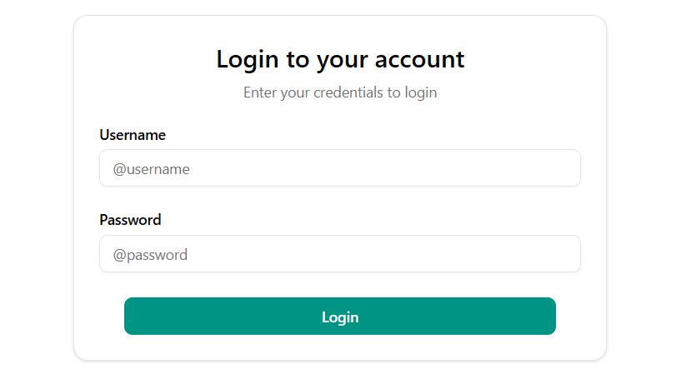
Dashboard
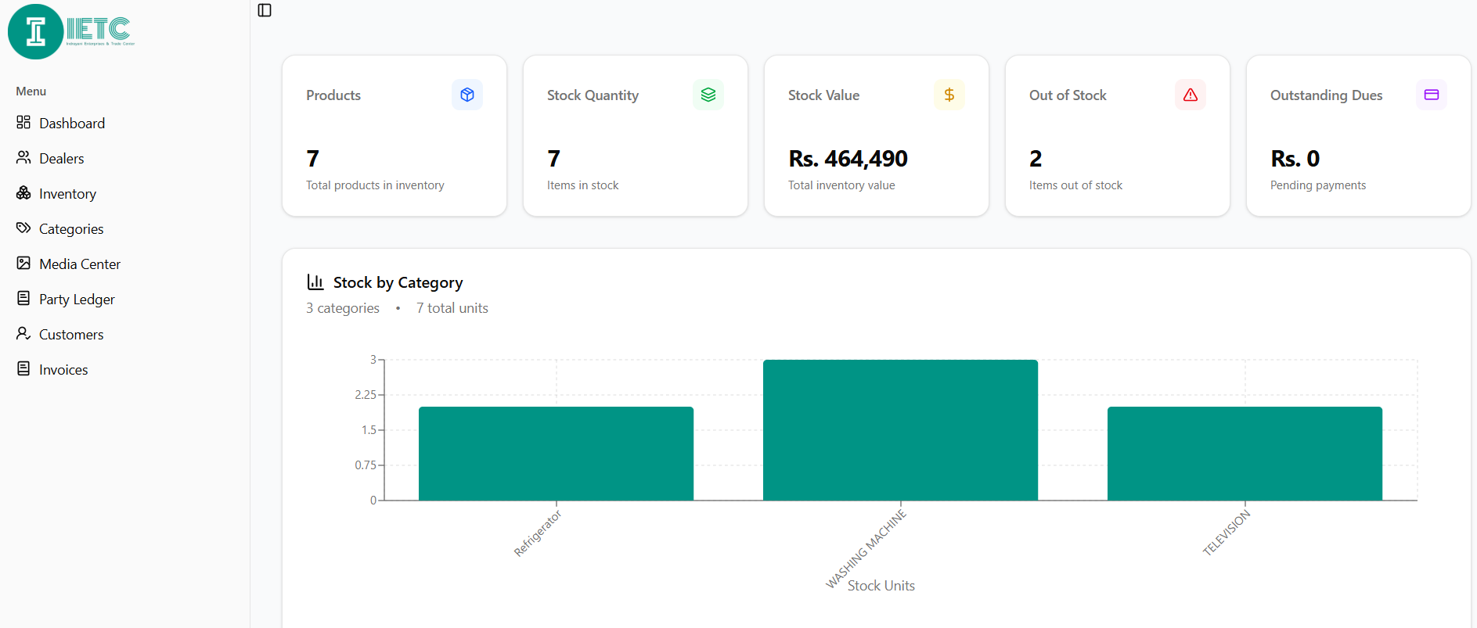

Dealers Page
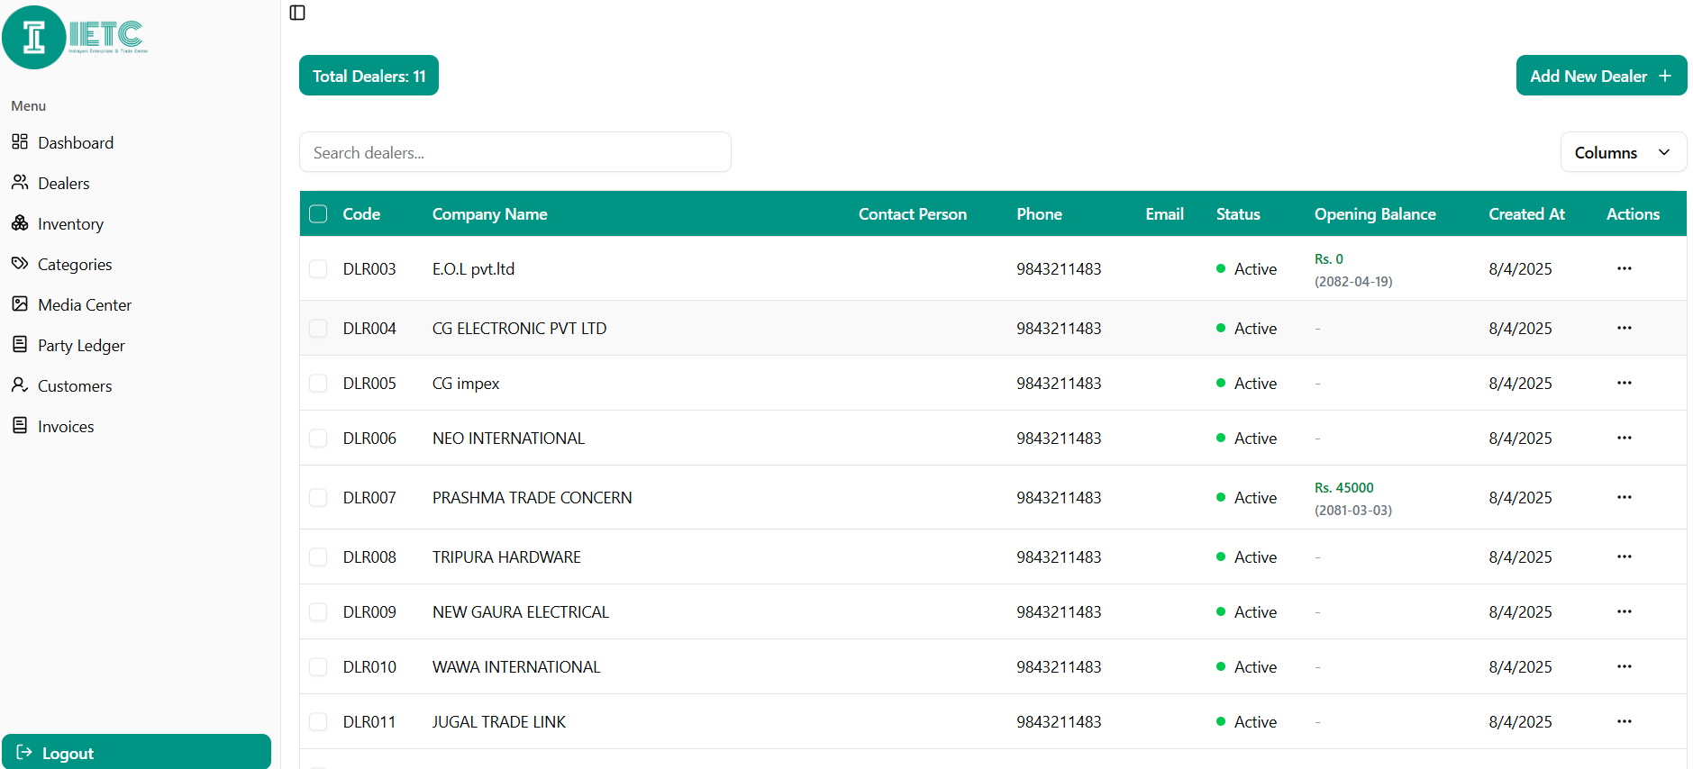

Inventory Page
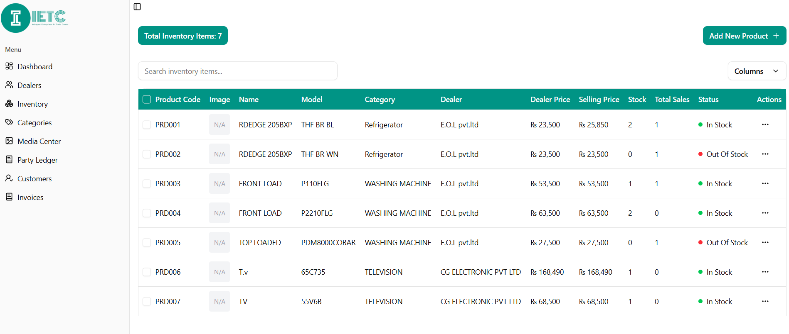

Media Center
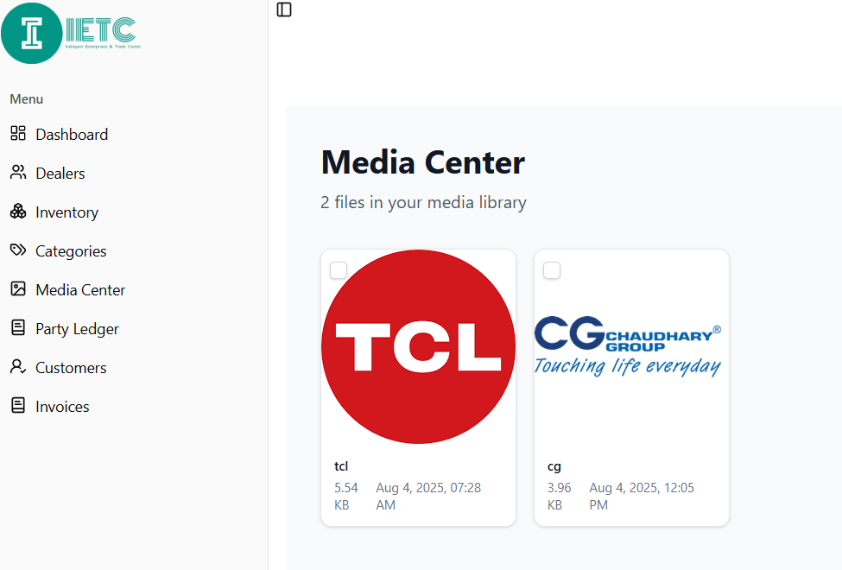
Party Ledger PDF
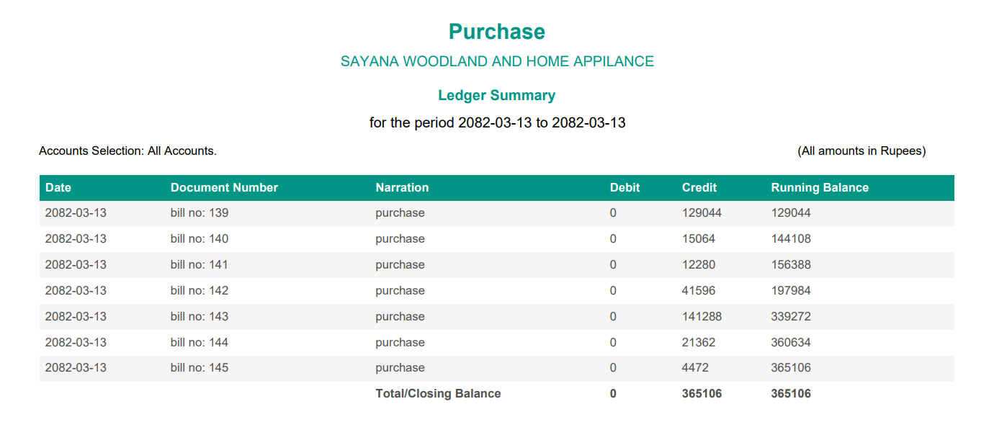
Invoice
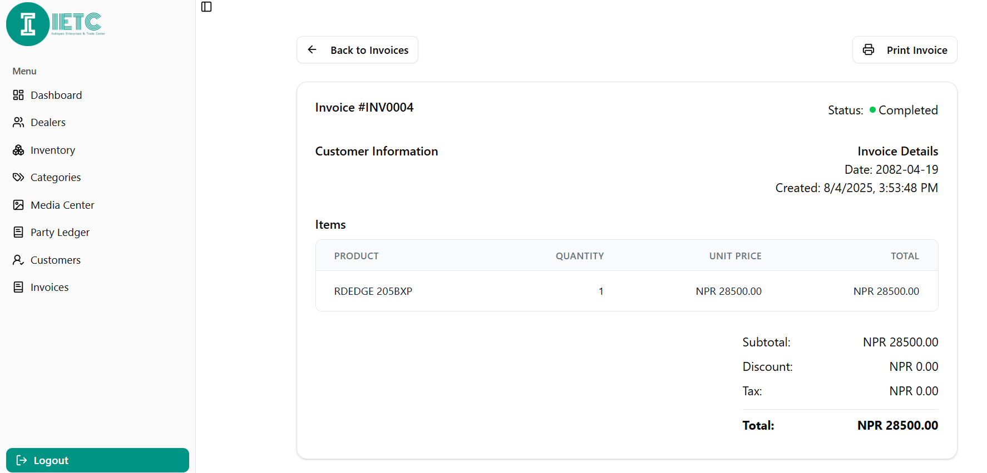
Customer Ledger

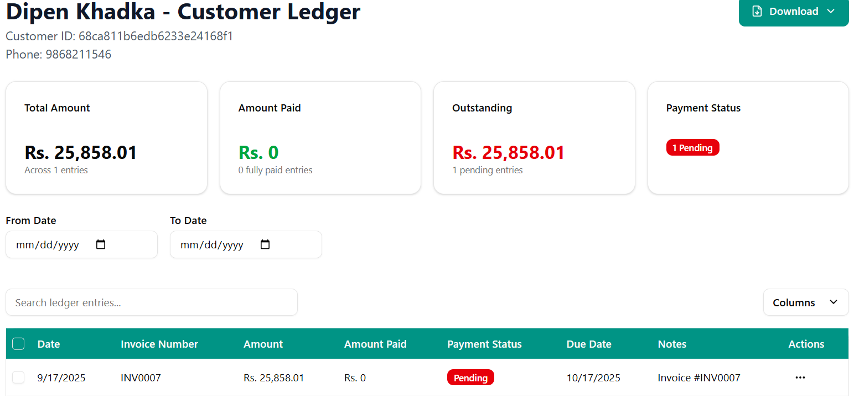
Generated Customer Ledger
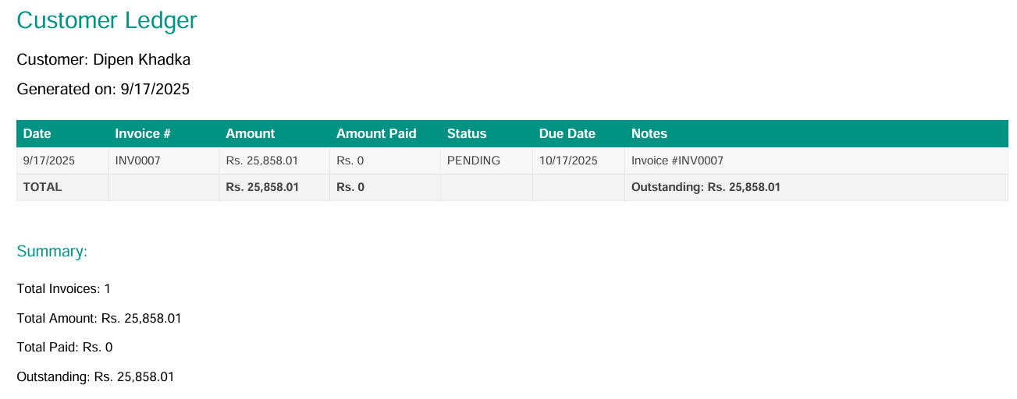
ABC Analysis
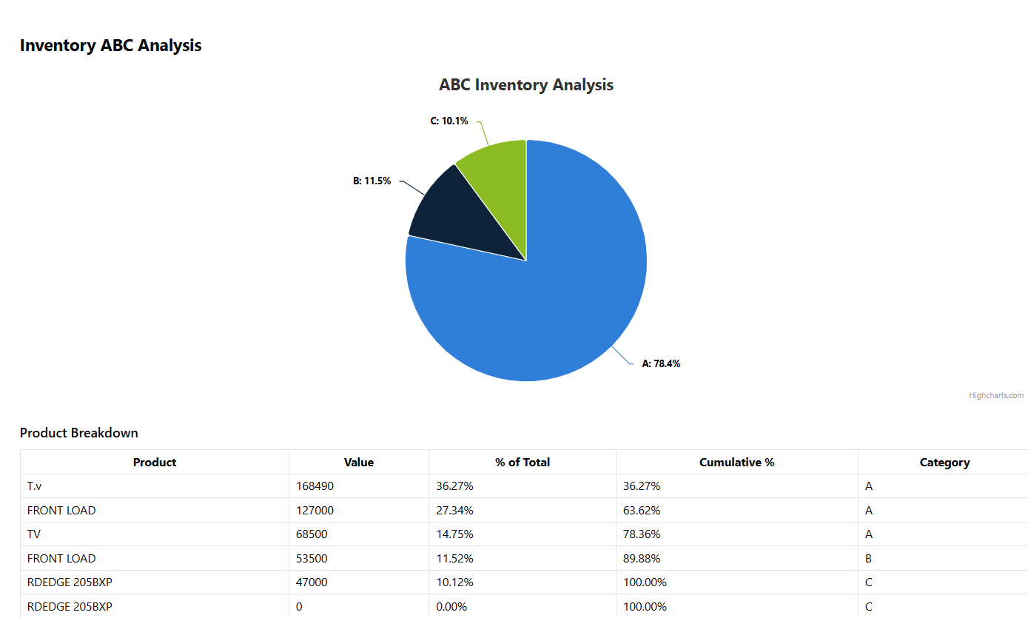
Kmeans Clustering

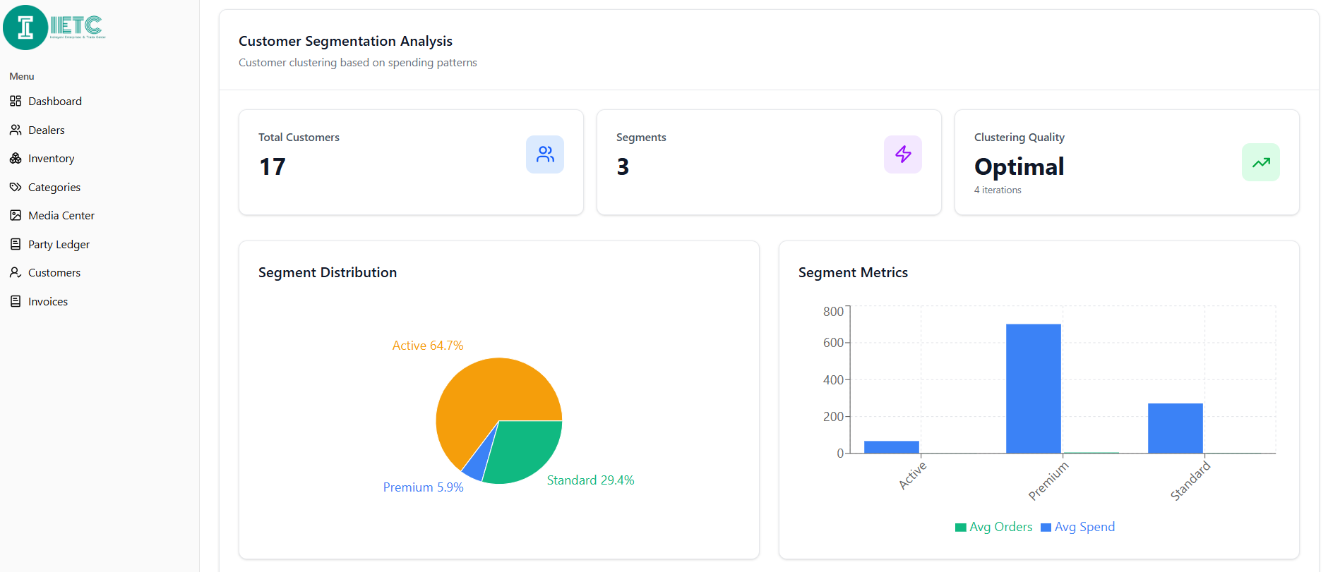

Customer Segmentation

