Project | 320 WEST MAG
Project address | Auburn, AL

Submitted By: | Kalfee Parker | Date: Tuesday, July 28, 2026
Contact | Office: (706) 289-5571 | kparkerbestclean@yahoo.com

Customer | Juneau Construction | 3715 Northside Parkway, NW  Building 300, Suite 750  Atlanta, GA 30327

Name | Contact Number | Email | Project role
Kalfee Parker | (706) 289-5571 | kparkerbestclean@yahoo.com | Final clean scheduler
Cara Frost | (404) 287-6000 | cara@juneaucc.com | Other
Nancy Juneau | (404) 287-6000 | njuneau@juneaucc.com | Other
Alex Hale | (404) 402-1161 | ahale@juneaucc.com | Project Manager

GENERAL CLEANING
- Removal of "CONSTRUCTION" trash & debris left on floors, walls and all items horizontal and vertical
- Dusting walls, baseboards, fixtures, and furnishings-cabinets counters, shelving
- Vacuum clean/dust display cases inside and outside
- Shine all stainless steel

RESTROOMS
- Clean & sanitize full restroom including toilets/urinals, sinks, doors,
- Wipe clean walls as necessary
- Empty trash/move all trash from restroom

WINDOW CLEANING
- All interior & ext. windows, which includes vestibules, and all doors
- Wash inside glass & window, remove all dirt, smudges, fingerprints, streaks, cobwebs

Floor Care Cleaning Specifications

CARPET CARE
- Vacuum carpet
- Spot clean carpets (looking for visible spots)

CERAMIC TILE/SLATE CLEANING
- Machine scrub all ceramic tile/Slate floors (including restrooms)
- Dust mop entire floor area
- Damp mop with cold water cleaner

VCT TILE Clean & Seal
- Complete gum, embedded material & scuff mark removal.
- Sweep & damp mop all exposed tile areas.
- Effectively protect all adjoining floors (carpet, wood, etc:) from solution & run-off /splash spillage
- Complete machine scrub AND STRIP of all exposed tile using a national brand neutral cleaner
- Professional application of one (1) coat of a national brand floor sealer
- Professional application of TWO (2) coats of a national brand floor FINISH

PRICING PER MENTIONED post construction clean SCOPE:

$70,000.00

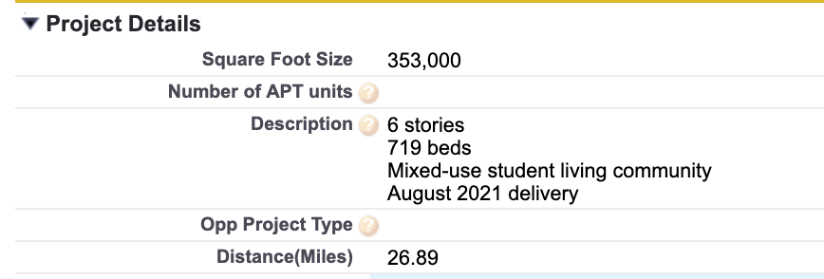

Typical mobilization types that can be managed by our company.

Rough clean is first mobilization. Usually before carpet is installed, this is the most time-consuming mobilization. Heavy dirt and dust are removed

Final clean will be mobilized after all finishes are installed and before punch list. Final clean shall make the unit 100% clean. Move in ready

Fluff Clean is last mobilization and is completed after punch list. This clean is a light clean to remove extra dust and floor marks created from punch list activities.

Acceptance/ Sign-off:

Customer: Juneau Construction

Date | Signature**

** Customer signature verifies acceptance of the specifications and the pricing per Scope of Work**

GENERAL NOTES:
Conduct pre-walk through with GC
- If non- punch list items create need for repeat work, an additional charge may be assessed.
- Any charge backs or additional charges will be pre-approved by both parties.

EXCLUSIONS:
- Construction debris or dumpster removal
- Out of scope work such as power washing exterior walkways, exterior signs will be quoted on a case-by-case basis.

