

**Support Worker**

Open Door North East (ODNE) is an award-winning, ambitious, and growing charity dedicated to supporting refugees in the Tees Valley region (Middlesbrough, Stockton-on-Tees, Redcar and Cleveland, Hartlepool, and Darlington). As we expand, we are seeking experienced support workers to join our team. If you have a background in the housing sector or experience working with vulnerable adults, you will have the opportunity to make a significant impact by helping refugees integrate and grow in independence in the UK.

In return, ODNE offers you the chance to be part of a dedicated and expanding team that is passionate about empowering refugees and supporting their journey to a better life.

If you are interested in this post, read on and you will find the following information in this pack:

* What the role involves and the person we’re looking for
* Who we are and what it’s like to work at ODNE
* How to apply and when the interviews will be

About Open Door North East

Open Door North East (ODNE) is a growing charity whose ambition is to alleviate and eliminate the devastating and complex effects of destitution and homelessness experienced by asylum seekers, refugees and other migrants in the Tees Valley. We are committed to supporting our service users to achieve their full potential by empowering them to find ways to thrive in the UK.

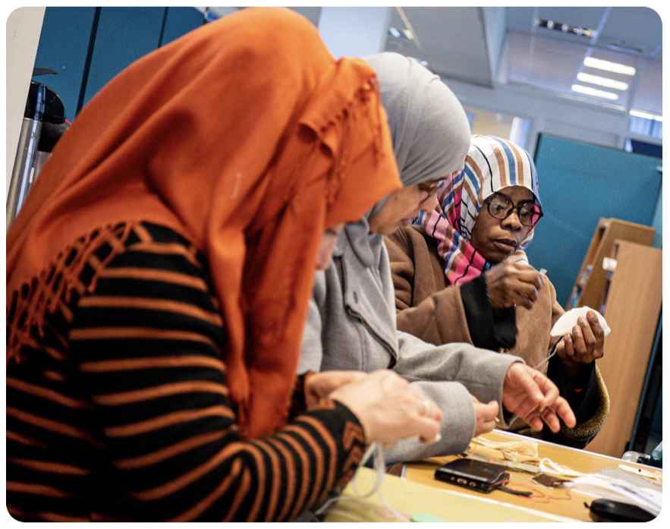

Open Door North East is much more than a housing provider. We believe this is a first step for people who have sought sanctuary in the UK, but compassionate, supportive relationships and effective casework are at the heart of who we are and what we do.

ODNE chooses to work in partnership with other organisations to achieve better outcomes for people and having close working relationships is key to our success.

About Our Programmes

We do this in three keys ways:

* Providing supported accommodation for newly granted refugees and people who are unable to access other forms of accommodation.
* Providing tailored casework to create better outcomes for people seeking sanctuary in the UK. This includes applications for Asylum Support, Welfare Support, Housing applications and regulated immigration advice (currently OISC Level One).
* Supporting people to integrate successfully into the UK through access to employment, English language support, meaningful activities, volunteering and developing life skills.

**Our Mission**

To support those seeking sanctuary to move out of poverty and destitution and be empowered to achieve their full potential.

**Our Vision**

Hope, Justice, Mercy and Dignity for those seeking sanctuary.

**Our Values**

* Hospitality - *Offering welcome and support to all seeking our help.*
* Compassion - *Showing grace and love to others.*
* Working Together - *Building community through valuing others.*
* Dignity - *Honouring and respecting the unique worth of every person.*
* Excellence - *Being the best we can be, with integrity, in all our work.*
* Inclusivity - *Serving our clients irrespective of race, gender, disability, religious belief, age, or sexual orientation.*

Open Door North East is a Charitable Company registered with the Charity Commission and Companies House. Company Registration Number 4819153 Charity Registration Number 1099865

**Job Description**

|  |  |
| --- | --- |
| Job Title: | Support Worker |
| Responsible to: | Programmes manager |
| Responsible for: | Delivering support work across our programmes |
| Salary: | Starting at £25,400 per annum + pension |
| Hours: | Full-time (37.5hrs) and part time* available |
| Contract: | Permanent |
| Annual Leave: | 25 days (+ bank holidays) |
| Location: | Based primarily at our Middlesbrough office with regular travel requirements locally, regionally and occasionally nationally. |

*\* While full time roles are available, we are open to receiving applications from people requesting part time hours.*

Duties and Responsibilities

You will support ODNE in delivering its programmes to its service users. You will support individuals and their families to overcome barriers and build the foundations for a stable, happy and independent life in the Tees Valley area. This will include (but not limited to) the following main areas of responsibility:

* Welcoming, engaging and supporting service users into Open Door North East.
* Working with the individual/family through assessment to develop a personal plan to support refugees with their immediate/medium term needs as well as longer term aspirations.
* Supporting service users to access and maintain safe and secure accommodation in ODNE depending on their circumstances and immigration status.
* To have a firm grasp of, and be responsible for, ensuring clients’ access and maintenance of appropriate benefits, housing, health, education and other appropriate services to assist their integration, including advocating on their behalf as needed.
* Working with a range of partners to identify and access programmes that engage individuals and families to support their independence and integration.
* To maintain accurate records of client information and case notes in accordance with all relevant legislation.
* To provide up to date knowledge of key services available to refugees in the Tees Valley area.
* To foster excellent working relationships with charity partners, statutory and non-statutory services to ensure a holistic package of care around the service users.
* To have a sound understanding of the support needs of refugees, asylum seekers and vulnerable migrants, demonstrating the skills to encourage increasing levels of confidence and interaction within the community.
* To work alongside our partners who will be delivering employment support services.
* The role will require you to work from ODNE’s office as well as in community settings across the Tees Valley including client’s homes when appropriate.
* You will be required to undertake an Enhanced DBS check.

You will be adaptable and flexible within the role to ensure that the presenting needs of the client, our contracts and the charity are fulfilled. This may mean that you are required to carry out additional/altered duties from time to time. Any substantial or significant changes will be discussed with the postholder.

Person Specification

E = Essential D = Desirable

|  |  |  |
| --- | --- | --- |
| CRITERIA | E | D |
| **Knowledge and experience:** |  |  |
| Excellent standard of numeracy and literacy (Five GCSEs at C or above or equivalent). * | ✓ |  |
| Excellent communication, presentation and facilitation skills. |  | ✓ |
| Have a sound understanding of the support needs of refugees, asylum seekers and other migrants and demonstrate the skills to encourage increasing levels of confidence and interaction within the community. | ✓ |  |
| Experience of working in the third/voluntary sector. |  | ✓ |
| Experience of working in the housing sector. |  | ✓ |
| Have a proven track record of providing one-to-one intensive support to individuals and/or families. | ✓ |  |
| Up-to-date knowledge and experience of the UK benefit systems, including Universal Credit. |  | ✓ |
| Up-to-date knowledge and experience of the UK asylum systems and barriers to access e.g. asylum support. |  | ✓ |
| Experience of managing challenging caseloads and conflicting priorities | ✓ |  |
| Flexible approach to work with the ability to develop new ideas and be willing to adapt to change. | ✓ |  |
| **Skills** |  |  |
| Proven ability to build relationships and maintain trust and confidence across a range of stakeholders including clients, colleagues and other service providers | ✓ |  |
| Experience of using a CRM or similar data recording system | ✓ |  |
| Excellent oral and written communication skills with the ability to adapt styles to engage in a variety of settings. | ✓ |  |
| A high level of self-motivation, teamwork and managing conflicting priorities. | ✓ |  |
| Competent IT skills, accurate data entry and ability to work independently using a range of applications and software including Microsoft Office. | ✓ |  |
| Ability to communicate effectively in a relevant second language. |  | ✓ |
| **Other** |  |  |
| Passionate about providing good quality support for vulnerable groups. | ✓ |  |
| A personal ethos that matches our mission, vision and values. | ✓ |  |
| In possession of a UK driving licence and use of a car |  | ✓ |

*We positively welcome applications from people with lived experience of the UK immigration and asylum system who may not have formal qualifications but have fluency in English, language, mathematical aptitude and relevant, demonstrable experience. We will be assessing these skills at the interview.

How to apply

If you would like to apply for the role of Support Worker,

please download and complete the application form and recruitment monitoring form on our website: [www.opendoornortheast.com/join-our-team](http://www.opendoornortheast.com/about-us/job-opportunities)

These should be sent by email to Andy Colclough, Chief Operating Officer at [andy@opendoornortheast.com](mailto:andy@opendoornortheast.com) by 5pm on1/11/24. All shortlisted candidates will be informed by 8/11/24 .