Product Specification
11/2013

Product: Middle install intelligent LCD Display
Mode: APT13LCD450U
Appreviation: 450U

Client
Customer
Audit

Supplier: Tianjin APT Development Co., Ltd.
Room 609, Hi-tech Building H, No.6
Huatian Road, Huayuan Industrial Area, Tianjin 300384, China

TEL: +86 22 83715556
FAX: +86 22 83719955
Mail: yzhao@aptdevelop.com

1 Product Name
1.1 The Middle install intelligent LCD Display
1.2 Model: APT13LCD450U

2 Suppliers
2.1 TianjinAPTDevelopmentCo.,Ltd.
2.2 Email : yzhao@aptdevelop.com apt@aptdevelop.com

3 Electrical Parameters
4V/36V battery supply
Rated operating current 10mA
Max operating current 30mA
Off leakage current 1uA
Max output current to controller 50mA
Operating temperature -20~70°C
Storage temperature -30~70°C

4 Dimensions & Material
4.1 Product shell is ABS, transparent window is made with high strength Acrylic, the stiffness equals the tempered glass.
4.2 Dimensions : host/L78mm*W46.8mm*H12.7mm

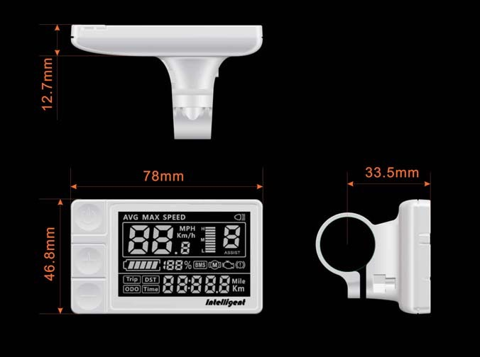

- Features

- Serial communications
- Speed display : AVG SPEED, MAX SPEED, SPEED(Real-time)
- Kilometer / Mile : Can be set according to customers’ habits.
- Smart battery indicator : Provide a reliable battery indicator, it will not fluctuate with the motor on/off.
- BMS support: BMS indicator, battery percentage, indicating the mileage indicator (need access to BMS information system support)
- Power indicator : Real-time battery power indication
- The brightness of the backlight adjustable : 5-sections
- 9-level PAS : 3-PAS/5-PAS/6-PAS/9-PAS... optional
- Mileage indicator : Odometer/Trip distance/ Riding time
- Error code indicator
- Parameter settings : Multiple parameter can be set through computer USB port, including PAS level / Wheel diameter / Voltage / Speed limit...

6 LCD Instructions
The figure of LCD display see below:

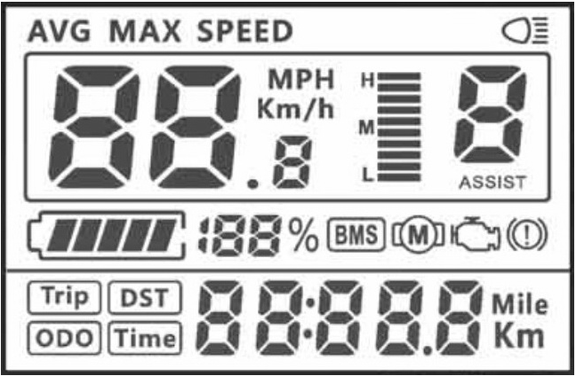
Lamp
Speed Mode
Mileage Information
Power Indicator
Speed Display
PAS Level
Undetermined
Error Code
Battery Indicator
Brake
BMS Indicator
Mileage Mode

7 Functional Description
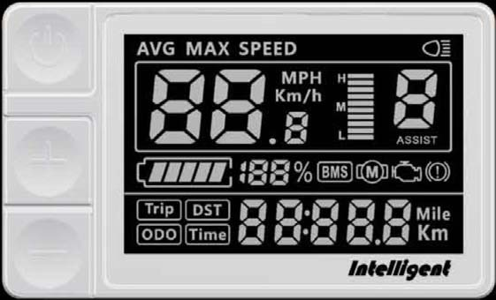
Power
Up

Down

7.1 PowerOn/Off

Press and hold Power button for 1.5 second can turn on/off the display. The Display can automatically shut down when there is no operate & ride for X minutes(X could be 0~9).

7.2 PAS operating
Short press UP/DOWN button can change the PAS level. Top PAS level is 9, 0 for neutral. Level quantities can be adjusted according to the customer requirements.
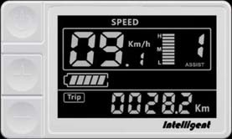
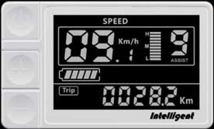
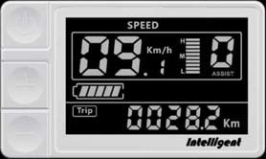

7.3 Speedmodeswitch&Mileagemodeswitch

Short press POWER Button can change the speed mode & the mileage mode
Speed AVG Speed Max Speed Trip ODO Time
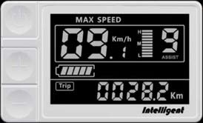
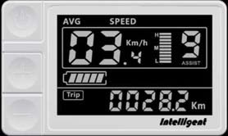

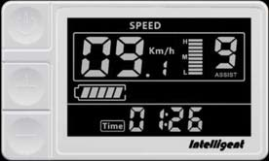
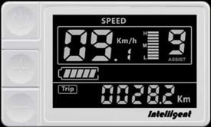

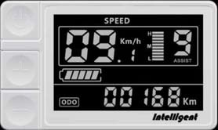

Speed mode switch& Mileage mode switch

*If there is no operation for 5 seconds, display will return Speed (Real-Time) display automatically.

7.4 Headlight / backlight On/Off
Press and hold UP button for 1 second can turn on/off the headlight/backlight.

The motor does not work when the battery voltage is low, Display still can keep the headlight on for a while when E-bike is in riding.
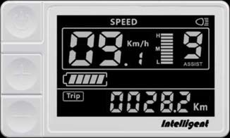
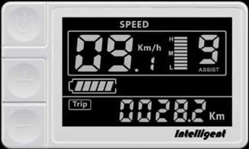

7.5 6km walk
Press and hold DOWN button for 2 seconds can get into walk mode, out of the mode when release the button.
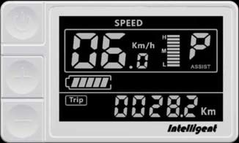

7.6 Data cleanup

Press and hold UP & DOWN buttons together for 1 second can reset several temporary data, temporary data include AVG Speed / MAX Speed / Trip / Time.

8 Parameter setting
Double press POWER button (press interval less than 0.3 second) can get into parameter setting state, the parameter twinkles.
Short press UP/DOWN buttons to change the parameter value, short press POWER button can switch to the next parameter.
Double press POWER button(press interval less than 0.3 second) can quit from the parameter setting state.
The display will automatically quit the parameter setting state when there is no operation for 10 seconds.

The order of parameters is as follows.
Wheel
diameter
Auto off time
Backlight/
Brighness
Kilometer/
Mile
Voltage set
Password
Speed limit set

8.1 Kilometer / Mile : The location of speed displays symbol S7, press UP/DOWN
button rotate display the symbol km/h / MPH (Km / Mile)
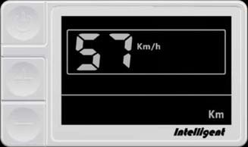
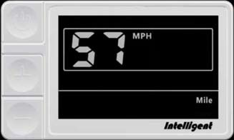

8.2 .Backlight brightness : The location of speed displays symbol bL1, press
UP/DOWN button display symbol 1~5 to change the brightness of the backlight.
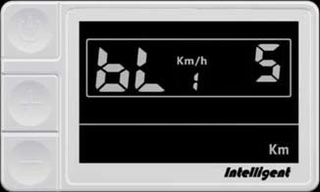
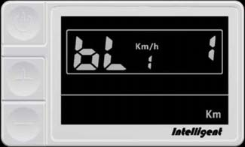

8.3 Auto off time
The location of speed displays symbol OFF, press UP/DOWN button to change the value from 1 to 9, the number represent delay time (minutes) before display shutdown automatically, default value is 5 minutes.
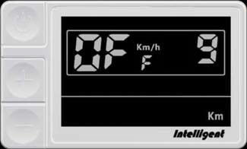
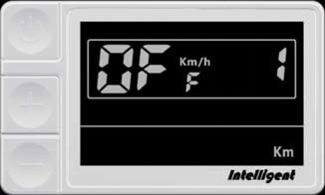

8.4 Wheel diameter
The location of speed displays symbol Wd, press UP/DOWN button rotate display the symbol 16/18/20/22/24/26/700C/28/29, value represents the diameter of the wheel (inch).
Wrong value for wheel diameter will cause speed&mileage abnormal.
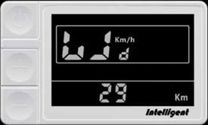
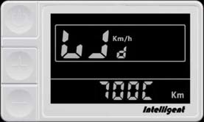
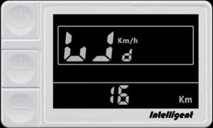

8.5 .Voltage set : The location of speed displays symbol bU0, press UP/DOWN button rotate display the symbol 24V/36V/UbE
UbE means user-defined voltage setting, this parameter can be set through computer.
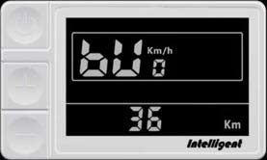
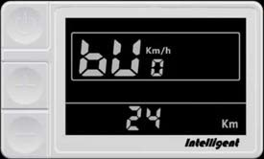
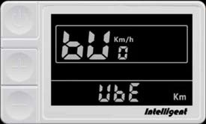

8.6 Password / Speed limit set
The location of speeds displays symbol PSd, require to input passwords, press UP/DOWN buttons to change the password value (0~9), short press POWER button to switch the password item, password is 4 digits, the default password is "1919". Press POWER button when password adjustment is completed.
Display will return to the Voltage set item if the password is incorrect. Correct password will enter the Speed limit set item.
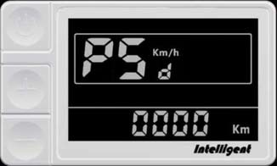
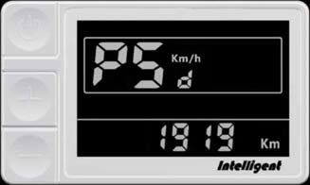

8.7 Speed limit set : The location of speed displays symbol , the location of
mileage displays speed limit value, the default value is . Press
buttons to modify the value, the value can be set from 10 to 45km/h. Press button to confirm when you finish the adjustment.
The maximum speed is restrict by the motor and controller, probably couldn’t reach the setting value.
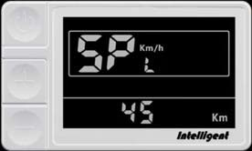
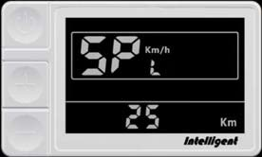
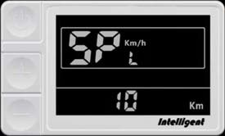

9 Error Code define
450U meter can give warning message when E-bike exist error, LCD display icon and the error code in speed position, error code is from 01 E~FF E, below.
Zhe definition see the table
Error Code | Error description | Handle
01 | Communication Error | Check the cable connection
02 | Controller protection | Check three-phase power line.
03 | three-phase power error | Check three-phase power line connection
04 | Battery low | Charge the battery
05 | Brake error | Check the brake connection.
06 | Turn error | Check turn to connect.
07 | Hall error | Check the hall connection
08-99 | Reserved | Please contact the manufacturer for error definitions

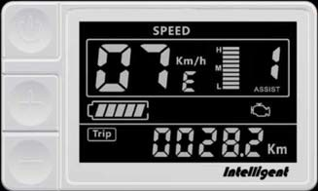
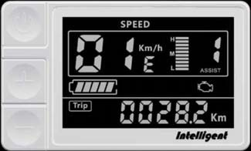

10 Assembly instructions
Please pay attention to the screw’s torque value, damaged caused by excessive torque is not within the scope of the warranty.
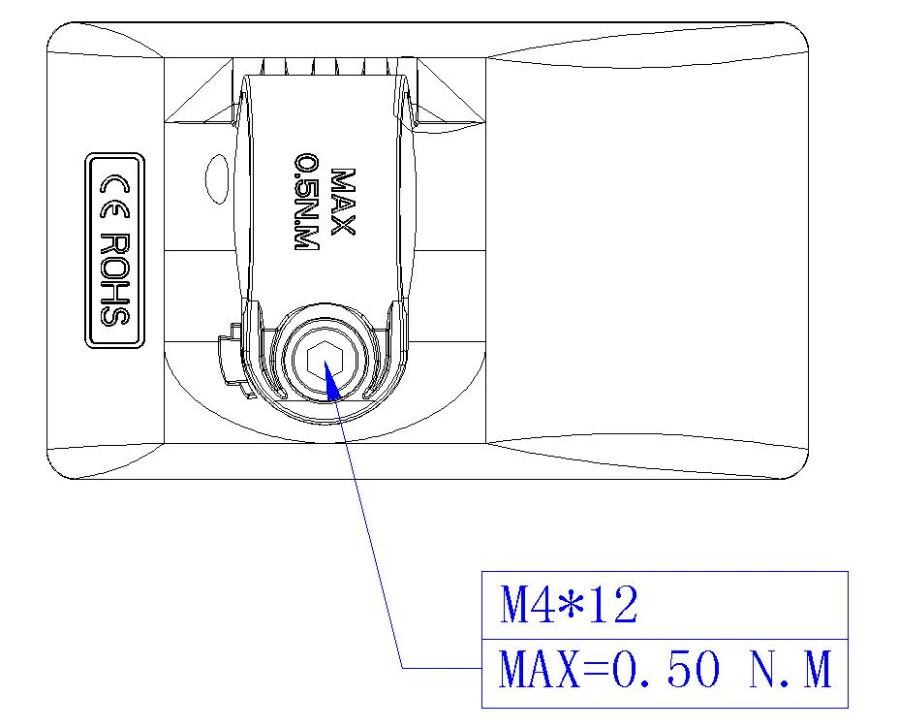

11 Output wire instructions
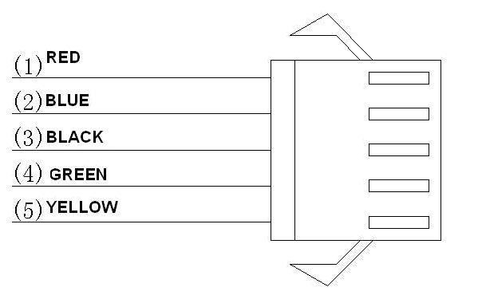
1. Red wire: Anode(24v/36v)
2. Blue wire Power cord to the controller
3. Black wire GND
4. Green wire RxD (controller -> display)
5- Yellow wire TxD (display -> controller)

12 PAS level instructions
PAS level can be customized, the highest level is 9, common used PAS level see the table below:

3 level | 5 level | 9 level
0 |  | 0 | No power assist
 | 1 | 1
 |  | 2
1 | 2 | 3
 |  | 4
 | 3 | 5
2 |  | 6
 | 4 | 7
 |  | 8
3 | 5 | 9

13 Certification
CE / IP65 (water proof) / ROHS.

14 Additional (default) Parameters, especially for the AM1

Those parameters are only accessable after password input is correct entered

A5 = 12
HA = 01
CU = 15
SP = 30 (max speed, I believe it's 30 Km/h), 25 Km/h e.g. for Germány
Hd = 0 (both of them are 0)
There is one with subscript 6
and another one with subscript P
PA = 5 (1-5 peddle assist settings)

