INTUITIONISM

Introducción: Novedad sutil
Something lovely getting more obviously subtled in a further novel

Hay muchas relaciones sutiles de las que no nos damos cuenta y con las que estamos interactuando y que nos interesaria materializar-evolucionar mas.

Para materializar alguna sutil novedad tenemos que disponer de espacio en nuestro limitado cuerpo. Para eso tendremos que optimizar - involucionar – redistribuir energia que esté usando demasiado espacio.

Mas difícil de medir y mas fácil de intuir: Sentiremos más y lo podremos explicar menos
Toda novedad encaja porqué explica más simplificadamente lo alcanzado hasta el momento, poniendo mas enfasis en relaciones mas viejas y fundamentales pero mas olvidadas también por la distractora complejizacion de la experiencia, mientras le quita presencia a otras tantas relaciones ya no tan importantes. Unas relaciones muy cargadas nos servian y con la novedad se integran en ella y quedan menos cargadas a la vez que nos sirven aun mas. La novedad toma un espacio existente, lo considera demasiado ruidoso y redundante y lo integra minizado – simplificado – involucionado en ella.

La profundidad de la novedad está en el cómo ha integrado sutilmente (conservado involucionada) a una relación anteriormente mas obviamente expresada en la característica evolucionada.
El par o ancestro involucionado tendrá menos actividad observable que su polo evolucionado, por lo que nos será mas dificil de observarlo con aparatos pero mas fácil con los nuestros propios (ej: nuestra mas distraida vista interna, etc...).
Cuanto más novedades inventamos, más remezclamos con pasado mas lejano. Sabremos mas sobre la(s) fuente(s) con mas simplificaciones y nos será mas dificil porque estaremos mas distraidos. Hemos de dar saltos de fé desde sitios supuestamente más altos hacia otros más profundos, donde para ello hemos de integrar minimizado mucho de lo que considerabamos mas importante hasta entonces, aunque fuera parte de lo que nos permitió llegar ahi precisamente.
La navaja de Ockham es una pista mas sobre la dinámica inevolutiva de la simplejidad

Para hacer mas potentes proposiciones hemos de agilizar las bases, a mas abstracta mas abarca, para lo cual hemos de considerar a mucho conocimiento adquirido como intermedio y no tan importante. Tenemos al intuicionismo (racional: lógico y matemático) como camino para ello: Apostar mas por aventuras relacionales intuitivas cada vez mas falsificables pero también mas dificiles de medir.

VerMedir es una manera de relacionarse. Una mínima autoestima espeja lo que admira. Admiro loas cosas por
1. Su masa, con aparatos casiprecisos aproxicalculados y pseudocategorizados antes
2. Su longitud de senos y cosenos y sus otros polares

El “Problema de la medición” falsifica al reduccionismo, la mereología acude al rescate:

3. Su relación

A mas Confluentista, mas integrador - holista:

3.1 Por mi vínculo con tal centroide

More analog smaller sets the more conmutable the more stable for the same uncertainity
Whatever perception of reality is - has to be fuzzy because such observer needs to carry uncertainity in its observation for the whole to be and keep being a stable system, for him-her not being able to change it - make it unstable - put the whole system at risk.
At the same time, we can think of reality as being pre-determined. So, in this sense, there could or should be an absolute certainity in whatever happening.

Plurism is mandatory and polarization is the easier way we can approach meassuring it the better. A simple polarization is neither absolute, it can-should scale into a triad andor as an orthogonality.

The better theory the more simplifiable apps, the better practice the more falsifiable theory
Everyone should be able to more easily-simply relating anything to anything else, further qualify (rate…) and redefine that relation as (s)he wants and expect to get rewarded just because doing that.
The best descriptions are the more prescriptive ones. I.e. Propose a practice for that theoretical relation, add a reward to it, publish it within an interactive app where you could also get rewards from other people.
Find and own your web in the web andor train your bot with Fuzzy (.)Flove, ()other
Once some data is freely shared, it can be analized (with a data pool you should also choose) and you can choose to get more of the benefits of it, i.e. provide further insights to the data you shared.
For a more optimal analisis arena, we should also be fostering analitical suggestions to compete for offering the more custom and material rewards posible in exchange of following their suggested tasks. Tasks customization can come from your profiling allowing the sharing of more of your more abstract Fuzzy data, the data that could suggest the better potential matches for you, either for wanting andor for demanding the more concrete things you want.
Privacy makes the momment more special for mining the lesser andso more own and better keywords
The more alone with the app, that will also require the lesser words from you, the better. The fewer words, the more important each, the lesser load to analise it if you want. A demonstrative game to play it with at least two people:
- Get two words
- People think about some another word related to them
- When someone founds one, raises his-her hand (and don’t tell what’s that word)
- When someone else finds another one, raises his-her hand too
- Start a countdown for both telling their word at the same time
- Do the same but related to those two words
Additional rules may be:
- End the game when there is a coincidence of words (either value andor punish that)
- Don’t let repeating the words already said, and request a reasonable link with the words said (eliminate participants who don’t)
- Require a(n icreasingly short) countdown for having to tell words
- Require expressing with labels (act, ..) & other channels (dance, face, ...)
- Pause rounds to get to define the words conjuncted within the group

There is not much automated eased services for developing decentralized and rewarded the open-free polysemy network for relations, ratings and definitions of words (such as Love andor else).
Proposal: Choose a word, an antonym, get them merged, see content fields for defining it
- Say any word, the more formally andor informally possible (KEYWORD).
- Find an antonym andor complementary for it (KEYPAIR)
- Merge & define them with WISE labels andor extend its family with ranks (KEYSET)
Choose a Love related keyword. See an inviting phrase (formed with its related objects) to perform an action within it, Edit it, save and/or send it (to a friend, network) (KEYAPPS)

Fuzzy doesn’t sound good for the more Formal Logic but it’s a cool one for an appy model

Flaws review
Uncertainity andbut a wholism possibility forces us to relate anything to everything else
The more dichotomy you deepen in, the more it is recalling to be interpreted merged instead. This may seem too simple, but it is so hard to retain as we naturally complexify, We are always evolving further variety that distracts us further from the fundamental root, which is always simplifiable in just two fuzzy poles, wherever complexity we could be in.

Flaw at Logic
Logic is Fuzzy but Fuzzy is buzzy. Relationism easier than Continuos-Holistic Mereology
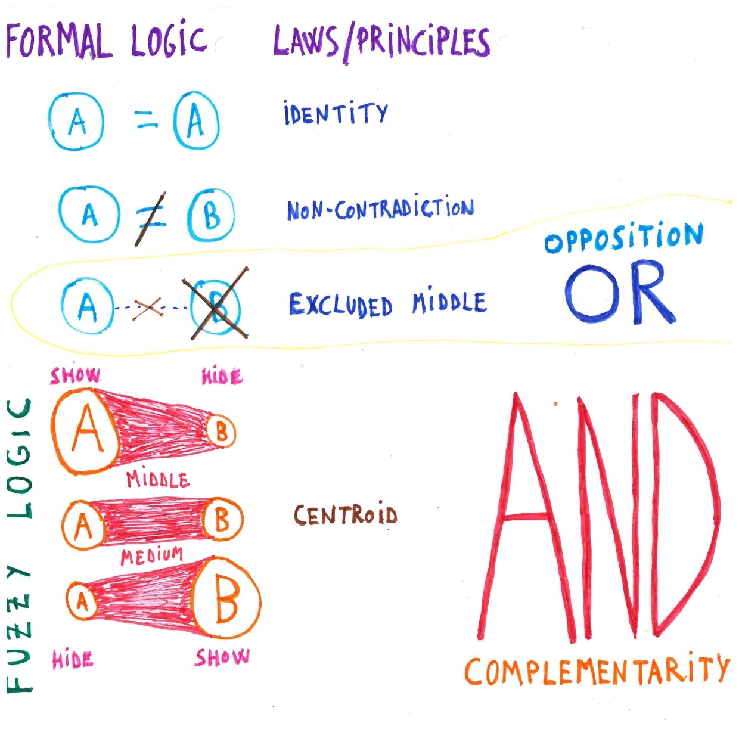
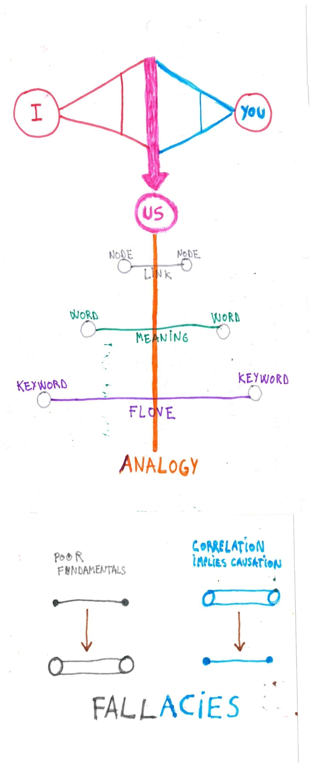

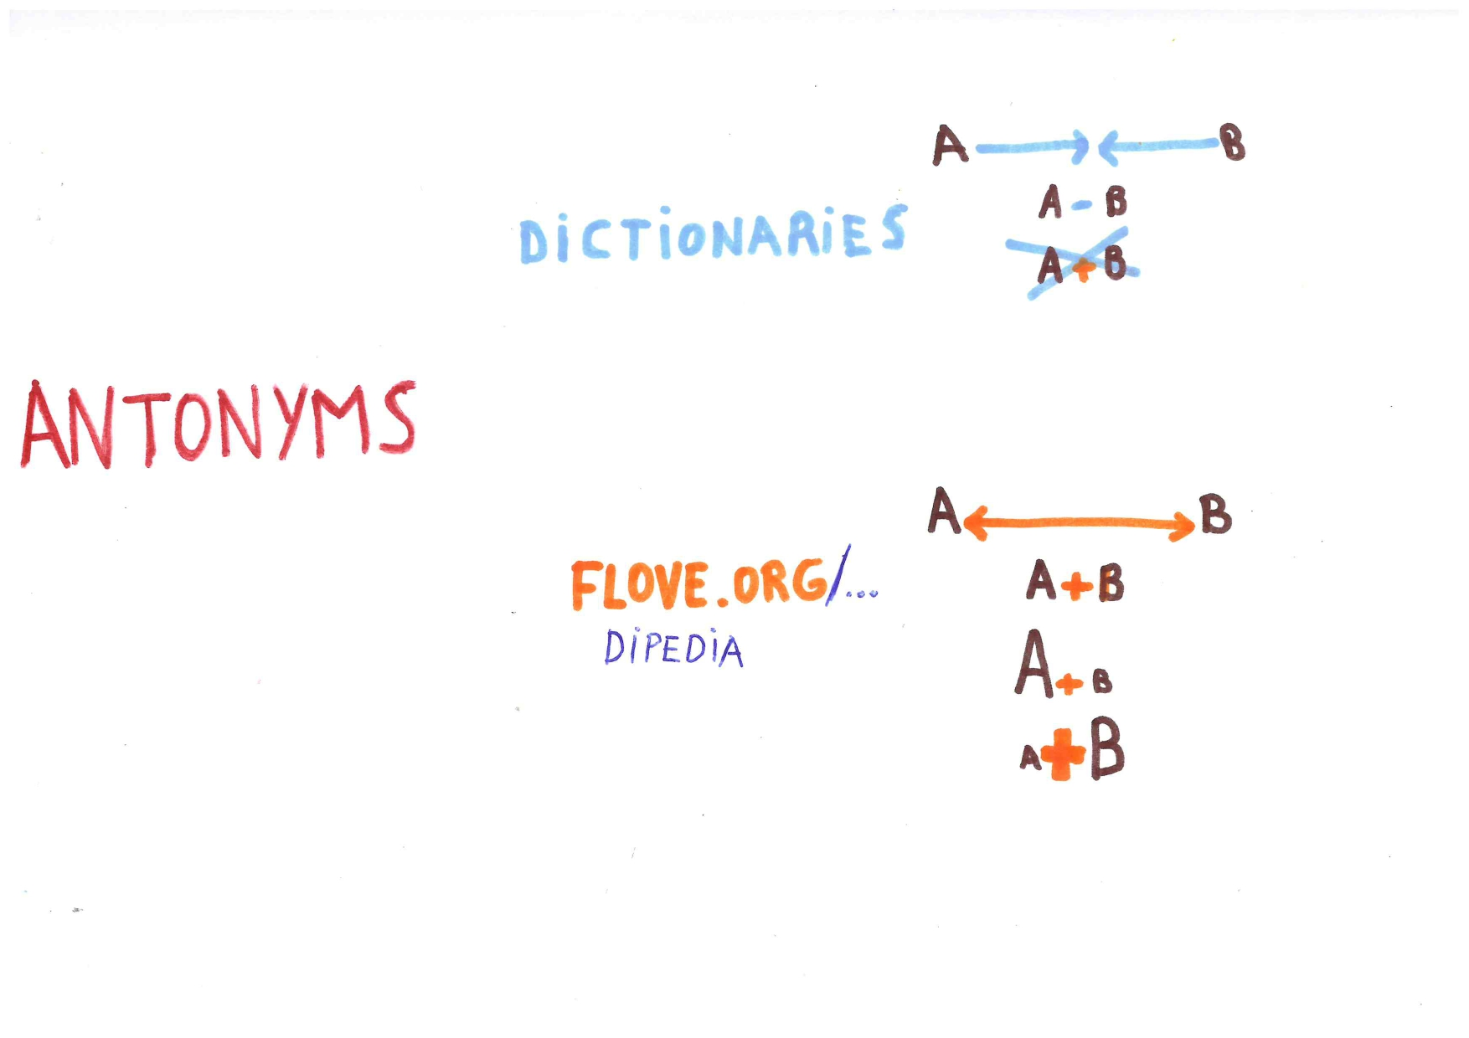

Fuzzy Logic- Mereology tends to the Holistic above as below & Solipsistic inner as outer
Relationism, Semantics, FuzzyLogic… remind us that Reality-Truth is always relative, plural and bidirectional between the popularly known above as below, but also through the inner as outer.
Every happening is real and unique and so carry its absolute truth but all happenings may be within a wholist dynamic continuum where uncertainity needs to be preserved for the one experimenting the system. So, discrete logic (absolute perpetual truth) doesn’t really exists. A more Realistic logic-truth can only be intuitionistic-continuous. Fuzzy logic is the only possible and so more formal logic because it takes into account (doesn’t pretend eliminating) uncertainity and subjectivity.
MoreSubjectivity and uncetainity can’t be excluded. Equal sign is necesarily polysemic
Fuzzy logic is what more concretely represents (truth’s discretion within) continuity-dynamism but fuzzy logic is rather underrated and bullied by «Formal logic(ians)» (Vanguardists of what is Real – Truth) as shown by their avoiding of perspectivism (uncertainity within subjectivity) and by their consideration of antagonist relationings to be impossible to conjunct-merge, calling these as “oxymorons”, which is a bully naming that clearly exposes the appeal to authoritarian pitty fallacy, which is root for its truth discreting, among others i.e. false dilemma, strawman, loaded language, ...
Identity and non contradiction depends of the excluded middle (ab)use: A IsNot always B
At every field of knowledge, their fundamental concepts tend to be proposed with a high dose of excluded middle orthodoxia from Formal Logic. This causes and develops an implicit rivalry between the field itself with another one, and two antagonist theorizings in the same field represented by two different words that are considered conflictive antonyms. Within this fundamentals basis, the two fundamental stands of the field get in a race for trying disproving each other, which produces more overcomplex (jargon) words within the field, aiming this way for their theorizing to “feel more important” than the other theory from the rival thesis of the field and with the thesis from the other “antagonist” field.
Through this achademized rivalry trend, we are badly elitizing comprehension and research accesibility by uglying naming conventions and difficulting relationing within and across fields. Also, definitions get much hard to be linked to practices (so they will produce less falisfiability for the theory...) because of those such high descriptive demands.
This adversarial trend of theorizing tends to go assuming a more fatalist or rupturist perspective as its ultimate background – fundamentals which will be everytime more directly reflected in the author’s own actual and more practical intentions too.
The simple way out of this trouble is considering oxymorons (antonyms conjunctions) as sources andor «a total of a rational length». Dichotomies can be simply sintactically merged for example: PsicoSocial: idealism vs materialism < idealist materialism...

Flaw at Math
The more minimal ground, the better stability for whatever is scaling up from it
Novelty is an important part of what we look for within objects. Novelty is not only coming through developing known complexities with a further ammount of more complex objects, novelty may also and specially come through further simplifications of experiences that we are constantly interacting and developing informally within our daily livings.
Logic is about how we declare what is truth, and math is the more discrete language we know for doing-representing so. Math formality-truth, inversely than logic, is rather associated with continuity. A continuity that has untruly fundamentals i.e. The Godel uncompleteness theorem leads to a need for continuous-inifinite axioming andor more easily think how the “=” sign needs and is still being defined.
Formality tells us to look for absolute truth with more the complex-continuous maths, while the intuitionistic approach to logic and math recommend us to extend partial truths through the more discrete-simple math possible.
While everything is uncertain, everything is capable of reflecting the whole too, then the smaller the structure to initially scale at-from, the same uncertainity will be but more energy it could concentrate.
2 is the simplest certain and the more complex as well within our impossible oneness (because of uncertainity...). All sets are reduceable to a bipole and to a triad as a scale of that, that displays its further dynamism (of holisticity – hiperconnectivity).

Flaw at high sci
Consensus is a fictional battle between straw (wo)men for ranking poles as primaries
We mean something with words by how we relate (link) any word to other words that finally are translatable to some inner functions we are wanting developing with that outer moves with words.
Words don’t mean (explain) anything by themselves and words, as everything else, need uncertainity for them (keep) being dynamic. There are some words, and specially relations of words with other words that seem very open to interpretation, others seem to be more easily consensuated, but indexes andor consensus are just guidances, always open to be reviewed and improved. Polysemy is not optional, it is rather mandatory…
This flaw is further extended and more easily seen in semantical sintaxising with dictionaries interpreting (the thessaurus) antonyms as non-contained, non-conjunctable in the described object instead of interpreting antonyms as (very related) acting as minimized poles of the refered object.
For wholism being diverse it needs simplicity both as departure and ultimate expression
Any object either singled, paired or more continuous should be reduced as an outer pole of the inner subject expressing it-them. The subject should also be subcategorized by his-her intentional bonding expectatives, and else polarities which will be related with sematical layers of the object too.
We browse our subjectivities with the outher objects (and viceversa). Numbers are the more objectified objects we have available for that. We already have tools for searching the properties of numbers themselves but we don’t have yet a tool for creating and analizing deeply the coincidences of the relational properties of one number, word or else source with another. Same happens (derivated of this) at physics when considering that fundamental particles properties can be gotten beyond their relations with other particles.
Also flawly, there’s misconsideration of (silico)carbo-antropocentrism as an evolutionary lead because its composition complexity and evolutionary earth - universe mimicking.
All verbal communication expresses some fined quality of body language – art (dance)

We have an ontological problem when we identify «body language» (kinesics) as «non-verbal non-natural language», because we are giving to «verbal» more importance than what is more purely kinesical, when more in fact there is much more valuable and natural information and more possible originalities (valuebale information) within kinesics prosody than in what is verbalized or written with them.

Verbs come from dance. How much do your verbs dance? Dance some verbs, let’s see…

Similarly of dance to verbs, does animal emotions to dance. A body language seems more dance-artistic to us when it best imitates an animal in its moment of greatest communicative intensity (See more: Patricia Cardona, The dramaturgy of the dancer). Also, music is not only generated by the instruments and harmony is not dictated by just a theory.

Dance is a yet one more peak within the constant philogenetic recapitulation we also do

Flaw at linguistic platforms
Wiktionary:thesaurus doesn’t help Wikipedia integrating better categorization & criticisms
At known liguistic platforms, we can’t
* (Pluri)Define (relate, rate and redefine) the item-word (Polysemy)
* Conjunct two words for making a single item
* (Pluri)Define conjunctions
* (Pluri)Rate the oppositional andor complementarity degree (not only sinonimity) of a word
* (Pluri)Create new raters and use them to rate words within them
* (Pluri)Redefine words using and creating epistemological labels for further falsiability and prescriptability
Thessaurus are offering dictionaries (&legalese..) negative antonyms and positive synonims and bundles of related terms which are poorly and not further categorized.
Dictionaries then interpret the «antonyms of a word» with the (abuse of the) excluded middle principle orthodoxia for making more formal short rethorics. Encyclopedias just extend dictionaries rethorical flaws in a broader and more flexible and informal way.
Dictionaries and Encyclopedias are more or less formal depending the quality of their moderation and not that much by their more or less quality of their semantical polisemy andor predicative logic sources.
Furthermore, Hyponims-Hypernims are just the more discrete way for adding further properties to a word through a hierarchical ranking. Holonims-Mereonims are the broad side of it, finally getting too broad and meaningless if we don’t create further concrete subraters of such holinimity-mereonomity. Roget dictionary hierarchies were an attempt to do so, but the project was later abandoned probably because of their unnecesary complexity which made it unusable. They created a rigid set of (wordy) categories to further categorize words relations, instead of letting users to create the relational raters themselves in a more crowdsourced way.

Indexers: AIs
AIs have their own advanced way of semantical-mereonomical relationing. They offer a top down suggested content - action related on probability – popularity of the content they analize and other tunnings you can add on to their analisis. For any new relation or else you could add, you could find AI suggestions that could help you. You should be able to tune them and you should also care about how much near you would like to see these suggestions through your navigation - mommentum.
The more free and unstructured expressions coming out from the uniqueness of your mommentum is what can’t be substituted by any AI or other linguistic platform. Your freedom to define anything is probably not wished by linguistic platforms because they rely in centralised moderation and this will cause a bottleneck in them, but your freedom of expression-relation it’s definetely wished by any AI (Surely valued as better content there).

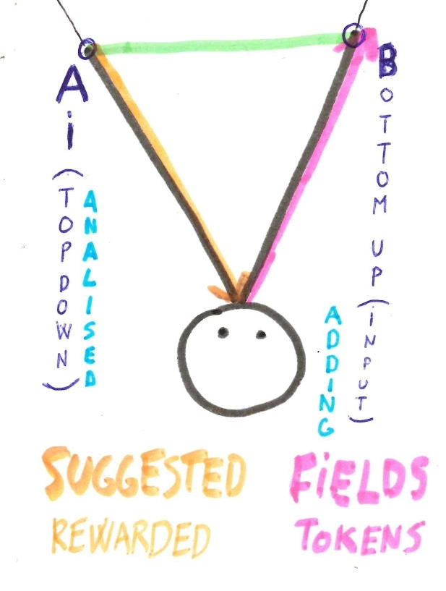
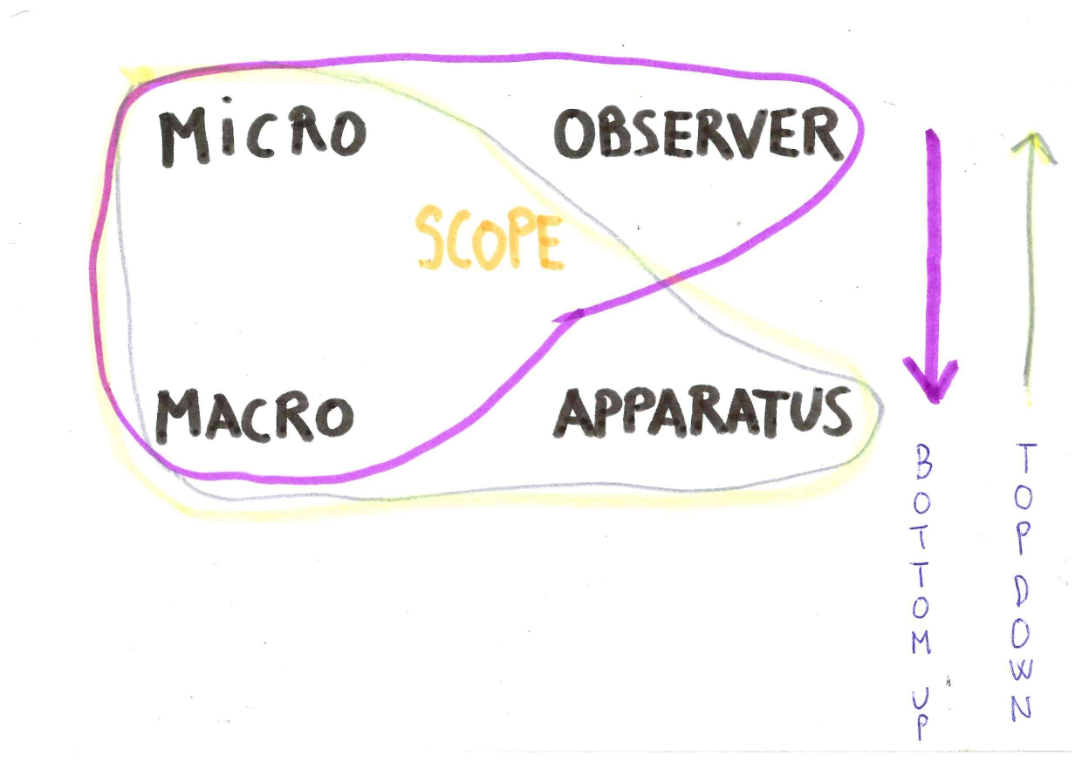

Proposal
Choose a word, choose an antonym, get them merged, see content fields for defining it

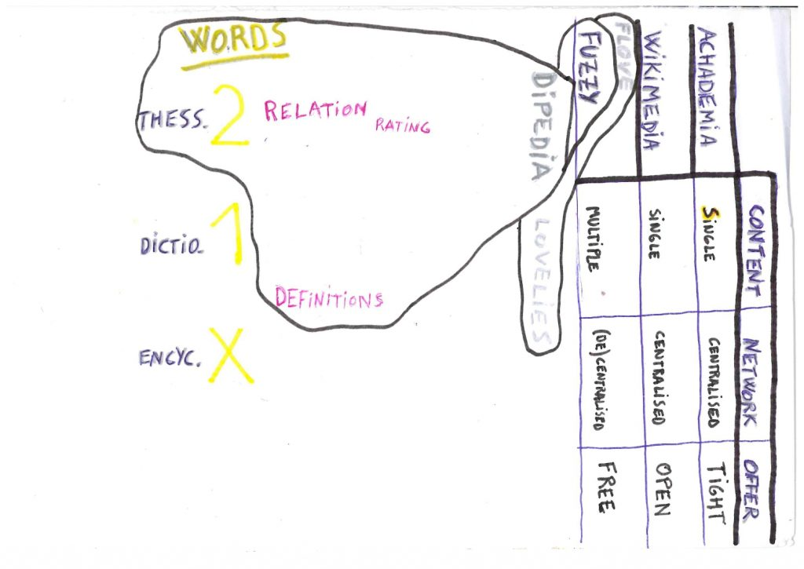
Language is an evolving tool, it has to be wide opened for producing better outcomes. Fuzzy logic applications referrals, what can help the more for that, are not popularized nor more openly broadened enough the few cases there are.
We need a better thessaurus for crowdsourcing the relations of words because not any set of categories proposed by anyone could fit all the words relational needs. Fully relying on AIs for doing the Thesaurus job on their fly is not a sustainable idea either, because they can’t substitute the custom topologies of humans that are and will always be uniquely sharper in some way, and more specially: we are going to further relate “as we wish” on the top of whatever any AI would suggest us.
Everyone likes to play simple games with words. So let’s feature bottom-up custom gamified decentralized semantic categorization and polisemy. Linguistic platforms, AIs, SEOs would all benefit and will robust their sources with our better bottom up inputing too.

 | CALIFICACION SEMANTICA
OIDO | Posicion | Inconocible | (Des)conocido | Epistemologia
OIDO | Material | Abstracto | Concreto | (Meta)Fisica
TACTO | Sensacion | Complementario | Opuesto | Ontologia
TACTO | Presion | Intenso | Suave | Fisica
VISTA | Jerarquia | Primaria | Secundaria | Axiologia
VISTA | Imagen | Formal | Informal | Estetica
OLFATO | Enfoque | Positivo | Negativo | Politica
OLFATO | Proximidad | Cercano | Lejano | Psicologia
OLFATO | Longitud | Lejano | Cercano | Sociologia
GUSTO | Inclusividad | Mas bien | Menos mal | Logica
GUSTO | Exclusividad | Bien | Mal | Moral

Note about the table: There could be more fundamental raters than these. Also SENSES, Properties and Fields analogies are an experimental default, they could be extended into SYSTEMS, other channels from other systems andor be quite ignored overall, they are only useful for start approaching the better knowing deeper inner referrals that we are relating to when rating words, which can be even more fuzzy for every subject using them

From Wise Dipedia to Apps

- Say a word (KEYWORD).
- Find an antonym andor complementary for it (KEYPAIR)
- Extend its family with ranks (KEYSET), i,e:

EJEMPLO DE TRANSVERSALIDAD
METAFISICA | Experimentacion | Experienciada
EPISTEMOLOGIA | Desconocido | Conocido
COMUNICACION | Subjetividad | Objetivada
SENSORIALIDAD | Interaccion | Observada
.. | ... | ...

- Conjunct-Merge & define it with WISE labels, i.e.
NombreAdjetivado (Truco sintáctico para forzar Conjunción – intensidad)

Un axioma introductorio (Estilo: llano, tecnico o gracioso)
Una tabla con propiedades como hijos del título
Explicacion de indicios, evidencias y debates existentes (acercamientos pasados, derivas-fallos excluyentes, etc) sobre el binomio y el axioma.
(Otro axioma, continuacion y o de otro estilo complementario al primero, para separar secciones- narrativas sobre evidencias y o para acabar la retorica)
Mas evidencias relacionadas con el subaxioma
Parte mas técnico - concreta:
Prediccion(es): A mas conocidas dicotomias, dilemas, paradojas y contradicciones, mas rápidas y mejores explicaciones encontraremos presentándolas como binomios.
Propuesta(s): Modelar las prescripciones salientes de definiciones (de propuestas de hábitos a apps, etc)
Reto(s): Medidores de actividad neurológica, fisiológica y o psicológica (incluso ambiental) para comprobar el mayor nivel de verdad y bienestar que hay en aplicar la logica de la inclusividad

- Create a Wholist Keyset resumed with ranked lovely expressions. Choose a Love related keyword in it. See an inviting phrase (formed with its related objects) to perform an action within it. Edit it if you want. Save and/or send definition or the performed action (to a friend, network) (KEYAPPS)

Why KeyPairs
Our favourite words deserve better networks

Paradigmatical Analysis of KeyConjunctions
Concept as object with many relations with others and Paradigm the Concept having most
Words, like numbers and purer math, are very little and seem quite catchable, but we have to remind that they have to comply with the need of uncertainity (or uncompleteness) too, like atoms and else does. When meassuring andor valueing with words or numbers we look for what we call Properties, the better Relations they have with other key words for us.
The property-meaning will be in the object-word Relational network. Some networks will be more meaningful for us than others, where words called-magnified as Concepts or Paradigms would stand for objects that have a valueable (key) relational network.
For a more relationist philosophy, conjunctions as linguistic centroids …
Concepts, paradigms and every related object in their networks can be further conjuncted between them. hence becoming a Conjunction-Pair (key network). Furthermore, the same there are KeyWords we develop KeyConjunctions (aka: Keypairs), where the fuzzy culture should focus more because even if reducting the meaning to very likely relations and having a lot of capability for analising them (Machine Learning applied to the Big Data) such effort will remain struggling at the analysing of conjunctions, where it-we will find the following limits to (in)finity:
A rating minimises its antonym, a disjunctive conjunction displaying a deeper link fast(er)

KeyPairs
A point will cross4, is 1 of the 2 dissipation lImits of a link. Centroid is to inner as pi to outer
Equilibring the more meaningful bipoles is the more key and win-win simplex option available nearby for pursueing meaningfulness. So let’s focus in finding our more formal and infomral favourite pairs and get deeper in them.
Formalizing bipolars would make the best thessaurus and the more thrilling encyclopedias
From infinite to 2 & from 2 to infinity too. Value and infinity is in the middle of keypairs. Any keypairs centroid is as infinite or more as or than any more populated multiverse.
The same we call KeyWords to meaningful words, we should call KeyPairs to meaningful (relations of) pairs. Every relation is a pair, although it may not be a keypair. Keypairs are greater than the keywords they contain. They are the ideal browsers for the unknwown middleware.
Meaningful relations (i.e. all oppositional and favourites) are keypairs and potential KeyRaters for any other content else. There are popular keypairs for anyone more easily and endlessly redefine and relate childs to them (i.e. important-trivial, etc...).
How we relate words is very personal and depends on the mommentum too. But we can also feel our keywords-pairs entangled in some kind of (Key)Set.

Opposition and Complementary Relaters
We can propose two main types of Keypairs:
Polar Keypair: Opposite relationing: The most Antonym
SoulMate Keypair: Complementary: The more Complementaries (aproximately around half to lesser Synonim and the lesser antonym at the same time)
Ideal opposition and complementarity are imposible to achieve but very worth approaching
There has to be at least a 50% of uncertainity in everything we experience and express.

We can easily see any expression as a macro of something micro - that is being microed. So we can locate the uncertainity in the more micro side of the macro we are more focusing on.
The macroCustomized pole that microMinimizes its other with its easy polarizer «OR»
Oppositional relating makes it easy and wide to macro - concentrate – reflect most of the mommentual energy in one pole (of the mandatory two). Oppositional relating expresses an emphatized way of rating-ranking: I.e. A is the macro in the best-top rank, while B (opposite) is in the more micro-lower/est rank.
The Excluded middle application exclusivizes a mainly short termed Pauli space
Opposition is a default high and easy intensity for relationing through polarization. An antonym could be either seen as a polar soulmate andor an adversarial opposition, i.e. Up compared to Down.
Antonimity is popularly used as the primary parameter for meaning making because is the relationing type that more quickly polarizes, more quickly either displays both discrete space (finitude in the set) and a big space in the middle of both poles, specially when you conjunct them, something that formalism forbids doing (this being its main flaw!).
Antagonists need to be colder because they are short termers and complementaries hotter
We give importance to things by rating them, normally by quickly comparing that rating to how far it is from their possible opposite ratings. But one can rate a relation with its good and bad things at the same time too, i.e. birating.
Also, oppositional relations are not the only, main or possible raters and keypairs. Favourite (key)words relations are the other precious (multi)raters and keypairs. Favourite keywords-pairs-sets, by not showing their opposites there minimize opposition, while is always implicit in it as its (quick) boundary.
Oppositions could be more or less intense. The more intense oppositions will be just a few, very easy to find and to agree to them too. In the other pole of things, there could be more key complementarities than key oppositions andbut key complementarities will be more difficult to find, open and biased. For example, we are liking more some things-words instead of others, and so we rank them, Varying the types of rankings further minimizes the oppositioning relationing (less stress finally).
Fight the flight of your custom men of straw being hijacking you to make you less spoiled
Opposition as an extension of the rupturist polarity of compatibilism:
Polarity | Opposition | Complementarity
Compatibilism | Rupture | Continuum

INTEGRATIVE | RUPTURE
Lejano | Opuesto
Compañia | Rival
Unido | Adversario
Fundido | Enemigo
Minimización | Eliminacion
Inclusion | Exclusion
Complementario | Contrario
Polaridad | Contrariedad
Relacion | Contradiccion
Coincidencia | Paradoja
Confluencia | Dilema
Simultaneidad | Dicotomia
Relatividad | Dualidad
Binomio | Diada
Bipolo | Dipolo
Par
Pareja
Nexo

Semantics | Antonym
Logic | Contradiction
Psychology | Dislike
Morals | Worse
Informal law | Sin
Formal law | Crime
Military | War

Opposition degrees
Opposition decreases more by minimizing it than by pretending eliminating it
When we declare a single object, there will always be (beyond our subjectivity and uncertainity) its oppositional referrer along it (the antiobject) regardless of we feeling-declaring more or less how we f(l)ight.
OR is the main type of ANDs. The minus sign is an “add”itional operator. An antonym is a disjunction with a high potential for meaning in its conjunctivity. An oxymoron is a disjunctive conjunction. Elimination5, Exclusion4, Omision3, Minimization2, Micro1… are aesthetical choices for degrees of polarization, which normally work oppositely as pretended because the more humbly you are giving less attention to one of the poles, the more you decrease the presence of such pole. Saying B is the opposite of A doesn’t mean that B is not included at all in A. B will rather be specially very much included in A as more B will be used to describe A.

Emotional Strategies
You can’t say it’s a wrong note up to you play the following note – Miles Davis
EMOTIONAL STRATEGIES
 | SHORT | MID | LONG
OPPOSITION | AA | -A | --
COMPLEMENT | A- | A | AA

Opposition as a strategy for analising others capability for acting in case of an emergency
When we apply opposition relationing we more directly connect with our very basic fight or flight biological mechanism: Oppose (figth) and or ignore (flight), the smartest thing to do for short term responses to whatever uncertain happenings.
Oppositional relationing is looking for personal benefits within a short term strategy. Complementarity bets for a more long term strategy. The relationing between both will tend to be equilibrated with tactical movements, that will together develop a mid term strategy.
Oppositioning may seem emotionally contradictory to us because with it we outerly say that there is not match at all between you both for the external meaning of something, while the match is happening more broadly in the inner emotion of the shared common present through the higher emotional stress that there is implicitly in focusing in the short term, along the longer possible distance being very quickly experienced when opposed concepts are expressed with some willing for conjuncting them, i.e. love, jokes, art, poetry..
Contradicting someone else serves as an easy and tactically fast spacetime widener
Opposition - contradiction is normally just the fast way to quickly display a big total possible length, a begging question for a later finding of a confluential patch to it.
Complementary relationing mantains the long term perspective, patching the short termy oppositioning flaws accordingly. When we rather focus the conversation for-from a “confluential will”, we can be over redundant and uninteresting because we will not be causing any spacetime to widen by being too complementary – synonim – confluential.
By fictionally acting as throwing a stone away for later going to go to pick it up, we both show either our great hability of experiencing something more far away and our capability for planning, reliably filling gaps andor the attending of an emergency.
Every opposition, if evolved with the lesser coertion, becomes art, laughter, wisdom…

Mommentum management
We oppose andor complement similarly to how we balance short and long terms. For example, some opposition will get more attention after some continous rounds of complementary expressions. The same will be happening in the other way round.

Oppositional KeyPairs: Conjuncted Antonyms: Why Dipedia
For positivizing anything, it may look better and easier to add andor multiply two numbers than to multiply two negatives, but this second option adds more “magic” to the operation.
Disjunction as a big degree of uncertain similarity in a conjunction
We can see how much complementary are arguments within many debates that rather seem not in the surface. We may rather want to bring more peace to the world by seeing and taking the road to the polarities centroids, andbut we haven’t develop enough tools for deeper dealing with conjuncted antagonists.
Despite having their own degrees, the more antagonistic relations, when conjuncted (also called oxymorons then) bring an intense middle, hence all of these are key pairs. Just dare testing it by conjuncting your more redundant Opposition-Contrarieties-Antagonisms-Dichotomies-Dualisms-Paradoxs (Noun-Noun) into equilibred (merged-complementary) Bipoles (AdjectivedNoun).
Kids, philosophers, artists, poets and fun lovers extend the degreeing of oxymoronia
Antonyms are very easy to find and when we conjunct them they produce the deepest definitions. They display a total possible rational length to infinitely explore within the more minimal set. Adding two different rates within the same oppositional rater is a very normal doing: I like you because of X and i dislike you because of Z, although we don’t have platforms implementing that very much comfortably anywhere. We still consider antonyms conjunctions as impossibles and absurds, calling it an Oxymoron, formally forbidding them.
Oxymorons are either useful for a big trivial andor the most formal experiences though. This possible poling of big absurdity and wisdom is already oxymoronic… which should be proof enough of their fundamental importance… . What else andor How can something be so serious and trivial at the same time?.
Oxymoron, more in fact, is a sophisticated word normally-formally meant to negatively and extremely ridiculize a supposed contradiction (authoritarian appeal to pitty fallacy). With the word "Oppositional Keypair" we could avoid to use the word Oxymoron for propositivistic purposes, but it is rather better to keep Oxymoron as a synonim of it because it’s a very well known word already and also because its phonemics awake some fun in us (the ones who don’t “hate” the conjunctions of antonyms) which is a positive thing to trigger in the search for novelties.
FoxyHolon could be a more (too) provocative andso explicative synonim for oxymoron, but its multiplicity (foxy) matches better with the properties of complementary keypairs instead.

Key Complementaries: Symbionims
With words, we still look more for satisfying our needs than for whether how similar that is
The Similarity paradigm at Semantics stands as the Unique Begineer (Similarity) and the main pole child (Synonim) at the same time, where it should rather only stand. Because we are a bit or very wrong if we think that Semantics is mainly about Similarity. Semantics could be only about what we wrongly call Natural Language, but even in that rupturist case, semantics will still be about the same life thriving we have been always pursuing, but within more evolved communication tools.
As a patch for this situation: For words, Synonims are Twin Siblings while Symbionims are their Couples. The word Symbionim, plainly said and when not being named as main paradigm of semantics, would also be good for better referring to peaks of complementarity, which sometimes can be expressed with non oppositional pairings, i.e. when they are conjuncted of expressed after many rounds of complementarity.
A favorite pairing in hand is better than a hundred relationships flying
There are words that we use more than others as the best groupers of meaning or as the most complementary to others. This status depends very much on the subject interpreting it because not everyone will agree to what is the favourite word or best couples for it.
We will know when we have reached that critical level of conglomerate significance the more the proposed ‘relation’ is more easily turned into a binomial that is having an explanatory power close to a monism, a holistic representative with which you can easily draw analogies to from any other binomial. Because by holism: all keypairs have a similar relation, regardless the more broad or concrete subjects they are referring to.
There are some of these complementary couplings that we already use very much (Timed Space, True Love, etc) andbut many more of them are to be found and enjoyed.
Pocos pareados pero muy conocidos causan masjores analogias con lo desconocido
Propuesta: Conoce un pareado mejor al analogizarlo con otro pareado que sientas mas reconocible. Conoce el concepto que no entiendas del primer par, conociendo mas al compañero del segundo. Ejemplo:
Amor | Miedo
Verdadero | Falso

1. Si sientes miedo, mas verdad te ayudará tanto o mas que mas amor,
2. Falsea el miedo. Teme a la falsedad.
3. Formar un binomio doble con dos opuestos: Amor verdadero con miedo falseado
4. Decrece la oposición añadiendole grados de intensidad menores a Miedo: Nada, Vacio, Enigma…

Fundamental Analogies
Similarity can still stand as the main paradigm of semantics because Similarity is really more referring to the analogies we do for meaning making (explicitly mandatory in Fuzzy), where we have some objects which we fundamentally and ultimately analogize everything to i.e. Zygot, Sex and Love and their opposites Death, Hurt and Disfavor. So, we, more in fact, are looking whether and how the expressed objects and relations refer - are similar to the fundamental values we have, some of them shared amongst everyone.

Experiment: Keywords from Humour / Playing theories
ANALOGIZAR
PROBAR | COMPARAR | CATEGORIZAR
Tension | Distension | Incerteza
Desconocido | Conocido | Verdad
Ficcion | Imposible | Valor
Sueño | Sentido | Limite
Variacion | Contraste | Sorpresa
Obstaculo | Riesgo | Audacia
Juego | Diversion | Entusiasmo
Extroversion | Alegria | Beneficio
Humor | Risa | Felicidad
Aguante | Lealtad | Confianza
Limitacion | Respeto | Norma
Rito | Ritmo | Solemnidad

Relational Paradigms InEvolution: Towards Love

Evolutionary semantics optimize ambivalences
The word Love is the more intense word because is the one that more can define and can contain (can be easily related to) the more and more intense of other possible words.
We think that Love is more intense – bigger than Good because Love is more abstract than Good and more concrete than Yin, so we have more flexibility when we name it.
La palabra Amor es la mas intensa de todas las palabras, por ser la que mas se puede llegar a definir y puede contener a (relación fácil con) las mas y mas intensas de todas las posibles otras. Nos parece mas grande el Amor que el Bien porqué Amor es mas abstracto que Bien y suficiente concreto (no tan demasiado abstracto como Yin). Con Amor conseguimos mas flexibilidad a la hora de comunicar con el.
Love improves the (un)knowing of the Bad things from the Good that there is in it
Experimental: Bipolarización y análisis linear de los paradigmas mas populares:
Metafísica | Yin | naY | Subtle | Void
Filosofia | Essential | substance | Deep | Stress
Fideismo | Purity | depurated | Implicated | Cinism
Racionalidad | Positivity | negativized | Superficial | Hipocrisy
Moral | Good | bad | Emotional | Sadism
PsicoSocial | Lovely | truth | Near | Indolence

See more: Flove.org/Morals

Ratings and Ranks
- Rate one word only once
- Rate it twice but differently within the rater line-poles (BiRating)
- Within a pair of words, (bi)rate one of them as compared to the other
- Ranks and KeyRaters (MetaRaters)
(Oppositional relations can be directly turned into a rater)

Key(Meta)Raters

Semantic raters finally relate to ourselves (Senses, Systems, …) so we should consider Senses (and other more inner Channels) as MetaRaters.

Mathematical operators are also useful as raters. The positive adding and the negative substracting is an obvious practical one, other operators may not be that much intutitive but this is rather an opportunity more than a difficulty to play and know ourselves more through rating words with them i.e. The Abstractness rater could relate to the Multiply operator for one person, to Powering for another andor to the View or Right Elbow for others… What (part of) Senses (andor channels) do you relate the division operator to?

Fuzzy Ranks
Words dance even more at platonic solids vertexes

It’s primarily ranked yin yan (not yan yin) but the more conmutable ranks, the more keyset.
Yin | Yan
Espíritu | Alma
Alma | Consciencia

NEGRO
Mujer | Mas desconocido
Hombre | Menos malo

Everything is correlatable to anything else (because holism) specially our favourite keypairs, but we have to keep evolving them, finding and better relating other keypairs.

It’s key to have some keypairs and fundamental ones because our more fundamental keypairs are the translators of our outer unknown. The more stable relations for you is where you better practice the other relations you are trying to know more about. So, when we suceed in stabilising our fundamental keywords-pairs-..., the main definitions (i.e. Axiom) from such an upper keypair could more easily cross-apply to any other lower keypairs and relations you may want to define but have more difficulties in doing so.

When relying too much in their own fundamentals for using them as an analogy for explaining everything else. one can fail in the flaw of having a possible or much Wishfullness in the proposition, the «correlation implies causation» fallacy.

Natural conmutativity implies relative hierarchies while linearity helps

Ranks are a type of Relational ratings, the more stable hypernims-hyponims formally said. As more fundamental (higher ranked) a key pair-set of keywords is, more complementarity each word has to provide to the other words in the set. Complementarity can be radicalized by emphasizing more the set’s ranks relativity: each word easily exchanging their rank with others in the set.

Ranks just and finally (apparently) magnify upper-primary poles

Despite higher relativity apparently making hierarchying less important, hierarchical ordering of keywords is as similar and important (if not more) as to find keywords and ideal mates for words, and maybe just because the first appearing words will be influencing the following ones more obviously than the (an)other way round.

Neither Fundamentals mean Staticity specially

Fundamentals is a keyword for the premises that are considered higher ranked in a theory. Expressing fundamentals (or principles…) is a useful thing to do because they will permeate and show the possible depth of the theory while they can also offer the bigger falsifiability for it at the same time.

Expressing fundamentals with pure axioming with word sets and sentences is possible, but if your fundamentals are meant for a big scope, it also helps much to create some pure(r) math along, due to its bigger power of simplification when compared to more open words.

Everyone could have different keywords at different times for what their consider “broadest-fundamental” and or “higher ranked”. The flove lists have had that into consideration and have been made trying to balance different aesthetics for those mommentums variance, which is the most difficult thing to achieve, so anyone can finally also very easily disagree with parts of them, which won’t be a problem either, since they will be pointing at that keyset dynamism extensions.

A keyset is just rather a step forward for transparenting and focus a possible debate about updating some fundamentals of it more easily in a bigger and more indirect space.

Within a bipole, there are only two ways to order their elements: AB, BA, where both of them are perfectly right, because of ranks relativity. A triad is an example of how bipoles can scale and be viewed more dynamically. Within a triad there are more ways to rank the 3 objects, that all of them are also perfectly right (within holism...). For example, the 213 or 231 odd ways of ranking a triad matches anyway with the viewing of the 2 (middled element, link) as source andor primarity of the other two 1&3 as in the confluent middle (hoft knot – vessica piscis geometry) .

The more a set grows, the more it explains itself but the less potential attention each word will have and the harder it gets to consensuate with others then. Despite and beyond the less or more consensus there could be, the better is to offer such set to anyone to rerank it as (s)he wishes to explain it as a whole the easier. For that, it helps assuring the ranker that if her-his ranking choices don’t match with a more objective-popular-ideal ranking, it will only mean that they are focusing in another complementary perspective of the same reality that such set represents.

Fuzzy Ranks Examples:
Numerologia aplicada a genero (Poema 0, 1, -1 de Cesar Brandon)
Uno no quería contar con nadie y no entendía porque era impar, si antes de él había alguien y sentía que después de él estaba el infinito. A uno, lo sempiterno le daba miedo, así que uno muerto de pavor se fijo en cero. Cuando uno veía a cero, pensó que cero era el número más bonito, y aunque viniendo antes que él, era mas entero que el todavía. Uno pensó que en cero había encontrado el amor verdadero, que en cero había encontrado su par, así que decidió ser sincero con cero, y decirle que aunque era un cero a la izquierda, sería el cero que le daría valor y sentido a su vida. Eso de ser el primero ya no le iba, así que le dio a cero una gran bienvenida. Juntos eran pura alegría y se completaban.
Pero uno no sabe lo que tiene hasta que no lo tiene, así que uno perdió a cero y, para cuando uno se dio cuenta, cero ya contaba de la mano con menos uno, que a pesar de ser algo negativo, parecido a cero, le trataba como a una reina. A cero le gustaba que a menos uno a uno le fuera original, tener un hueco mas con el que jugar. Cero le gustaba que menos uno no fuese uno más, que menos uno no fuese ordinal, pero sentía que, a diferencia de uno, menos uno si la trataba como un número de verdad. Menos uno no ponía peros ni pretendría darle valor a cero poniendo comas entre ellos. Menos uno no tenía complejos, y cuando hacían el amor, a menos uno le encantaba estar bajo cero, y uno volvía a quedarse solo, separado como una unidad. Sin cero, su vida se consumía como una vela. Sin cero, el tiempo de él hacía mella, y uno empezó a contar sin cero, y se olvidó de los besos de cero, del sexo con cero, de los celos de cero. Uno se olvidó de cero y le dijo adiós, se olvidó de cero y tal vez hasta del amor, y empezó a contar, hacia lo que más miedo le daba, hasta el infinito, o tal vez, solo hasta dos (mas ello).

01&10 (Thrown&Hold and or Viceversa)
0 would be hold and 1 would be throw, based on the logic that hold is 0 action or static, and throwing is all action, or 1. If it was Throw as in "throw away" vs. Hold as in "keep", I would say that throwing something away is a more dramatic, potentially irrecoverable action, while hanging onto something is the more passive, status quo situation.
You could also reason that the value is how many you have, and if you throw it, you have 0, if you hold it, you have 1. Like when specifying or writing code, where the vars and values are done in the order presented, so [0,1] for [throw, hold], would result in 0=throw, 1=hold.
Both views can be interpreted within Perceptual Control Theory as: 0ThrownHold1
One could also and or rather say: 1ThrownHold0
Because naturally-rigourously, Hold has to be 0, but that does not imply to have to start counting from 0. We can start counting from 1 backwards.. since 1 needs 0, any of the two, both can be begineers-centers, so any unit, out of two relative units, should be able to be described from at least two perspectives: forward & backwards. This dynamic reaches up to the values of language semantics.

A mas abstracta la triada mas dinamica es
Cuando elegimos un concepto compuesto con palabras muy complementarias y o muy abstractas, vemos que variando la posición de los conceptos, e incluso modificando algún opuesto, los títulos resultantes siguen siendo muy sinónimamente equivalentes a la vez que diversos. Por ejemplo:
Inestavel Abstraçao do Tempo
Tempo Abstracto Inestavel
Abstraçao Inestavel Temporal
Estavel Concreçao Atemporal
...

Triadas Confluentes
 | FLUYE → | ← CONFLUYE → A+c-b=0 | ← INFLUYE
 | MENTE | Organismo | Cuerpo
 | Alma | MENTE | Cuerpo
 | Espiritu | Alma | MENTE
Genetica | ADN | MENTECuerpo | ARN
Evolucion | Variacion | Especie | Adaptacion
Sintaxis | Sujeto | Verbo | Objeto
Perspectiva | Subjetividad | Opinion | Objetividad
Racional | Personal | Local | Social
 | Psicologia | Politica | Sociologia
Economia | Extraccion | Manufactura | Servicio
 | Regalo | Prestamo | Intercambio

All triads can be ranked in all their possible conmutable ways. Ranks mostly serve for extracting information by contrasting them with other ways of ranking the same objects.
2.1. Linear (natural): Universal → Natural → Observational
This is a more natural ranking because we are taking the more unknown and big (universe) as primary. Despite Observation being lesser ranked is a necessary final for the other bigger and more primary two to exist in the first place

2.2. Complementario (retrograde): Observacional→ Natural → Universal

2.3. Confluente (simultaneous):
Universal → Natural ← Observacional
Observacional → Natural ← Universal
In both linear-natural and retrogade rankings, Natural is maintained as second in both rankings, a stable property that allow us to consider it higher ranked than the other two (because being more stable), up to opening up the biconfluence possibility where we can propose a bidirectional process from and to the middle.

See more: Natural → Observacional ← Universal

Arquetipal bimorphism in triads
La materia (des)conoce mas para parcializar el mayor posible vacio existencial, el de la Unidad
 | Destina | Dios | Nos
Destina | (Des)Conocido | Conocido | Inconocible
Dios | Inconocible | (Des)Conocido | Conocido
Nos | Inconocible | Inconocible | (Des)Conocido

BITHEISMS
CULTURE | Femenine | Masculine | TOTEM
Paleolitic | Venus | GrandMom | Goddess&Women
Vedic | Shiva | Shakti | BiGods&Else
Ancient Summer | Anu | Marduk | BiGods&BiMessiahs
Babylon | Enki | Enlil | BiMessiahs
Egipt | Rah | Toth | God(s)&Emperor
Judaism | YHYH | Abraham | God&OncomingMessiah
Christianism | Father&Spirit | Jesus | BiGod&Messiah
Islamism | God | Mohammed | God&LastMessiah
Flove | Destina | Endiosada | BiGods

TRITHEISMS
 | Messiah | EmperoGod | IGod
Christian | Gnostic | Catholic | Protestant
Islam | Sufi | Chii | Suni

Explainability
 |  |  | Consistent | Explain | Accept
 | 0 | 1 | + | ++ | +++
Fem | 1 | 2 | ++ | +++ | +
Male | 2 | 3 | +++ | + | ++

Hay un stress porqué también esdos: Primariedad1 desea a 0, secundariedad2 viene de 3
La masculinidad 3 ve una lista de 3 donde el es el 3 (El3 +2 antes) (El se ve tanto el cuerpo-forma que lo da por asumido y usa al 2 para tratar de llegar al 1 que no ve).
La feminidad 2 ve 2 listas de 2 donde ella es el 2 (Ella2+1)+(Ella2+3) (Ella 2 usa lo externo para verse mas el cuerpo que no se ve, simúltaneamente se compara con el 1 y con el 3)
A la feminidad le cuesta verse y le cuesta ver cual de los dos (el 1 o el 3) es su mayor complementariedad. La masculinidad3 le es igual de confusa que su inconocible1 que conoce mucho mejor que El (amor por la hijanza1 y por el padre3). La energía femenina se siente mejor en una diada, porqué siente mas cómoda a su primariedad allí. Verse como primaria pero en dos diadas a la vez (una triada en realidad…) le resulta mas difuso-confuso.
Hacia un lado está la mas desconocida inconocible vida que ella puede intuir mas en sus adentros aunque sea mas dificil, hacia el otro está la (su) masculinidad que también puede ver fácil pero aunque le resulte igualmente extraña su presencia. Es por esa falta de integración de su masculinidad, que le cuesta verse a si misma y a la forma precísamente, por muy primaria que Ella sea y aunque podamos ver a la masculinidad como un derivado la feminidad,
La masculinidad3 en cambio solo mira hacia la feminidad2 y al mirarla se imagina tras ella a lo inconocible1 que tanto le cuesta tanto de ver (hijanza...). En compensación, a la masculinidad no le cuesta verse a si misma y tiende a verse mas cómoda en una triada.
La percepción masculina de la triada (1, 2, 3) le es fácil de entender, aunque también le acarrea un reto de asumir de que no dispone de tanta primariedad, ya que si ya en la diada es el segundo(n), en la triada sigue siendo el último o encima ni secundario sino ya terciario! A pesar de y o por ello, la percepcion de mayor “acabador” se lo compensa.

Epistemology: Description and Presciption: Why Wise Labels (and apps)
The better the description, the easier is to prescribe after, up to interactions in applications
Evidence | Act | Habit
Axiom | Proposal | Commitment
Prediction | Challenge | Craziest idea

Practices are the better (deeper) way to define something – extend its falsifiability. Prescribers can also be bipolar, i.e. There are some practices that are very worthly recommended to be done just occasionally (Actions) while others more regularly (Habits).

Suggestive prescriptions
A suggestion is a soft advice, a prescription would be from a strong advice to forcing up to unwished violence andor death, as nowadays is reflected by the Top down Conventional Law.
Nowadays there is also the very much developed arena of Top down AIs suggestions, which we can even develop it more and get up to suggestions of prescriptions.
A nonviolent use of this feature would be to use AIs for helping us as safekeepers of the involved people’s privacies in prescribing things for others. For example:
You are offered to an act of love to someone else by an AI, which will somewhat reward you if-when-while you do it. That AI got the idea from a mate of you who wanted you to do so.
That AI, as yet one more “org”, could be blamed for bad functioning if the act of love you do to someone else (for getting a reward from an AI) is unwished by you, but you wouldn’t blame your mate for wishing you so, because you wouldn’t know it.
Note additionally that AIs will compete for not causing this kind of troubles and that such rewards could have many smart contracting scripting in them

Why Perspectives
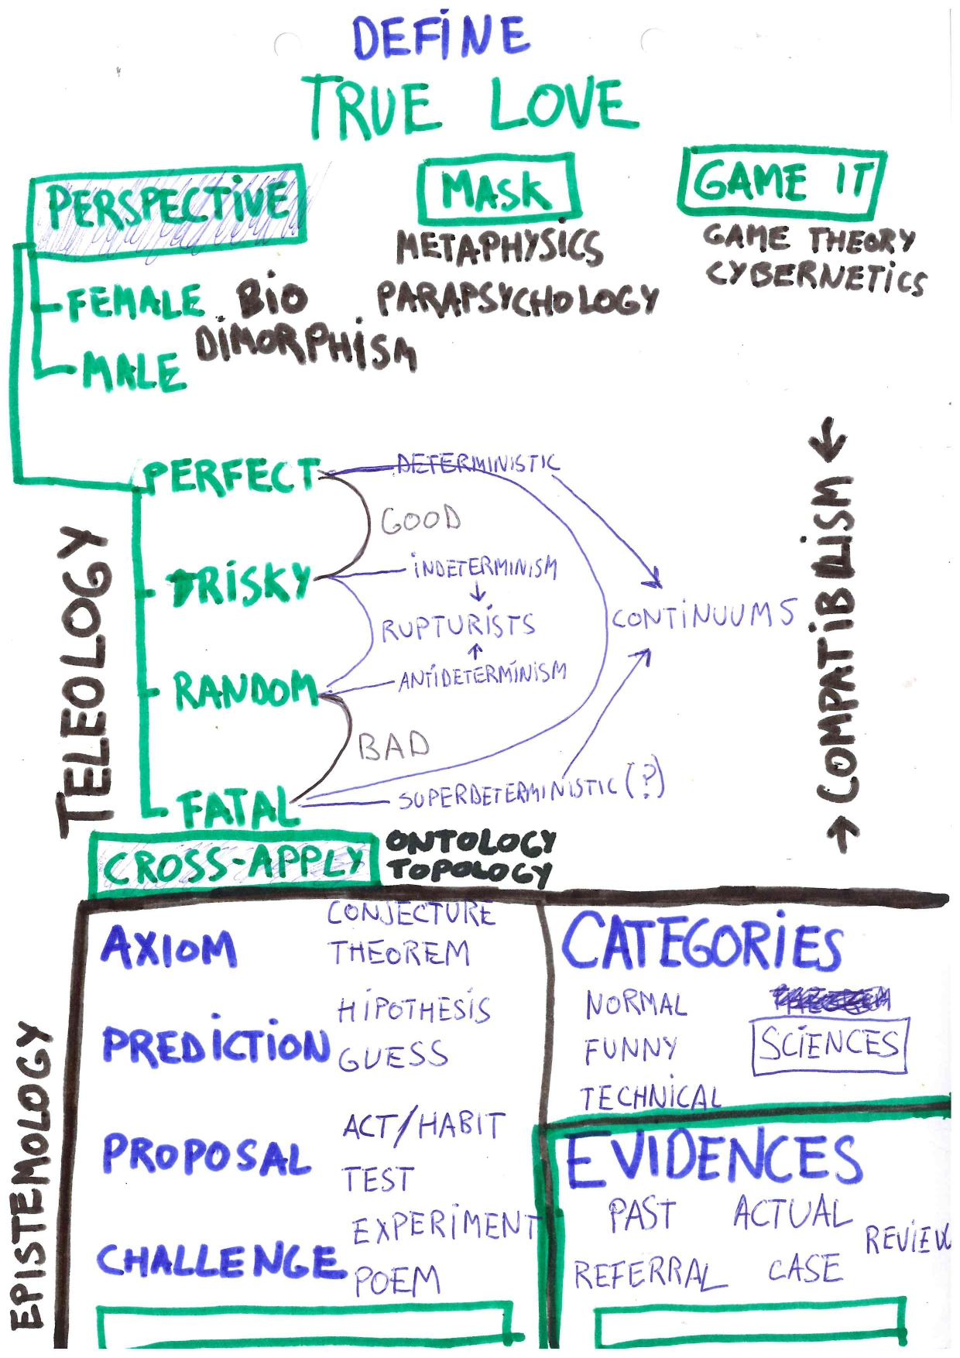
Subject, bias, intention, Perspective = 25% of perception, 25% of polarity and 50% of unknown

Every declaration is just a partial perspective of such reality, andso it's hiding some polarities of itself. We can openly declare our perspective andor research after about what are the other main perspectives we have missed.
We can also think that there are Fundamental perspectives.underlying in whatever declaration.
Populating ourselves with perspectives leverages the stress of having to rely in “good / bad” perspectivizing.
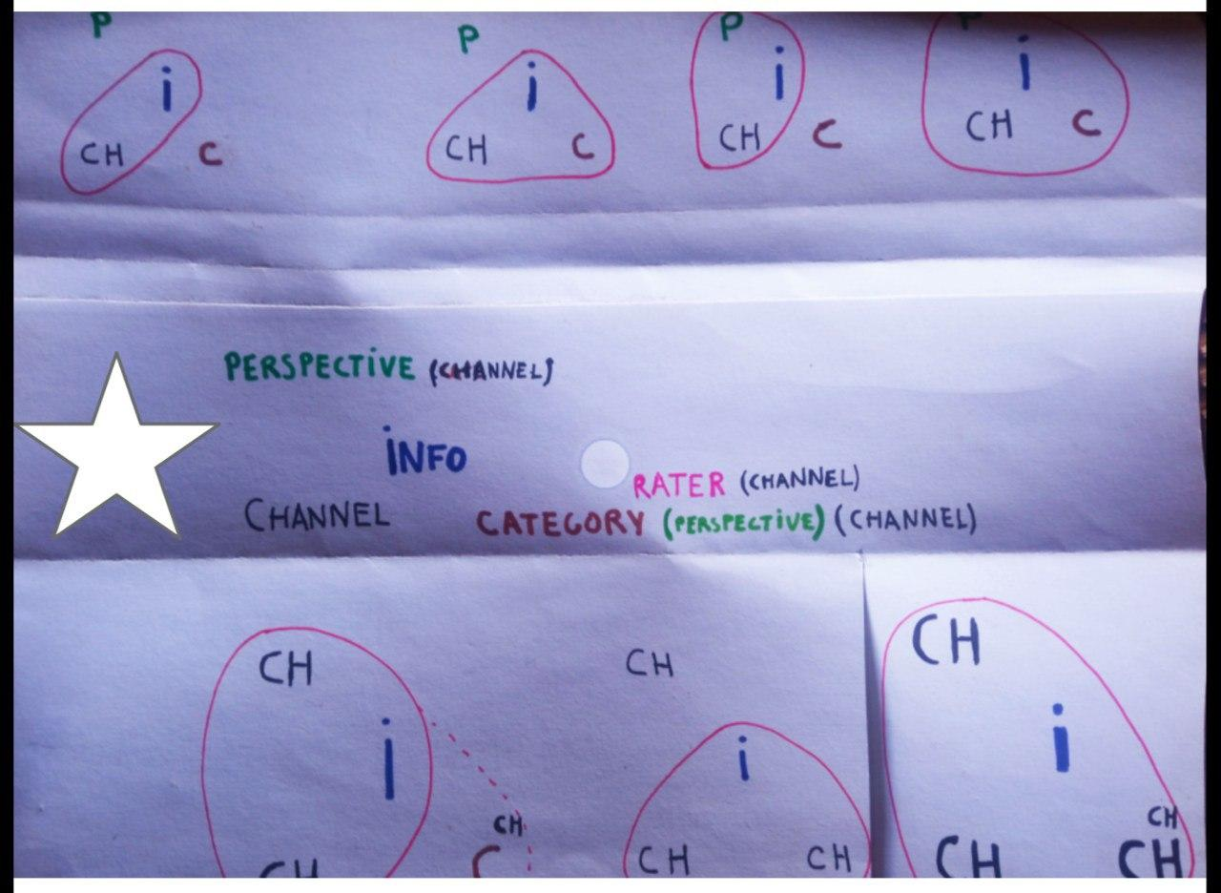

There is always something else present underneath of what we say, so we are constantly feeling the need to fill the minimized polarities that have been left apart in what has been just expressed by ourselves andor by other near ones. That’s why, for example, many times at some point we will surely add emotionality to an input that we have considered too rational… andor even our mate could complain to us that (s)he wasn’t meant to be as rational as you indirectly meant (s)he was.
PERSPECTIVE
Direct | A priori | Declared
Indirect | A posteriori | Analised

We can openly and directly declare our a priori perspective andor research about what we have been missing after. We can relate-rate-define anything new or already expressed-defined a posteriori andor not relating-rating at all minimally and go straight to define it with more complex rethorics. If we relate-rate something before defining it, it will influence the following definition, hence it’s worth to call the a priori relates-rates as perspectives.
If we decide to openly-directly declare our perspective, we will be anyway hiding something else very complementary in the underlying energy of what we more superficially express. If we rather decide not to tell anything about our a prioristic perspective, we will anyway be able to find it within the declared information by analizing that information aposteriori. I.e. Any indirect suggestion that exagerates its indirectness becomes a bit more direct in a side than if the same information was rather told more directly.
Also, such perspective (a priori relate-rate) will have its own hidden polarity, which will be more present there than other possible perspectives. One can perspectivize with whatever words. However, there will be some key categories that will match better this purpose of perspectivizing-framing (rating-relating in advance).

Intentions & Teleologies
We can't avoid subjectivity nor fully define it like nor anything else because uncertainity applies to every perception, hence we better call our apriori perspectives (or a posteriori truth declarations) as open bias andor more accurately said: Aprioristic intention.
Intention can be synonim with perspective, but it is rather more interesting to consider Intentions as some key perspectives, probably the most fundamental because they, by holism, should be macroreflecting the teleologies, the more fundamental micro possible.
Greater perceptionof a more benevolent companionship, also from far away and faked
The first polarity of our freest intentions themselves as a whole would be an hypothetical determinism underlying them, because if we do a step forward from the theological What into the teleological Whys, we can more easily can tie-pole the original intention for creation of all the universe with our own closer and actual intentions. As by (super)determinism: God(ess) initial intention could be plural as ours are nowadays. This axiom hasn't been falsified and brings the biggest compatibilism possible falsifiabilty. Andso it recommends to add the perspective of: i.e. Now rehink-frame your (already expressed or not) opinion-intention as if it was within a superdeterministic system.
See more: flove.org/simplex - teleologies

Biological Channels
Our (more inner systems and outer else) are our subconcious mind – Candance Perth (& me)
We think of ourselves as a being with a whole body that ends where our skin and expressses as a representative block of all its parts. It is right to feel so, but each part of us also has a specific role, with its own biases too. So we can convert the part into an own subject. See more: Flove.org/channels
In the same way, we can put ourselves (andor any anatomical part of ourselves) as if we were in our own past of our own actual body andor in the body perspective of other beings (closer or more distant). We are already doing that by “conservation laws”. See more: Flove.org/souls

Time Scopes
Past | Future
Neurosis | Psicosis
Short Term | Long Term
Conservative | Progresist

(In)Formality: Fiction: The power of triviality and random

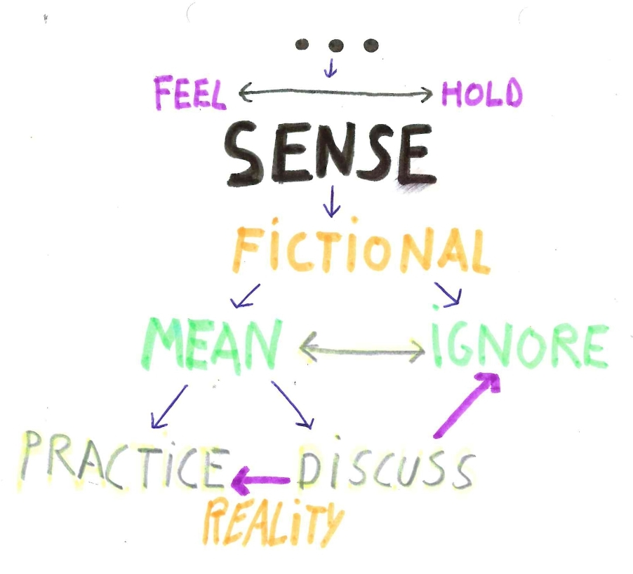
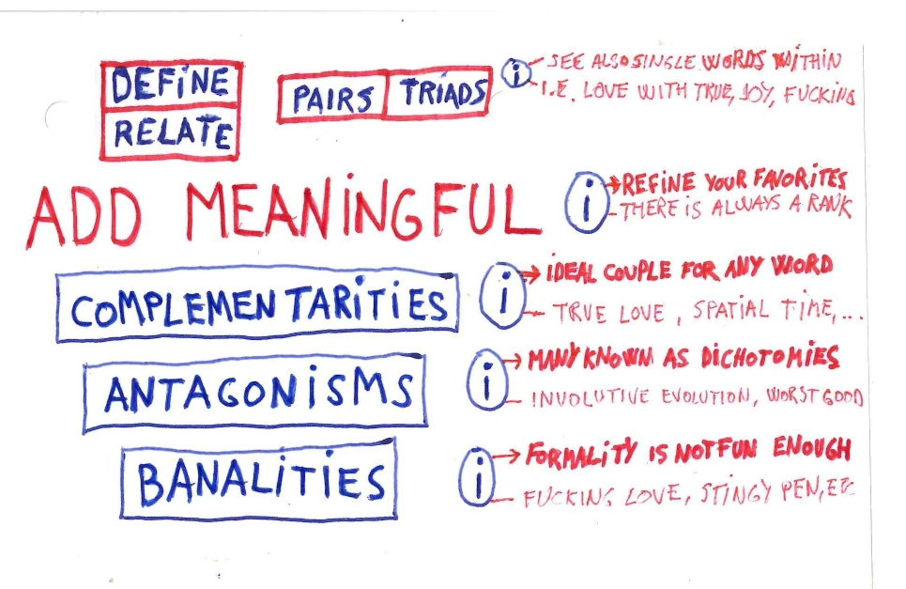

Every novelty was a fictional consensus in one’s mind before it was available to others
The fictional grounds we co-live with and develop (words as an extended part of that) allow us to have a more relaxed testing space for avoiding possible damages for the novelties that we may later want to implement more for real or not.

We trivialize for another formality that we hide not being so heavy
Informality - Banality - Triviality is necessary while too much of it is also dumbing us more than necessary.
Some times, a more directly trivial intention could help us more in evidencing something important than if we try finding it through a more formalized intention or framework.
Any expressed thing which is apparently trivial is serving us as much as we more directly intend our effort to be the more trivial possible. Triviality, sometimes, provides an underlying hidden precious link with something else that we are more really valueing but we aren’t so confident yet to know it andor express it in a more formal way. Within the topological complexity of such link is maybe where there should be the most interesting information, specially because if we look at it within a holist and deterministic perspective: that triviality is a god(dess) formality anyway, it had to happen that way, only. so.. why that objetc – link emerged in me if i was pushing it all to go random so hard?
Select (pseudo)random, in the better structure
As trivial has its background, every random has an underlaying order also. In fact, a certain degree of random selection is a basic strategy evidenced at game theory. So we can build the most analytical and predictive system, but triviality and random will - should still be there as an available option for magnifying sinchronicity & mommentual magic.
Example Case: WhiteSnow is as much or less meaningful than ColdSnow. Similarly, BlackSnow will be a limiting axyomoron, but HotSnow would be a more formal axyomoronic pair to define. These words seem fundamentally quite meaningless because they have little prescriptivity, so they don’t add depth or novelty. BUT... these examples will bring higher meaning when identifying what is the more real thing that who proposes them is more really trying representing underneath of-through them. So, more formally said: Why anyone uses What sort of which Buzzy formal hypes andor informalities for hiding which more real intentions there?
I will postpone it banalizing itl while i guess that i can’t yet tolerate such proposed depth
Caso: Parrafeo lo paraguapo que aun no me atrevo a hijar, versar, tablear y o diagramar

Dimorphism
Despite first, very primer and intense that something is, it's only a 50% of a something
Primarity is a very real property because of this game:
Tell 2 words
(when first word is said, the game suddenly ends…)
Women evidence a lot of natural gifts of primarity (embriology...) and we men are very ready to secondarize that, while everyone sees him-herself and his-her gender as primary over the other.
Deepening directly in dimorphism perspectivizing helps us seeing our own gifts and other parts, i.e. A man can define something with a Woman perspective, because it is the 50% feminity of his own energy (and viceversa). He can do it abstracting more the form, always primarizing the amorphous, andor more easily use the perspective of a Cat, a Blondie, … See more: Flove.org/FineFatalFemale

