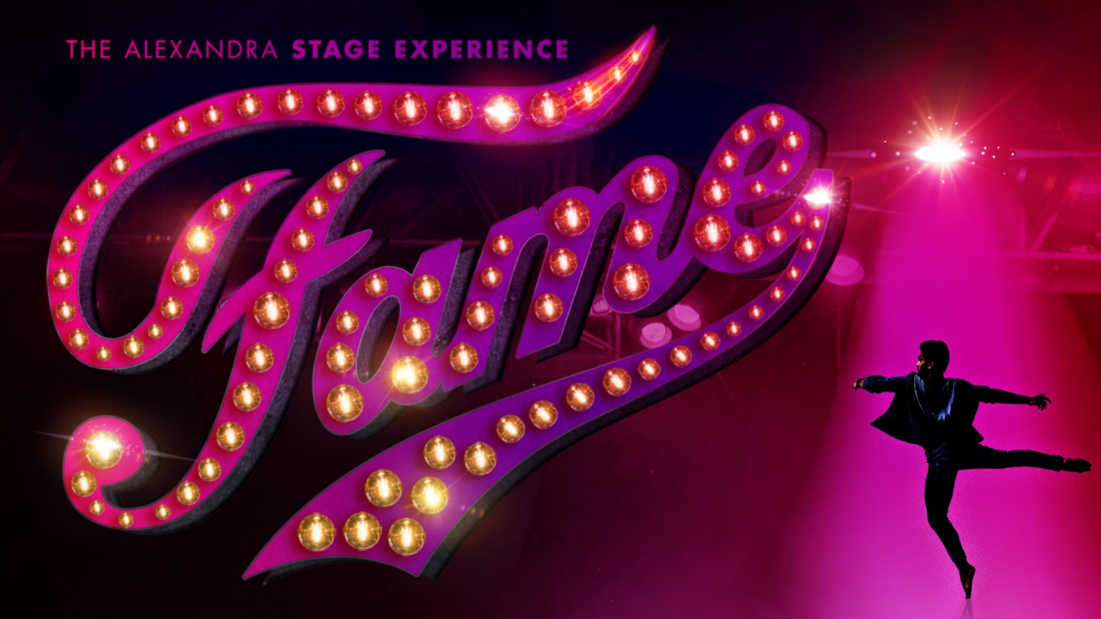

**OPEN AUDITIONS Sunday 29 May 2022**

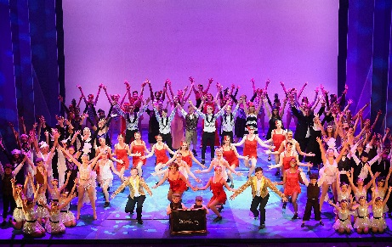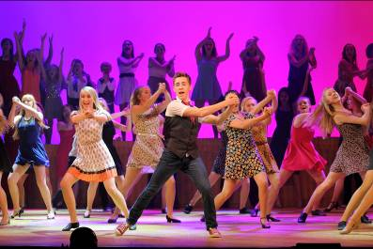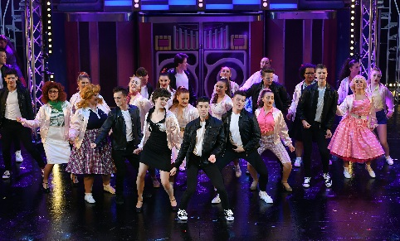

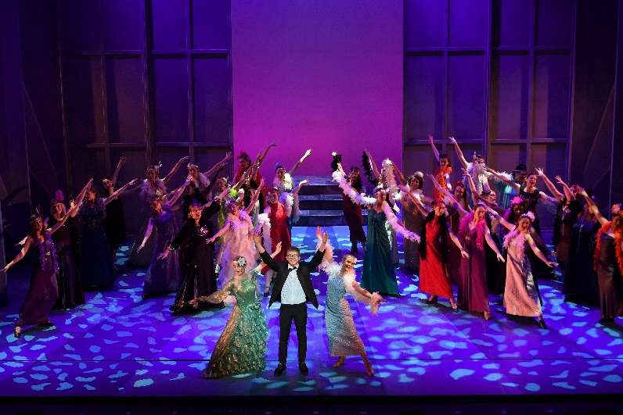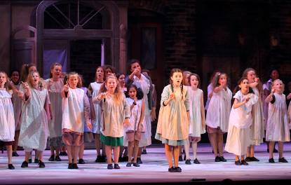

Stage Experience is open to anyone aged 9 - 24 who can commit two weeks of their summer holiday to putting on a musical! You will work alongside our industry professional Director, Choreographer and Musical Director to mount a full-scale production of *Fame* in just two weeks!

It is a unique opportunity to make new friends, hone your skills in a fast-paced theatre environment and ultimately, experience what it is like to take part in a large-scale production on a par with West End/touring musicals.

The fortnight culminates in 5 fully-staged performances complete with our professional orchestra, set, lighting, sound and costumes at The Alexandra, Birmingham.

**Stage Experience runs from Fri 12 – Sat 27 Aug 2022**

**Performances Wed 24 – Sat 27 August, Wed – Sat 7.30pm and Sat 2.30pm**

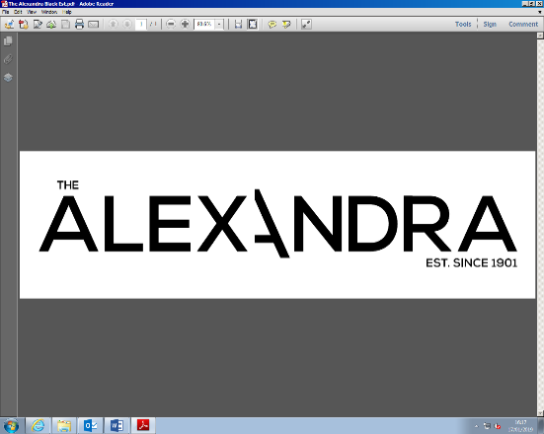

**Audition Criteria**

• You must be aged 9-24 on 12 August 2022

• You must be available to audition on Sunday 29 May 2022

• You must be available to attend a recall on Thursday 2 June 2022 if requested, in order to be considered for a leading role

• You must be prepared to sing, dance and act at your audition in front of the panel and other people auditioning

**Technical Interview Criteria**

• You must be aged 16-24 on the 12 August 2022

• You must be able to attend the interview session on Sunday 29 May 2022 at 10.30am

• Interviews will be in a group and will take no more than 2 hours

**Criteria for all Participants**

• You must be available for all dates between the Fri 12 – Sat 27 August 2022 (no exceptions)

• You must be able to get yourself to and from The Alexandra for all rehearsals and performances

**How to register**

Please complete the registration form in full. Either the paper form below and return to the address below along with 1 passport sized photograph. Or apply online – bitly.com/fame2022

Registration forms should be returned by Friday 13 May 2022 to:

Stage Experience Team, The Alexandra, Station Street, Birmingham B5 4DS

For further questions or enquiries please contact:

[stageexperiencebirmingham@theambassadors.com](mailto:stageexperiencebirmingham@theambassadors.com) or call 0121 230 9071

**Stage Experience Fees**

If you are successful at your audition the fee to take part in Stage Experience is:

£200 for performers and £150 for technical placements. There will be a discount for siblings of £30 each.

If you are successful at audition and we cast you in the show you will be notified during the week commencing 6 June 2022.

**Audition Information**

Auditions will take place on Sunday 29 May 2022: Surnames A-J for 9.00am registration for an audition session from 10am to 1pm. Surnames K-Z for 1.00pm registration for an audition session from 1.30pm to 5.00pm. End times are approx. and will depend on quantity of auditionees.

You will be notified on the audition day if we require you to return for a recall audition on Thursday 2 June 2022. If you are not asked to attend a recall audition, this does not mean you have been unsuccessful, but it does mean that you are not being considered for a leading role.

Please be prepared to stay the entire duration of your audition session.

***Please note that only those auditioning are allowed into the auditorium.***

**Frequently asked questions:**

**How much does it cost to audition?** Auditions are completely free of charge. If you are selected to take part in Stage Experience there will be a fee of £200.

**Does everyone who applies get an audition?** Yes, if you register for an audition by returning the registration form along with 1 passport sized photograph by Friday 13 May 2022 you are eligible to audition on Sunday 29 May 2022. Please note that due to the number of applications we receive you will not get a confirmation of audition.

**Do I need to prepare anything for my audition?** No, you do not need to prepare anything, everything will be taught to you on the day. For the recalls you will be explained if you need to prepare anything.

**What do I need to wear for my audition?** Please make sure you wear loose, comfortable clothing that you can dance in and trainers or dance shoes which must be worn at all times on the stage. Please also ensure that you bring something to drink with you.

**What time will I finish at the audition?** We have estimated that the am session for Surnames A-J will finish at 1.00pm, and the pm session for Surnames K-Z to finish at 5.00pm. Please note that these times are an approximation and will depend on how many auditionees attend. We would recommend ensuring that all auditionees bring a mobile phone *(which must be silenced during the audition)* with you so you are able to contact someone to collect you after your audition. No one will be asked to leave the venue if they are waiting to be collected. A chaperone will also be in the venue as well as theatre staff. Family are welcome to wait in our bar areas throughout, or leave and return nearer the finish time.

**How will we audition?** At the beginning of your session you will do a physical and vocal warm up. You will then sing through the line of the chosen song with the Musical Director and be taught a short dance routine. Groups of 10 will go up and perform the dance together. Groups are spilt by age – those who have not yet finished compulsory schooling (born after 1st September 2006) and those who have finished compulsory schooling (born before 31st August 2006). On the day these groups will be called Juniors and Seniors.

**What happens after my audition?** You will be written to week commencing 6 June 2022 to say whether you have been successful or not.

**What happens at the recalls?** During the course of the day we will gradually work through to identifying who will be cast as the named principal characters in the show. This will be done through acting and singing a variety of different musical numbers from the show. If you are asked to leave at any point during the recalls this does not necessarily mean you haven’t been cast in the show, but may mean we have already decided on your role and no further auditioning is necessary.

**What if I don’t get a recall audition?** Although this means you are not being considered for a leading role there will still be strong dance, acting and singing opportunities for all who are successful in being cast in the show.

**If I’m offered a place on Stage Experience, what happens then?** If you’re one of the lucky auditionees offered a place in Stage Experience you will be sent further details of rehearsals and the fee to take part, which must be paid in advance.

If you would like to receive communications regarding future Stage Experience projects or other performance/technical opportunities with The Alexandra, please check the relevant boxes below as agreement that The Alexandra can contact you.

Don’t worry, you can ‘opt out’ of these communications at any time by emailing [stageexperiencebirmingham@theambassadors.com](mailto:stageexperiencebirmingham@theambassadors.com) and rest assured no one else will be passed your details for marketing purposes.

I would like to hear from The Alexandra via:

Email

Post

SMS

Telephone

**STAGE EXPERIENCE 2022 AUDITIONS**

**PHOTOGRAPHY AND VIDEO CONSENT FORM**

During the auditions photographs or video footage may be taken by The Alexandra staff and/or visiting media for use by the Theatre and/or local press.

I (state name) ____________________________________________ agree to have my photograph taken or appear in any video footage filmed as part of Stage Experience activities that may be used by the theatre or local press if necessary.

Full Name

Age

*Please sign below if you are aged 18 and above*

Signed

*Please ask your parent / guardian to sign below if you are aged 17 and under*

Parent / Guardian Name

Signed

Relationship to Participant

**Please staple**

**a passport sized**

**photo here**

This will be the photo that will be used if you require a child performance licence.

***The Alexandra Stage Experience 2022***

APPLICATION FORM



**RCL: YES NO**

**Cast:**

**No**

**Do you have any special requirements we need to be aware of?**

**Height (cm):**

**D.O.B:**

**Name**:

**Address:**

**Phone:**

**Email:**

***FOR ADMINISTRATION USE ONLY:***

**S D L O**

**   **

ID NO.

**Where did you find out about Stage Ex?**

**FOR COMPULSORY SCHOOL AGE PERFORMERS ONLY**

**Who is your local authority (who your council tax is paid to)? Please circle:**

Birmingham Coventry Derbyshire Dudley

Warwickshire Sandwell Solihull Staffordshire

Wolverhampton Walsall Leicestershire Worcestershire

Other.................................................................................................................

Child performance Licences will be required for anyone who has not finished compulsory schooling (year 11) by June 2022.

**Phone and email are: (please circle)**

**Home/family My details member’s details**

Rehearsal dates

**Fri 12 – Tue 23 August 2022**

Performance dates

**Wed 24 – Sat 27 August 2022**

I am applying to be a Performer (open to 9-24 yrs): 

I am applying to be in the Technical Team (open to 16-24 yrs): 

**9 – 24 years old**

(Age on 12/08/22)

**OPEN AUDITIONS** for performers:

**Sunday 29 May 2022**

Surnames A - J

9am-1pm (approx)

Surnames K - Z

1pm-5pm (approx)

Recalls will be held on

**Thursday 2 June 2022**

**INTERVIEWS** for technical crew:

**Sunday 29 May 2022 – 10.30am**

Ages 16-24

**Please complete this form AND the photo waiver, attach A PASSPORT SIZED PHOTO and return to:**

STAGE EXPERIENCE

THE ALEXANDRA

STATION STREET

BIRMINGHAM

B5 4DS

Completed and returned forms **received by Friday 13 May** guarantee your audition place.

***SEE YOU IN MAY!***

**Yes**