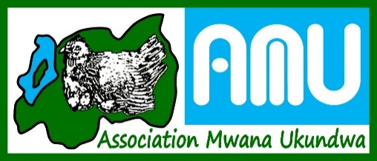
ASSOCIATION MWANA UKUNDWA KAYONZA BRANCH

ANNUAL REPORT
2022

Introduction
The District
Kayonza is a district located in Eastern Province, Rwanda. Its capital is Mukarange. The population of Kayonza District is projected to 344,157 people in 2012, living in 12 Sectors;
Gahini, Kabare, Kabarondo, Mukarange, Murama, Murundi, Mwiri, Ndego, Nyamirama, Rukara, Ruramira, and Rwinkwavu., and 50 Cells and 421 Villages.
Kayonza is the home of Akagera National Park, a popular tourist destination for safaris, and also a district whereby a beautiful Lake Muhazi is located.

Association Mwana Ukundwa (A.M.U), through expanding efforts to vulnerable children, started supporting in Kayonza District in 2015.

This report describes the activities that have been done by A.M.U-Kayonza in 2022 which were to contribute to socio-economic reintegration of children at risk within their self-sustained families under the main objectives ;

- Ensuring quality formal and informal education for vulnerable children especially children with hiv infected and children with disablities through primary and secondary sponsorships.
- Contribution to ensuring child protection through create and support to child protection clubs leading children’s rights awareness campaign in schools, churches and in communities.
- Contribution to stop new HIV infections through supporting Clubs anti-SIDA to conduct awareness campaigns in schools, churches and communities and through strengthening strengthen the socio-economic position of women and children living with HIV.
- Contribution to poverty alleviation through formation and support transformative Self-Help Groups (SHGs) for caregivers
Spiritual transformation cross-cutting in all the 4 objectives

Beneficiaries

Association MwanaUkundwain 2022supported 216 children in Kayonza Districtincluding ;

- Children infected by HIV/AIDS
- Children with disabilities
- Vulnerable Children / Poor Children
- Teen-mothers
 | Categories | Male | Female | Total
1 | Children with Hiv infectrd (Primary) | 35 | 31 | 66
2 | Children with hiv incfected ( secondary) | 12 | 16 | 28
3 | Children with disabilities (Primary) | 13 | 11 | 24
4 | Children with disabilities (Secondary) | 2 | 1 | 3
5 | Children with disabilities (Don’t study) | 4 | 4 | 8
6 | Vulnerable Children (Primary) | 20 | 10 | 30
7 | Vulnerable Children (Secondary) | 11 | 16 | 27
8 | Teen-mothers | 0 | 30 | 30
 | TOTAL | 97 | 119 | 216

Operational area

In 2022, A.M.U Kayonza operated in 5 sectors of Kayonza district in Eastern province, including ;

 | Sectors | Cells | Villages | Population
1 | Mukarange | 5 | 38 | 42,055
2 | Nyamirama | 5 | 36 | 30,528
3 | Rukara | 6 | 42 | 31,176
4 | Kabarondo | 5 | 35 | 30,588
5 | Gahini | 5 | 36 | 32,650
 | TOTAL | 26 | 187 | 166,997

Church partners

 | Church
1 | ADEPR Mukarange | 9 | Revelation Church
2 | ADEPR Kayonza | 10 | Assemble de Dieu
3 | ADEPR Nyagatovu | 11 | EAR Kayonza
4 | ADEPR Kabuga | 12 | EMLR Kayonza
5 | ADEPR Munazi | 13 | LCR Kayonza
6 | ADEPR Ragwe | 14 | Eglise Vivante
7 | EPR Kayonza | 15 | Restauration Church
8 | EPR Kabarondo

Schools partners

 | School | District | Sector
1 | NYABUBARE Primary School | Kayonza | Mukarange
2 | MUKARANGE PROTESTANT Primary school | Kayonza | Mukarange
3 | G.S MUKARANGE CATHOLIQUE | Kayonza | Mukarange
4 | G.S KAYONZA | Kayonza | Mukarange
5 | G.S RUTARE | Kayonza | Mukarange

Self Help Groups for lifeguiders supported by A.M.U

No. | Name | Members |  |  | District | Sector | Savings
1 | Abunzubumwe | 2 | 19 | 21 | Kayonza | Mukarange | 884,410
2 | EjohezaKiyenzi | 0 | 15 | 15 | Kayonza | Gahini | 388,700
3 | ImberehezaKiyenzi | 1 | 16 | 17 | Kayonza | Gahini | 409,000
4 | TuzamuraneKiyenzi | 0 | 8 | 8 | Kayonza | Gahini | 162,000
5 | Tubakunde | 1 | 9 | 10 | Kayonza | Mukarange | 235,400
6 | AbadahemukaNyabubare | 0 | 15 | 15 | Kayonza | Mukarange | 518,400
7 | Abakundamucyo | 1 | 23 | 24 | Kayonza | Mukarange | 196,150
8 | Abishyizehamwe | 0 | 18 | 18 | Kayonza | Mukarange | 325,100
9 | Abahujumugambi | 8 | 17 | 25 | Kayonza | Mukarange | 293,590
10 | TwitezimbereRugendabari | 4 | 11 | 15 | Kayonza | Mukarange | 186,800
11 | TwitezimbereBwiza | 4 | 12 | 16 | Kayonza | Mukarange | 638,250
12 | IcyerecyezoBwiza | 0 | 16 | 16 | Kayonza | Mukarange | 169,250
15 | AbadahemukaBwiza | 1 | 14 | 15 | Kayonza | Mukarange | 211,290
16 | IcyerecyezoNyakagarama | 4 | 20 | 24 | Kayonza | Mukarange | 772,800
17 | Abakundamurimo | 0 | 9 | 9 | Kayonza | Mukarange | 119,500
19 | Twubakubuzima | 2 | 13 | 15 | Kayonza | Kabarondo | 165,800
20 | Twiyubake | 9 | 8 | 17 | Kayonza | Kabarondo | 392,550
21 | Dukundane | 2 | 18 | 20 | Kayonza | Kabarondo | 183,250
22 | InezaKabarondo | 3 | 9 | 12 | Kayonza | Kabarondo | 209,200
23 | DufatanyibikorwaRukara | 1 | 9 | 10 | Kayonza | Rukara | 127,600
 | Total | 43 (M) | 279 (F) | 322 |  |  | RFW6,589,040
List of SHGs supported by A.M.U-Kayonza and their savings

 | Activities, Indicators, and Impacts
 | Activities | Indicators | Impacts
 | Education
Activity 1.1 | Pay school fees, scholastic and uniform for the OVC in Primary schools. | Scholastic materials including exercise books wereprovided to 187 the OVC, HIV/AIDS children and children withdisabilities in bothprimary and secondary. | After getting scholastic materials, now the children study better, and italsohelped their parents because it was not easy for them to get the school materials.
Activity 1.2 | Payschoolfees, scholstic and uniform for the OVC, HIV/AIDS, and children with disabilities in Secondary schools. | School fees for the OVC, HIV/AIDS children and children with disabilities were paid for 63students in secondary schools. | The children who were paid school fees and scholastic materials which now help them in their studies, are nowstudying were and are happy. The parents who could not afford to pay for their children are also very grateful to A.M.U-Kayonza.
Activity 1.3 | Facilitatecommunitylibraries for children in differentcommunities and ECDs home based. | A.M.U-Kayonza facilitate dlibraries in communities and ECDs especially in Bwizacell, where A.M.U supported 6 ECDs in the same area by training the facilitators and provided library materials such books and different tool kits | Before A.M.U-Kayonza started helping ECDs, it was very difficult, because there were no equipment for ECDs, but now they are working well, and the sector of Mukarange thanks A.M.U-Kayonza for that work.  Also the A.M.U library continues to help children who attend and this is reflected in their grades at school, you see that their grades go up from semester to semester. This is because they are helped by reading books, and learning different things including languages, sciences, computers, etc.
Activity 1.4 | Promote sports and culture and developphysical and cognitive development for children and organizing open day. | A.M.U-Kayonzahas done everything possible to help children with different talents. So far there are children who play soccer, children who dance different dances (traditional, modern dances), children who speak poetry, and others who are talented in art. | A part of improving their talents, this program also helped the children to love each, which helped them learn to live well at a youngage. Moreover, there are children due to the talents they have shown in playing football, theywere able to find good institutions to study, and others found teams that pay them (even though they have not reached the level we want).
 | Child protection
Activity 2.1 | Paycommunity-Based Health Insurance to children and parents who live with HIV/AIDS and mos tvulnerable families. | In 2022, A.M.U-Kayonza pai dHealth Insurance to 152 people. | The families supported by A.M.U-Kayonza are sopoor, soi tis not easy for them to gettreatment. After paying the health insurance, parents were able to get medical treatment, and even for their children, including those with HIV/AIDS who must be monitored by a doctor often.
Activity 2.2 | Support groups for Children who are HIV/AIDS infected and children with disabilities. | Two support groups were organized ; one in the | The children who participated were taught ;  - How to take medecine (ARVs) properly  - Hygiene, and  - Cultivating kitchen garden.  This will help them to behealthy, and to have a healthydiet.
Activity 2.3 | Support and train young girls whohad been te victims of (S)GBV and gave birth at earlyage (unwantedpregnancies) on tailoring. | In partnership with the District of Kayonza, A.M.U-Kayonza helped 30 Teen-mothers, where they were taught the vocational training (Sewing) for 10 months. | These young girls (Teen-mothers), afte rbeing taught sewing, now they have capacity to go to the labor market and earn money.  They were given different skills, where they were taught to save and work in development teams. They were divided into groups (of 3), and each group when they finished was given a sewing machine ; they were also given breeding animals to help them develop. In cooperation with the local government, we will continue to help them.  Also, in the ten months they have been in A.M.U-Kayonza, they have testimonies . some of themwerebaptized. As A.M.U-Kayonza, wewillstay close to them.
Activity 2.4 | Support the most vulnerabl echildren in the program with basic needs and case management, mainly children with disabilities and infected by HIV/AIDS. | A.M.U-Kayonza helped 3 children with disabilities to betreated, where 2 children received prostheses , and one under went surgery.  Other children were have been helped in various problems where they werevisited by staff and facilitators whotake care of them day by day. | After getting prosthesis, they now very happy, they can walk for a long distance, which has helped them to keep up with their school.
Activity  2.5 | Conducting different campaigns to 5 schools for prevention of new infection of HIV/AIDS amoun gyoung people and their families. | In 2022, 5 school clubs weretrained in HIV/AIDS prevention campaigns. On March 30, 2022, an Open-Day washeld, the theme of which was, ‘’Rubyirukomugireuruharerwogukumiraindazidateganyijwe n’UbwandubushyabwavirusiItera SIDA.’’ – Youth fight against Hiv through prevention of getting early prégnant | schools where the teachers started testifying, that due to campaigns students gave up their immoral behavior.
 | Poverty alleviation/ Family development
Activity 3.1 | Training on management self help groups and sustainable development to facilitators and SHGs committees. | The facilitators were trained twicein 2022, on SHGs performances and the SHGs A.M.U-Kayonza wants to wo rkwith must be like. Wenow have 8 facilitators in all 5 Sectors. | After these trainings, it is clear tha tthere are changes in SHGs. Some of them seemed like they were going to stop working together, but so far they are working well and have a goal of development.
 | Spiritual care
Activity 4.1 | Conduct meetings and prayer gathering for SHGs. | The 2 meetings and prayergathering for SHGsmembers, on the theme ; ‘’Psalm 116 :12’’ | Through the Word of God, the parents decided to accept Jesus, and thi swas reflected to the family conflicts that have been resolved and the relationships in the SHGs members that have become better.
Activity 4.2 | ConductChildren’s spiritual gathering in holiday (One wil lbe in summer and other in christmas holidays in eachbranch). | 3 youths’ spiritual gatheringwereheld, including one organized in general, for Teen-mothers and Secondary students, and the other two were organized for Teen-mothers.  The theme for the 3 meetings was in  ‘’1 Timothy 4 :8-12’’ | The childrenchangedtheirbehaviors, theydecided the way of worship. They them selves say that it is helping them in their daily lives.
Activity 4.3 | Organizeannualretreat for A.M.U staff and strategicvolunteers. | In 2022, A.M.U-Kayonza staff membersparticipated in a retreatorganized by A.M.U which took place at CENETRA Hotel in Gasabo District in Kigali City. | This retreatwasanopportunity to meetagain as A.M.U staff as wework in different branches.  There wasalso a discussion about the work and programs of A.M.U.  And it was a good time to pray. The retreat of 2022 wasverywellorganized, wewereblessed !
Other activities were achieved in 2022

- The SHGs continued agriculture which helped them to get enough food and to harvest the market.
- Teen-mothers’ parents were encouraged to care for their children and love them.
- A.m.u-kayonza joined other rwandans to commemorate the 28th genocide against the tutsis.
- a.m.u-kayonza gained another partner which is rwanda book mobile. we work together in library programs such as encouraging children to read and love book. now we have access to tools to help us in that program.
- in 2022, in order to continue promoting children’s talents, we have given musical instruments, which are helping us a lot.
- in 2022, as a partner of the kayonza district, we participated in jadf exhibition organized by jadf-kayonza.

Photos

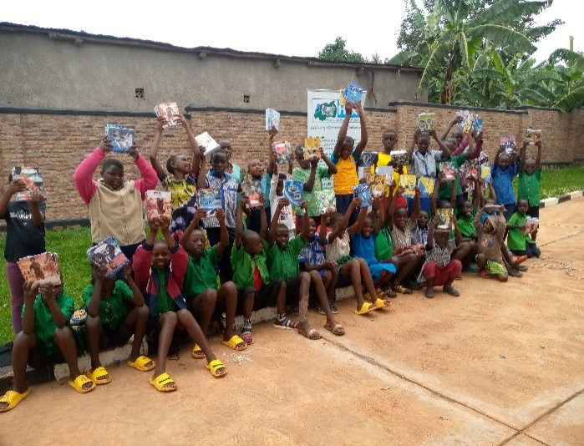
Students supported by A.M.U-Kayonza after receiving scholastistic materials

The

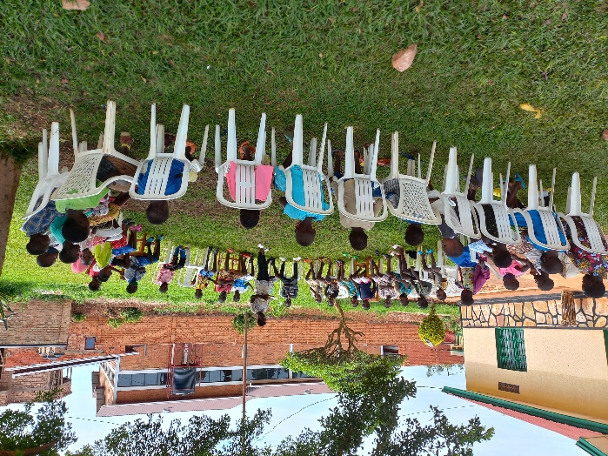
The A.M.U-Kayonza’slibraryproduced good results, whichreflected in the grades theyhad in the school

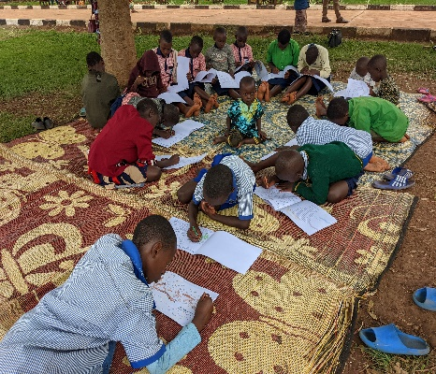
In collaboration with Rwanda Bookmobile, now A.M.U-Kayonza has foundtools to help it in the library, where the childrenparticipate, you can seethat the numberisincreasing and they like itverymuch

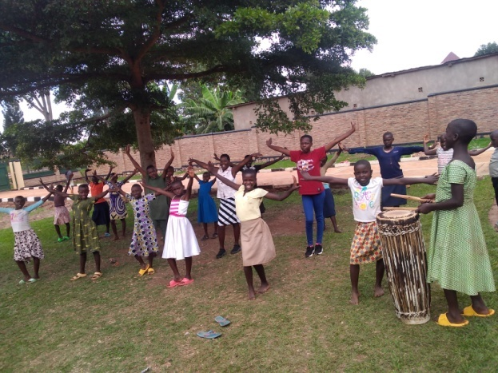

A.M.U-Kayonza helped children improve their talents, now children are divided into different clubs depending on the child’s talent

In support groups, childrendiscussed how to takemedecineproperly, hygiene, and theywereencouraged to growkitchengardens.

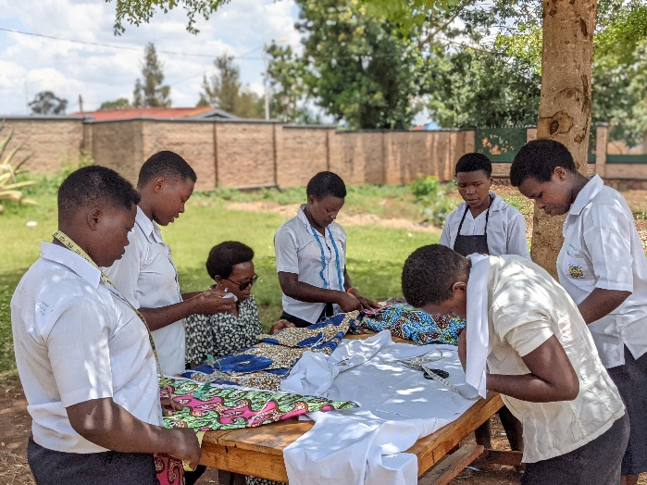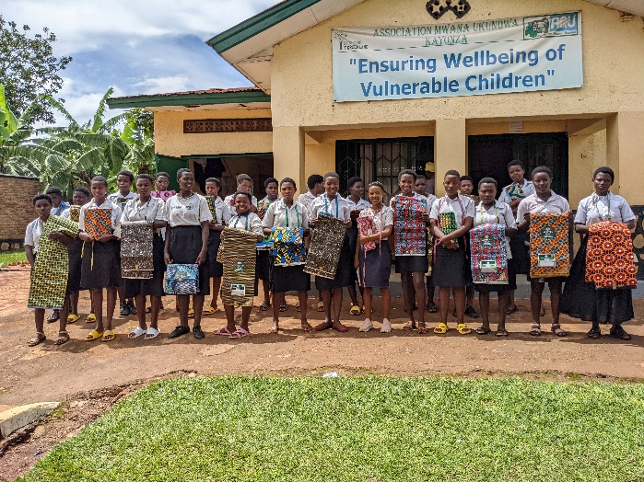
TheseTeen-mothers have been learning to sew for ten months. It was difficult for them in the begining but A.M.U-Kayonza has put lot of effort int oit and now the best results have been achieved. We are proud to have put theminto self development groups, each group now has a sewing machine and a pig to breed.

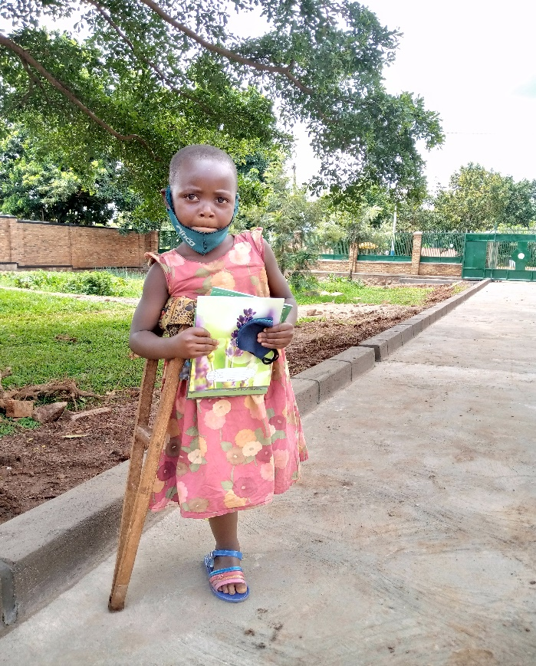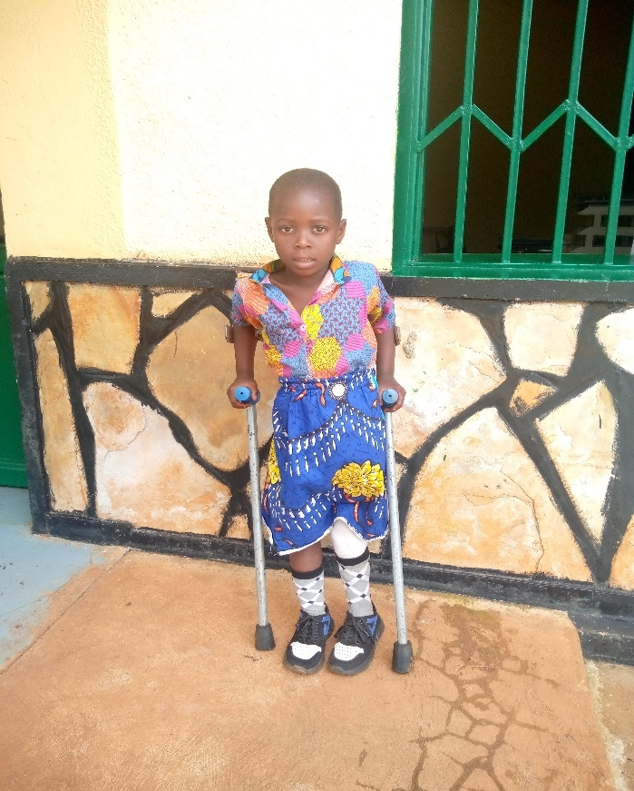
This is AKIMANIMPAYE Latifahbefore and aftergettingprosthesis

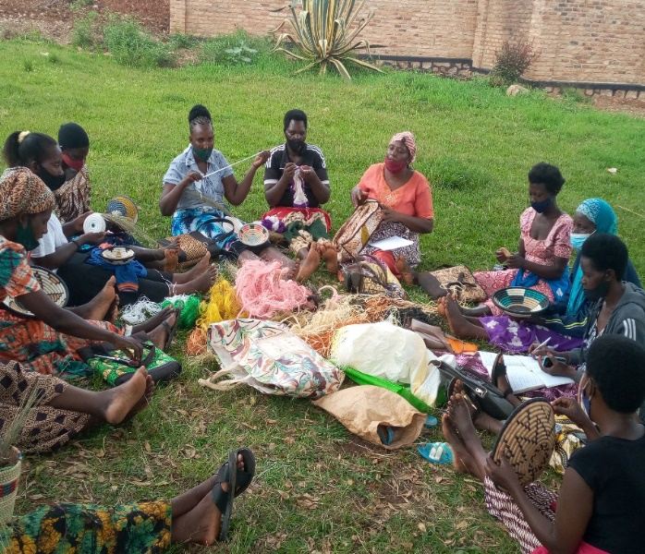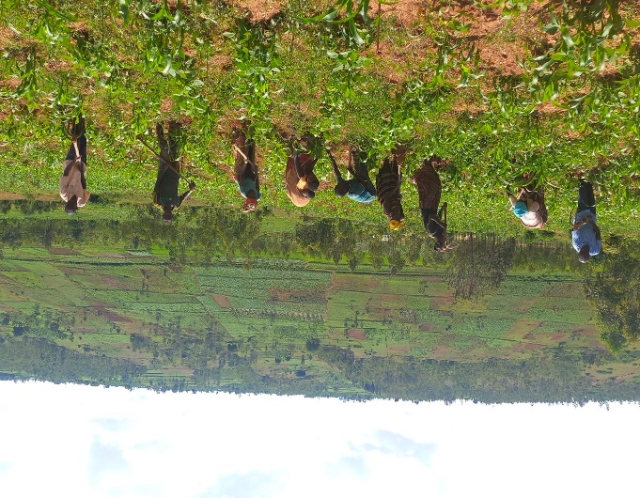
The SHGs continue their self development activities.

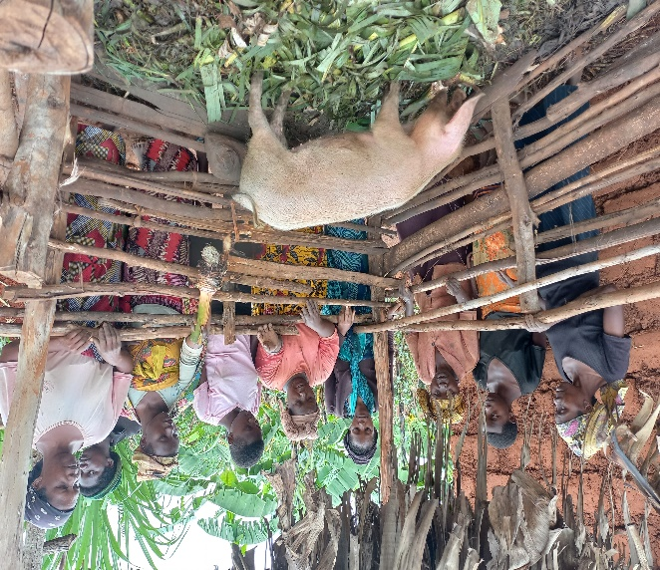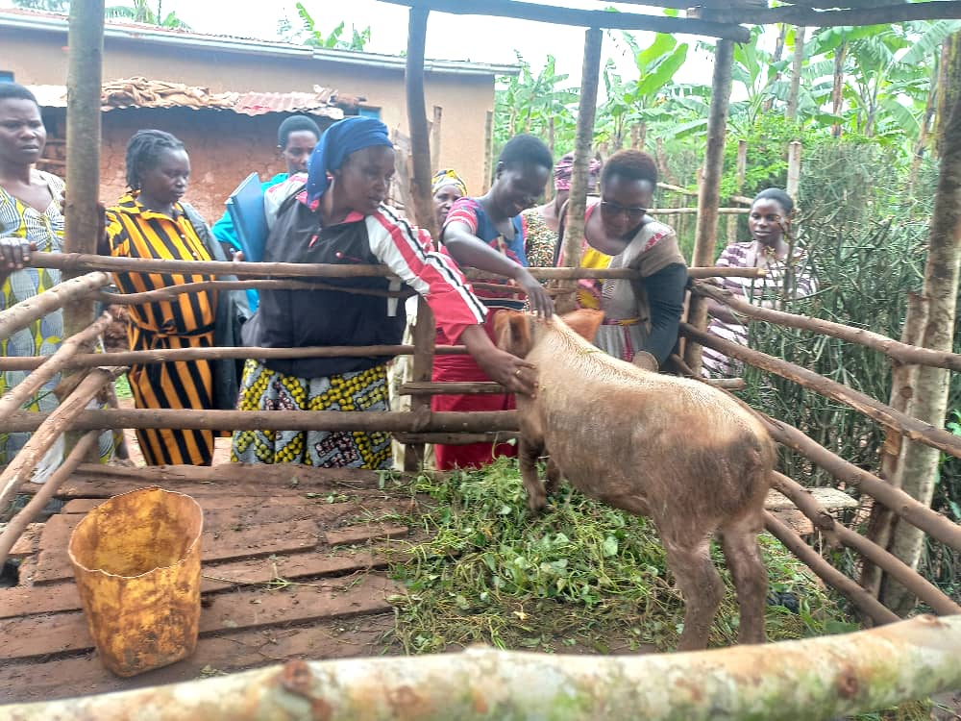
In the program of poverty alleviation, 6 pigs were given to 6 SHG swith the purpose of ending malnutrition among them and their children and economic development of SHGs

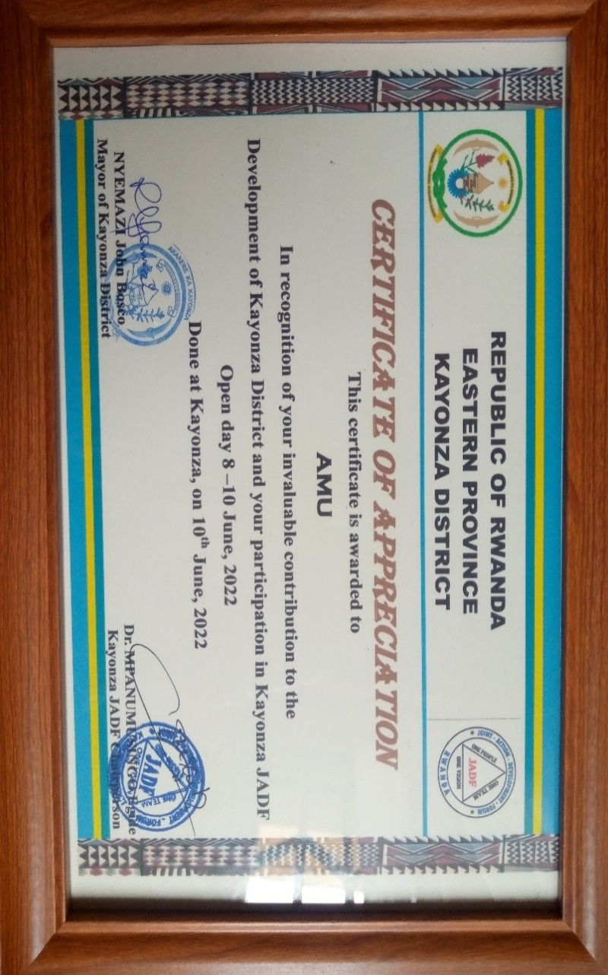

We Wish You a Happy New Year 2023!



Done at Kayonza, January 2023
By A.M.U-Field Coordinator
ISHIMWE Henri Pierre
+250 788 632 458

