**Secure Research Data Management App**

**Mr. G. Prasad *1, Lokesh Choudhary*2, G. Yuva Prakash Sai*3 ,Vamshi Tejan*4**

*1Assistant Professor, Internal Guide, ACE Engineering College Of Information Technology, Hyderabad, Telangana, India.

*2,3,4Student, ACE Engineering College Of Information Technology, Hyderabad, Telangana, India.

**ABSTRACT**

To develop a secure application for the Research and Academia sector, enabling efficient data management with configurable public and private access app name “RESEARCHNEST”. Researchers, educators, and students can store, organize, and share their work, ensuring collaboration while protecting sensitive information. Key features include research data management, publication sharing, and project collaboration. The app aims to enhance academic workflows and promote open knowledge sharing. This innovative solution addresses the critical need for secure and efficient data handling in academia.

1. **INTRODUCTION**

The project aims to develop an innovative, secure, and user-friendly digital platform designed to address the complex and multifaceted challenges researchers face in managing their data. Research data comes in diverse forms and often involves intricate workflows, from data collection and processing to analysis and dissemination**.** The platform will streamline these processes by offering robust tools for organizing, tagging, and discovering data, ensuring that researchers can manage their resources more efficiently. Recognizing the critical importance of regulatory compliance, the platform will include features to support data anonymization, consent management, and adherence to retention policies, helping researchers meet ethical and legal standards seamlessly. To maintain the accuracy and reliability of research findings, the system will incorporate mechanisms for data validation, quality control, and automated backup and recovery, safeguarding data integrity across its lifecycle. Built with security at its core, the platform will provide advanced encryption, role-based access controls, and audit trails to protect sensitive information and foster trust among users. Moreover, the project will facilitate collaboration and knowledge sharing by enabling researchers to prepare, publish, and share their data with ease, integrating with leading data repositories and offering customizable sharing options. By addressing these critical aspects, the project aspires to empower researchers with a comprehensive solution that not only simplifies data management but also enhances the quality, security, and impact of their work in an increasingly data-driven research landscape.

This project is rooted in the understanding that research data management is a cornerstone of modern scientific inquiry, yet it remains one of the most significant pain points for researchers across disciplines. With the growing volume and complexity of data, researchers often struggle to maintain organization, ensure compliance with regulations, and uphold data integrity. This platform is designed to address these challenges by offering a centralized hub that simplifies data workflows while adhering to the highest standards of security and usability. Whether dealing with structured datasets, multimedia files, or complex metadata, the platform will provide researchers with the tools they need to organize, access, and utilize their data effectively. Beyond addressing operational efficiency, the platform recognizes the broader responsibilities of researchers, such as safeguarding sensitive information and ensuring ethical practices. By integrating features like consent management, data anonymization, and retention policy automation, the platform will act as a guardian of ethical compliance, reducing the burden on researchers and institutions alike. Its intuitive interface and automated workflows aim to bridge the gap between technical and non-technical users, making advanced data management capabilities accessible to all members of the research community.

Furthermore, this project emphasizes the importance of collaboration and knowledge dissemination. In today’s interconnected research ecosystem, the ability to share and publish data is critical for driving innovation, reproducibility, and impact. At its core, this project is a response to the evolving demands of the research landscape. It aspires to not only meet current needs but also anticipate future challenges by incorporating scalable infrastructure and adaptability. By creating a robust, secure, and user-centric platform, this initiative seeks to empower researchers with the confidence and tools they need to focus on their core mission: advancing knowledge and driving meaningful discoveries.

1. **METHODOLOGY**

The system follows an interactive and data-driven approach to facilitate user engagement and research data management. The User interacts with the System, which processes various functionalities such as Data Storage, Access Control, Secure Sharing, Metadata Tagging, and Research Collaboration. The System ensures seamless operation by managing these features and interacting with the Database to store and retrieve relevant data.

User inputs are processed by the system to perform secure data transactions, manage access permissions, and organize research materials efficiently. The system also allows customization through role-based access control and enables collaborative research through controlled data sharing. The Secure Data Management feature encourages compliance with academic and ethical guidelines by tracking modifications and ensuring data integrity.

The Database securely stores research data, including project files, metadata, access permissions, and collaboration records. The interaction between the system and database ensures real-time data processing, retrieval, and updates, enabling a smooth research experience. This structured methodology enhances data security, accessibility, and collaborative efficiency in academic environments.

1. **MODELING AND ANALYSIS**

The modeling and analysis of ResearchNest focus on its structural design, data flow, and user interaction. Various UML diagrams, including use case, sequence, and class diagrams, are used to represent system workflows.

* **Use Case Diagram:** Defines the interactions between users and the system, highlighting functionalities like user authentication, project creation, file management, and access control.

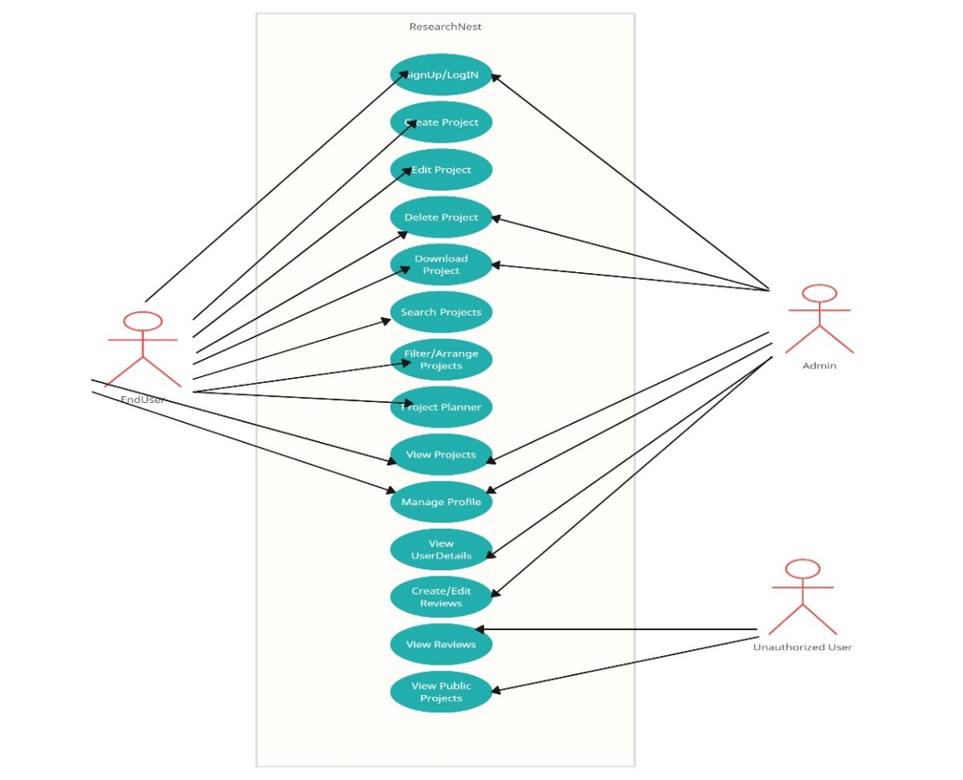

**Figure 1:** USE CASE Diagram.

* **Sequence Diagram:** Depicts the flow of information between the user interface, backend, and database when executing key operations, such as uploading research files or modifying permissions.

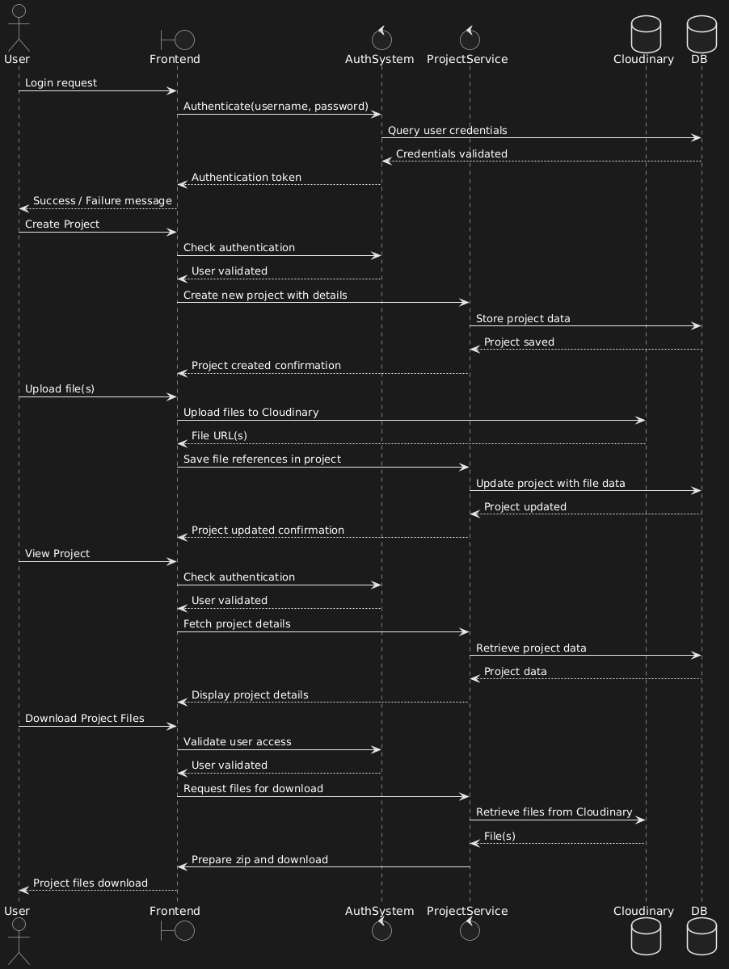

**Figure 2:** SEQUENCE Diagram.

* **Class Diagram:** Represents the system's data structure, illustrating the relationships between different entities, such as Users, Projects, Files, and Access Permissions.

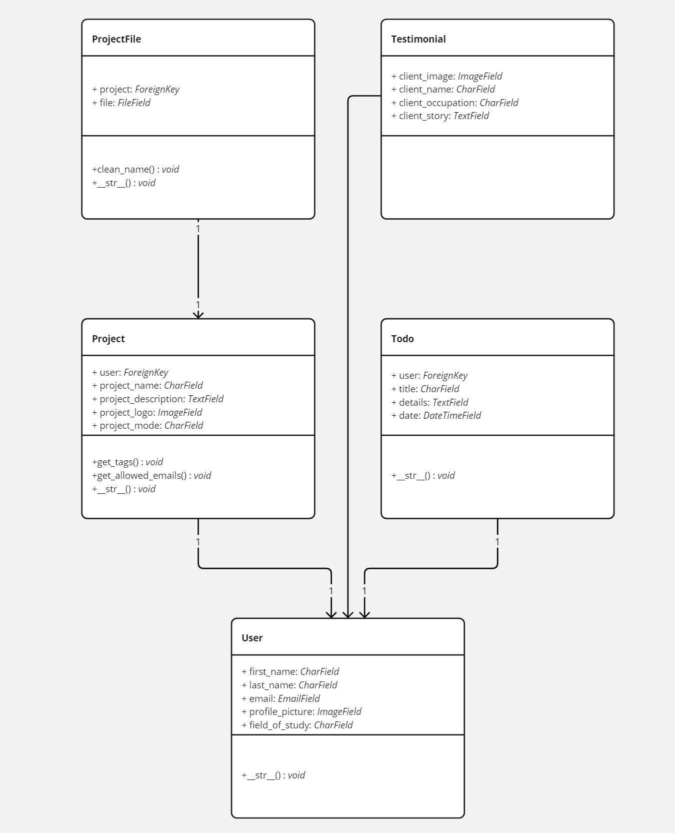

**Figure 3:** CLASS Diagram.

* **Data Flow Diagram (DFD):** Shows the movement of data within the system, ensuring that user requests and database transactions are managed efficiently.

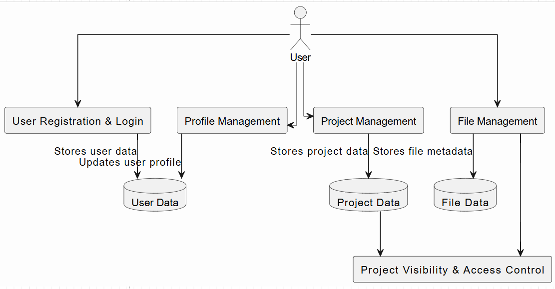

**Figure 4:** DATA FLOW Diagram.

Through these models, ResearchNest ensures a well-structured, scalable, and secure system architecture that meets the needs of academic researchers.

1. **RESULTS AND DISCUSSION**

ResearchNest has demonstrated significant improvements in secure data management for academic researchers. The following benefits were observed:

* **Enhanced Data Security:** Encryption protocols and access controls safeguard sensitive research data.
* **Streamlined Research Collaboration:** The platform allows controlled sharing and multi-user collaboration.
* **Efficient Data Organization:** Tagging, metadata management, and structured storage enhance research efficiency.

Additionally, the user-friendly interface facilitates quick adoption among researchers, enabling them to focus on innovation rather than data security concerns.

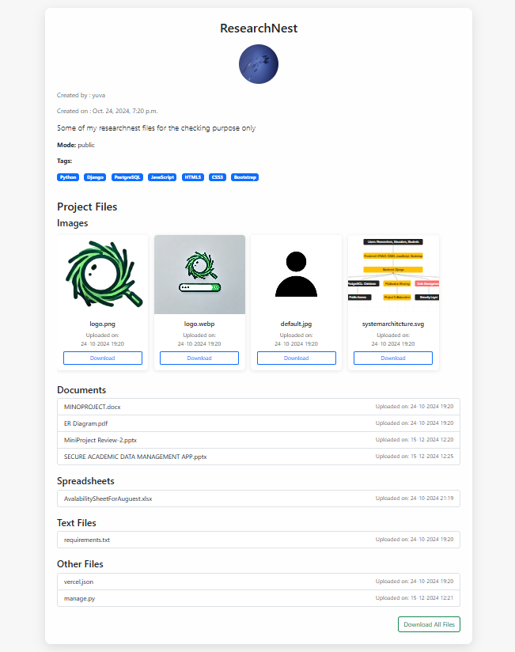

**Figure 1:** Data Organization.

1. **CONCLUSION**

ResearchNest addresses the critical need for secure and efficient academic data management. By integrating encryption, access control mechanisms, and seamless collaboration features, the application ensures data integrity and promotes knowledge sharing. Future enhancements will focus on AI-driven data recommendations and integration with global research repositories.

1. **REFERENCES**
2. Christine L. Borgman, "The Conundrum of Sharing Research Data," *Journal of the American Society for Information Science and Technology*, 2012.
3. Leonardo Candela & Pasquale Pagano, "Virtual Research Environments: An Overview and a Research Agenda," *Data Science Journal*, 2013.
4. Jonathan P. Tennant, "The Academic, Economic, and Societal Impacts of Open Access," *F1000Research*, 2016.
5. Andrew M. Cox & Stephen Pinfield, "Research Data Management and Libraries," *Journal of Librarianship and Information Science*, 2014.