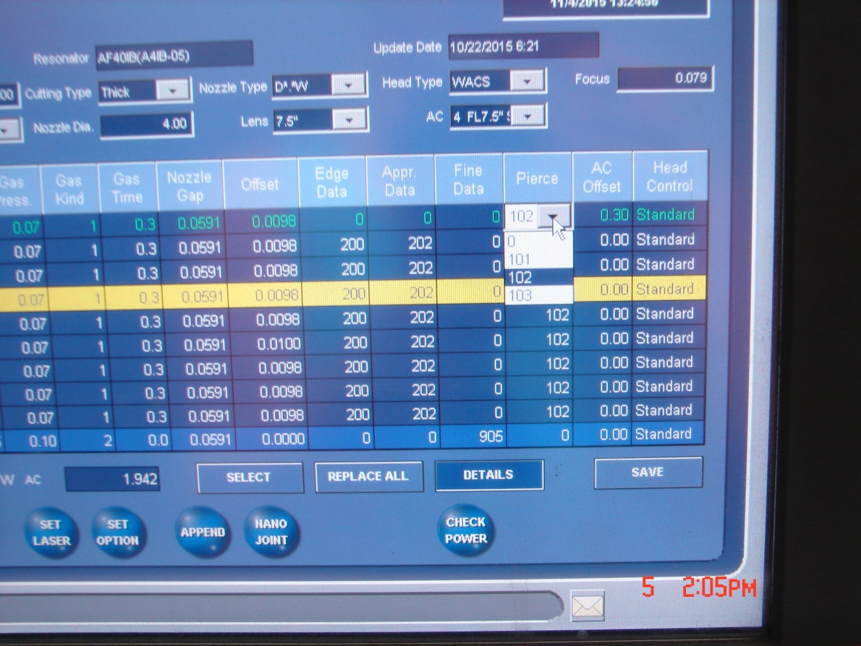

1

1. Open the pull down menu in the cut page and select 103.

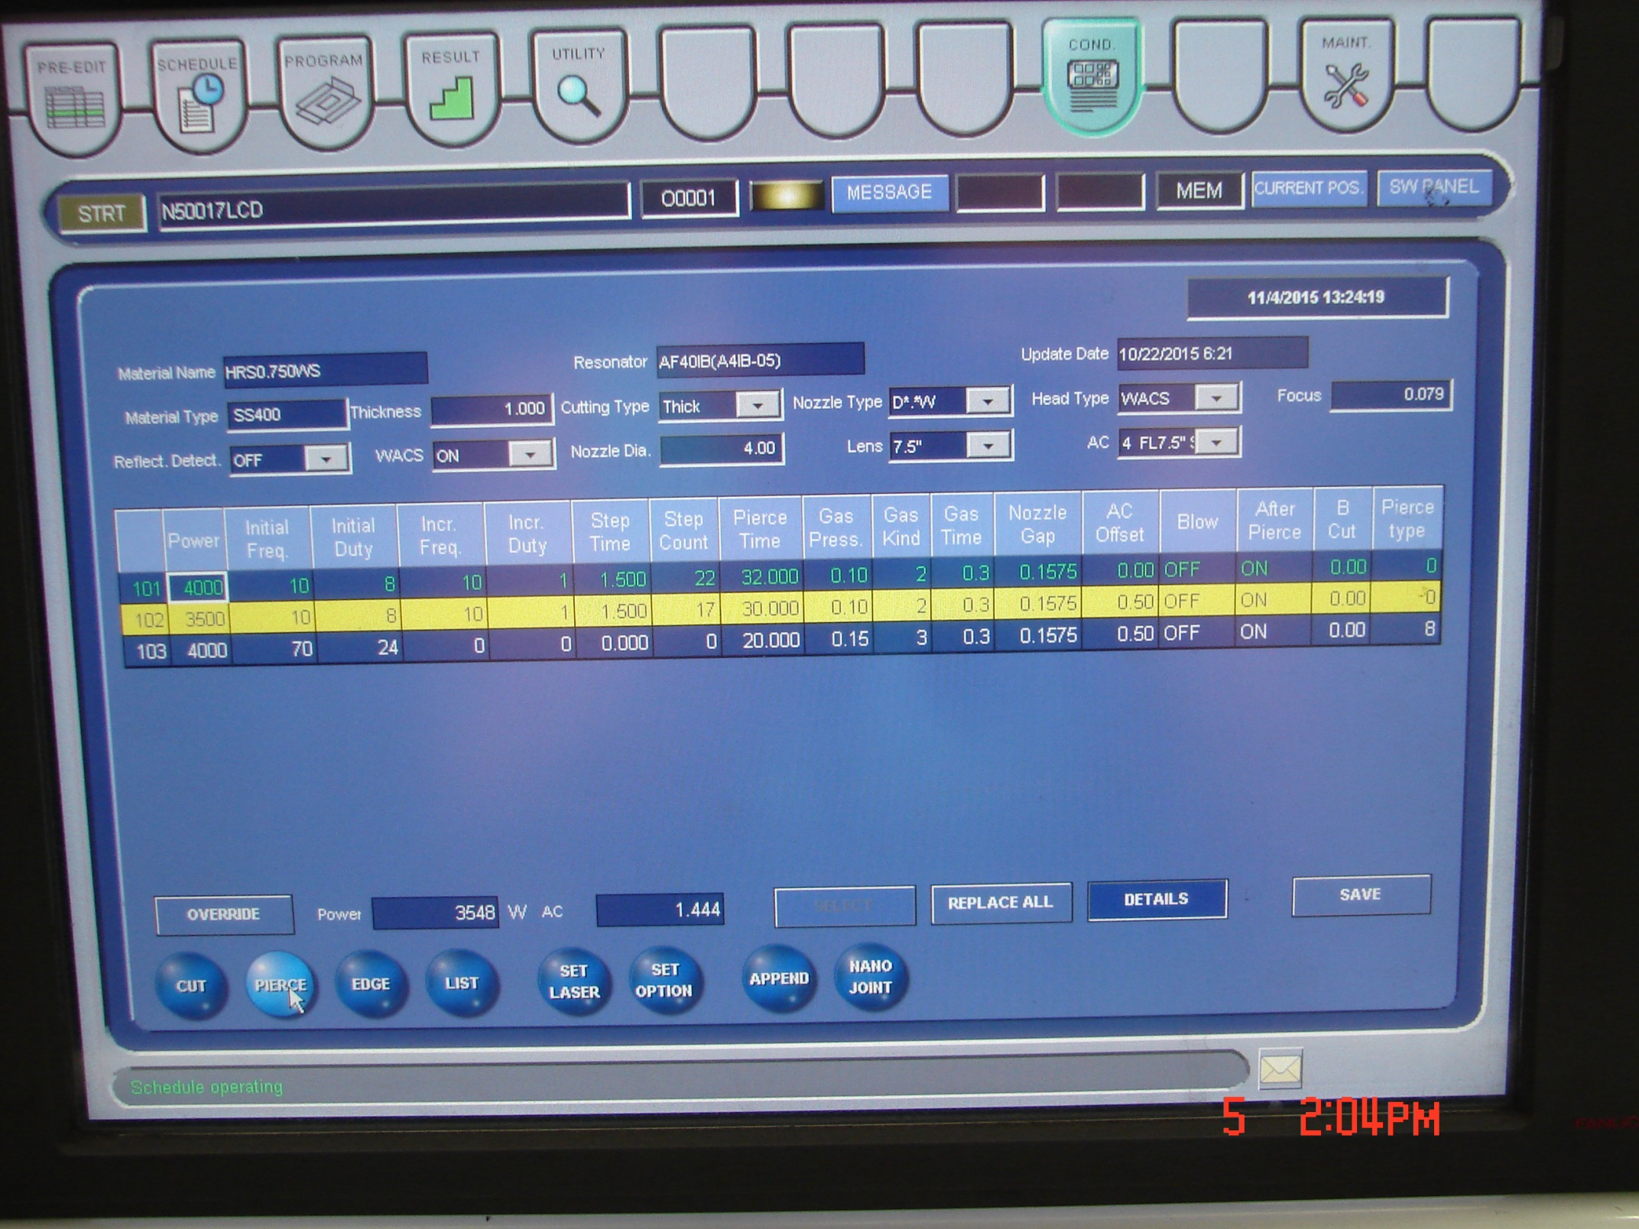

101

102

103

1. These are the pierce conditions that get use when you set the pierce type from the cut page. Set the cut page to 101 and it will pierce with the top condition (101) use 103 for stainless. Power 2000, Freq 100, Duty 2000