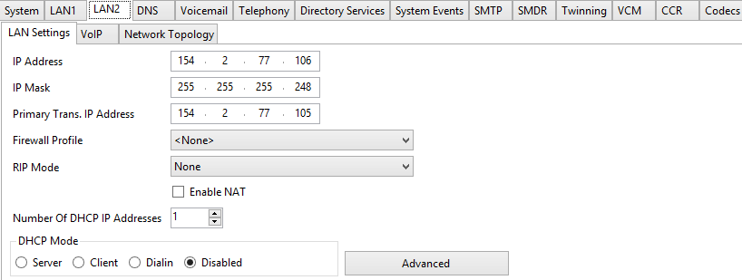

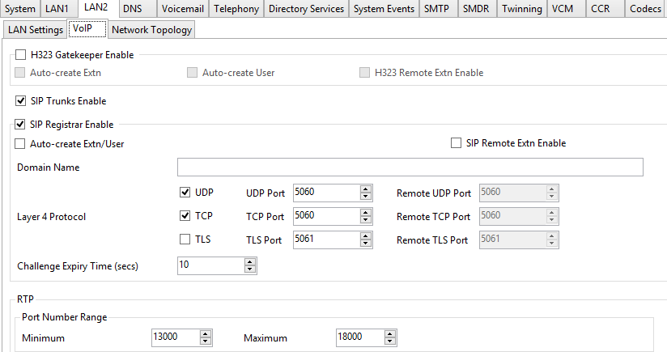

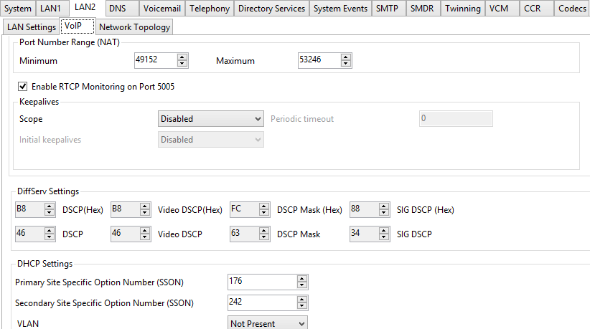

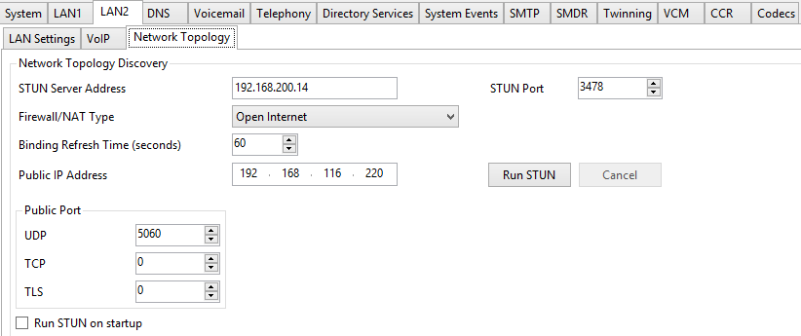

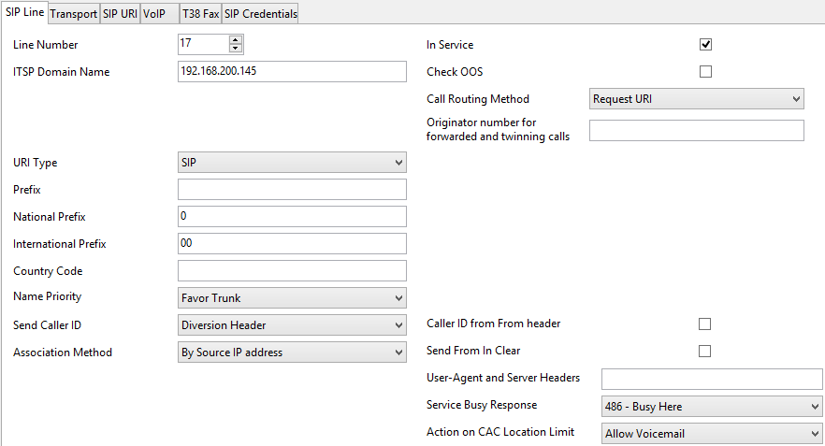

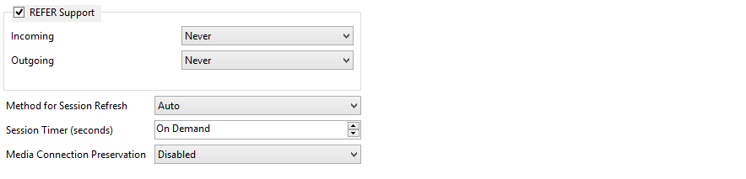

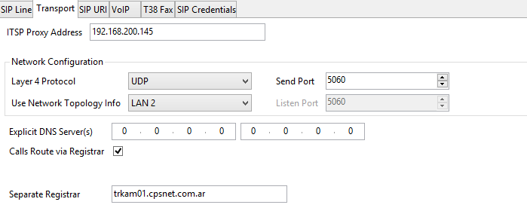

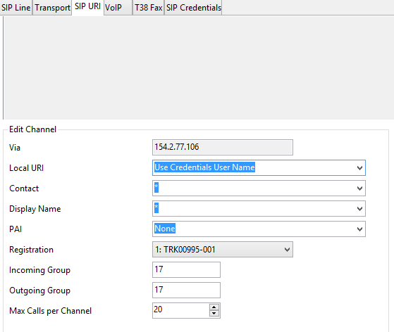

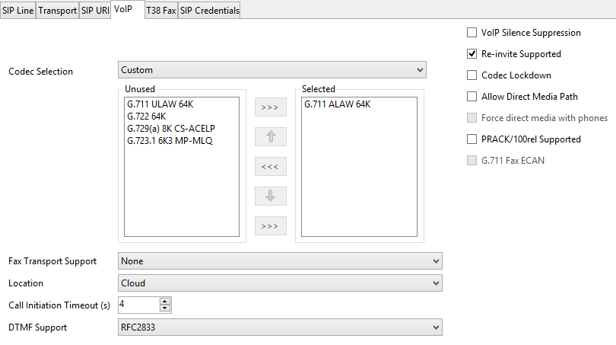

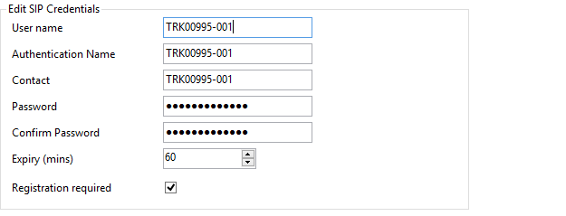

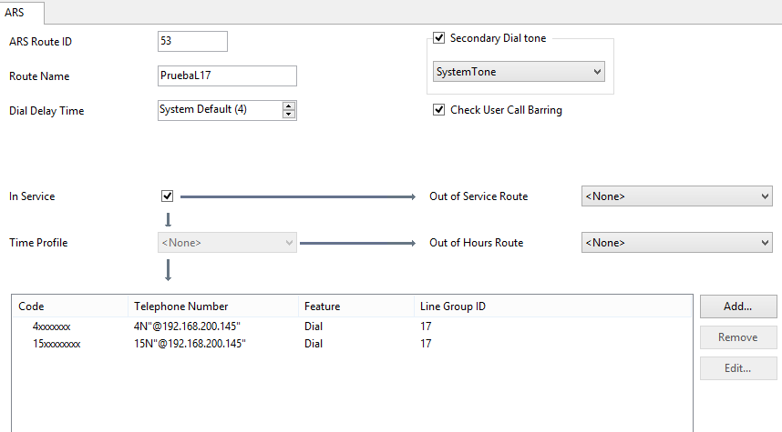

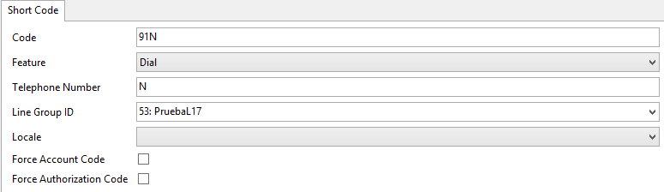

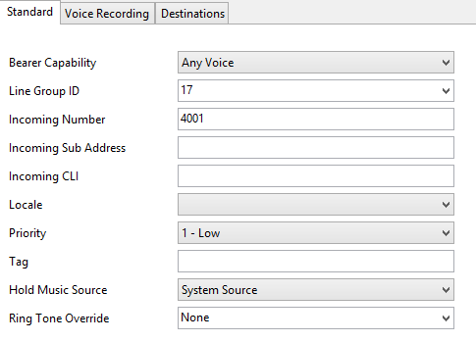

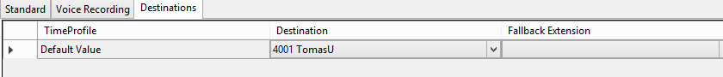

**Trace outgoing call (OK)**

INVITE sip:45454545@192.168.200.145 SIP/2.0

Via: SIP/2.0/UDP 154.2.77.106:5060;rport;branch=z9hG4bK7e351191c9dba6ba0fc05ebe7384e9d4

From: "4038" <sip:TRK00995-001@192.168.200.145>;tag=c6eec60550a7292f

To: <sip: 45454545@192.168.200.145>

Call-ID: f0beb735eb98ec48c90645fe107acea9

CSeq: 1229789745 INVITE

Contact: "4038" <sip:7008@154.2.77.106:5060;transport=udp>

Proxy-Authorization: Digest username="TRK00995-001",realm="voip.cps.com.ar",nonce="V+b/n1fm/nN74jSsfl9YqZC+SIYWcwpr",response="9aa374405984191f1ade3f78ddbbea78",uri="sip: 45454545@192.168.200.145"

Max-Forwards: 70

Allow: INVITE,ACK,CANCEL,OPTIONS,BYE,INFO,NOTIFY,UPDATE

Content-Type: application/sdp

Supported: timer

User-Agent: IP Office 9.0.7.0 build 983

Content-Length: 204

v=0

o=UserA 1367299934 2973522557 IN IP4 154.2.77.106

s=Session SDP

c=IN IP4 154.2.77.106

t=0 0

m=audio 13000 RTP/AVP 8 101

a=rtpmap:8 PCMA/8000

a=rtpmap:101 telephone-event/8000

a=fmtp:101 0-15

**Trace incoming call (Fail)**

24/09/16 19:31:27-286ms Line = 17, Channel = 1, SIP Message = Response, Direction = From Switch, From = TRK00995-001@192.168.200.150, To = 12224038@192.168.200.154, Response = 100 Trying

24/09/16 19:31:27-289ms Line = 17, Channel = 1, SIP Message = Response, Direction = From Switch, From = TRK00995-001@192.168.200.150, To = 12224038@192.168.200.154, Response = 404 Not Found

24/09/16 19:31:27-296ms Line = 17, Channel = 1, SIP Message = Ack, Direction = To Switch, From = TRK00995-001@192.168.200.150, To = 12224038@192.168.200.154