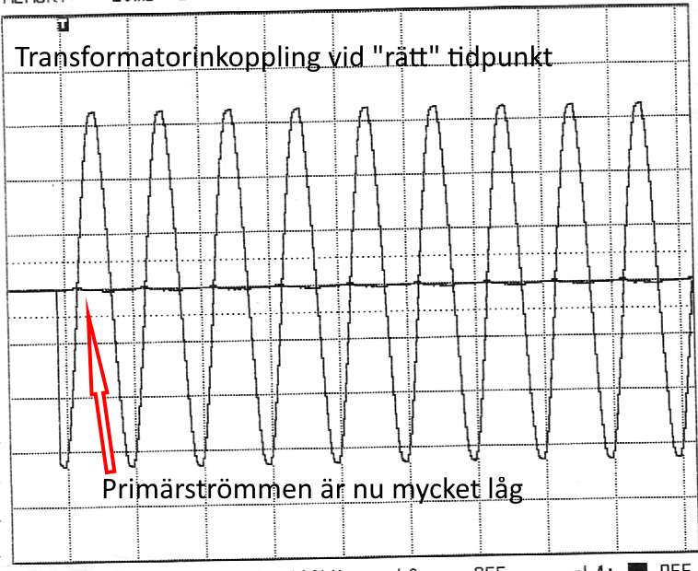 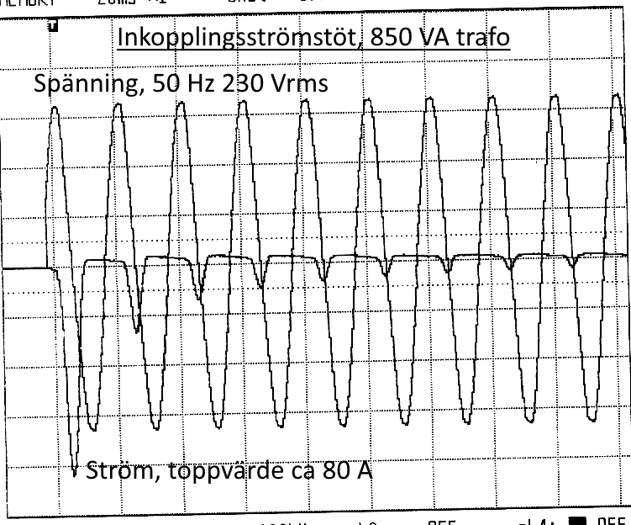

Small transformer, 850 VA, 230 V. Connection at maximum voltage (ca -90 degrees) and at zero volts (at zero degrees). Rated current is close to 4 A and peak inrush is >80 A. So, inrush factor is around 20. Not caring about difference between RMS and peak amps.

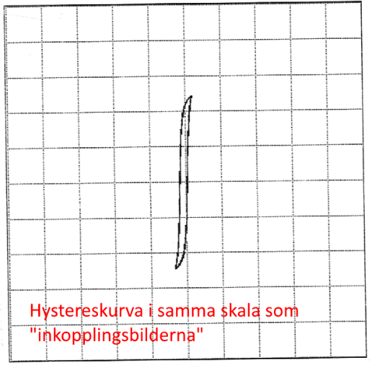 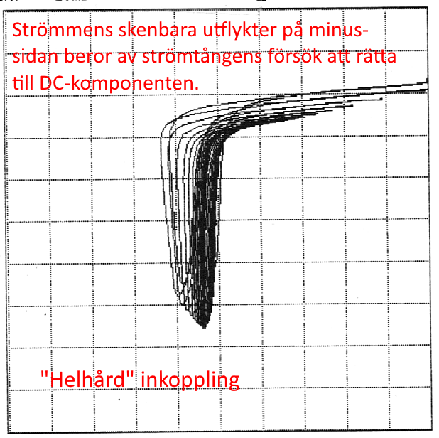

Corresponding H (x) and B (y). Nice “narrow” hysteresis curve when switching near voltage peak and not-so-nice when switching at zero volts.

This curve also shows that a DC clamp should be used in order to correctly capture the DC component. The clamp used is an AC one and its inability to handle the DC component shows in second picture where the current (x) gradually offsets so the left. This may be a problem in some (older) protection that do not “know” how to handle the even hermonics.

For good measure, here are also what switch-off looks like when a capacitor is connected in parallel so the switch-off transient is converted to a ringing waveform that demagnetizes the core.

