User:admin passw:administrator 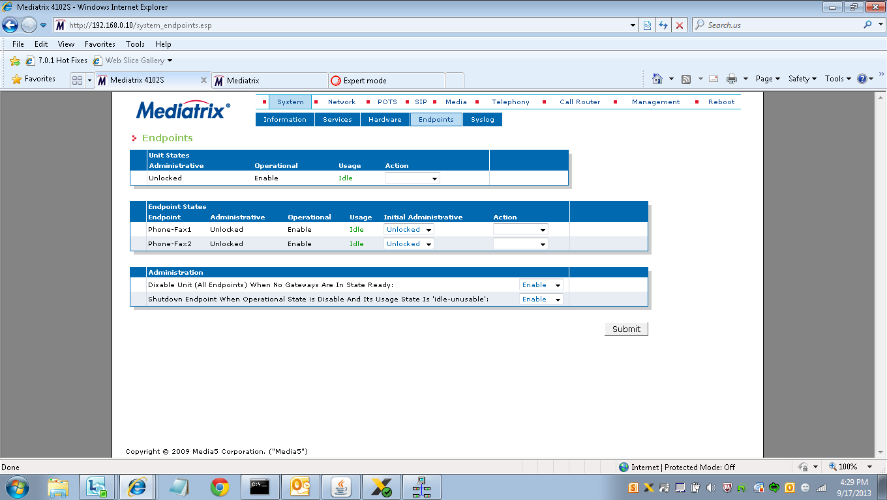

System>endpoints (go to action unlocked ) default LAN-IPAddress 192.168.0.10 WAN 192.168.0.1

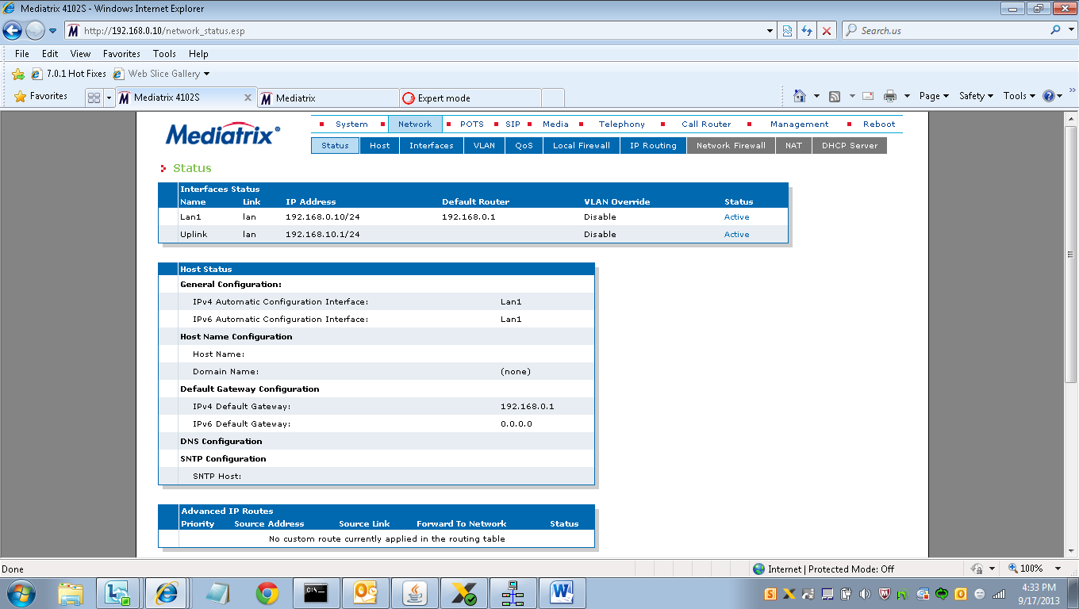

Network>Status Active

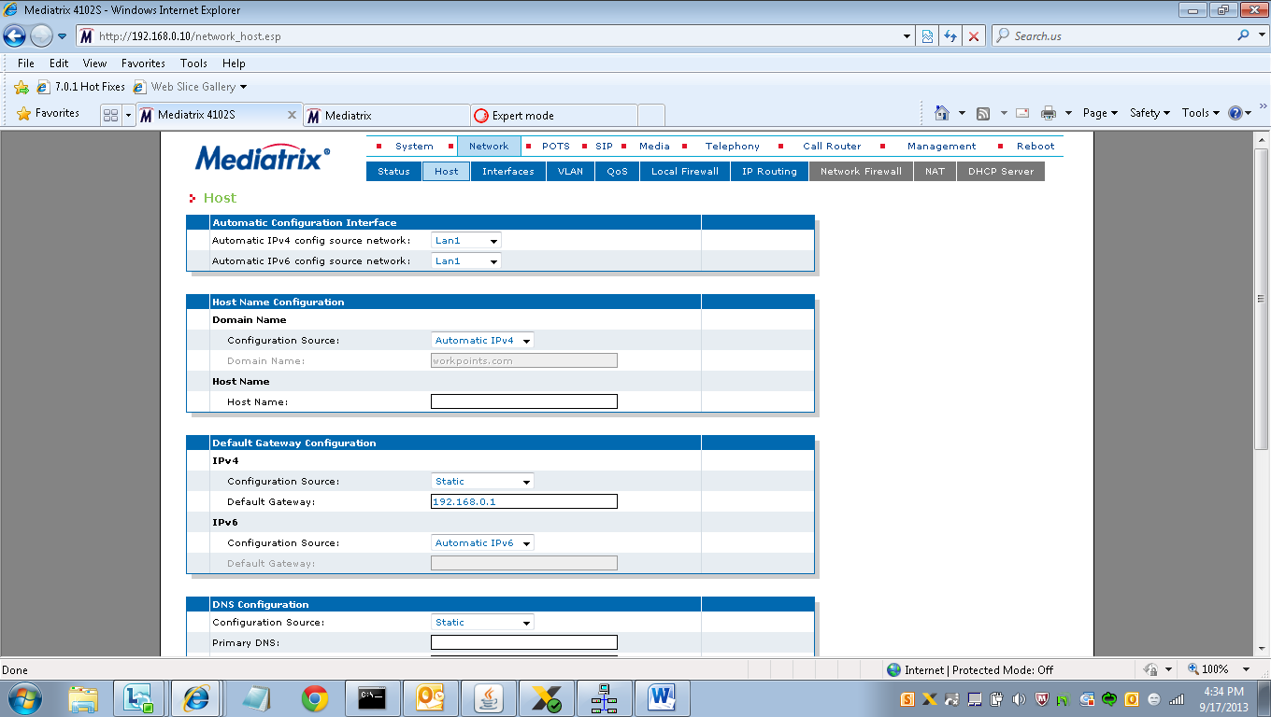

Network>Host (IPv4 Static, 192.168.0.1 default gateway)

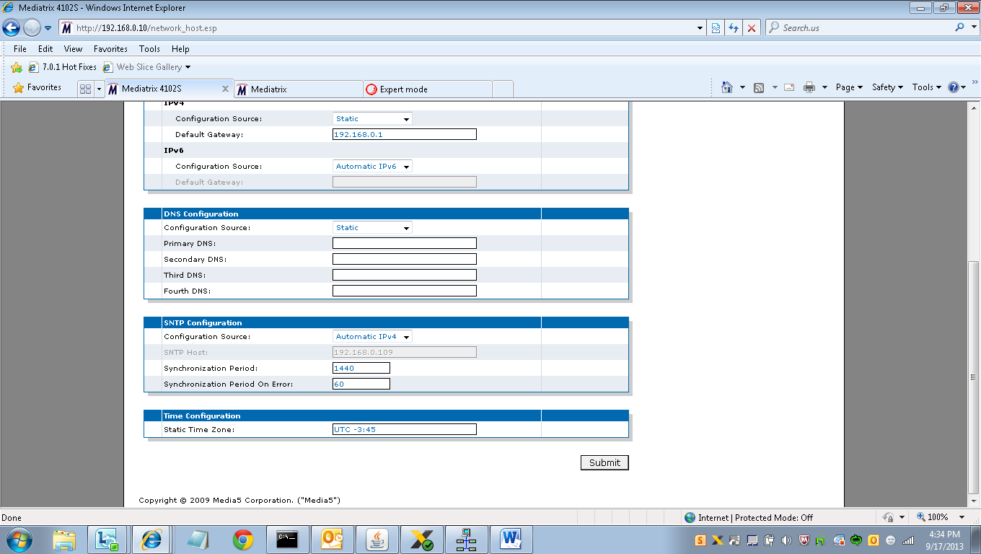

Network>Host>SNTP and Time Zone (UTC-3:45)

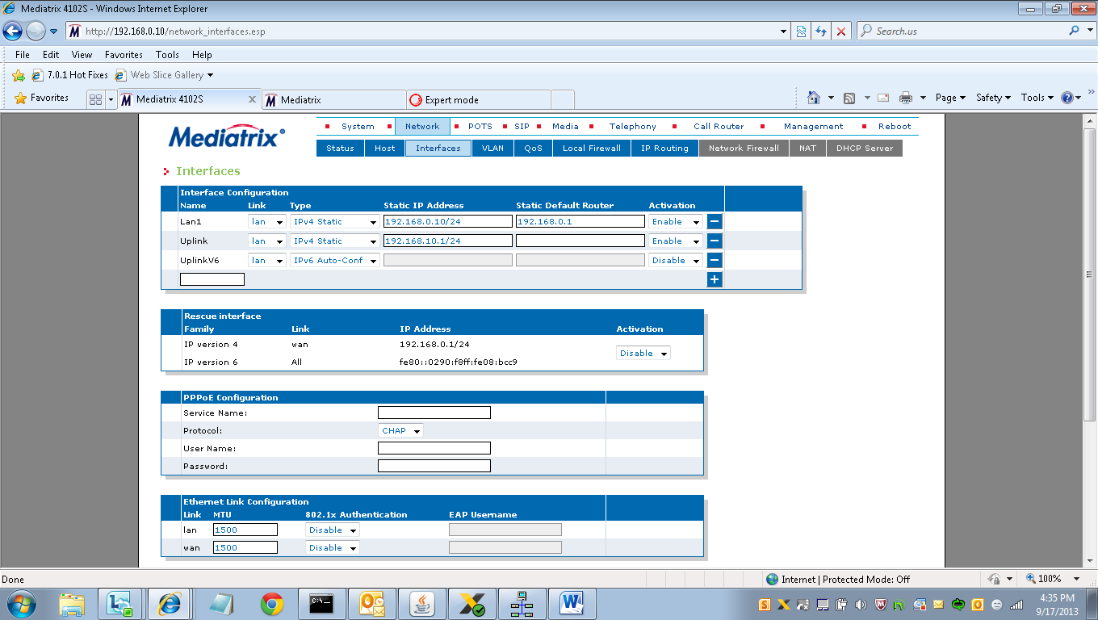

Network>Interfaces Lan1-192.168.0.10/24, router 192.168.0.1

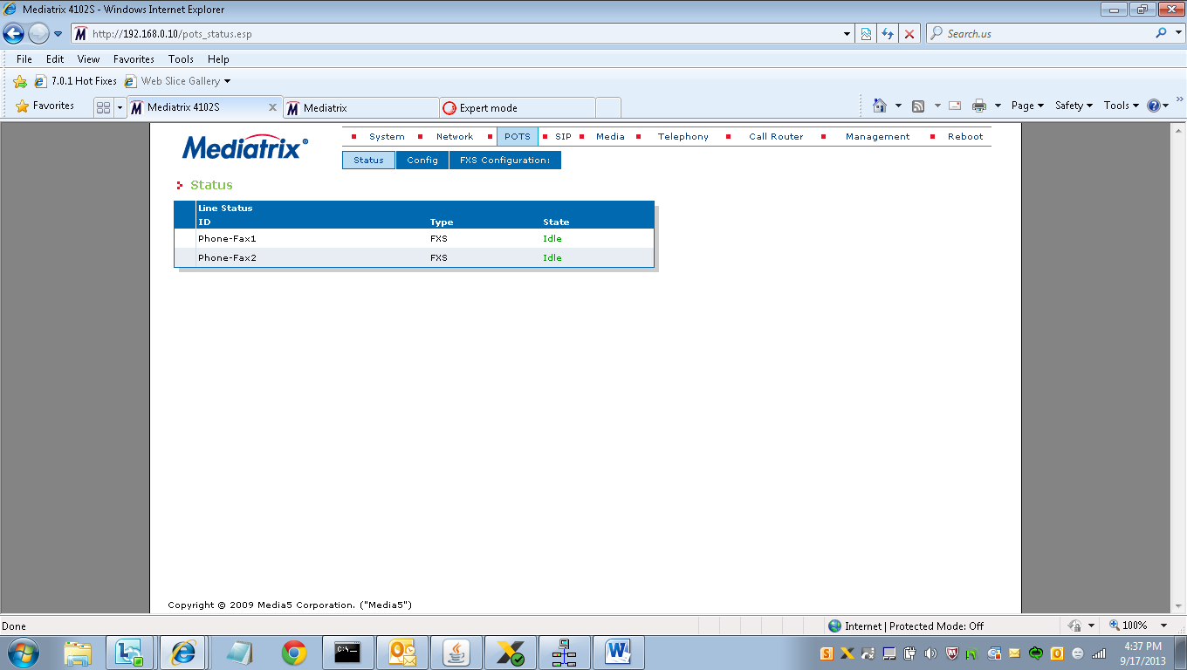

POTS>Status “idle”

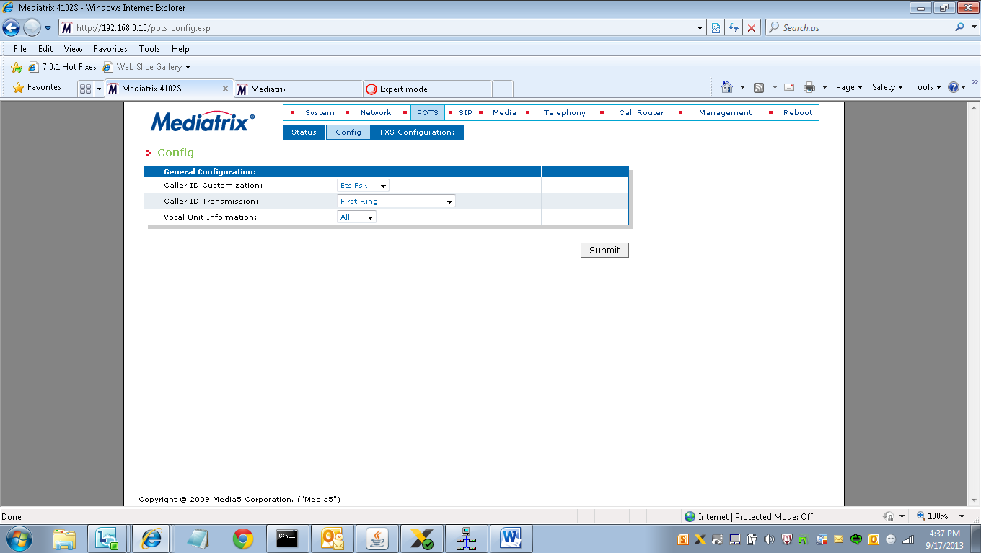

POTS>Config

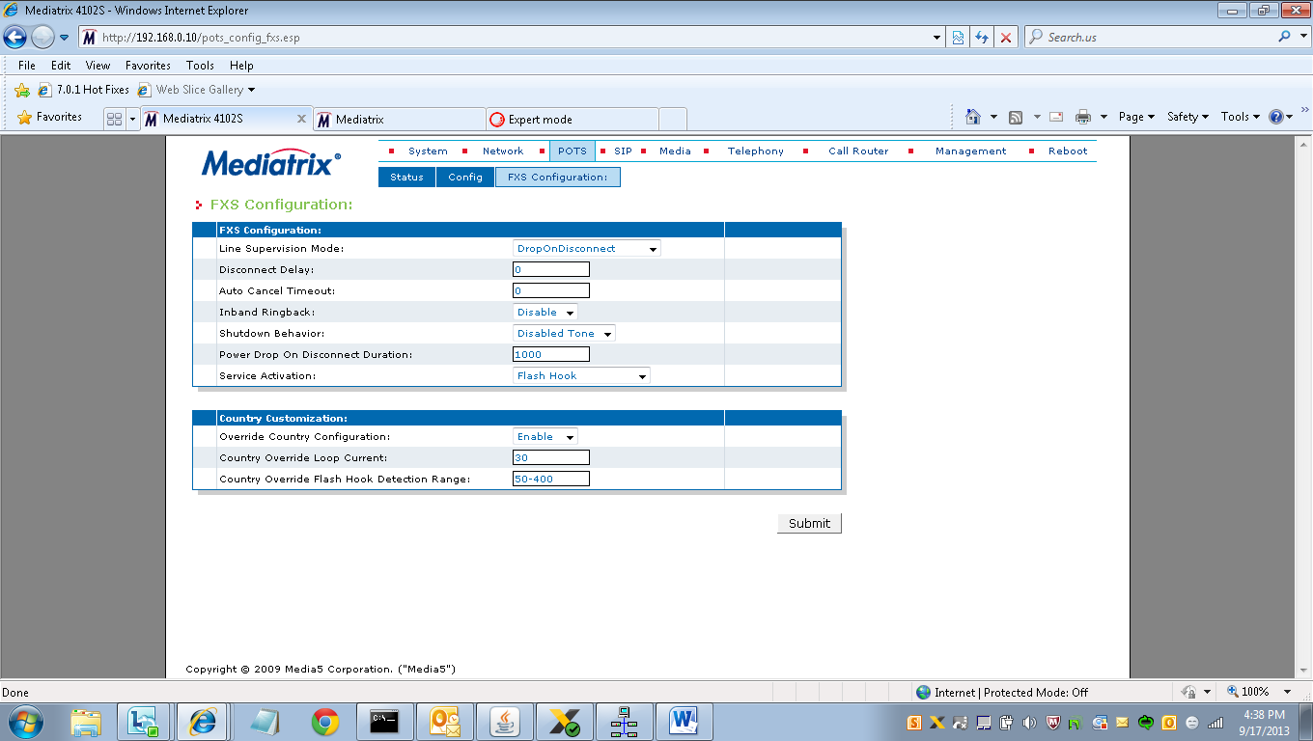

POTS>FXS Config(refer to above config and change it accordingly)

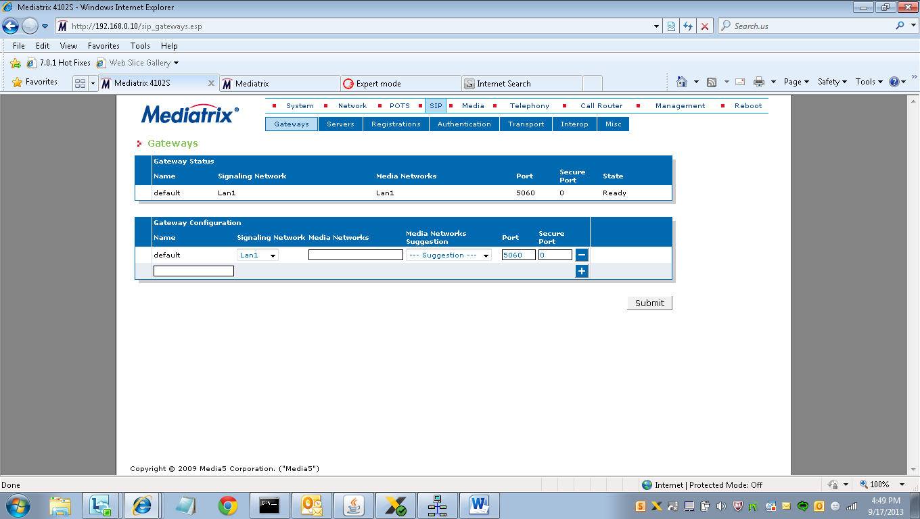

SIP>Gateway>Status Port=5060 Secure Port=0

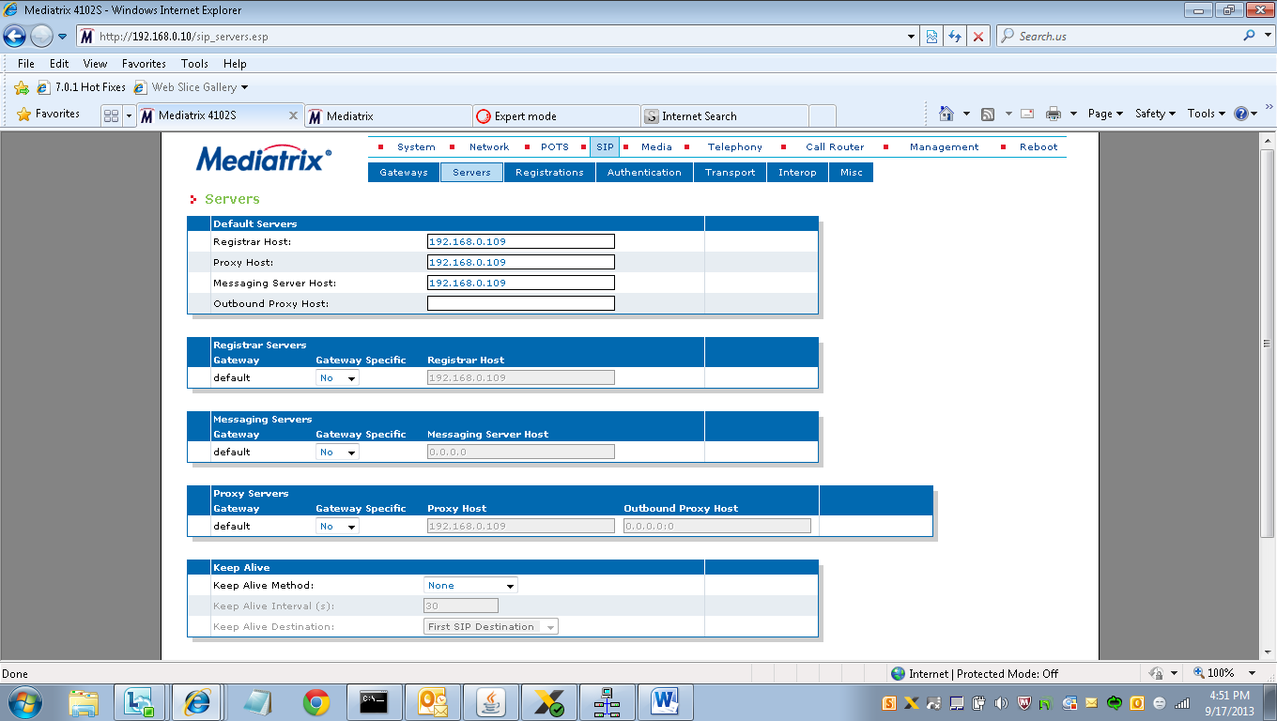

SIP>Servers OSO or SIP Proxy Provider IPaddress

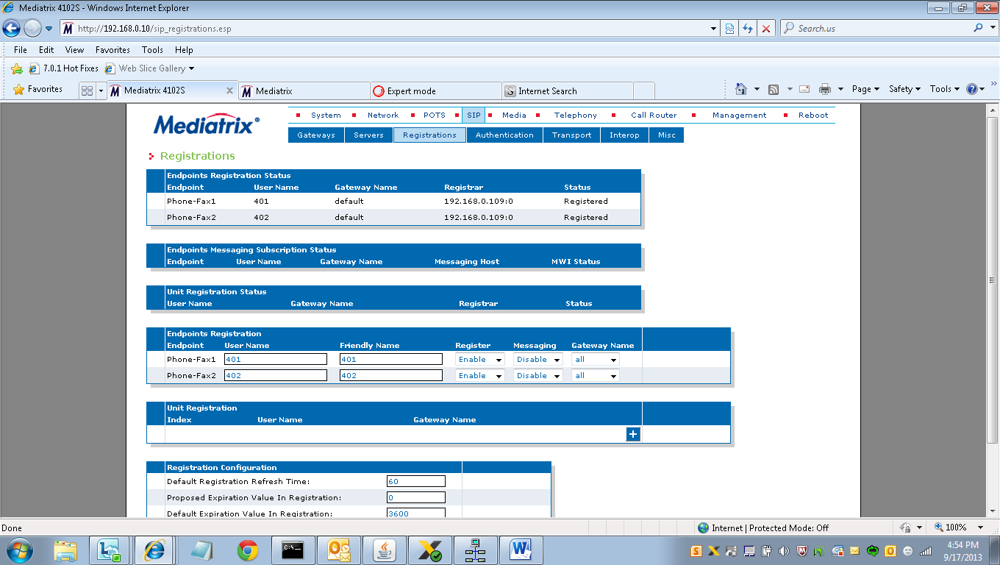

SIP>Registrations

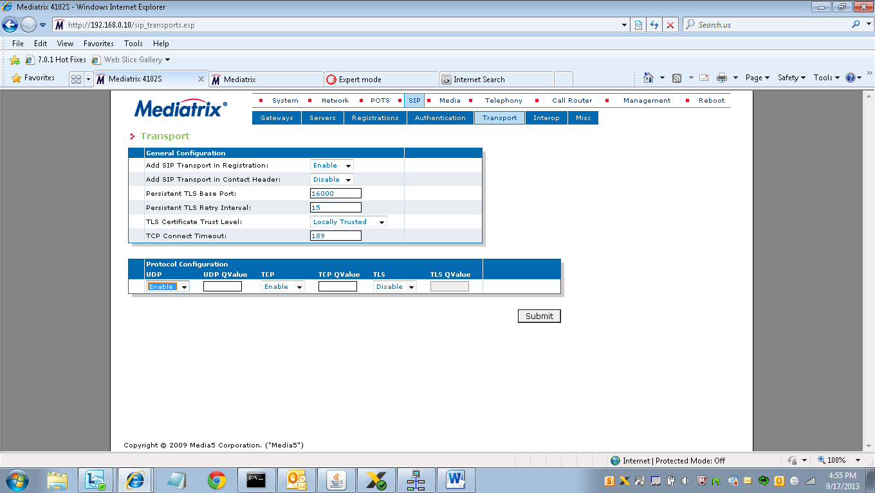

SIP>Transport