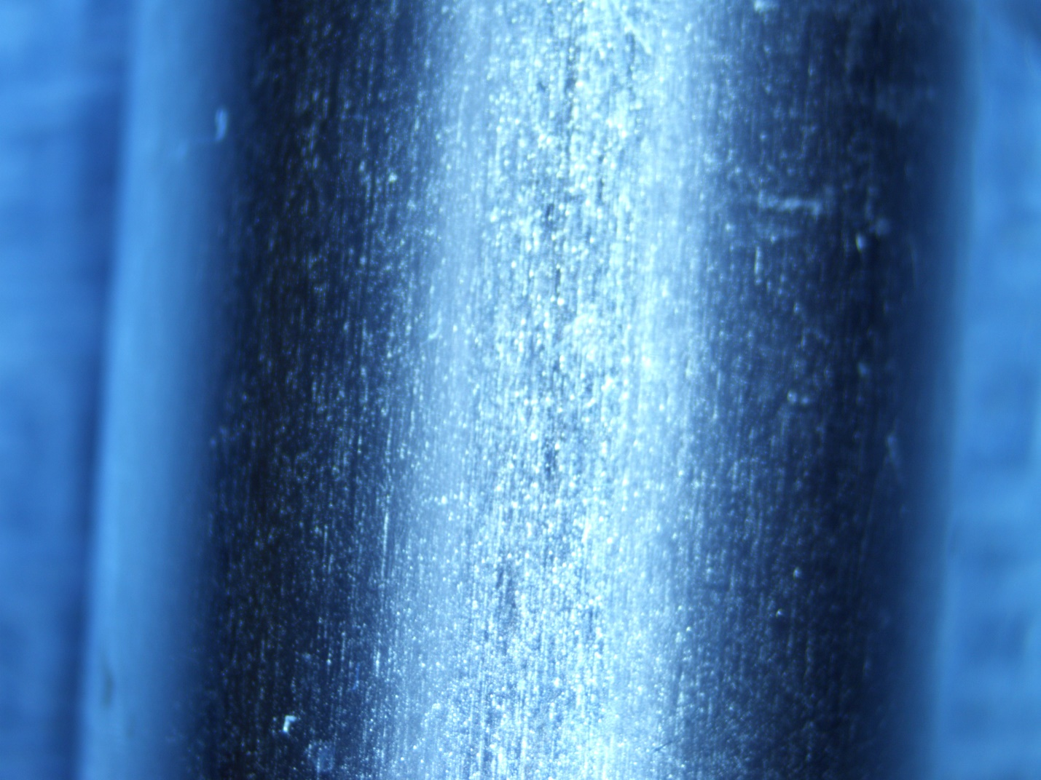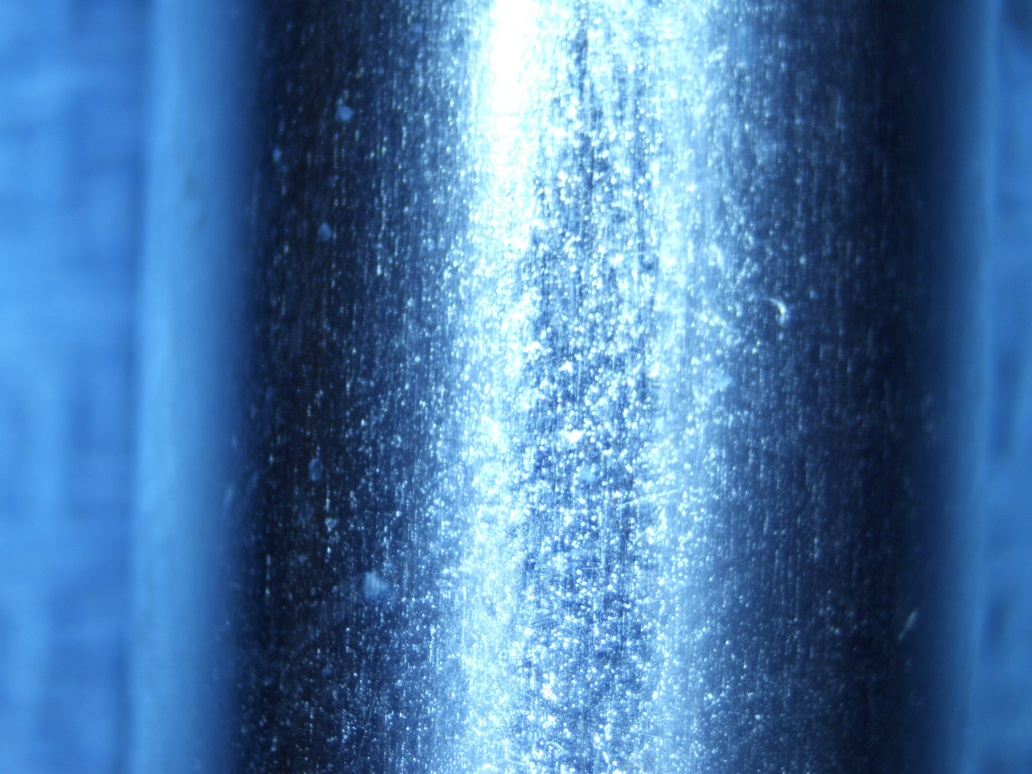

**PISTON “A”**

**SURFACE FINISH MEASURED TO BE 6.98 µin**

**PISTON “A”**

**SURFACE FINISH MEASURED TO BE 6.98 µin**

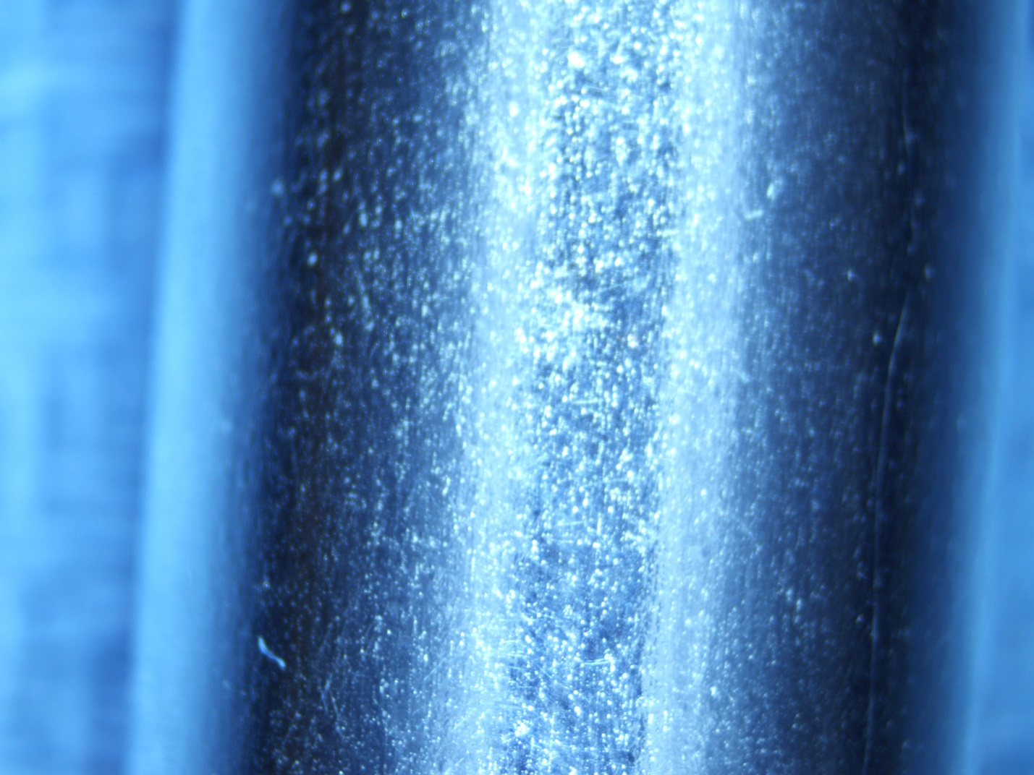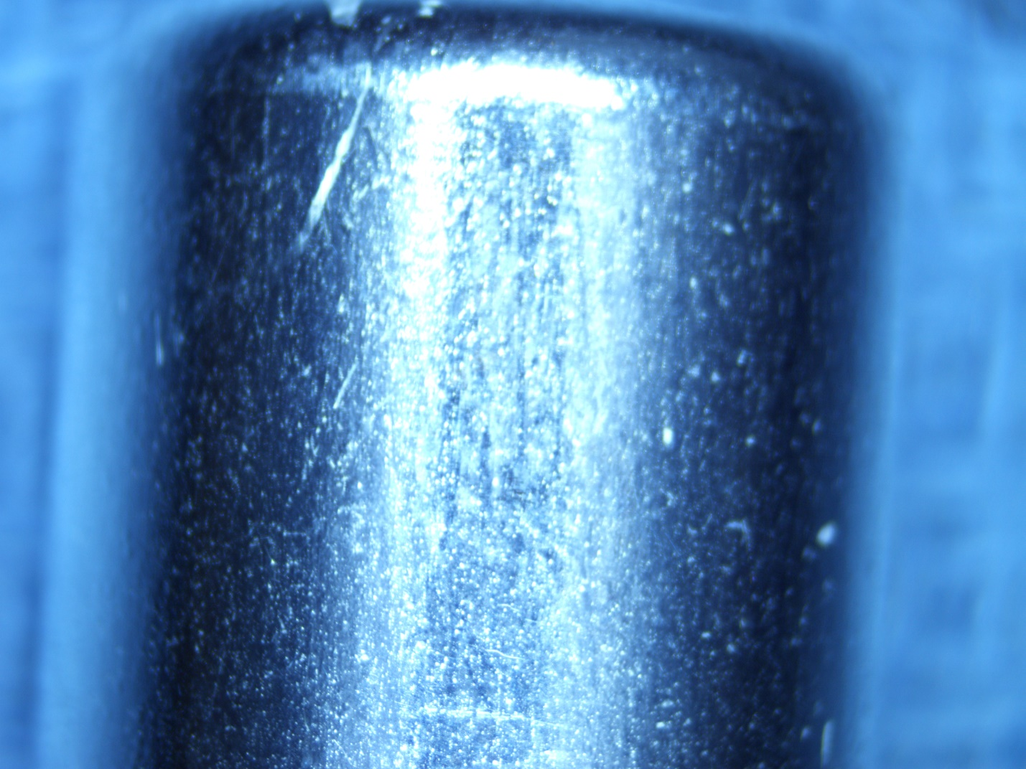

**PISTON “B”**

**SURFACE FINISH MEASURED TO BE 12.13 µin**

**PISTON “B”**

**SURFACE FINISH MEASURED TO BE 12.13 µin**