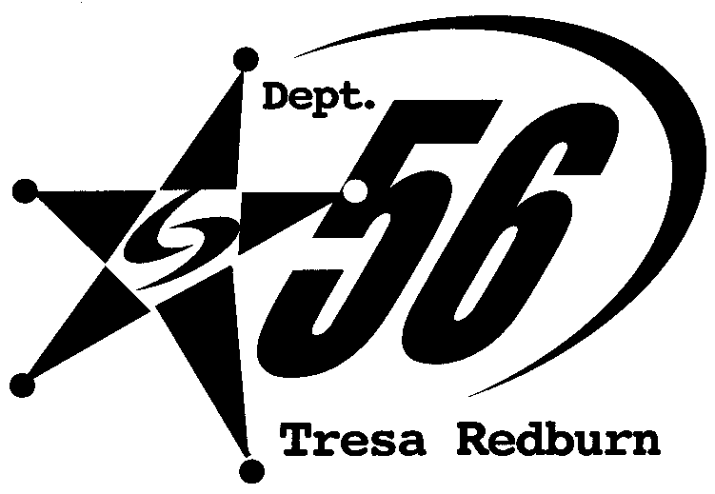

DATE: APRIL 15, 2010

BETTYE LaVETTE
TO DEBUT ENTIRE NEW CD LIVE
AT HIGHLINE BALLROOM 5/26;
DAY AFTER RELEASE OF
‘INTERPRETATIONS: THE BRITISH SONGBOOK’

LETTERMAN BOOKED FOR JUNE 23

In conjunction with BETTYE LaVETTE’s highly anticipated release of INTERPRETATIONS: THE BRITISH SONGBOOK on May 25, she will perform the following evening on May 26 at the Highline Ballroom in New York City. For this special night, BETTYE will present the new album live in its entirety from start to finish. Other dates of note coming up for BETTYE include the Doheny Blues Festival in Dana Point, CA on May 23, Richard Thompson’s Meltdown Festival in London on June 17 and a performance on the LATE NIGHT WITH DAVID LETTERMAN on Wednesday, June 23.

INTERPRETATIONS was produced by Grammy-nominee BETTYE, Rob Mathes and Michael Stevens and is a 12-song journey through compositions by the Beatles, Rolling Stones, Led Zeppelin, Traffic and Pink Floyd, among others, before concluding right where the very idea for the new album started: Bettye’s visceral show-stopping rendition of The Who’s “Love Reign O’er Me” from the 2008 Kennedy Center Honors, which appears here as an extended bonus track.

Meanwhile, advance praise from the artist world keep coming in:

Bettye LaVette is a huge influence on the world of R&B. I’ve followed her since “Let Me Down Easy” in the mid ’60s. She is blessed with an instantly recognizable voice full of power and emotion. At this point in her long and illustrious career I’m honored and very happy to hear her version of “No Time To Live.”
-Steve Winwood

Stay tuned for the latest news about BETTYE LaVETTE at www.bettyelavette.com and www.anti.com.

