ALFA MIST
LONDON-BASED MULTI-HYPHENATE SHARES NEW SINGLE
“AGED EYES” FT. KAYA THOMAS-DYKE - LISTEN / WATCH HERE

HEADLINE U.S. TOUR KICKS OFF APRIL 27TH

Photo credit: Kay Ibrahim / download here

Alfa Mist returns today with the soul-inflected new song “Aged Eyes,” the latest single from Variables, his new album out April 21st via ANTI-. The track features bass and vocals from his longtime collaborator, Kaya Thomas-Dyke, and follows the release of recent singles “4th Feb (Stay Awake)” and “BC.” Throughout “Aged Eyes,” Alfa Mist leads the way on keys while Thomas-Dyke blends her gossamer vocal over a finger-picking guitar melody to swell into a strings-laden, cinematic chorus. The moving song about a yearning hope, draped in memorably emotive piano melodies and intuitive grooves also features Jamie Leeming (guitar), Avishai Rozen (drums), Peggy Nolan (cello), and Junior Alli-Balogun (percussion).

LISTEN & SHARE “AGED EYES”
>>https://youtu.be/PvQStSZIiD4<<

The London-based multi-hyphenate is also set to return to the road for dates in the UK, EU and United States this spring, and follows his sold out 2022 tour. He’s also announced a slew of new shows through this fall. See dates below. Alfa’s live presence is packed with urgent energy and speaks of his restless creativity – a driving force that has enabled his remarkable work-ethic to date.

Alfa is yet to be boxed into a specific genre as his music spans everything from hip-hop beat-making to producing for artists such as rapper Loyle Carner, composing neo-classical works for the London Contemporary Orchestra, and reworking tracks from composer Ólafur Arnalds and pioneering jazz label Blue Note. Since the release of his first full-length project Nocturne in 2015, Alfa has established himself as one of the UK’s most focused and distinct musical voices, and he has worked with the likes of Jordan Rakei and Tom Misch, drummer Richard Spaven, producer Lester Duval and singer Emmavie.

Building on the success of 2017’s debut album, Antiphon, which has amassed over 10 million views on YouTube, 2019’s Structuralism and 2021’s debut for ANTI-, Bring Backs, Variables now finds Alfa moving forwards with renewed intensity and purpose. “The whole album is more uptempo and influenced by the freedom of returning to gigs,” Alfa explains. “It feels like I’m coming back to my early days of making grime beats and creating tracks that make me want to bop my head fast.”

In addition to his own music, Alfa currently heads up his own label Sekito, releasing records from Jamie Leeming, trumpeter Jsphynx and bassist Rudi Creswick, with more slated for 2023. He also hosts the Are We Live podcast with Barney Artist and Jordan Rakei.

ALFA MIST TOUR DATES
Mar 03 Hannover, Germany - Pavilion / Großer Saal
Apr 01 Utrecht, Netherlands - Transition Festival
Apr 27 Philadelphia, PA - The Ardmore Music Hall
Apr 29 Brooklyn, NY - Music Hall of Williamsburg
Apr 30 New York, NY - Racket
May 02 Chicago, IL - Thalia Hall
May 04 Los Angeles, CA - Fonda Theatre
May 05 San Francisco, CA - August Hall
May 13 Berlin, Germany - XJAZZ! Festival
May 20 Norfolk, UK - Norfolk & Norwich Festival, Norwich
May 25 - 28 Liège, Belgium - Jazz a Liege Festival
May 28 London, UK - Cross The Tracks Festival
Oct 04 Paris, France - La Cigale
Oct 09 The Hague, Netherlands - Paard Van Stal
Oct 10 Nijmegen, Netherlands - Doornroosje
Oct 11 Groningen, Netherlands - Spot
Oct 27 Budapest, Hungary - House of Music
Oct 28 Prague, Czech Republic - Mladi Ladi Jazz Festival
Nov 16 Dublin, Ireland - Opium Rooms
Nov 18 Glasgow, UK - BAaD
Nov 19 Manchester, UK - RNCM Concert Hall
Nov 20 Bristol, UK - Trinity
Nov 22 London, UK - Outernet

Ticket Available Here: https://alfamist.co.uk/live

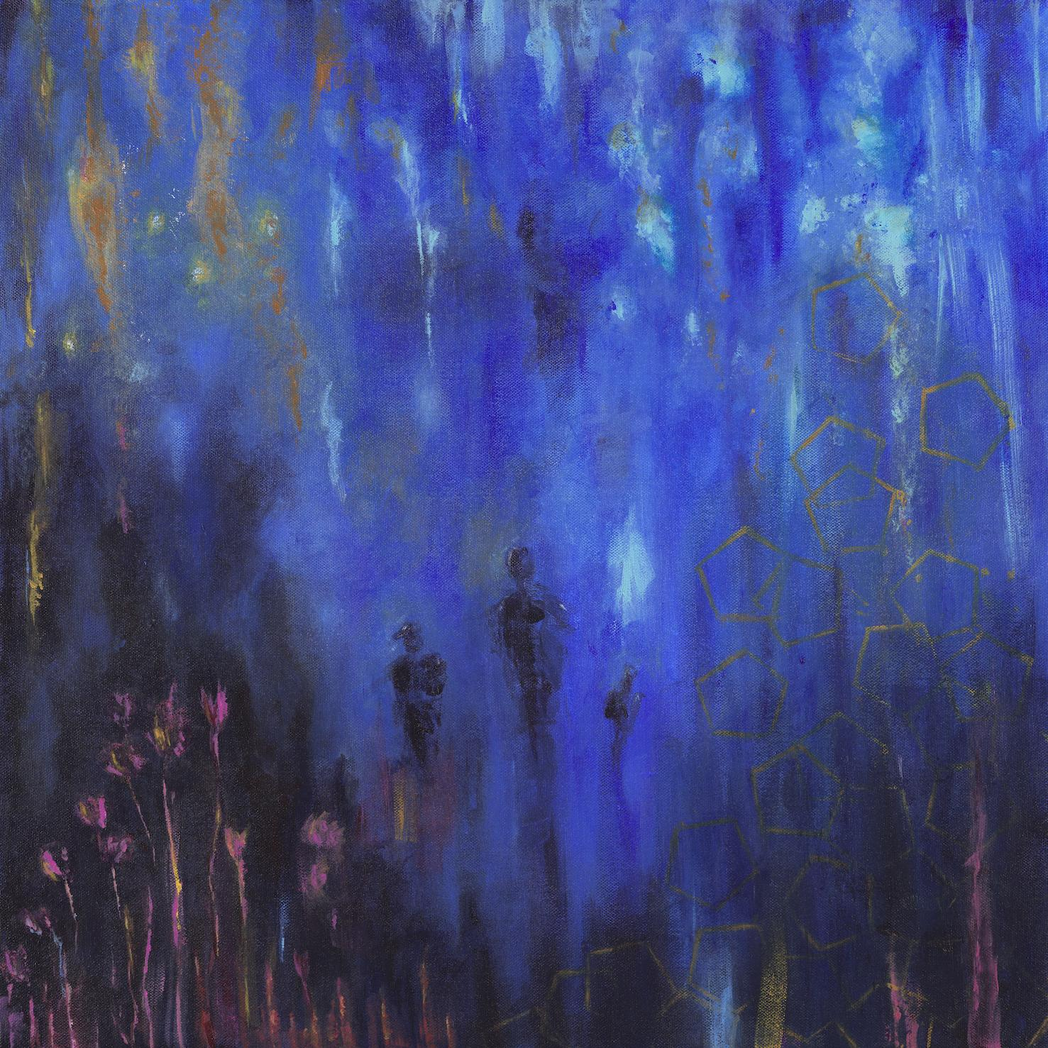
‘Variables’ artwork by Kaya Thomas-Dyke / download here

Follow Alfa Mist
Twitter // Instagram // Spotify

