February 13, 2020
For Immediate Release

Watch Andy Shauf Perform on Jimmy Kimmel Live!

North American Tour In Support of The Neon Skyline Continues
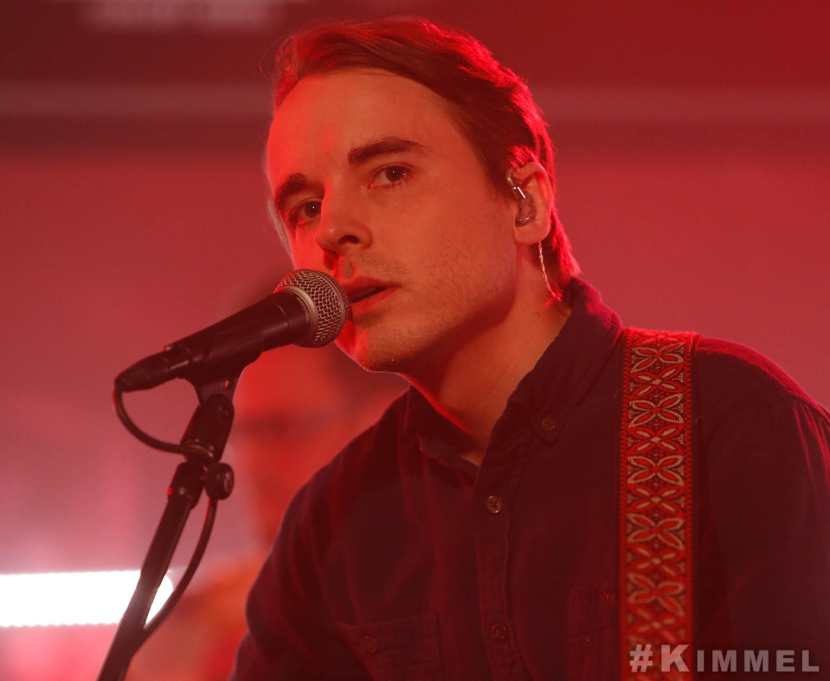

“The Neon Skyline unfolds into a wistful, funny, and heartbreaking world of its own.”
- Pitchfork

"Lonely guy singer-songwriters ranging from Paul Simon to Harry Nilsson [are] Shauf’s predecessors, but for most listeners in 2020, I think [Andy Shauf is] going to come across as something utterly new.” - Fresh Air

“A gifted singer-songwriter. More than that, a gifted storyteller.” - NPR Music

“The closer you pay attention to the breezy facade, the deeper you’re drawn into [Andy Shauf’s] vignette.” - Stereogum, Album of the Week

Andy Shauf’s new album, The Neon Skyline, has been garnering a slew of praise from critics and fans since its release on ANTI- last month. Last night, Shauf made his Jimmy Kimmel Live! debut in support of the release. He performed the “joyful and a tad flirtatious” (Cool Hunting) “Try Again”, as well as “Neon Skyline” as a web exclusive. Onstage, he was joined by Karen Ng (clarinet), Daniel Pencer (clarinet), Colin Nealis (keys), Joshua Daignault (bass), Chris Bezant (guitar), and Phil Melanson (drums). This is Shauf’s first late-night appearance in support of The Neon Skyline, and his most recent since playing The Late Late Show with James Corden in 2017. Last month, he made his daytime television debut on CBS This Morning: Saturday.

Shauf just kicked off his North American and European four month tour in support of The Neon Skyline. The album debuted at #1 on the Alternative New Artist chart and has amassed over 5 million streams worldwide.

Watch Andy Shauf Perform on Jimmy Kimmel Live!
“Try Again” - https://youtu.be/bVS3d62QN3Q
“Neon Skyline” - https://youtu.be/rcaKzCw9ntQ

Stream/Purchase The Neon Skyline --
https://andyshauf.ffm.to/theneonskyline

Watch/Listen/Share:
“Try Again” Video - https://youtu.be/thiHFeIw_5U
“Things I Do” Stream - https://youtu.be/MF9DjpLsZWM
“Neon Skyline” Video - https://youtu.be/Ao22GlYHBqU
“Living Room” Stream - https://youtu.be/qixF-nQX7WM

Andy Shauf Tour Dates:
Thu. Feb. 13 - Houston, TX @ White Oak Music Hall *
Fri. Feb. 14 - Austin, TX @ Mohawk *
Sat. Feb. 15 - Dallas, TX @ Deep Ellum Art Co. *
Tue. Feb. 18 - Phoenix, AZ @ Crescent Ballroom *
Thu. Feb. 20 - Los Angeles, CA @ Fonda Theater *
Fri. Feb. 21 - San Francisco, CA @ August Hall *
Sat. Feb. 22 - Sacramento, CA @ Harlow’s *
Mon. Feb. 24 - Portland, OR @ Revolution Hall *
Tue. Feb. 25 - Seattle, WA @ Neumos *
Wed. Feb. 26 - Vancouver, BC @ Commodore Ballroom *
Fri. Feb. 28 - Calgary, AB @ Bella Concert Hall *
Sat. Feb. 29 - Edmonton, AB @ The Starlite Room *
Mon. March 2 - Saskatoon, SK @ Broadway Theatre *
Tue. March 3 - Regina, SK @ The Exchange *
Wed. March 4 - Winnipeg, MB @ Park Theatre *
Thu. March 5 - Minneapolis, MN @ Fine Line Music Hall *
Fri. March 6 - Milwaukee, WI @ Colectivo *
Sat. March 7 - Chicago, IL @ Thalia Hall *
Fri. March 13 - Lyon, FR @ Epicerie Moderne *
Sat. March 14 - Bordeaux, FR @ Krakatoa *
Tue. March 17 - Birmingham, UK @ Hare and Hounds *
Wed. March 18 - Glasgow, UK @ Mono *
Thu. March 19 - Manchester, UK @ Gorilla *
Fri. March 20 - Leeds, UK @ Brudenell Social Club *
Sat. March 21 - Bristol, UK @ Fiddlers *
Sun. March 22 - Brighton, UK @ Chalk *
Wed. March 25 - Brussels, BE @ Botanique Orangerie *
Thu. March 26 - Utrecht, NL @ TivoliVredenburg *
Fri. March 27 - Rotterdam, NL @ Rotown *
Sat. March 28 - Nijmegen, NL @ Doornroosje *
Mon. March 30 - Hamburg, DE @ Elbphilharmonie *
Tue. March 31 - Copenhagen, DK @ Loppen *
Wed. April 1 - Stockholm, SE @ Nalen Klubb *
Thu. April 2 - Oslo, NO @ Ingensteds *
Sat. April 4 - Berlin, DE @ Silent Green *
Sun. April 5 - Cologne, DE @ Luxor *
Mon. April 6 - Rouen, FR @ Le 106 *
Tue. April 7 - Paris, FR @ Trianon *
Wed. April 8 - London, UK @ Shepherds Bush Empire *
Thu. April 23 - Toronto, ON @ Danforth Music Hall ^
Fri. April 24 - Toronto, ON @ Danforth Music Hall ^ - SOLD OUT
Sat. April 25 - Montreal, QC @ Corona Theatre ^
Sun. April 26 - Sheffield, MA @ Race Brook Lodge ^
Tue. April 28 - Boston, MA @ Paradise Rock Club ^
Thu. April 30 - Brooklyn, NY @ Warsaw ^
Fri. May 1 - Philadelphia, PA @ Union Transfer ^
Sat. May 2 - Washington, DC @ Black Cat ^
Mon. May 4 - Charlottesville, NC @ The Southern ^
Tue. May 5 - Carrboro, NC @ Cat’s Cradle ^
Wed. May 6 - Asheville, NC @ The Grey Eagle ^
Fri. May 8 - Atlanta, GA @ Terminal West ^
Sat. May 9 - New Orleans, LA @ One Eyed Jacks ^
Sun. May 10 - Birmingham, AL @ Saturn ^
Tue. May 12 - Indianapolis, IN @ Hi-Fi ^
Wed. May 13 - Pittsburgh, PA @ Andy Warhol Museum ^
Fri. May 15 - Asbury Park, NJ @ House of Independents ^
Sat. May 16 - Woodstock, NY @ Colony Cafe ^

*= w/ Molly Sarlé
^ = w/ Faye Webster

Website | ANTI- | Instagram | Facebook | Twitter | Bandcamp

For more information, contact:
Jessica Linker & Patrick Tilley | Pitch Perfect PR –
jessica@pitchperfectpr.com, patrick@pitchperfectpr.com

##

