CHRISTIAN LEE HUTSON ANNOUNCES NEW ALBUM PARADISE POP. 10

NEW TRACK “AFTER HOURS” OUT NOW
WATCH THE VIDEO HERE
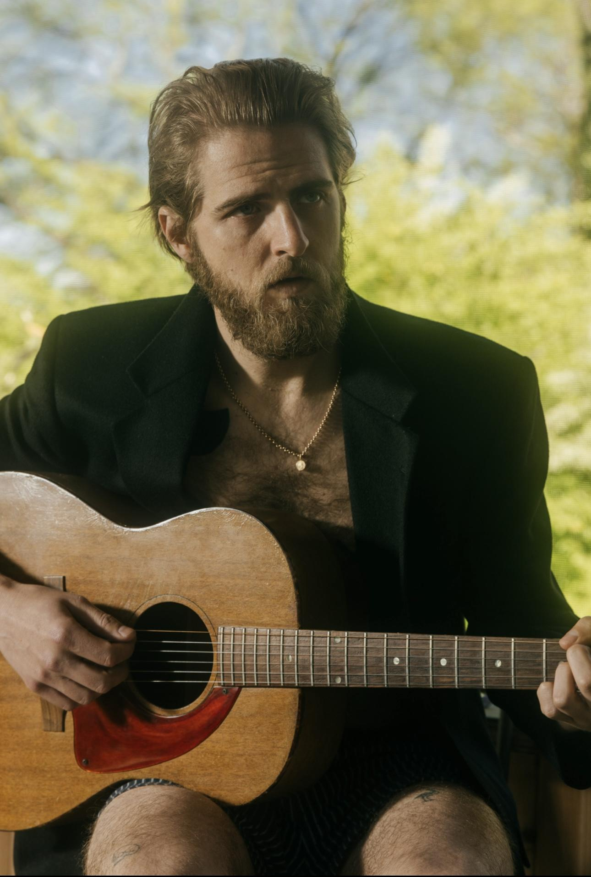
(Christian Lee Hutson by Michael Delaney. Download hi-res HERE)

Acclaimed California musician Christian Lee Hutson has announced his new album Paradise Pop. 10 for release on September 27th on ANTI Records. Today’s news comes with an impressive first track taken from the new album, “After Hours.”

In a perfect example of Hutson’s sparkling, inimitable songwriting skills, “After Hours” finds the protagonist singing from a condominium in a corporatized Heaven, to the woman he misses back on Earth, over a plucky acoustic guitar and shimmering, soft synths courtesy of GRAMMY-nominated musician Shahzad Ismaily. The accompanying video, directed by Meg Ha, captures the melancholy otherworldliness of the track as Hutson drifts through a candlelit house party.

WATCH THE “AFTER HOURS” VIDEO HERE

Paradise Pop. 10 is co-produced with three of Hutson’s longtime collaborators: 4x GRAMMY winner Phoebe Bridgers, GRAMMY-nominated songwriter & producer Marshall Vore and GRAMMY-nominated engineer & multi-instrumentalist Joseph Lorge. The album also features guest vocals from Bridgers, Katy Kirby, and Maya Hawke - another frequent collaborator whose universally lauded new album credits Hutson as producer and co-writer.

Recorded in the depths of winter at Brooklyn’s Figure 8 Studio, the close-knit talents from Los Angeles hunkered down to craft a brilliantly constructed and tender album. A captivating, breezy charm permeates every track of Paradise Pop. 10, with each song hooked around Hutson’s warm, earthy vocals and dexterous story-telling. Whether fragile finger-picking folk or rousing, beachy power pop, these songs are informed by a sense of creeping melancholy about the place Hutson has spent most of his life; in the lead up to the writing and recording of the album the sprawling, inscrutable city of Los Angeles had become haunted in his mind. A move to the East Coast, and the “eyes up” city of New York, was required to refresh his memory banks. “I wanted to make an eyes up record. A looking forward record,” he explains.

He elaborates: “Sometimes when you live somewhere for a really long time, the place starts to feel like a memory graveyard. Every corner becomes kind of haunted in a way, kind of dragging you out of the present. That’s what LA became like for me. Spending so much time revisiting all these emotional landmarks ended up giving me the feeling that I was missing my life. Like it was passing me while I was looking the other way…. It felt really connected to the city.I would spend half my life in the car, just completely on autopilot, re-living my life, from the beginning, on repeat every day.” Having relocated to New York City, he says he feels a very different energy around him, one he describes as,“You’re alive right now. You’re living your life today.”

Paradise Pop. 10 takes its name from a real life “town” set deep in the woods of Parke County, Indiana, near where Hutson spent some of his childhood. There, just past the population sign, you’ll find a row of 5 houses on one side of the road and a cemetery on the other.

Christian shares, “When I was a kid, my dad used to take me up there, mostly because of the novelty of the town limits sign, but also because it was so quiet and peaceful. For years, he would say that if life ever got too crazy, we could go up there and start living our real lives; be the people we were always meant to be.
It occurred to me while making this record, that most of our lives we spend waiting to “be the people we were always meant to be.” I wanted to name this record after that town because it always symbolized an arrival to me. It was the ‘when’ that I looked forward to as a child. ‘When’ it all made sense and I was finally who I was meant to be.”

Hutson has also unveiled plans for a Fall European tour, and two U.S record release shows, slated for September 26 at South Pasadena Masonic Lodge and September 30 at Music Hall of Williamsburg in Brooklyn, NY. All tour dates below.

Paradise Pop. 10 is Hutson’s first release since 2022’s Quitters, which saw him earn widespread critical acclaim. Produced by Phoebe Bridgers and Conor Oberst, it was the follow up to his dazzling 2020 debut, Beginners, praised by Pitchfork as “a stunningly empathetic study of human frailties.

Watch Christian Lee Hutson performing “Rubberneckers” with Phoebe Bridgers on CBS This Morning’s ‘Saturday Sessions’

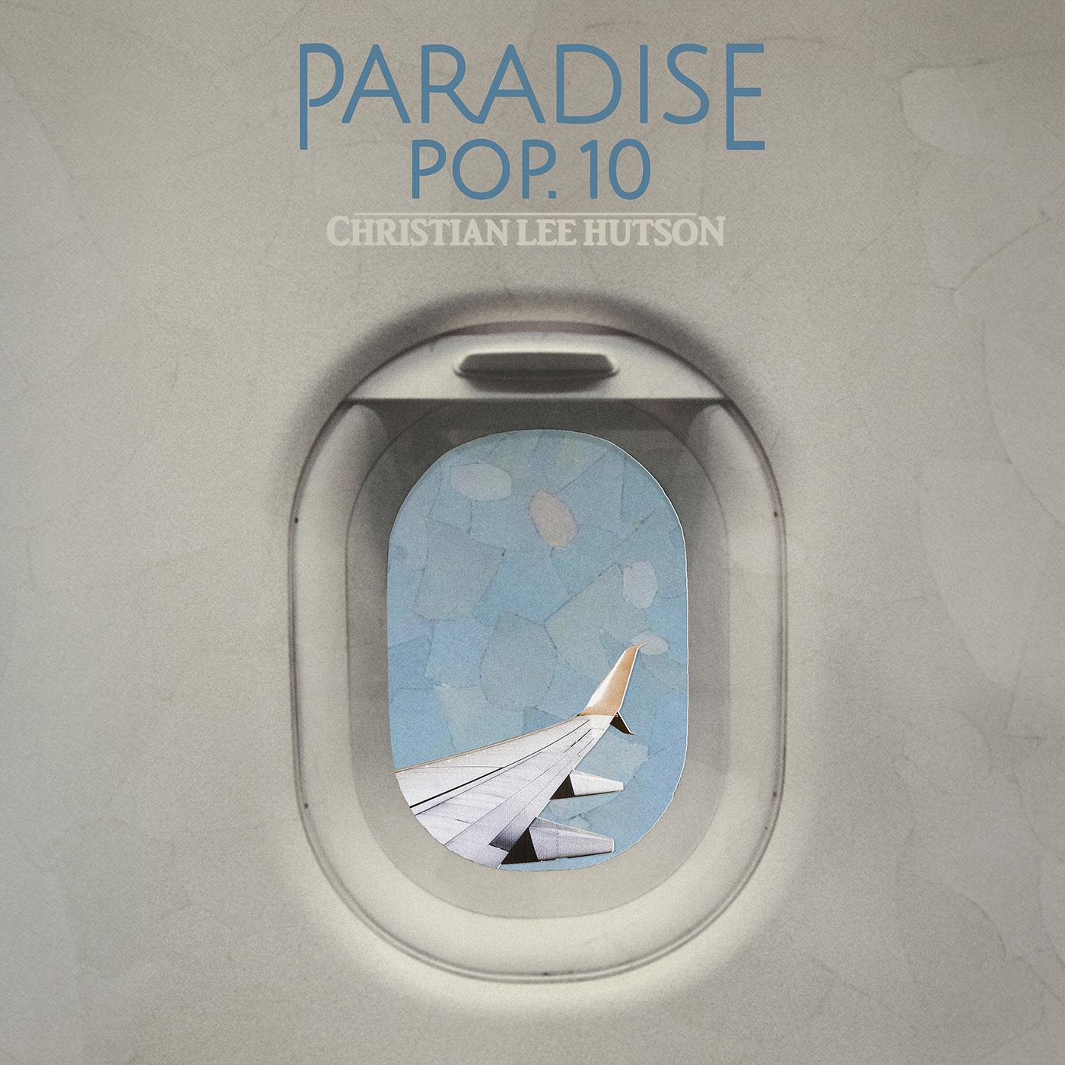
PRE-ORDER ‘PARADISE POP. 10’ HERE

Tracklist for Paradise Pop. 10

- Tiger
- Carousel Horses
- Autopilot
- Water Ballet
- Candyland
- Flamingos
- Fan Fiction
- After Hours
- Forever Immortalized
- Skeleton Crew
- Beauty School

Christian Lee Hutson - Fall Tour:

September 26 - South Pasadena Masonic Lodge - Los Angeles, CA
September 30 - Music Hall of Williamsburg - Brooklyn, NY
October 30 - Belleville - Oslo, Norway
October 31 - Debaser - Stockholm, Sweden
November 1 - Pustervik - Gothenburg, Sweden
November 2 - Ideal Bar - Copenhagen, Denmark
November 3 - Privatclub - Berlin, Germany
November 5 - Witloof Bar - Brussels, Belgium
November 6 - Paradiso Upstairs - Amsterdam, Netherlands
November 7 - Pitchfork Avant Garde - Paris, France
November 10 - Inside Seaside - Gdansk, Poland
November 12 - Dareshack - Bristol, UK
November 13 - Lafayette - London, UK
November 14 - The Lodge at Deaf Institute - Manchester, UK
November 15 - Oran Mor - Glasgow, UK

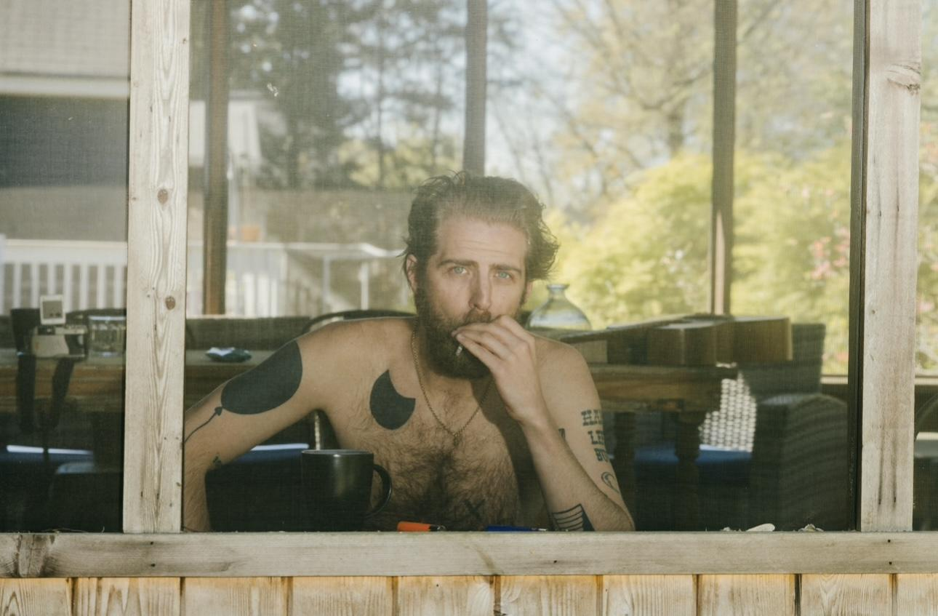
(Christian Lee Hutson by Michael Delaney. Download hi-res HERE)

Praise for Christian Lee Hutson:

“Few lyricists can paint such clear portraits in such a small space; even fewer can set them so naturally to such long-breathed melodies.”
Pitchfork

“These are small films in song, delicate and devastating, lingering long.”
The Guardian

“...he wraps jagged, elliptical stories in delicious haunted melodies and intriguing, colourful, self-deprecating lyrics… these songs, even those with rough edges, are infused with a real sense of humanity, their black humour cocking a snook at an indifferent world.”
The Irish Times

“masterful storytelling… an artist fully formed and wise beyond his years”
No Depression

“When Hutson is at his most unguarded and vulnerable, he makes for one of his generation’s strongest songwriters.”
The Line Of Best Fit

“Hutson possesses a rare balance of critical wit and soul.”
Paste

“Hutson is an integral new voice in the extended collective of fast-rising twenty-something L.A. singer-songwriters”
Rolling Stone

Keep up with Christian Lee Hutson:
Instagram | Twitter | YouTube | Facebook | Website | TikTok

For more information on Christian Lee Hutson, please contact The Oriel Co:
Chloë Walsh - Chloe@TheOriel.co / Anna Ross - Anna@TheOriel.co

For ANTI: Kelly Kettering - kelly@epitaph.com

