August 19, 2022
For Immediate Release

Cass McCombs’ New Album, Heartmind, Is Out Today via ANTI-

Watch the Video for “New Earth”

North American Tour Runs Sep. 7th-17th
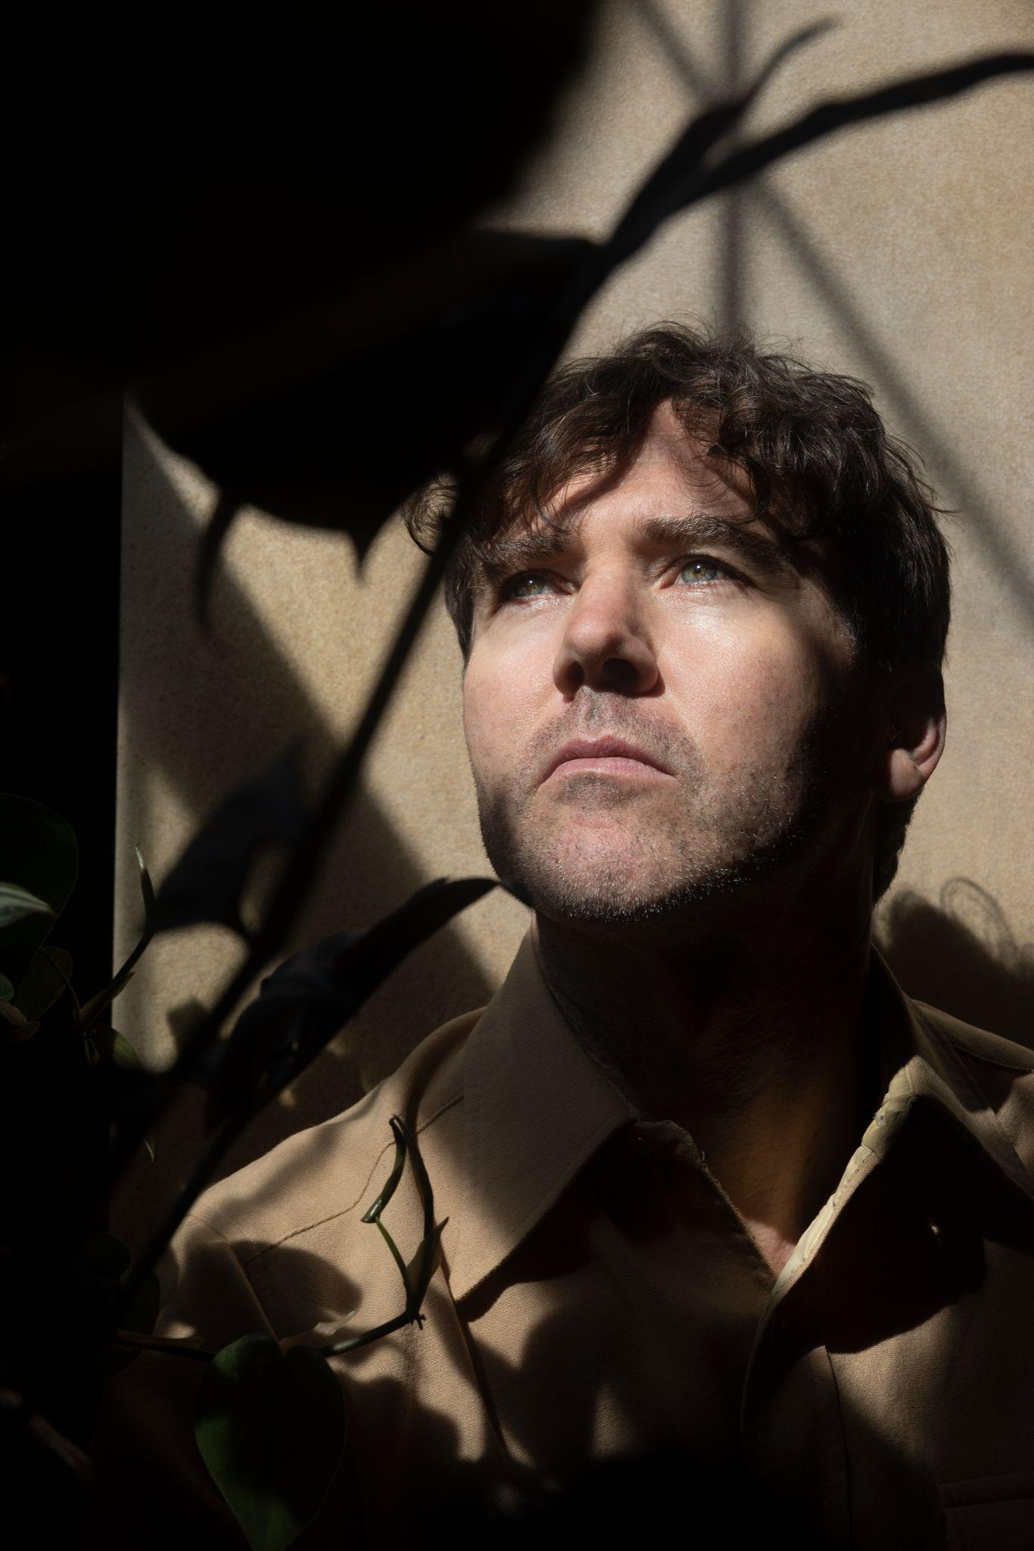
Photo Credit: Ebru Yildiz

“McCombs doesn’t need any dream machine to induce new visions: 10 albums in, he’s more than capable of looking at the world differently all by himself, watching as life strobes by in all its curious forms.”
- MOJO, Album of the Month

“[McCombs’] songs are not always easy, they’re not always straightforward, but 10 albums in, they’re mounting up to create one of the most impressive bodies of work of the century so far.” - Uncut, Album of the Month

Today, Cass McCombs releases his tenth album, Heartmind, via ANTI-. In conjunction, he presents a new video for one of its songs, “New Earth.” Heartmind feels like a journey among assorted tuneful feelings, somehow shaped to meet whatever it is a particular listener needs. Where some may hear dark humor, others might hear relentless pain; where some may hear winning cynicism, others might hear harrowing nihilism.

Produced by frequent Frank Ocean collaborator, Buddy Ross, “New Earth” is a clever paean of post-humanity renewal: “Today is the day after the last day on Earth // It’s such a glad day! // After a very, very, very bad day // After today, who can say?” “‘New Earth’ I guess you could say is a lighthearted, bossa nova-ish song about welcoming in a new dawn where wildlife crushes technology,” says McCombs. “I owe a debt to the musicians, Joe Russo, Jon Shaw, Frank LoCrasto, The Chapin Sisters, and producer Buddy Ross for helping create this imaginary event/place/feeling.” The song’s accompanying video was animated by Daniel Bermudez.

Watch Cass McCombs’ Video for “New Earth”

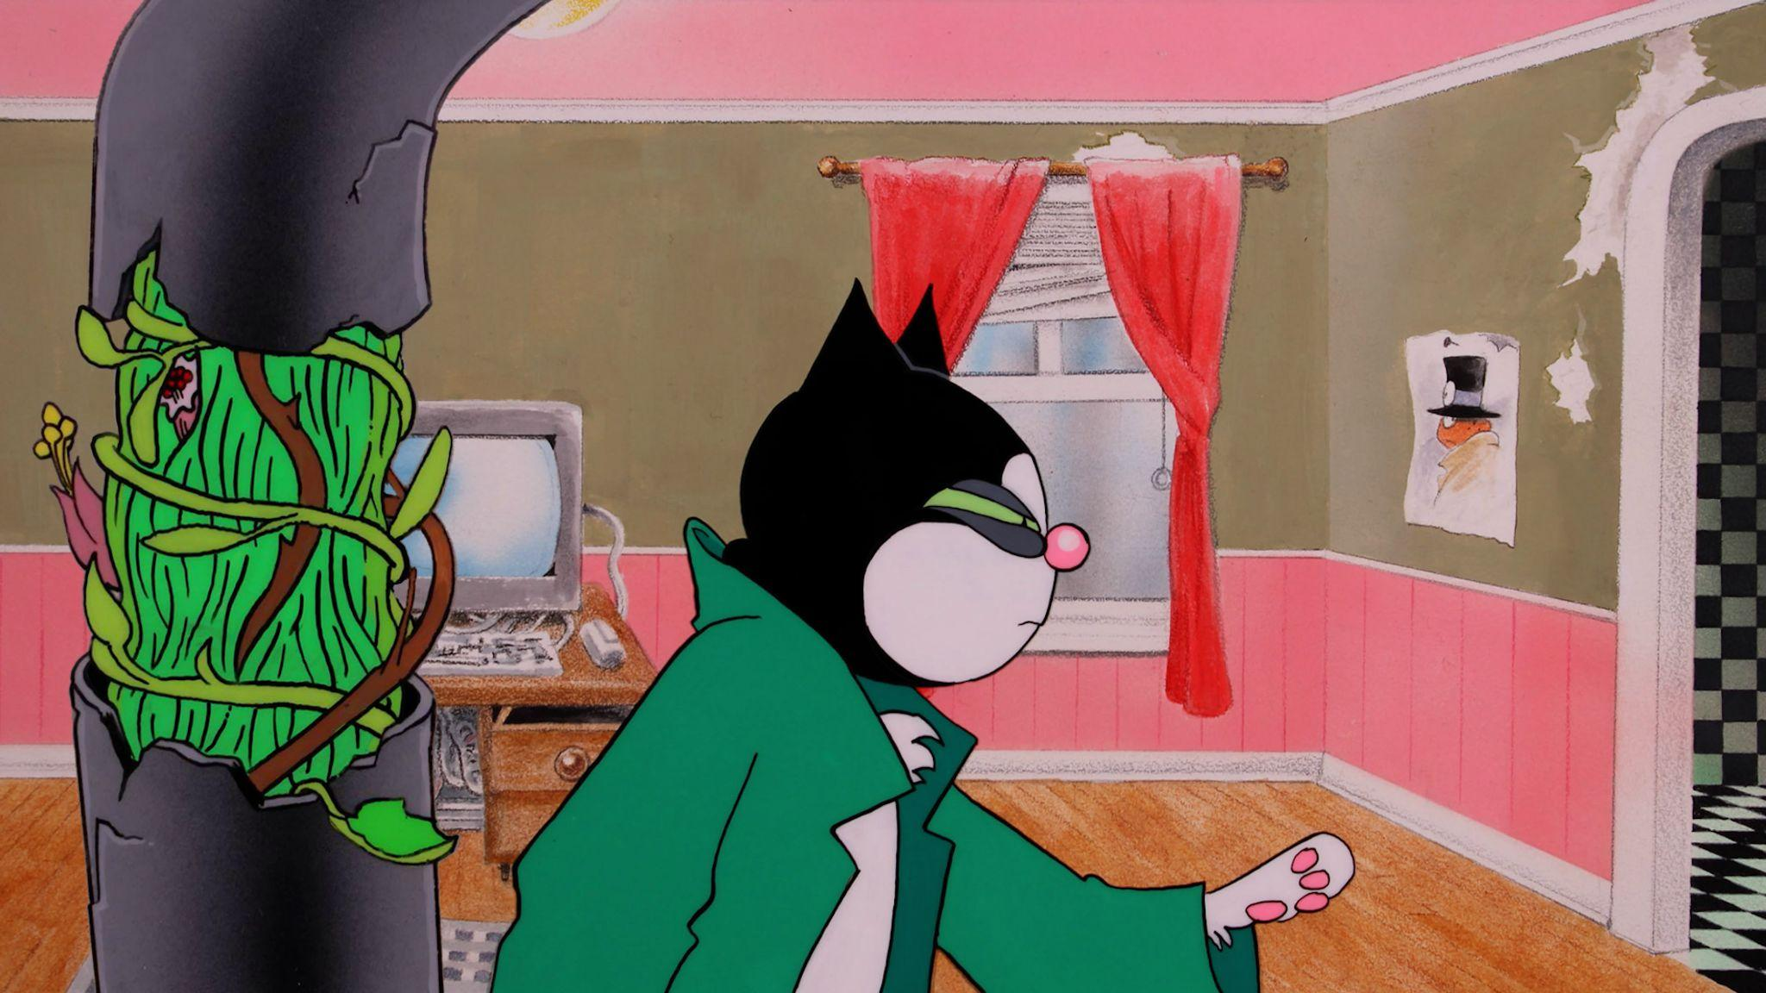
Still from “New Earth” video

Next month, Cass McCombs will embark on a North American tour in support of Heartmind. A full list of dates can be found below and tickets for all shows are on sale now.

Watch/Listen/Share
Purchase Heartmind
“Belong to Heaven” Video
"Unproud Warrior" Video
“Karaoke” Video
“Instrumental Karaoke Version”

Cass McCombs Tour Dates
Wed. Sept. 7 - Cleveland, OH @ Beachland Ballroom
Thu. Sept. 8 - Ferndale, MI @ Magic Bag
Fri. Sept. 9 - Chicago, IL @ Thalia Hall
Sat. Sept. 10 - Indianapolis, IN @ HiFi
Sun. Sept. 11 - Pittsburgh, PA @ Mr. Small’s
Mon. Sept. 12 - Toronto, ON @ Lee’s Palace
Wed. Sept. 14 - Boston, MA @ Royale
Thu. Sept. 15 - Ardmore, PA @ Ardmore
Fri. Sept. 16 - New York, NY @ Webster Hall
Sat. Sept. 17 - Washington, DC @ 9:30 Club
Wed. Sept. 28 - Madrid, ES @ Teatro Lara
Thu. Sept. 29 - Zaragoza, ES @ Luis Galve
Fri. Sept. 30 - Alicante, ES @ Teatro Arnichas
Sat. Oct. 1 - Valencia, ES @ 16 Toneladas
Tue. Oct. 4 - Milano, IT @ Bellezza
Thu. Oct. 6 - St. Gallen, CH @ Palace St. Gallen
Fri. Oct. 7 - Schorndorf, DE @ Manufaktur
Sat. Oct. 8 - Paris, FR @ Café De La Danse
Mon. Oct. 10 - Bristol, UK @ Redgrave Theatre
Wed. Oct. 12 - Manchester, UK @ The Stoller Hall
Thu. Oct. 13 - London, UK @ Alexandra Palace Theatre
Sat. Oct. 15 - Dublin, IE @ Liberty Hall
Sun. Oct. 16 - Glasgow, UK @ Mackintosh Church
Tue. Oct. 18 - Brussels, BE @ Botanique Rotonde
Wed. Oct. 19 - Cologne, DE @ Artheater
Thu. Oct. 20 - Utrecht, NL @ Cloud 9
Sat. Oct. 22 - Berlin, DE @ Frannz Club
Sun. Oct. 24 - Hamburg, DE @ Nochtspeicher
Tue. Oct. 25 - København S, DK @ DR Studie 2
Wed. Oct. 26 - Stockholm, SE @ Slaktkyrkan
Fri. Oct. 28 - Oslo, NO @ Oslo Parkteatret

Download Cass McCombs’ hi-res press images and album art

Heartmind Cover Artwork (photo by Cass McCombs)

Website | Facebook | Instagram | Twitter

For more information, contact:
Jessica Linker | Pitch Perfect PR – jessica@pitchperfectpr.com, 773-942-6954

