DANNY ELFMAN RELEASES
SQUAREPUSHER REMIX OF “WE BELONG”

THE LATEST REIMAGINING OF MUSIC FROM ELFMAN'S HERALDED NEW ALBUM BIG MESS

LISTEN NOW HERE

THE GRAMMY MUSEUM® ANNOUNCES A CONVERSATION WITH DANNY ELFMAN; A SPECIAL LIVE Q&A WITH ELFMAN IN LOS ANGELES
ON SEPTEMBER 28TH

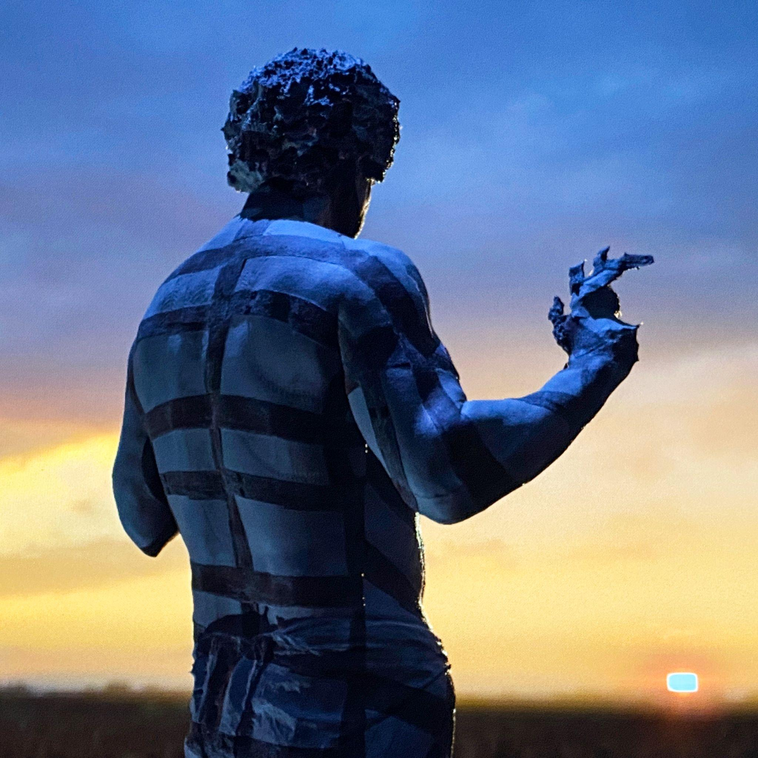
“We Belong (Squarepusher Remix)” Single Artwork

September 10th, 2021 (Los Angeles, CA) - Today, Danny Elfman has released a brand new Squarepusher remix of “We Belong,” a song originally featured on Elfman’s heralded new double album Big Mess [ANTI- / Epitaph Records]. The new version serves as a complete reinterpretation from the mind of Squarepusher, combining Elfman’s haunting vocals and orchestral elements with the English electronic musician’s signature blitz of glitchy percussion and furiously arpeggiated synthesizers. Listen now here.

“When “Big Mess” bass player Stu Brooks and I began talking about the possibility of reaching out to remixers for different collaborations on re-inventing songs from the album, Squarepusher was one of the first names we discussed,” says Elfman. “He’s obviously a legend in that field. I was really excited that he responded positively and chose the song “We Belong” to mix. I couldn’t be happier with the result.”

"Danny Elfman is a living legend and I was thrilled to be asked to do a remix for him,” adds Squarepusher. “I chose 'We Belong' partly because it's in E flat, which is a nice escape from guitar-friendly tonalities, and also because I was especially drawn to the vocal elements. For instrumentation I used some of my old analogue hardware including a Yamaha CS-80.”

The release arrives on the heels of the announcement of A Conversation with Danny Elfman; a special upcoming live Q&A with Elfman presented by The GRAMMY Museum®. Set for Tuesday, September 28th at the Clive Davis Theater in Los Angeles, CA, the intimate conversation will dive into the making of ‘Big Mess,’ and will be moderated by writer David Wild. Pre-sale tickets are available now and general onsale begins tomorrow, September 11th, at 12PM PT here. Visit here for more information.

Squarepusher’s remix of “We Belong” marks the third collaborative effort for Elfman from Big Mess, as he previously joined forces with Zach Hill of Death Grips for a remix of “Kick Me” and most recently teamed up with Trent Reznor to unleash a brand new duet version of his song “True.” The reimagined single of “True” caught the eye of Entertainment Weekly, Vulture, Pitchfork, Rolling Stone and more, and showcases a sonic collision of two musical icons, fusing vocals from Reznor and Elfman with vicious industrial percussion, cinematic piano flares and walls of feedback. To coincide with the release, Elfman also debuted a new music video for the track, which can be viewed now HERE. Directed by Aron Johnson, who contributed visual effects to the Sarah Sitkin-directed music video for the album version of “True,” the piece features warped imagery and retro VHS aesthetics that capture the song’s intensity. Combining segments of Sitkin's archived footage along with brand new 3D modeling, the visual serves as a remix in itself of the original music video, reinterpreted through the eyes of Aron.

After releasing a string of dynamic singles and aesthetically groundbreaking videos, Elfman officially unveiled ‘Big Mess’ in June, his first solo record in thirty-seven years. Clocking in at 18 tracks, the expansive double album finds the 4x Oscar nominated, Grammy and Emmy Award-winning composer breaking bold new ground as both a songwriter and a performer. Joined on the album by drummer Josh Freese (Devo, Weezer, The Vandals), bassist Stu Brooks (Dub Trio, Lady Gaga, Lauryn Hill), and guitarists Robin Finck (Nine Inch Nails, Guns N’ Roses) and Nili Brosh (Tony MacAlpine, Paul Gilbert), the project has garnered widespread praise since its release:

“A fiercely political work filled with bombastic peaks and strikingly meditative valleys.” - LA Times

“The best representation of himself he’s ever created in his half-century career.” - SPIN

“Expertly conceived, meshing sawing classical strings, gutsy rock, electronics and enough energy to power a small city.” - American Songwriter

“A sonic howl — part glam rock, part orchestral, part punk, with driving, industrial songs that are liable to disintegrate or tear off into a different direction.” - Associated Press

“9 out of 10...A whirlwind of unbounded creativity as only Elfman could envision and produce." - Metal Injection

The songs on ‘Big Mess’ unite both harmonically complex arrangements and simple high energy driving music with biting, acerbic wit as they reckon with the chaos and confusion of the modern world. And while the anger, frustration, and isolation of it all is palpable in his delivery, ‘Big Mess’ is about more than simply blowing off steam. In making the space to truly sit with his emotions and write without limitations, Elfman achieved a kind of artistic liberation on the record that had been eluding him for decades, rediscovering his voice and reinventing himself all at once in the process.

These feelings of anger, angst and frustration that permeate ‘Big Mess’ are explored in the album’s artwork and music videos as well, which push the boundaries between art and technology and each feature Danny in distinct ways. For the cover artwork, Elfman was 3D scanned and transformed into a grotesque looking digital sculpture by Sarah Sitkin. Using CGI, 3D technology, motion capture and artificial intelligence, each music video was uniquely made and are inextricable from the songs that inspired them. Led overall by Elfman’s creative director Berit Gwendolyn Gilma, each of the video’s directors - Aron Johnson (“Happy”), Jesse Kanda (“Sorry”), Sven Gutjahr (“Love In The Time of Covid”), Petros Papahadjopoulos (“Kick Me”), Sarah Sitkin (“True”), Sam & Andy Rolfes (“Insects”) – have created individual statements that shape a diverse but cohesive whole. The Big Mess album and visuals were produced by Danny Elfman and executive produced by Elfman’s longtime manager Laura Engel.

‘Big Mess’ is out now via ANTI- / Epitaph Records and is available on all digital streaming platforms here.

###

CONNECT WITH DANNY ELFMAN:
https://www.dannyelfman.com/
Instagram | Facebook | Twitter | Spotify

For More Info on Danny Elfman, Contact:
Kelly Kettering | ANTI- Records Publicity | Kelly@epitaph.com

Luke Burland / BB Gun Press / luke@bbgunpress.com
Peter Quinn / BB Gun Press / peter@bbgunpress.com

