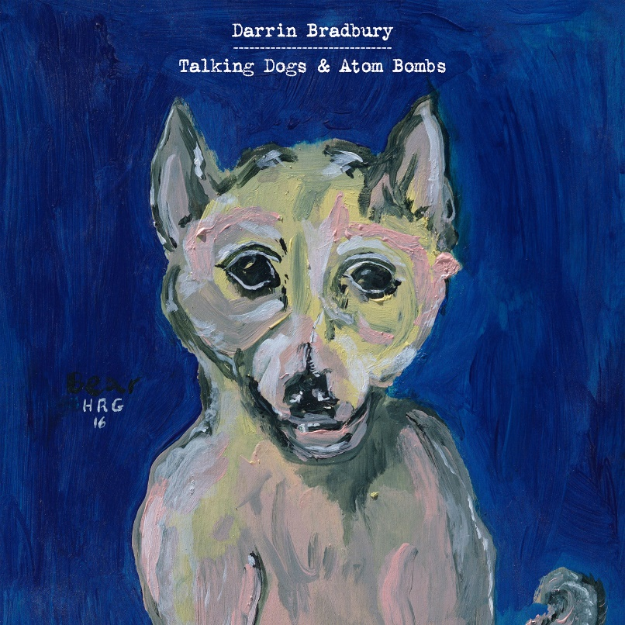

For Immediate Release—

Darrin Bradbury Releases Talking Dogs & Atom Bombs via ANTI- Records
Album Garners National and Regional Acclaim

September 20, 2019 – Nashville, TN – Known for blending dark humor with obvious-once-you-hear-them observations on everyday life, Darrin Bradbury’s songs are both funny and thought-provoking. Today, Bradbury is proud to share his anticipated new album Talking Dogs & Atom Bombs, his first for ANTI- Records. Produced by Kenneth Pattengale (The Milk Carton Kids), Talking Dogs & Atom Bombs is a collection of contemplative songs that were shaped by Bradbury’s own struggles with depression. Using his unique wit, Bradbury paints a lighthearted perspective on the pressures of life in America. He released two tracks from the album this week, including “The Trouble with Time”, a stunning duet featuring Grammy-nominated singer-songwriter and fellow Nashvillian Margo Price, and “This Too Shall Pass” via Billboard. Bradbury also announced new U.S. tour dates this week supporting Cory Branan, following October dates with John Moreland; in late November, he will embark on his first European tour in support of Jarrod Dickenson. Talking Dogs & Atoms Bombs is available today, click here to purchase or stream.

In addition to Billboard, Talking Dogs & Atom Bombs has garnered national praise from a multitude of outlets that include NPR, Rolling Stone Country, No Depression, Wide Open Country, American Songwriter and The Bluegrass Situation; regionally, Bradbury has been the subject of stories in Nashville Scene and The East Nashvillian, and was recently hailed by critics at Sounds Like Nashville.

“His caustic reflections are delivered with dark humor: He makes everyday life funny, and he makes you smile with the weirder scenarios he brings to life.” – NPR

“A sharp-witted satirist, he finds ways to bend real-life circumstances into occasional sensational narratives with their own dark underbelly.” – Billboard

“Darrin Bradbury spins magic, both dark and light, out of the mundane…
Talking Dogs & Atom Bombs almost never acquiesces to hopelessness without finding some little twist of humor or moment of wonder to relish.” – No Depression

“Bradbury’s catalog is built with memorable songs that deal with
the humor and heartache of modern American life.” – American Songwriter

“Fans of John Prine, Steve Goodman and other lyricists who're as quick-witted as they are hilarious will find a kinship with Bradbury.” – Wide Open Country

A self-described folk satirist, Talking Dogs & Atom Bombs highlights Bradbury’s natural gift for storytelling; Bradbury enlisted the help of only one other writer for the entire album—ANTI- label-mate, friend, and fellow esteemed Nashville musician, Jeremy Ivey. The tracking of Talking Dogs & Atom Bombs was completed in a similarly simple way; using the same combo of musicians for every song on the record. Aside from producer Pattengale’s mellotron and vocal contributions and the aforementioned Ivey’s bass and piano playing, only two extra musicians were called to round out the band; Alex Muñoz on additional guitars and Dillon Napier on drums.

The only exception is the lone guest vocalist on the album, modern outlaw country queen and longtime supporter of Bradbury, Margo Price, who adds a somber harmony to “The Trouble With Time.” A country ballad tinged with elements of indie rock, Price's crystalline vocals compliment Bradbury's signature sound and plainspoken lyrics. Written with his parents in mind, Bradbury wanted his family to have a "go-to" song to share with their friends – a track that represented his unique songwriting style that, in his own words, “wouldn't weird them out”. Price commented, “The first time I heard 'The Trouble With Time', I was sitting at my kitchen table. Darrin played it for me and I immediately started to cry. It’s just a great song... who doesn’t want to go back to another time and find somebody they lost. I know I do.”

“When I write, there are things that I want to get away with,” Bradbury says. “I want to get away with the line, ‘I woke up this morning and I got out of bed / Tripped on my pants and fell on my head.’ ” Overall, Talking Dogs & Atom Bombs is a beautifully refined version of Bradbury’s writing; going for broke, connecting the dots, and doing it with blunt honesty that brings it all home. “If I can get you to take that seriously, and not skip a beat when you listen to it, that's what I want.”

On Tour:
Sept 20 – Nashville, TN – Grimey's In-Store
Sept 30 – Baltimore, MD – Creative Alliance *
Oct 1 – Alexandria, VA – The Birchmere *
Oct 4 – Garwood, NJ – Crossroads *
Nov 8 – Charlotte, NC – The Evening Muse +
Nov 10 – Chapel Hill, NC – Local 506 +
Nov 14 – New York, NY – City Vineyard +
Nov 15 – Philadelphia, PA – Boot & Saddle +
Nov 16 – Middletown, CT – MAC 650 +
Nov 18 – Boston, MA – Haymarket Lounge +
Nov 22 – London – The Cavendish Arms ^
Nov 23 – Broadhempston – Broadhempston Church ^
Nov 24 – Shrewsbury – Henry Tudor House ^
Nov 25 – Manchester – Gullivers ^
Nov 27 – Halifax – The Lantern ^
Nov 28 – Norwich – Waterfront Studio ^
Nov 29 – London – The Cavendish Arms ^
Nov 30 – Liverpool – Prohibition Recording Studio ^
Dec 1 – Glasgow – The Blue Arrow ^
Dec 2 – Edinburgh – The Voodoo Rooms ^
Dec 3 – Newcastle – Cluny 2 ^
Dec 5 – Bristol – Rough Trade ^
Dec 7 – Belfast – Ulster Sports Club ^

* supporting John Moreland
+ supporting Cory Branan
^ supporting Jarrod Dickenson

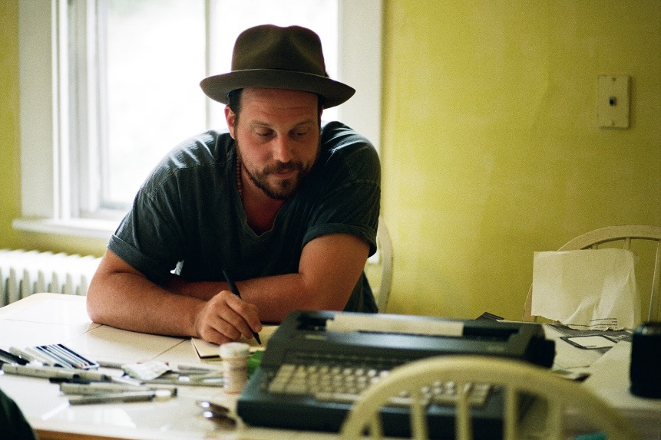
About Darrin Bradbury:
Darrin Bradbury writes about the way things really are in America – a singular perspective shaped by a natural gift for storytelling, a lingering battle with depression, and a sly sense of humor. A self-described folk satirist who has toured the country for more than a decade, Bradbury collects his oddball observations in his newest album, Talking Dogs & Atom Bombs.

Bradbury grew up in New Jersey with an early interest in performing, partly because of his mother’s career as a circus clown. At the age of 7, he felt certain that he would either become a songwriter or a cartoonist. He learned to play guitar as a vessel to tell his stories -- and because his handwriting and grammar steered him away from being a novelist. By the age of 18, he’d discovered Bob Dylan, Jack Kerouac, and Paul Simon, and decided to hit the road.

At 25, he moved from Charlottesville, Virginia, to Nashville, to try making it as a songwriter. For three months, he slept in his car in a Walmart parking lot, and developed a local following by playing open mic nights. With a handful of self-funded EPs and albums, Bradbury steadily cultivated a national audience by touring constantly. Produced by Kenneth Pattengale of the Milk Carton Kids, Talking Dogs & Atom Bombs is Bradbury’s first release for ANTI- Records.

