May 27, 2025

For Immediate Release

**Andy Shauf’s Foxwarren Release New Single/Video, “**[**Deadhead**](https://youtu.be/-F7c7Es0nuM)**”**

**New Album, *2*, Out This Friday Via ANTI-**

**North American Tour Kicks Off in August**

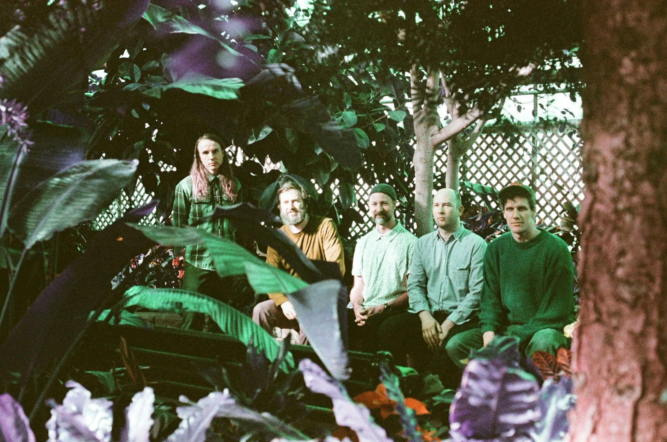

Photo Credit: Landon Johnson

Canadian quintet **Foxwarren** – **Andy Shauf**, **Avery** and **Darryl Kissick**, **Dallas Bryson**, and **Colin Nealis** release the new single/video “**Deadhead**,” the final preview from their new album, ***2***, out this **Friday** via **ANTI-**. Following “**Yvonne**,” praised by *AV Club*as “an understated kind of gorgeous,” “Deadhead” sees Foxwarren on a quest for levity. The song seamlessly moves from an MF Doom-like pitch-shifted sample to a line-dance guitar lick to honeyed country-rock harmonies of the titular band all in three minutes. There are darting flutes, mangled electronics, and meticulous snippets of rhythm, all expertly placed to illustrate the song’s emotional tumult. “I won’t stop dancing,” as Shauf sings, is exactly the feeling the song evokes.

The song’s eccentric video was directed by **Joe Cappa**, who explains: “I bought a bunch of wigs and medieval costumes and sort of came up with the premise of the video as I was dressing the puppets. When I put the blonde wig and mustache on the main character it really spoke to me. Those legs on the flute playing baby are my 10 month old son’s.”

“To all the deadheads, we say 'don't stop dancing.'” — *Foxwarren*

“Deadhead” exemplifies the unique approach Foxwarren took in creating *2*. After touring their lauded 2018 self-titled debut, the band dropped the familiar band-in-a-room routine. Instead, in their own home studios across four provinces, all five members would upload song ideas, melodic phrases, or rhythmic bits to a shared folder. In Toronto, Shauf would then plug these into a sampler and construct songs from the fragments supplied by his bandmates, leaning into classic hip-hop techniques and musique concrète alike as unlikely lodestars. Foxwarren would convene at weekly online meetings, offering long-distance suggestions about which way a song might shift. The result is mesmerizing and uncanny, an album that traces two sides of a relationship through 37 minutes of collage art that aspires to “sound best blasting out your car window,” as put by Shauf.

[**Watch the Video For “Deadhead”**](https://youtu.be/-F7c7Es0nuM)

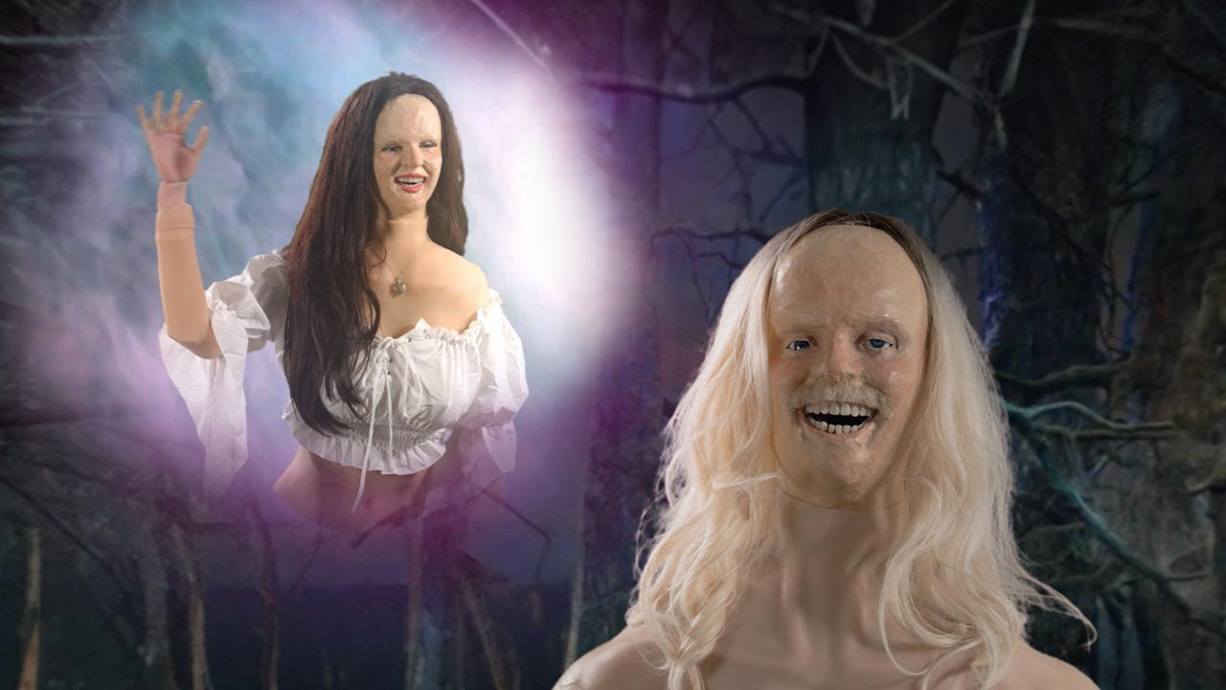

“Deadhead” Video Still

By himself, Shauf has already had a stellar career, his reputation built by the sweet melodies and uniquely imaginative and precise storytelling found on 2016’s *The Party* through to 2023’s *Norm*. Foxwarren, especially here, is a crucial part of that ongoing process, but *2* represents something even more significant—five friends now nearing the end of their second decade making music together, pushing against what they’ve learned how to do in order to venture somewhere new. It is the sound of friends who trust each other, cutting themselves loose from their past and their preconceptions to have some fun with a sampler and the very idea of songs.

Last month, the band announced an expansive North American tour, their first since 2019. A full list of shows is below and tickets are on sale now. Additionally, Foxwarren *2* Listening Parties are taking place beginning today through May 30th at record stores around North America and Europe. For cities, record stores and further information, visit [foxwarren.hq](https://foxwarrenhq.com/).

[**Pre-order *2***](https://foxwarren.ffm.to/two)

[**Watch the Video For “Yvonne”**](https://www.youtube.com/watch?si=XiMw4l5us-EtROLW&v=B3Kvs25QnTk&feature=youtu.be)

[**Watch the Video For “Listen2me”**](https://youtu.be/oyO8rpimy6Y)

**Foxwarren Tour Dates:**

Wed. Aug. 6 - Salt Lake City, UT @ Gallivan Center #

Fri. Aug. 8 - Jacksonville, OR @ Britt Festival Pavilion #

Sat. Aug. 9 - Portland, OR @ Pioneer Courthouse Square #

Sun. Aug. 10 - Seattle, WA @ Woodland Park Zoo #

Sat. Sept. 13 - Montreal, QC @ Théâtre Fairmount

Tue. Sept. 16 - Detroit, MI @ El Club

Wed. Sept. 17 Chicago, IL @ Thalia Hall

Fri. Sept. 19 - Nashville, TN @ The Blue Room

Sat. Sept. 20 - Nashville, TN @ The Blue Room

Mon. Sept. 22 - Washington, DC @ The Atlantis

Tue. Sept. 23 - Boston, MA @ The Sinclair

Wed. Sept. 24 - Brooklyn, NY @ Warsaw

Thu. Sept. 25 - Philadelphia, PA @ Underground Arts

Fri. Sept. 26 - Kingston, NY @ Assembly

Sun. Sept. 28 - Toronto, ON @ The Opera House

Wed. Nov. 26 - Winnipeg, MB @ The Park Theatre

Fri. Nov. 28 - Regina, SK @ The Exchange

Sat. Nov. 29 - Saskatoon, SK @ Coors Event Centre

Sun. Nov. 30 - Edmonton, AB @ Midway Music Hall

Mon. Dec. 1 - Calgary, AB @ The Palace Theatre

Thu. Dec. 4 - Vancouver, BC @ Vogue Theatre

Fri. Dec. 5 - Seattle, WA @ Neumos

Tue. Dec. 9 - San Francisco, CA @ The Independent

Thu. Dec. 11 - Los Angeles, CA @ The Bellwether

# supporting Waxahatchee

[**Download cover art & hi-res images of Foxwarren**](http://www.pitchperfectpr.com/foxwarren)

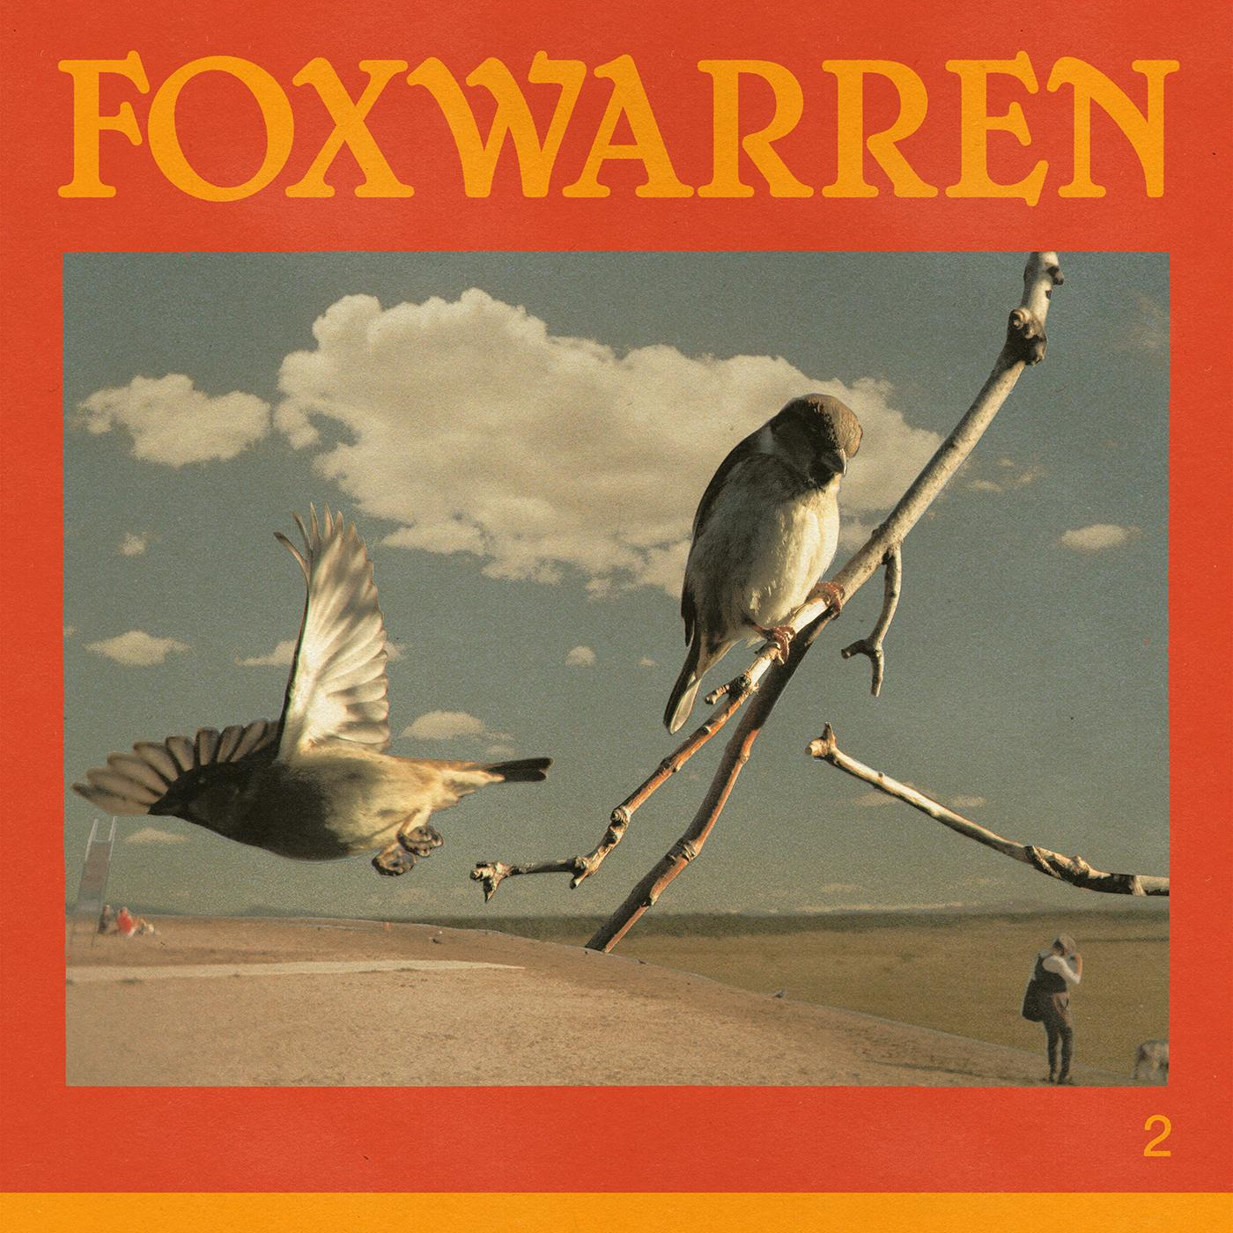

*2* Album Artwork

**Foxwarren Online**:

[Facebook](https://www.facebook.com/foxwarrenband/) | [X](https://x.com/foxwarrenband?lang=en) | [Bandcamp](https://foxwarren.bandcamp.com/album/foxwarren) | [ANTI-](https://www.anti.com/artists/foxwarren/)

For more information, please contact:

Jessica Linker & Patrick Tilley - [jessica@pitchperfectpr.com](mailto:jessica@pitchperfectpr.com), [patrick@pitchperfectpr.com](mailto:patrick@pitchperfectpr.com)

###