April 22, 2025

For Immediate Release

**Andy Shauf’s Foxwarren Announce First North American Tour In Six Years**

**& Release New Single/Video, “**[**Yvonne**](https://www.youtube.com/watch?si=XiMw4l5us-EtROLW&v=B3Kvs25QnTk&feature=youtu.be)**”**

**New Album, *2*, Out May 30th Via ANTI-**

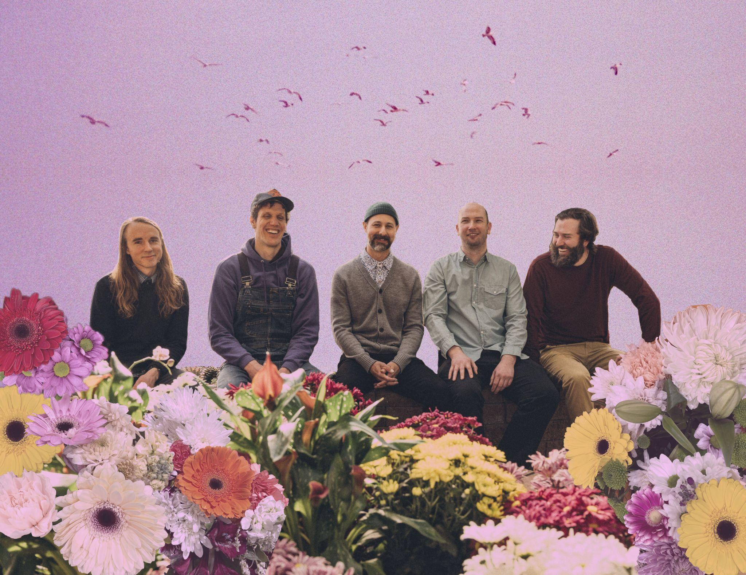

Photo Credit: Landon Johnson

Canadian quintet **Foxwarren** – **Andy Shauf**, **Avery** and **Darryl Kissick**, **Dallas Bryson**, and **Colin Nealis** – announce a **North American Tour** and release “**Yvonne**,” the second single/video from their new album, ***2***, out **May 30th** via **ANTI-**. The band’s expansive tour, their first since 2019, will go on sale on **Friday, April 25th** at **10am** local time. A full list of shows is below, with tickets and further information available [here](http://www.foxwarrenhq.com).

Following lead single [“**Listen2me**,”](https://www.youtube.com/watch?v=oyO8rpimy6Y&feature=youtu.be) “Yvonne” is a compulsory study of love’s strange spell. Shauf sets the beach-like scene above a polyrhythmic sampled loop, and then when his vocal harmonies hit the string section singing, “I don’t know what I’d do without you, Yvonne,” it’s like watching the sun rise in someone else’s eyes.  “Yvonne, the woman scanning the beach each morning for buried treasure, deserves a love song too,” the band says. A collage-style animated video by artist **Meghan Fenske** accompanies “Yvonne,” nodding to the cut-and-paste elements of *2*.

[**Watch the Video For “Yvonne”**](https://www.youtube.com/watch?si=XiMw4l5us-EtROLW&v=B3Kvs25QnTk&feature=youtu.be)

Over the last decade, Shauf has become known as “a phenomenal storyteller” (*NPR Music*). He’s built a reputation for his “natural ear for all of the vintage sounds that give his music an ‘out of time’ quality” (*Uproxx*) and his “gorgeously produced collection of short folk-fiction” *(Variety*). He is always using some fresh fascination, skill, or concept as the catalyst for albums he writes, plays, and produces almost entirely by himself. But before Shauf’s solo acclaim, he was a member of Foxwarren. Following Shauf’s 2016 album, *The Party*, Foxwarren’s self-titled debut album arrived in 2018, almost an entire decade after the formation of the band, garnering solid reviews, packed live shows, and a Juno Award nomination. It became some of Shauf’s most celebrated music, immediately overcoming any suggestion whatsoever that this was just a side project.

Riding a crest of enthusiasm, Foxwarren headed into the studio in fall of 2018, hoping to cut a half-dozen songs for a follow-up rather quickly. Given a little distance, though, the songs felt flat. So Foxwarren opted to try something entirely new: In their own home studios across four provinces, all five members would upload song ideas, melodic phrases, or rhythmic bits to a shared folder. In Toronto, Shauf would then plug these into a sampler and construct songs from the fragments supplied by his bandmates, leaning into classic hip-hop techniques and musique concrète alike as unlikely lodestars. Foxwarren would convene at weekly online meetings, offering long-distance suggestions about which way a song might shift. It was a long and difficult process, but *2* became an uncanny revelation for Foxwarren; they warped and pushed the florid folk-rock of their past until it evolved into a mesmerizing song cycle about the vagaries of love.

By himself, Shauf has already had a stellar career, his reputation built not only by the sweetness of his melodies and sharpness of his words but also his inability to rest with past success. Foxwarren, especially here, is a crucial part of that ongoing process, but *2* represents something even more significant—five friends now nearing the end of their second decade making music together, pushing against what they’ve learned how to do in order to venture somewhere new.

[**Pre-order *2***](https://foxwarren.ffm.to/two)

[**Watch the Video For “Listen2me”**](https://youtu.be/oyO8rpimy6Y)

**Foxwarren Tour Dates:**

(New Dates in Bold)

Wed. Aug. 6 - Salt Lake City, UT @ Gallivan Center #

Fri. Aug. 8 - Jacksonville, OR @ Britt Festival Pavilion #

Sat. Aug. 9 - Portland, OR @ Pioneer Courthouse Square #

Sun. Aug. 10 - Seattle, WA @ Woodland Park Zoo #

**Sat. Sept. 13 - Montreal, QC @ Théâtre Fairmount**

**Tue. Sept. 16 - Detroit, MI @ El Club**

**Wed. Sept. 17 Chicago, IL @ Thalia Hall**

**Fri. Sept. 19 - Nashville, TN @ The Blue Room**

**Sat. Sept. 20 - Nashville, TN @ The Blue Room**

**Mon. Sept. 22 - Washington, DC @ The Atlantis**

**Tue. Sept. 23 - Boston, MA @ The Sinclair**

**Wed. Sept. 24 - Brooklyn, NY @ Warsaw**

**Thu. Sept. 25 - Philadelphia, PA @ Underground Arts**

**Fri. Sept. 26 - Kingston, NY @ Assembly**

**Sun. Sept. 28 - Toronto, ON @ The Opera House**

**Wed. Nov. 26 - Winnipeg, MB @ The Park Theatre**

**Fri. Nov. 28 - Regina, SK @ The Exchange**

**Sat. Nov. 29 - Saskatoon, SK @ Coors Event Centre**

**Sun. Nov. 30 - Edmonton, AB @ Midway Music Hall**

**Mon. Dec. 1 - Calgary, AB @ The Palace Theatre**

**Thu. Dec. 4 - Vancouver, BC @ Vogue Theatre**

**Fri. Dec. 5 - Seattle, WA @ Neumos**

**Tue. Dec. 9 - San Francisco, CA @ The Independent**

**Thu. Dec. 11 - Los Angeles, CA @ The Bellwether**

# supporting Waxahatchee

[**Download cover art & hi-res images of Foxwarren**](http://www.pitchperfectpr.com/foxwarren)

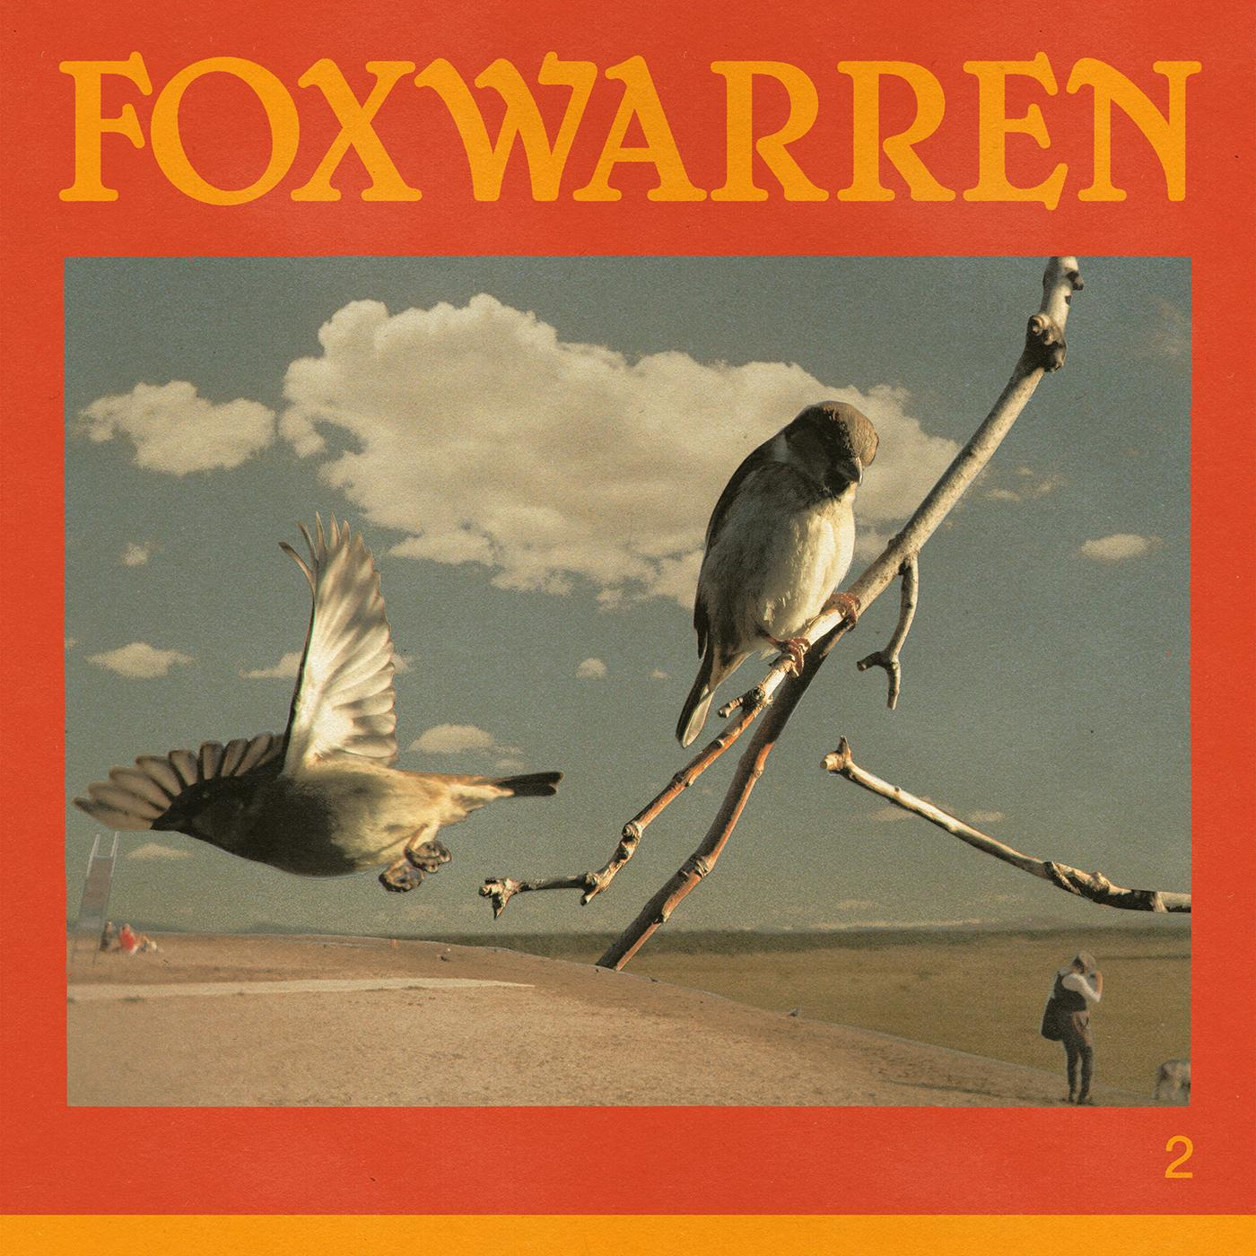

*2* Album Artwork

**Foxwarren Online**:

[Facebook](https://www.facebook.com/foxwarrenband/) | [X](https://x.com/foxwarrenband?lang=en) | [Bandcamp](https://foxwarren.bandcamp.com/album/foxwarren) | [ANTI-](https://www.anti.com/artists/foxwarren/)

For more information, please contact:

Jessica Linker & Patrick Tilley - [jessica@pitchperfectpr.com](mailto:jessica@pitchperfectpr.com), [patrick@pitchperfectpr.com](mailto:patrick@pitchperfectpr.com)

###