HEY, KING!
Release New Single and Video for
|“Half Alive” Today via
ANTI- Records
Watch Intimate Video Directed By and Featuring Hey, King! HERE

Produced by Ben Harper

August 4, 2020, Today Indie rock duo, Hey, King!, released their new single “Half Alive” via ANTI- Records. Hey, King! is songwriter, vocalist, and multi-instrumentalist Natalie London and her partner, vocalist and percussionist Taylor Plecity; the powerful “Half Alive” is their most personal song to date. Listen to the track and watch its new video HERE.

“‘Half Alive’ is the first song Ben Harper and I disagreed on the title for. I wanted to call it “sex song,” London jokes, “I still insist on calling it that on stage to the embarrassment of my mom when she’s in the audience.”

“Half Alive” is a perfect slice of London and Plecity’s relationship. Encompassing longing, chaos, and surrender, the song takes you on a journey between these two musicians.

For a song as incredibly personal and powerful as this, it made sense to have the band articulate it visually. They succeeded in creating something that feels vulnerable with a rawness and sensuality that serves the physicality of the song. Directed by and featuring London and Plecity, the video reflects their intimate and personal vision.

This song also speaks to London’s journey to allow love in her life again. After an almost fatal struggle with Lyme disease which left her bedridden for four years, the song speaks on how her relationship with Plecity changed her life.

In the final statement of the song, London powerfully sings, “I was only half alive before I loved you.” She explains, “That doesn’t mean you aren’t a whole person outside of a relationship, but it wasn’t until I let myself truly be loved that I realized how much of me had been comfortably numb.”

“Half Alive” is the band’s third single, Hey, King! previously released, “Don’t Let me Get Away” and Lucky”. All three songs were produced by multi GRAMMY Award winning musician and producer Ben Harper.

Ben Harper has been Hey, King!’s biggest champion since the moment he first discovered them through a mutual friend. Working with Harper in the studio evolved over the course of a year into a full length album which will be coming out on ANTI- in 2021.

Hey, King! is a high-spirited eight piece orchestral band when playing live, Hey, King! has the exuberance of Arcade Fire, the freewheeling simplicity of Tom Petty and the wit-filled resonance of Fiona Apple.

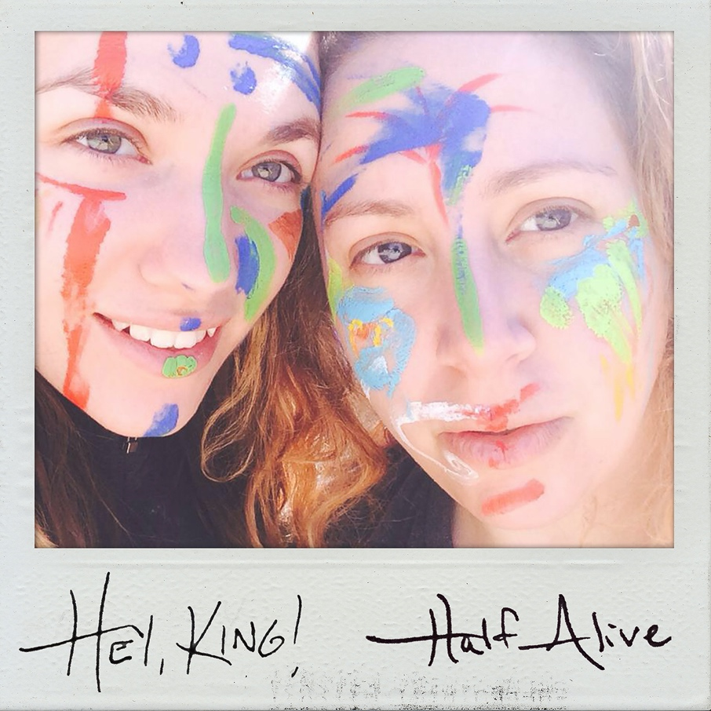

“Half Alive” is Out Now

https://heykingofficial.com/
F acebook | Instagram | Twitter

CONTACT: Facci PR

Sarah Facciolo - sarah@faccipr.com - 610-764-8334

