July 29, 2024
For Immediate Release

MJ Lenderman Releases New Single/Video, “Joker Lips”

New Album, Manning Fireworks, Out September 6th Via ANTI-

Fall North American Tour On Sale Now

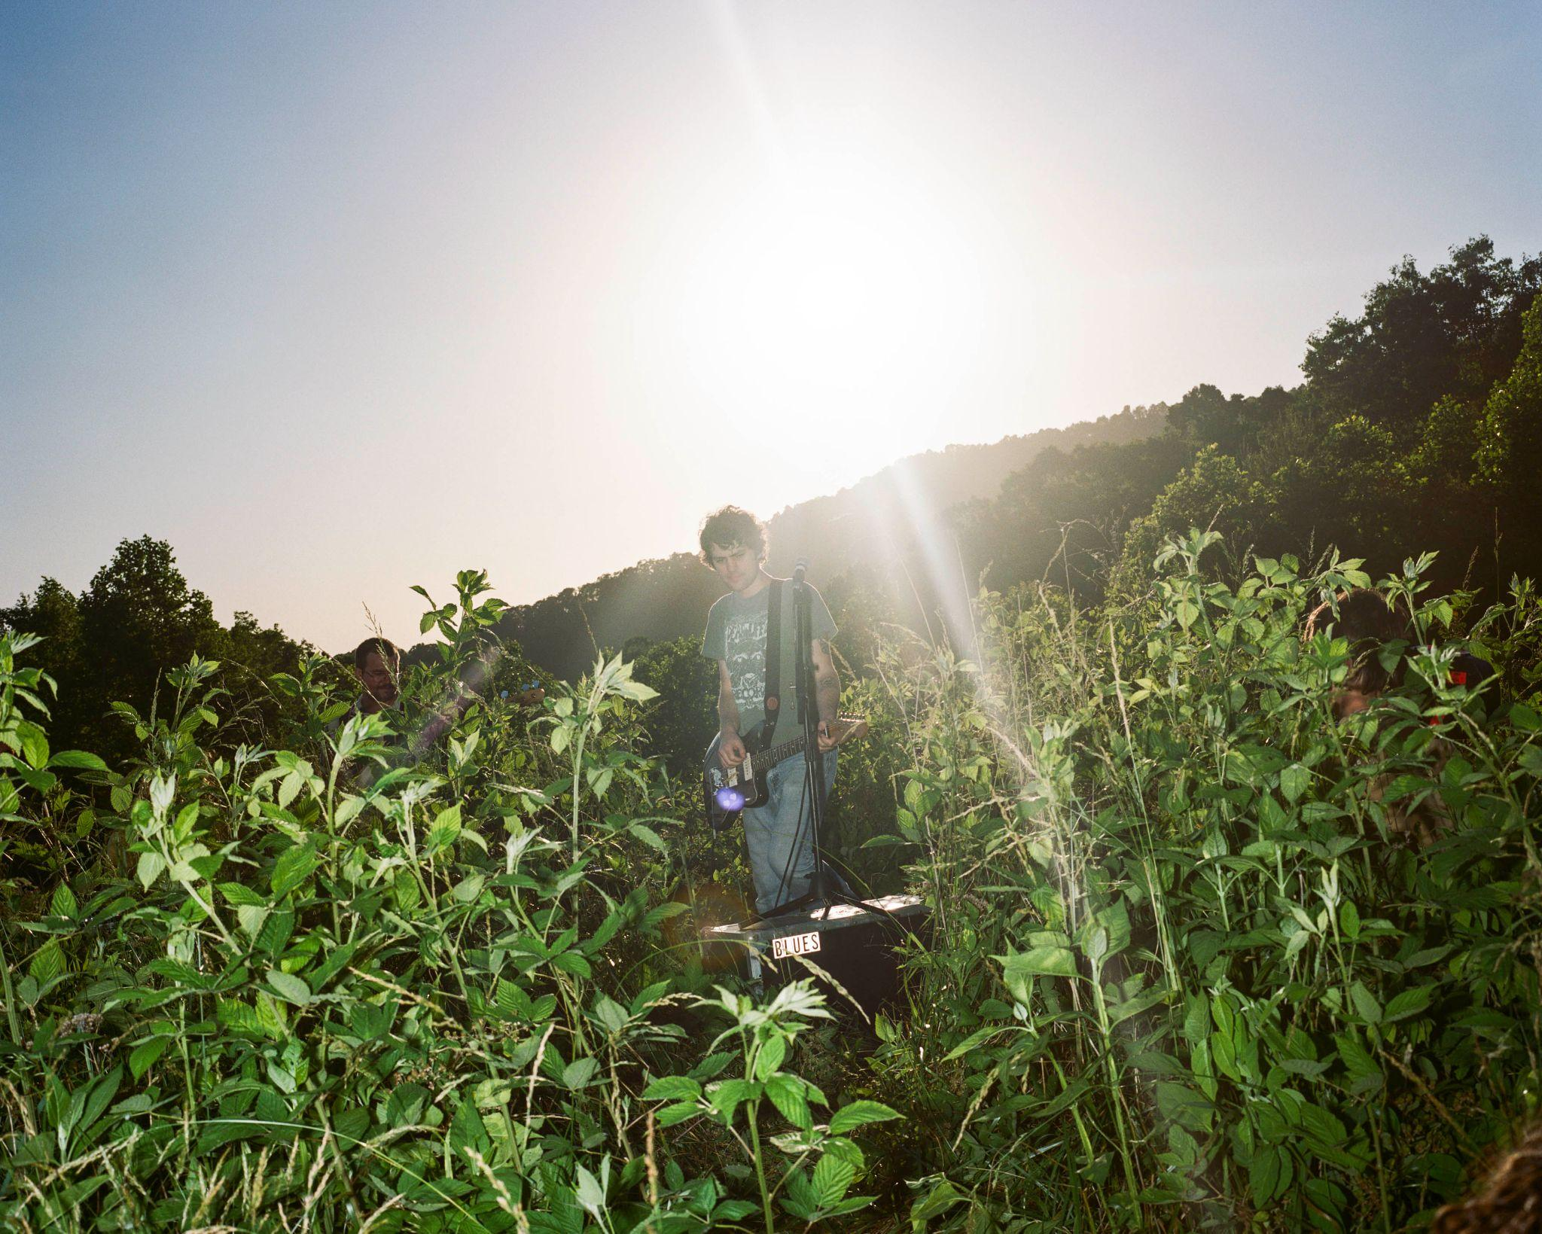
Photo Credit: Sam Resetarits

“On ‘She’s Leaving You,’ Lenderman has never made failure sound so good…Cap it off with a coarse, Crazy Horse–esque guitar solo and you’ve got a winner of a song.”
— Vulture, The Best Songs of 2024 (So Far)

“MJ Lenderman reliably writes with the wit and hindsight of someone at least double his age. The proof is in the slacker-country jam ‘She’s Leaving You.’”
— Stereogum, #1 Song of the Week

“‘She’s Leaving You,’ abounds with twangy, alt-country guitars, Lenderman’s reedy, emotive delivery…It’s a typical MJ Lenderman song, but typical Lenderman is always extraordinary.” — UPROXX

Last month, MJ Lenderman — the North Carolina-based singer, songwriter, and musician — announced his new album, Manning Fireworks, out September 6th via ANTI-, and released the “future fan favorite” (Consequence) lead single/video, “She’s Leaving You.” Today, Lenderman gives us another slice with the new single/video “Joker Lips.” A magnetic song about feeling pushed out by everyone else, Lenderman provides us a look at a renewed sincerity in his work, as he deadpans “Please don’t laugh / Only half of what I said was a joke.” Maybe you hear a tremble in his voice? That’s the frown behind the mask, finally slipping from Lenderman’s face. The video for “Joker Lips,” directed by Ben Turok, features Lenderman and The Wind performing in an overgrown field clung to the side of a mountain in Western North Carolina as plants seemingly envelop the band.

Watch the Video For “Joker Lips”

Manning Fireworks is an instant classic of an LP — a remarkable development in Lenderman’s story as an incisive singer songwriter, whose propensity for humor always points to some uneasy, disorienting darkness. The punchlines from his previous albums are still here, as are the rusted-wire guitar solos that have made him a favorite for indie rock fans looking for an emerging guitar hero, with Lenderman letting us in on his frank observations on the intersection of wit and sadness.

Recorded at Asheville’s Drop of Sun Studios and co-produced with frequent collaborator Alex Farrar, Lenderman plays nearly every instrument on the album, routing sadness and shame through guitars that echo the sparkle of R.E.M and the insistence of Drive-By Truckers. Writing where the poetic clarity of William Carlos Williams and the economy of Raymond Carver meet the striking imagery of Harry Crews, there are feelings of self-doubt and world weariness present, but the conditions are rendered with a clarity and care that make his songs feel like short films, as Lenderman simply offers everyday anxieties and enthusiasms in uncanny ways.

Lenderman and his live band The Wind will be embarking on a North American headline tour this coming fall, including three sold-out shows in New York and back-to-back nights in Chicago and Atlanta, alongside shows all over the Southeast, Midwest, and East Coast. Ryan Davis & the Roadhouse Band will be supporting on all dates, and tickets and more information can be found here.

Pre-order Manning Fireworks

Watch the Video for “She’s Leaving You”

MJ Lenderman Tour Dates
Thu. Sept. 5 - Sat. Sept. 7 - Raleigh, NC @ Hopscotch Music Festival
Wed. Sept. 18 - Nashville, TN @ Blue Room at Third Man % [SOLD OUT]
Thu. Sept. 19 - Nashville, TN @ Basement East (ANTI- Showcase at Americanafest)
Thu. Oct. 3 - Atlanta, GA @ Terminal West &
Fri. Oct. 4 - Atlanta, GA @ Terminal West & [SOLD OUT]
Sat. Oct. 5 - Nashville, TN @ Basement East & [SOLD OUT]
Sun. Oct. 6 - Knoxville, TN @ Bijou Theater &
Mon. Oct. 7 - Louisville, KY @ Whirling Tiger &
Tue. Oct. 8 - St. Louis, MO @ Off Broadway &
Thu. Oct. 10 - Omaha, NE @ Waiting Room &
Fri. Oct. 11 - Iowa City, IA @ Gabe’s &
Sat. Oct. 12 - Minneapolis, MN @ First Avenue &
Sun. Oct. 13 - Eau Claire, WI @ Stones Throw & [SOLD OUT]
Mon. Oct. 14 - Milwaukee, WI @ Turner Hall &
Wed. Oct. 16 - Chicago, IL @ Thalia Hall &
Thu. Oct. 17 - Chicago, IL @ Thalia Hall &
Fri. Oct. 18 - Detroit, MI @ El Club &
Sat. Oct. 19 - Toronto, ON @ Lee’s Palace & [SOLD OUT]
Mon. Oct. 21 - Montreal, QC @ Theatre Fairmount &
Tue. Oct. 22 - Boston, MA @ The Royale &
Thu. Oct. 24 - Philadelphia, PA @ Union Transfer &
Fri. Oct. 25 - Brooklyn, NY @ Music Hall of Williamsburg & [SOLD OUT]
Sat. Oct. 26 - Brooklyn, NY @ Music Hall of Williamsburg & [SOLD OUT]
Sun. Oct. 27 - Brooklyn, NY @ Music Hall of Williamsburg & [SOLD OUT]
Tue. Oct. 29 - Pittsburgh, PA @ Thunderbird Music Hall &
Wed. Oct. 30 - Washington, DC @ 9:30 Club &
Fri. Nov. 1 - Asheville, NC @ The Orange Peel &
Mon. Nov. 11 - Berlin, DE @ Privatclub ~
Tues. Nov. 12 - Hamburg, DE @ Hafenklang ~
Thu. Nov. 14 - Amsterdam, NL @ Bitterzoet
Fri. Nov. 15 - Brussels, BE @ Botanique Witloof Bar
Sat. Nov. 16 - Paris, FR @ Point Ephemere ~
Mon. Nov. 18 - London, UK @ The Garage ~ [SOLD OUT]
Tue. Nov. 19 - London, UK @ The Garage ~ [SOLD OUT]
Thu. Nov. 21 - Manchester, UK @ YES Pink Room ~ [SOLD OUT]
Fri. Nov. 22 - Leeds, UK @ Brudenell Social Club ~
Sat. Nov. 23 - Dublin, IE @ Workman’s Club ~ [SOLD OUT]
Sun. Nov. 24 - Dublin, IE @ Whelan’s ~

% Solo w/ Karly Hartzman
& w/ Ryan Davis & the Roadhouse Band
~ w/ Hollow Hand

Download hi-res images of MJ Lenderman

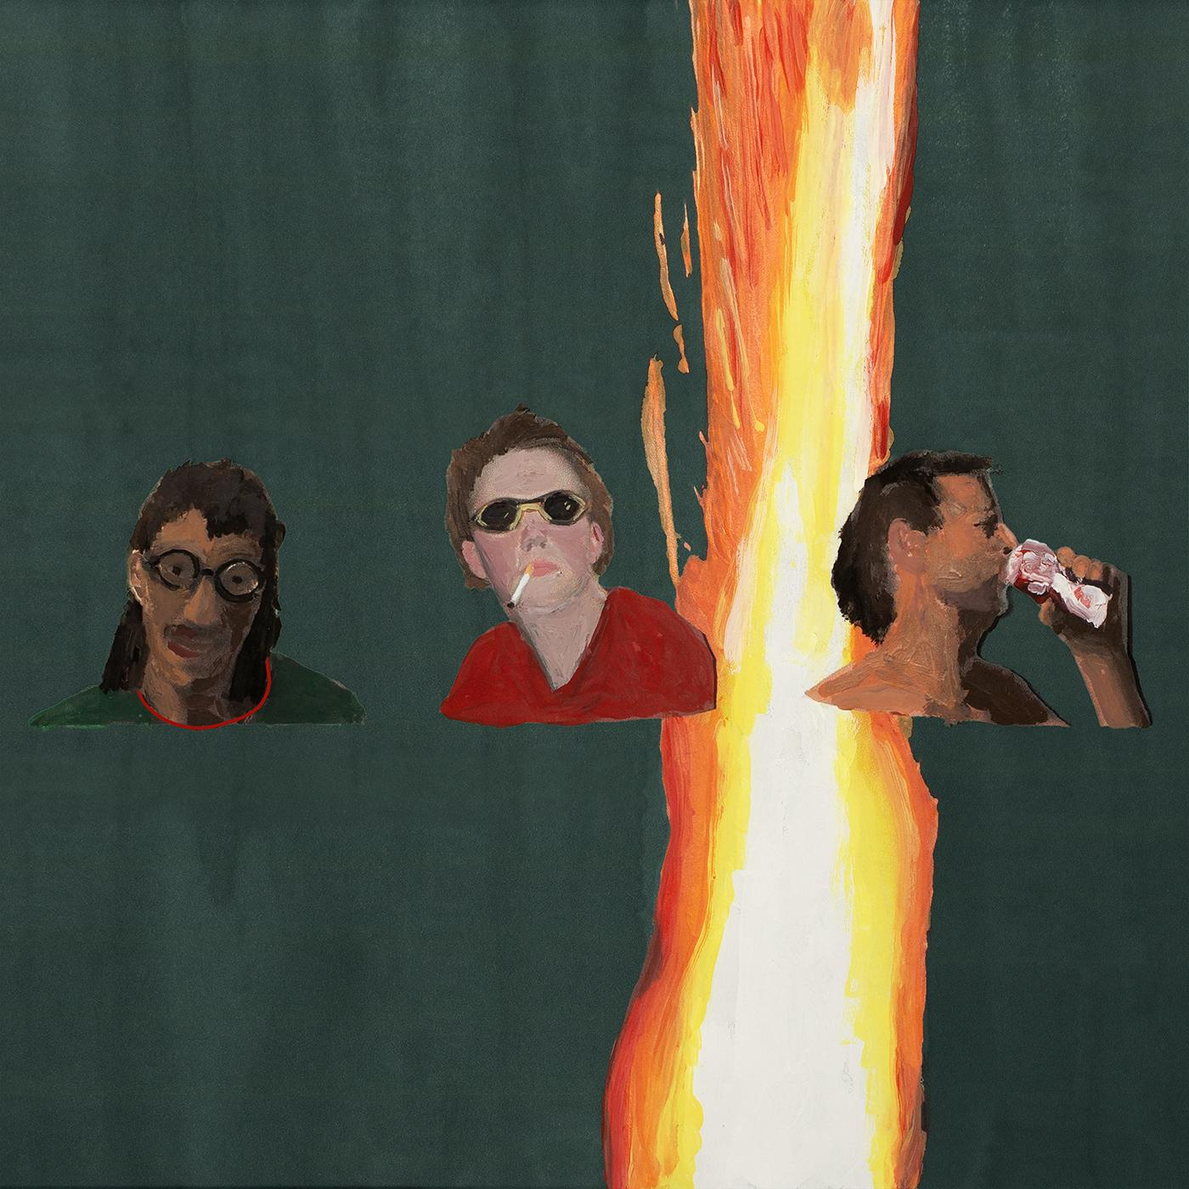
Manning Fireworks Album Artwork

Website | Bandcamp | Instagram | Twitter

For more information, contact:
Jessica Linker & Jacob Daneman | Pitch Perfect PR -
jessica@pitchperfectpr.com, jacob@pitchperfectpr.com

###

