July 9, 2024
For Immediate Release

MJ Lenderman & The Wind Announce Fall North American Tour
In Support of Manning Fireworks, New Album Out September 6th Via ANTI-

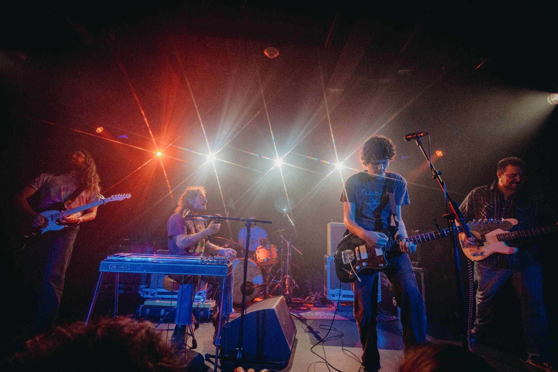
Photo Credit: Josh Darr

“[‘She’s Leaving You’] finds Lenderman flexing his characteristically clever and candid songwriting skills.” — Rolling Stone

“MJ Lenderman reliably writes with the wit and hindsight of someone at least double his age. The proof is in the slacker-country jam ‘She’s Leaving You.’” — Stereogum, #1 Song of the Week

“Manning Fireworks seemingly aims to double down on Lenderman’s irresistible folk rock stylings and clever, frank lyricism.” — Consequence

“The playfulness in Lenderman’s music makes for a damn fun live show" — GQ

On the heels of MJ Lenderman announcing his new album, Manning Fireworks, out September 6th via ANTI-, and releasing lead single, “She’s Leaving You,” the North Carolina-based singer, songwriter, and musician announces a fall North American headline tour. Featuring MJ’s live band The Wind, the tour includes back-to-back nights in New York and Chicago, plus shows all over the Southeast, Midwest and East Coast with Ryan Davis & the Roadhouse Band supporting on all dates.

For those unfamiliar with the MJ Lenderman live show, 2023’s “triumphant live album” (Pitchfork), And The Wind (Live and Loose!), perfectly documents why Lenderman is one of the most exhilarating live acts around, and why critic Steven Hyden proclaimed Live And Loose! as “the definitive entry in his discography thus far” and the best album of the 2020s so far. Tickets for all dates will be on-sale July 12th at 10am local time, and can be purchased here.

With Manning Fireworks, Lenderman lets us in on his frank observations on the intersection of wit and sadness. The punchlines from his previous albums are still here, as are the rusted-wire guitar solos, but there’s a new sincerity, too, as Lenderman lets listeners clearly see the world through his warped lens.

Recorded at Asheville’s Drop of Sun Studios during multiple four-day stints whenever Lenderman had a break from the road, and co-produced with frequent collaborator Alex Farrar, Lenderman plays nearly every instrument on the album. It is a remarkable development in his story as an incredibly incisive singer-songwriter, whose propensity for humor always points to some uneasy, disorienting darkness. Writing where the poetic clarity of William Carlos Williams and the economy of Raymond Carver meet the striking imagery of Harry Crews, there are feelings of self-doubt and world weariness present, but the conditions are rendered with a clarity and care that make his songs feel like short films, as Lenderman simply offers everyday anxieties and enthusiasms in uncanny ways.

Pre-order Manning Fireworks

Watch the Video for “She’s Leaving You”

MJ Lenderman Tour Dates
(New Dates in Bold)
Thu. Sept. 5 - Sat. Sept. 7 - Raleigh, NC @ Hopscotch Music Festival
Wed. Sept. 18 - Nashville, TN @ Blue Room at Third Man % [SOLD OUT]
Thu. Sept. 19 - Nashville, TN @ Basement East (ANTI- Showcase at Americanafest)
Fri. Oct. 4 - Atlanta, GA @ Terminal West &
Sat. Oct. 5 - Nashville, TN @ Basement East &
Sun. Oct. 6 - Knoxville, TN @ Bijou Theater &
Mon. Oct. 7 - Louisville, KY @ Whirling Tiger &
Tue. Oct. 8 - St. Louis, MO @ Off Broadway &
Thu. Oct. 10 - Omaha, NE @ Waiting Room &
Fri. Oct. 11 - Iowa City, IA @ Gabe’s &
Sat. Oct. 12 - Minneapolis, MN @ First Avenue &
Sun. Oct. 13 - Eau Claire, WI @ Stones Throw &
Mon. Oct. 14 - Milwaukee, WI @ Vivarium &
Wed. Oct. 16 - Chicago, IL @ Thalia Hall &
Thu. Oct. 17 - Chicago, IL @ Thalia Hall &
Fri. Oct. 18 - Detroit, MI @ El Club &
Sat. Oct. 19 - Toronto, ON @ Lee’s Palace &
Mon. Oct. 21 - Montreal, QC @ Theatre Fairmount &
Tue. Oct. 22 - Boston, MA @ The Royale &
Thu. Oct. 24 - Philadelphia, PA @ Union Transfer &
Fri. Oct. 25 - Brooklyn, NY @ Music Hall of Williamsburg &
Sat. Oct. 26 - Brooklyn, NY @ Music Hall of Williamsburg &
Tue. Oct. 29 - Pittsburgh, PA @ Thunderbird Music Hall &
Wed. Oct. 30 - Washington, DC @ 9:30 Club &
Fri. Nov. 1 - Asheville, NC @ The Orange Peel &
Mon. Nov. 11 - Berlin, DE @ Privatclub ~
Tues. Nov. 12 - Hamburg, DE @ Hafenklang ~
Thu. Nov. 14 - Amsterdam, NL @ Bitterzoet
Fri. Nov. 15 - Brussels, BE @ Botanique Witloof Bar
Sat. Nov. 16 - Paris, FR @ Point Ephemere ~
Mon. Nov. 18 - London, UK @ The Garage ~
Tue. Nov. 19 - London, UK @ The Garage ~ [SOLD OUT]
Thu. Nov. 21 - Manchester, UK @ YES Pink Room ~
Fri. Nov. 22 - Leeds, UK @ Brudenell Social Club ~
Sat. Nov. 23 - Dublin, IE @ Workman’s Club ~ [SOLD OUT]
Sun. Nov. 24 - Dublin, IE @ Whelan’s ~

% Solo w/ Karly Hartzman
& w/ Ryan Davis & the Roadhouse Band
~ w/ Hollow Hand

Download hi-res images of MJ Lenderman

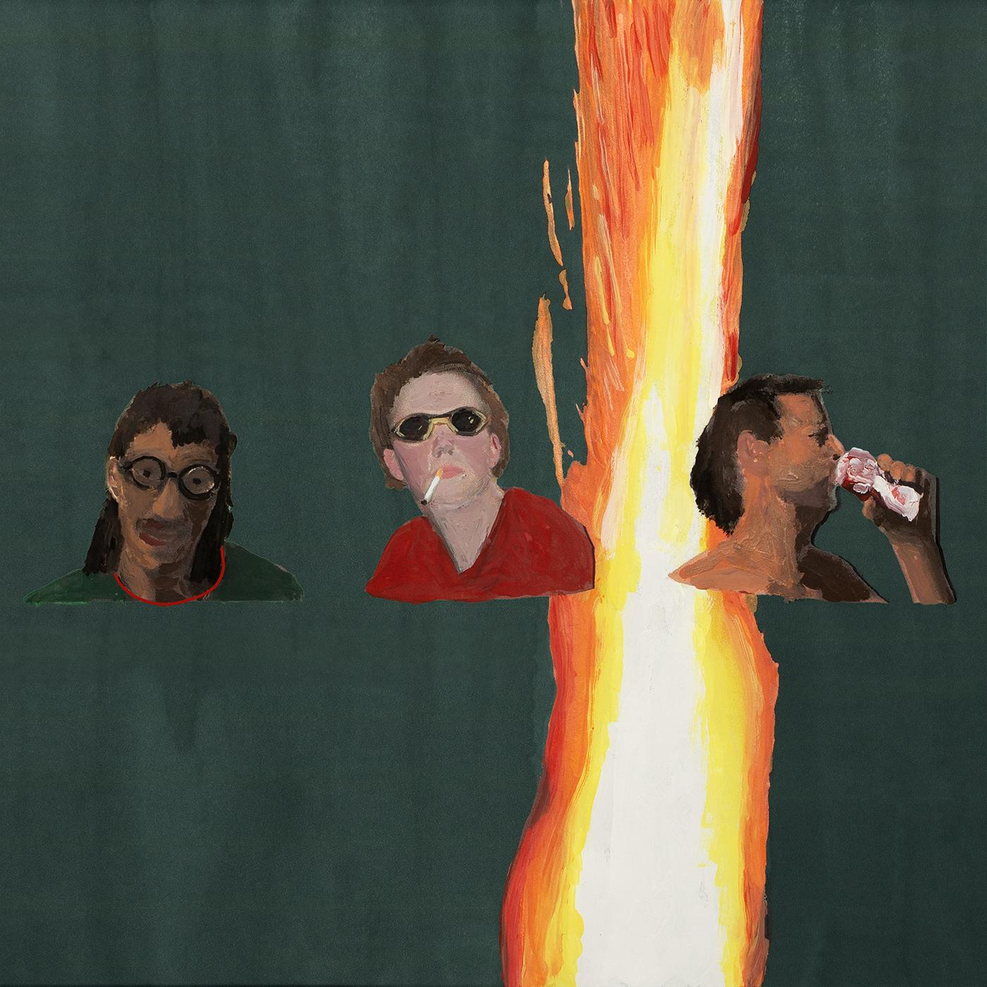
Manning Fireworks Album Artwork

Website | Bandcamp | Instagram | Twitter

For more information, contact:
Jessica Linker & Jacob Daneman | Pitch Perfect PR -
jessica@pitchperfectpr.com, jacob@pitchperfectpr.com

###

