M. Ward Reveals “Unreal City” Video;
North American Tour Kicks Off April 17; New Track “Torch” Out Now

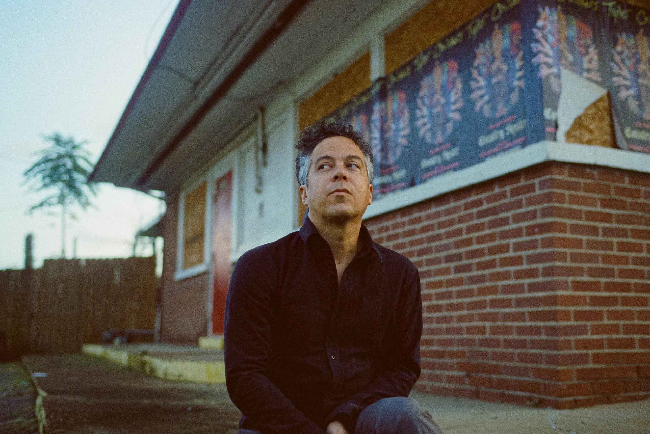
Photo Credit: Wrenne Evans

Watch “Unreal City” Video HERE

M. Ward has unveiled the video for his current single “Unreal City.” Directed by Beatrice Pegard and filmed in Paris, France, the video comes ahead of the April 3rd release of highly anticipated new album Migration Stories (Anti Records). Pegard adds, "The video is about finding joy and wonder in the most random moments and places, paying homage to Jean-Luc Godard and the New Wave."

Another track from the album, “Torch,” is out now.
Listen to “Torch” Here

For Migration Stories, his tenth studio album, Ward journeyed to Quebec, Canada to work with Arcade Fire’s Tim Kingsbury, Richard Reed Parry, producer/mixer Craig Silvey (Arcade Fire, Arctic Monkeys, Florence and the Machine) and Teddy Impakt. Together they recorded a collection of 11 songs inspired by stories of human migration. Languid, hazy and often dream-like in narrative, these songs have their origins in pictures from newspaper and television reports, stories told by friends and tales from Ward’s own family history. At Arcade Fire’s Montreal studios the assembled talents recorded what he describes as “11 largely instrumental ballads - a sci-fi fast forward to a more silent night many generations from here to a maybe-era where movement is free again.”

M. Ward released the album’s sublime opener “Migration Of Souls” at the tail end of 2019.

Listen to “Migration Of Souls” Here

Watch the Music Video for “Unreal City”
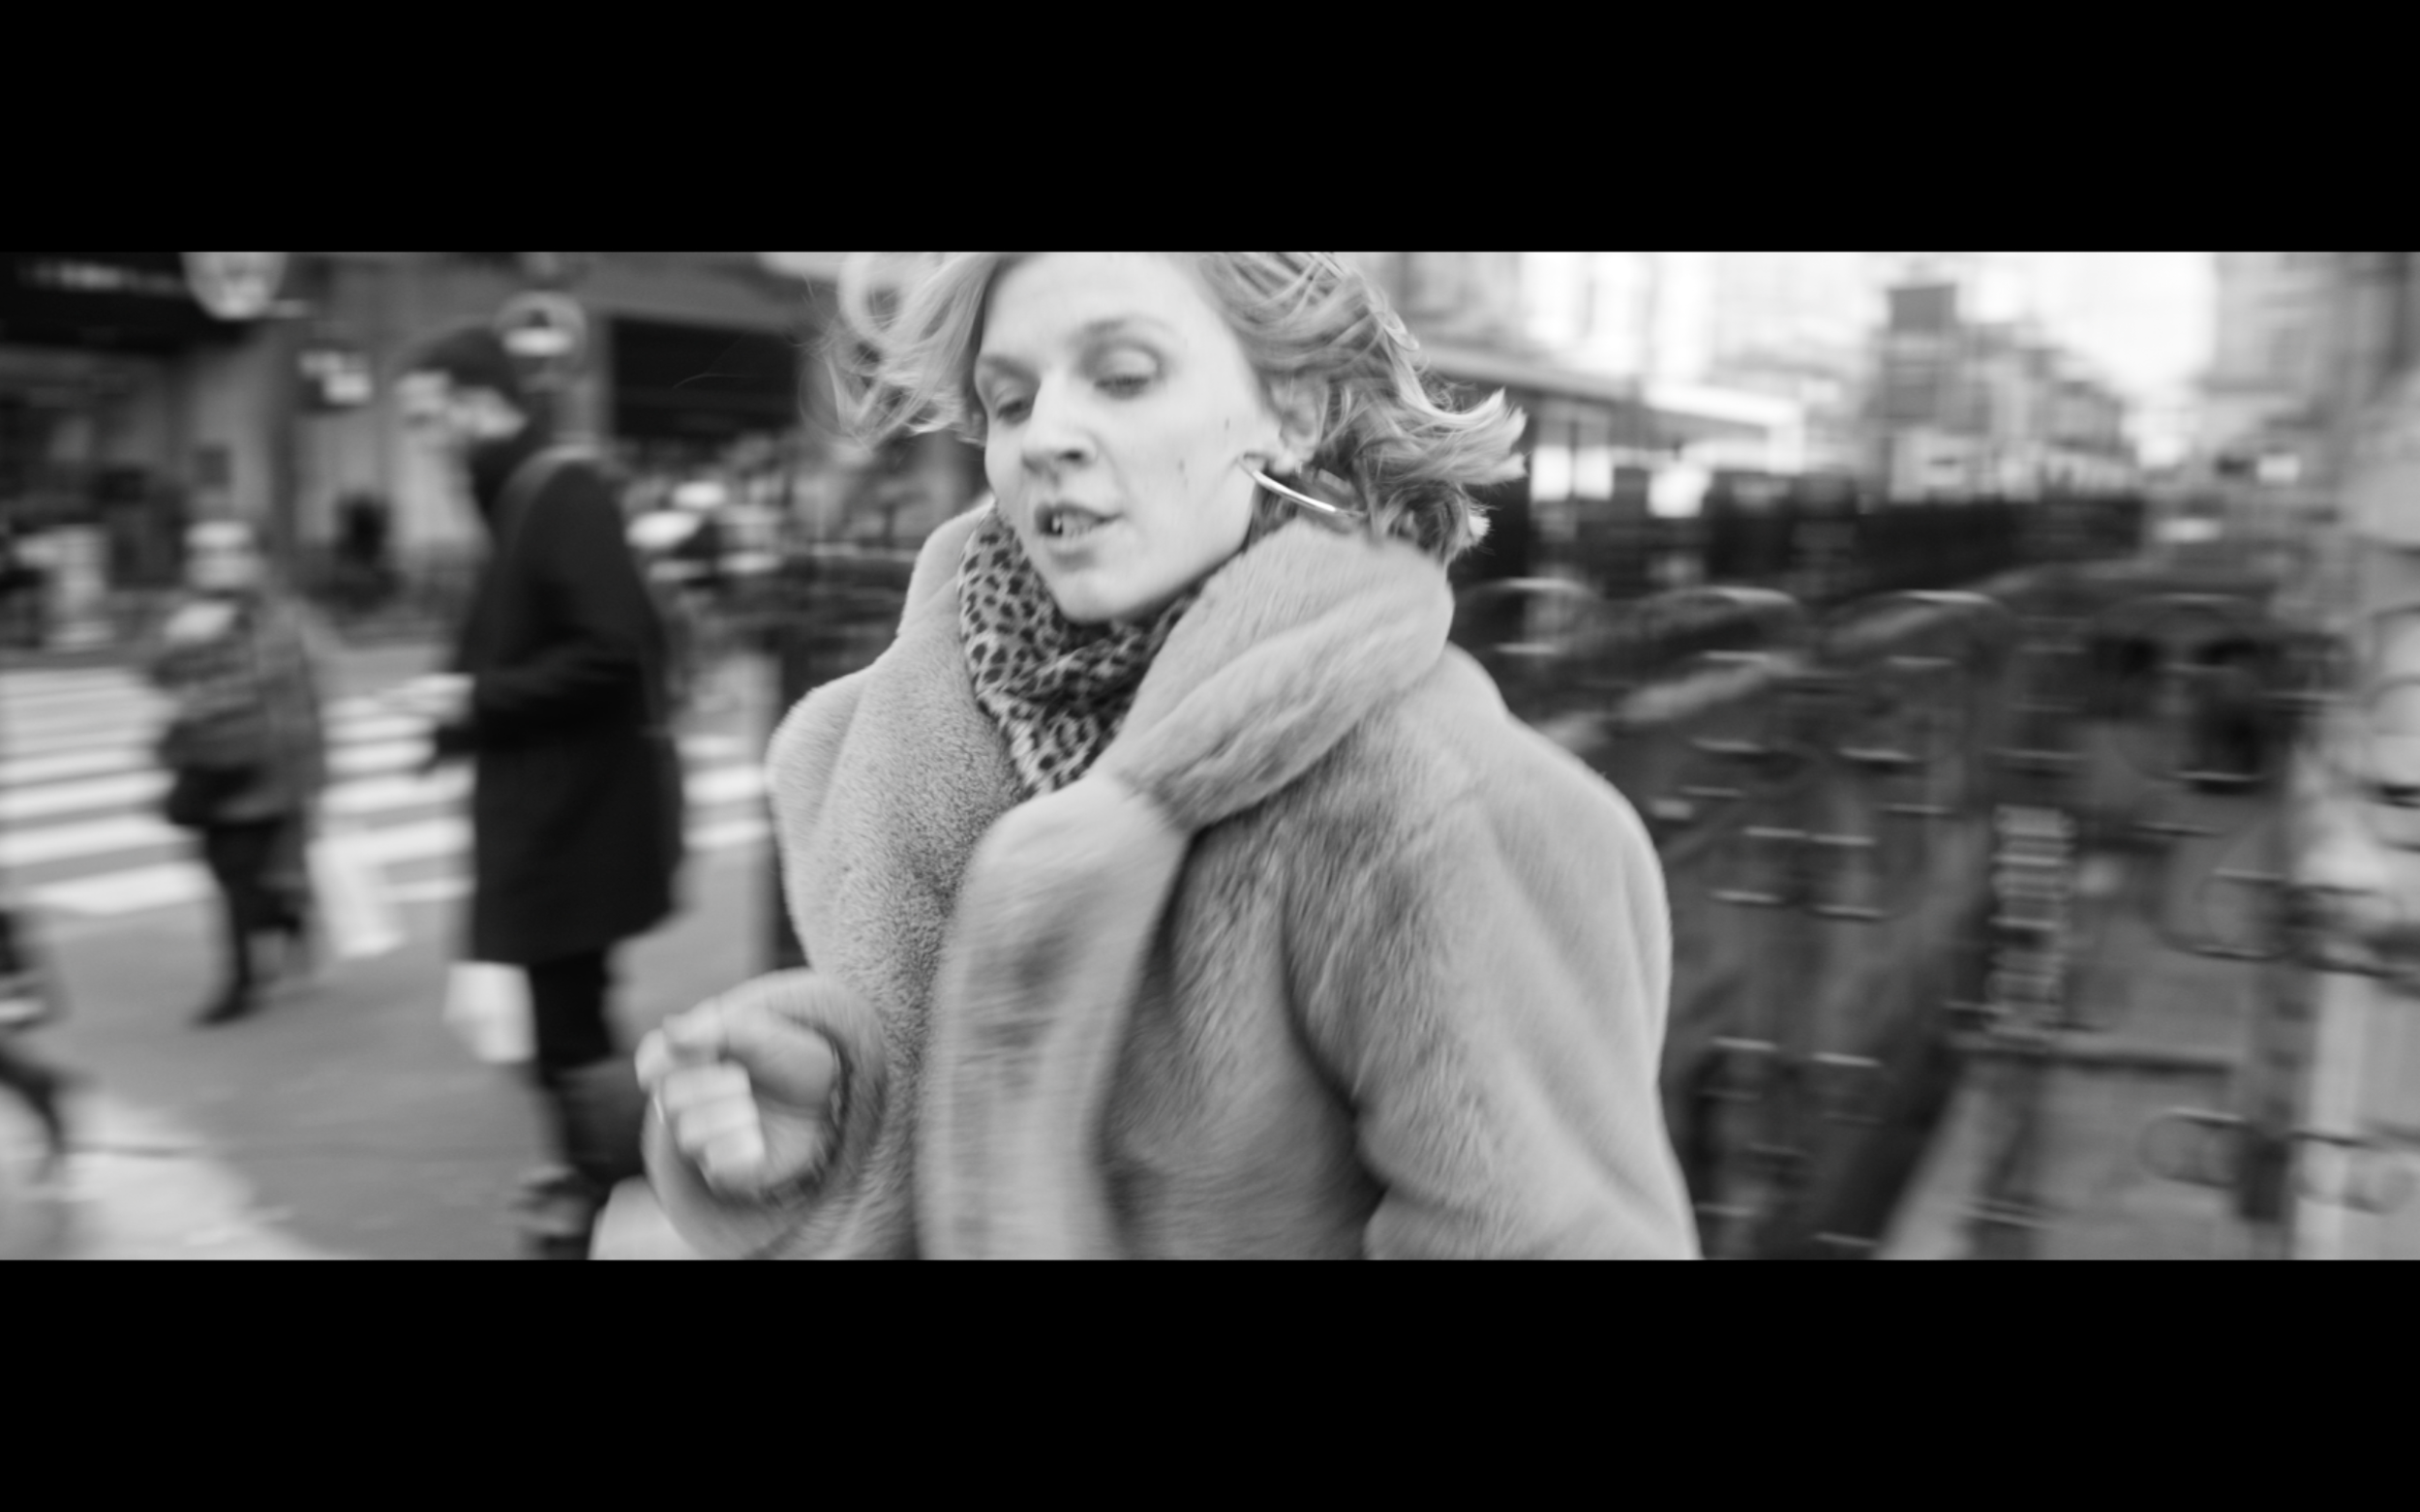

M. Ward Tour Dates:

04/17/20 - Philadelphia, PA @ Union Transfer - Tickets
04/18/20 - Washington, DC @ U Street Music Hall - Tickets
04/19/20 - Jersey City, NJ @ White Eagle Hall - Tickets
04/22/20 - New York, NY @ Bowery Ballroom - Tickets
04/24/20 - Boston, MA @ The Sinclair - Tickets
04/25/20 - Holyoke, MA @ Gateway City Arts - Tickets
04/26/20 - Woodstock, NY @ Levon Helm Studios - Tickets
04/28/20 - Ithaca, NY @ The Haunt - Tickets
04/29/20 - Toronto, ON @ The Great Hall - Tickets
05/01/20 - Chicago, IL @ Thalia Hall - Tickets
05/02/20 - Madison, WI @ Majestic Theatre - Tickets
05/03/20 - Minneapolis, MN @ First Avenue - Tickets
05/10/20 - Los Angeles, CA @ Regent Theater - Tickets
05/11/20 - Felton, CA @ Felton Music Hall - Tickets
05/14/20 - Portland, OR @ Revolution Hall - Tickets
05/16/20 - Seattle, WA @ The Neptune Theatre - Tickets
05/17/20 - Tacoma, WA @ Elks Temple - Tickets
05/19/20 - Sonoma, CA @ Gundlach Bundschu Winery - Redwood Barn - Tickets
05/20/20 - San Francisco, CA @ The Chapel - Tickets
05/22/20 - San Luis Obispo, CA @ Fremont Theater - Tickets
05/23/20 - Solana Beach, CA @ Belly Up Tavern - Tickets
10/27/20 - Edinburgh, UK @ The Caves - Tickets
10/28/20 - Liverpool, UK @ District - Tickets
10/29/20 - London, UK @ Islington Assembly Hall - Tickets
10/31/20 - Paris, France @ La Maroquinerie - Tickets
11/01/20 - Amsterdam, Netherlands @ Paradiso Noord - Tickets
11/02/20 - Cologne, Germany @ Blue Shell - Tickets
11/04/20 - Berlin, Germany @ Privatclub - Tickets
11/05/20 - København, Denmark @ Hotel Cecil - Tickets
11/06/20 - Oslo, Norway @ John Dee Live Club & Pub - Tickets
11/07/20 - Stockholm, Sweden @ Södra Teaterns - Tickets

Early Praise for M. Ward & Migration Stories:

“Migration Stories is a spare and spacious 11-song album. It’s written from the point of view of people living their day-to-day amidst political chaos, relying on faith and hope to keep going to try and find better lives. Ever since early human history, people have migrated, immigrated and emigrated. So, Ward thought, he should tell some of their stories. And he does so in his signature restrained, hypnotic style.” - American Songwriter

"While “Migration of Souls” leaned into Ward’s more sparse eerie folk roots, his latest single sits more in an ’80s-soaked synthy realm. Sparkling percussion, caramel-smooth synths, and tiny little punchy beats all meld in soothing sounds, with Ward’s own signature gravely timbre moving across with an unshakeable ease."” - Consequence of Sound

“The record approaches the complex conditions of human passage, some of which evoke Ward’s family history. But it does so from a place of aspiration, projecting an image of free movement amid peace.” - The Oregonian

Keep up with M. Ward:
Instagram / Website / Facebook / Twitter

For more information on M. Ward contact Chloe Walsh or Shane Greenberg: ChloeW@GrandstandHQ.com / ShaneG@GrandstandHQ.com / 213 278 0320

