February 20, 2024
For Immediate Release

CBS Saturday Morning Hosts Madi Diaz
in Support of New Album, Weird Faith, Now Out Via ANTI-

Watch Diaz Perform “For Months Now,” “Everything Almost,”
And “Don’t Do Me Good”

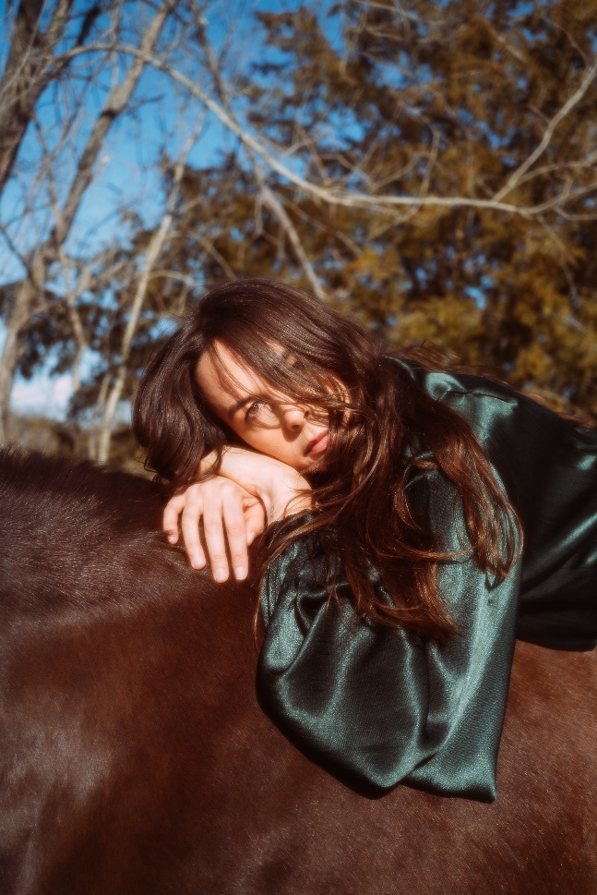
(Photo credit – Muriel Margaret)

“Madi Diaz fills Weird Faith with…crystal-clear, diamond-sharp writing on the rewards, anxieties, and humiliations of romance” — Pitchfork

Madi Diaz is “barreling towards stardom” (Billboard) and was welcomed on CBS Saturday Morning for the second time this past weekend in support of her new album, Weird Faith, now out via ANTI-. Following a whirlwind release week, performing on The Tonight Show Starring Jimmy Fallon and in-store performances at Rough Trade in New York City and Grimey's in her hometown of Nashville, Diaz (guitar, vocals) performed "For Months Now," “Everything Almost,” and “Don’t Do Me Good” alongside Allison Crutchfield (guitar, backing vocals), Brian Betancourt (bass) and Zoë Brecher (drums). The Weird Faith North American tour kicks off tomorrow, Wednesday, February 21 in Atlanta, GA.

Watch Madi Diaz’s Performance On CBS Saturday Morning:
"For Months Now"
"Everything Almost"
"Don't Do Me Good"

When Diaz started writing Weird Faith, she knew it would be bigger than a love story. These tracks explore how anxiety-inducing — if not downright humiliating — falling in love can be. The three songs performed on CBS Saturday Morning showcase common themes tied to this relatable experience of spinning out on the fall into love. “Everything Almost” displays Diaz’s constant wondering within a relationship, “For Months Now” explores the difficulty of trusting someone with your heart, and “Don’t Do Me Good” mourns the inevitable end. Weird Faith is “full of folk-pop gold” (Rolling Stone) and renders a self-portrait that captures Diaz in a fleeting moment in time, hungrily alive and forever searching.

Stream/Purchase Weird Faith
Watch Madi Diaz’s “Don’t Do Me Good” Video (Feat. Kacey Musgraves)
Watch Madi Diaz’s “Same Risk” Video
Watch Madi Diaz’s “Everything Almost” Lyric Video

Madi Diaz Tour Dates:
Wed. Feb. 21 - Atlanta, GA @ Terminal West *
Thu. Feb. 22 - Durham, NC @ Motorco Music Hall *
Fri. Feb. 23 - Charlotte, NC @ Neighborhood Theatre *
Sat. Feb. 24 - Charlottesville, VA @ Jefferson Theater *
Tue. Feb. 27 - Washington, DC @ The Atlantis *
Wed. Feb. 28 - Philadelphia, PA @ World Cafe Live *
Thu. Feb. 29 - Cambridge, MA @ The Sinclair *
Fri. Mar. 1 - Brooklyn, NY @ Music Hall of Williamsburg *
Sun. Mar. 3 - Toronto, ON @ The Danforth Music Hall *
Tue. Mar. 5 - Ann Arbor, MI @ The Ark #
Wed. Mar. 6 - Chicago, IL @ Lincoln Hall #
Thur. Mar. 7 - St. Louis, MO @ Off Broadway #
Fri. Mar. 8 - Nashville, TN @ Brooklyn Bowl #
Thur. Mar. 14 - Spicewood, TX Luck Reunion
Sat. Mar. 16 - Dallas, TX @ The Kessler Theater !
Tue. Mar. 19 - Denver, CO @ Bluebird Theater %
Wed. Mar. 20 - Fort Collins, CO @ Aggie Theatre %
Fri. Mar. 22 - Salt Lake City, UT @ The State Room %
Wed.-Sun. Mar. 20 - 24 Boise, ID Treefort Fest
Mon. Mar. 25 - Vancouver, BC @ Fox Cabaret %
Tue. Mar. 26 - Seattle, WA @ Madame Lou's %
Wed. Mar. 27 - Portland, OR @ Doug Fir Lounge %
Fri. Mar. 29 - Oakland, CA @ The New Parish %
Sat. Mar. 30 - Felton, CA @ Felton Music Hall %
Tue. Apr. 2 - San Diego, CA @ Music Box %
Thu. Apr. 4 - Los Angeles, CA @ Troubadour %
Fri. May 24 Boston, MA Boston Calling

With Special Guests:
* Olivia Barton
# Jack Van Cleaf
% Daniel Nunnelee
! Jackson Scribner

Praise for Madi Diaz’s Weird Faith:

"You’ll be playing this one over and over again.” — Rolling Stone on ‘Don’t Do Me Good’

“[Weird Faith] feels like…a level up in every regard.” — Paste
“[Madi and Kacey’s] voices beautifully intertwine and give what could be a solely devastating track a hint of an uplifting tone.” — PEOPLE on “Don’t Do Me Good”

"Weird Faith…exceeds any new hype she’s gathered, as a collection of complex love songs that’s often breathtaking in its artistic clarity.” — Billboard

“Weird Faith seems poised to cement Diaz’s place in the musical landscape of Americana.”
— them.

“[Madi Diaz] blends striking vulnerability with raw hopefulness on Weird Faith.”
— Garden & Gun

“Diaz captures the duality of both positive and negative feelings that materialize even when things are at their best. Her songs have long been about these internal reflections on her life and personal growth—on Weird Faith, they just happens to include a love story.” – FLOOD

“[Weird Faith] is a fraught meditation on love and unhealthy cycles, filled with bare-bone confessionals that find her circling her own neurotic habits, toxic thought patterns, and an ever-hopeful desire to be better.” — NYLON

“Diaz flexes her own particular It Factor with Weird Faith.” — Exclaim

Download hi-res images and jpegs of Madi Diaz

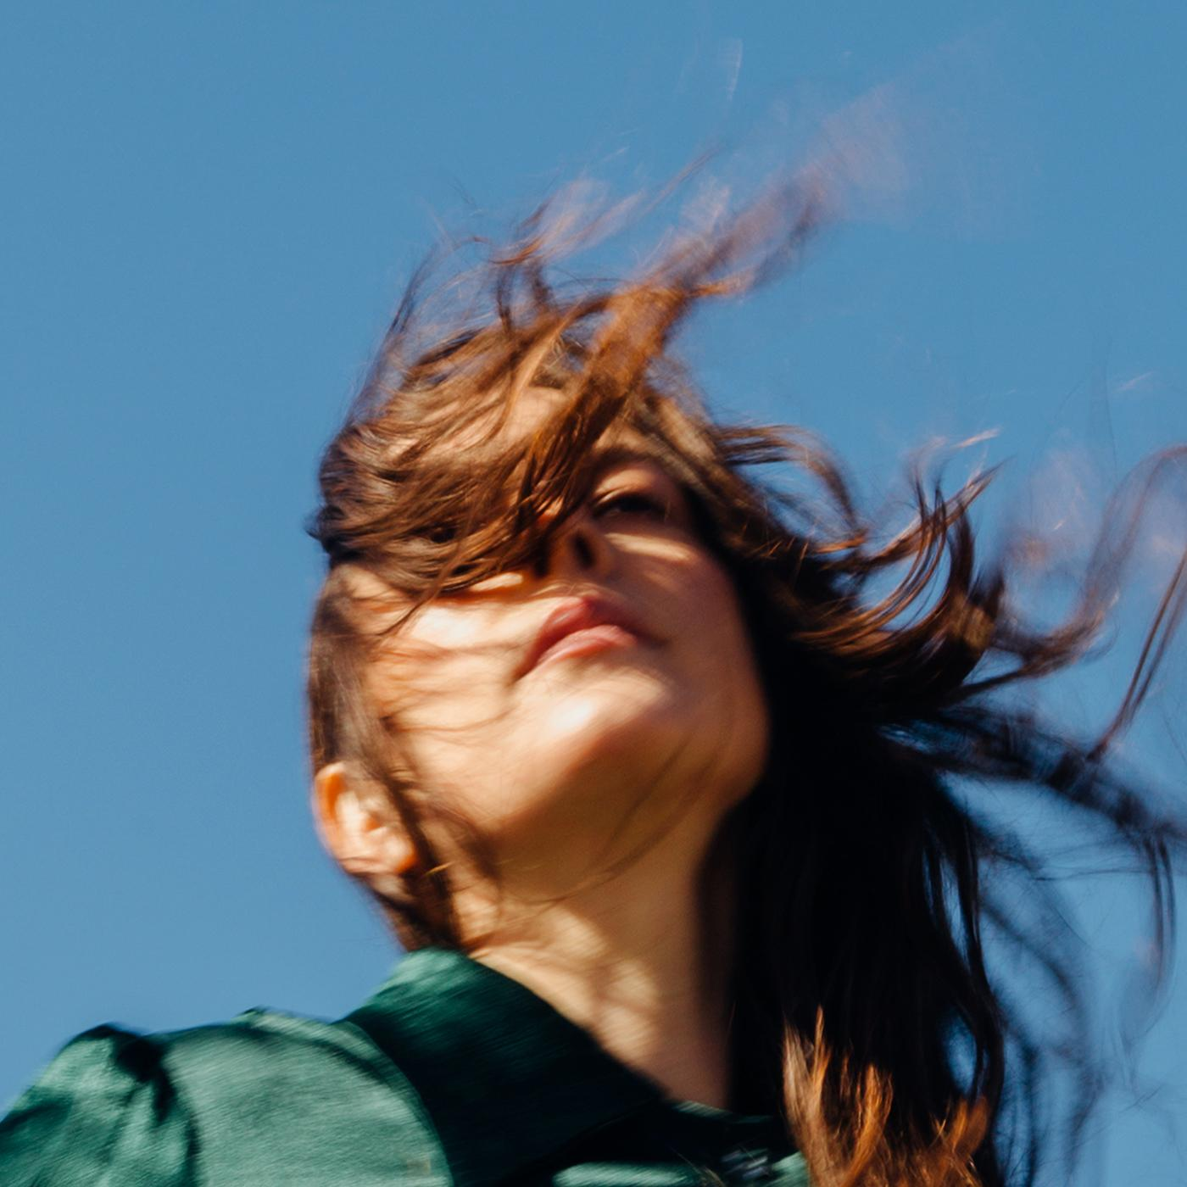
(Weird Faith Cover Artwork)

Madi Diaz Online:
Website | Instagram | Facebook | Twitter

For more information, contact:
Jessica Linker & Jaycee Rockhold | Pitch Perfect PR –
jessica@pitchperfectpr.com, jaycee@pitchperfectpr.com, 773-942-6954

