April 10, 2024
For Immediate Release

Madi Diaz Releases New Single, “One Less Question” Featuring Lennon Stella

Watch Diaz & Stella Perform “One Less Question” On Jimmy Kimmel Live!

New Album, Weird Faith, Now Out Via ANTI-

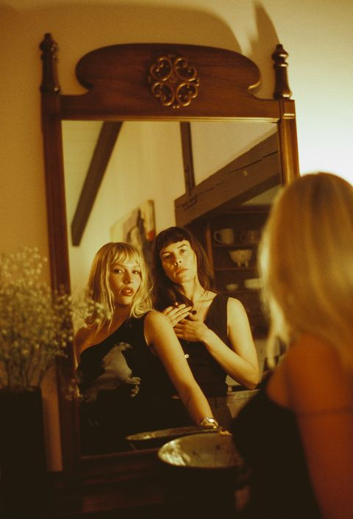
Photo Credit: Caity Krone

“Madi Diaz is barreling toward stardom.” — Billboard

“[Madi Diaz] is at the height of her powers.” — NPR Music

“Nashville’s secret weapon is leveling up with an LP full of folk-pop gold.” — Rolling Stone

“[Diaz's] specialty as a songwriter is creating intimate moments of a grand scale through her cathartic, sing-along hooks. The songs would sound just as at home in a sold-out arena as they would alone in the car on a late-night drive.” — Nashville Scene

Nashville musician, songwriter and performer Madi Diaz just wrapped her headline tour in support of her “magnificent” (Forbes) new album, Weird Faith, further establishing Diaz as “one of our most important songwriters” (Paste). Bold in its honesty, Weird Faith highlights the human experience of spinning out on the fall into love. She now returns and further explores these ideas with “One Less Question” featuring multi-hyphenate Lennon Stella. Together, Diaz and Stella debuted the song last night on Jimmy Kimmel Live!, marking Diaz’s return to the show. Co-produced by Konrad Snyder and Diaz, who co-wrote with Stella, and Kate York, the song is about real love, and, as Diaz explains, “how real love doesn’t make you wonder. How it feels when you know in your whole body that this person is in your life to stay. It’s unconditional. It's trust. It’s true. It’s just one less question you have to answer because that person IS an answer. What a beautiful thing to get to experience that feeling.”

Diaz further states, “I’m beyond honored that Lennon let me record my version of this song, and the very idea that she said yes when I asked her to be a part of it couldn’t be more of a dream come true. I’m honored to have her be a part of this story and I’m honored to be a small part of hers. This song simply wouldn’t exist if we hadn’t found one another.”

“I love this song so much,” says Stella. “Madi and I wrote it with Kate York, on the night of a hang at my house out in Leipers Fork. I am so excited for this one to be heard. It’s incredibly special to the three of us.”

“One Less Question” furthers Diaz’s collaborations with incredible musicians, including Angel Olsen, Waxahatchee, Courtney Marie Andrews, Joy Oladokun, and most recently Kacey Musgraves, who Diaz will be supporting throughout Europe and the UK beginning later this month.

Listen To “One Less Question” (Feat. Lennon Stella)

Watch Madi Diaz Perform “One Less Question” On Jimmy Kimmel Live!

Stream/Purchase Weird Faith
Watch Madi Diaz’s “Don’t Do Me Good” Video (Feat. Kacey Musgraves)
Watch Madi Diaz’s “Same Risk” Video
Watch Madi Diaz’s “Everything Almost” Video

Madi Diaz Tour Dates:
Sun. Apr. 28 - Dublin, IE @ 3Olympia Theatre %
Wed. May 1 - Amsterdam, NL @ Paradiso %
Thu. May 2 - Amsterdam, NL @ Paradiso %
Fri. May 3 - Brussels, BE @ Ancienne Belgique %
Sun. May 5 - Cologne, DE @ Carlswerk Victoria %
Mon. May 6 - Hamburg, DE @ Docks %
Thu. May 9 - Glasgow, UK @ O2 Academy Glasgow %
Fri. May 10 - Glasgow, UK @ O2 Academy Glasgow %
Sat. May 11 - Manchester, UK @ O2 Academy Manchester %
Mon. May 13 - Wolverhampton, UK @ The Halls Wolverhampton %
Tue. May 14 - London, UK @ Roundhouse %
Wed. May 15 - London, UK @ Roundhouse %
Thu. May 16 - London, UK @ St. Pancras Old Church
Fri. May 24 - Boston, MA @ Boston Calling
Sun. Sept. 22 - Louisville, KY @ Bourbon & Beyond

% supporting Kacey Musgraves

Praise for Madi Diaz’s Weird Faith:

“What starts with modest acoustic guitar strumming rises with an orchestral crescendo to match the urgency of her questions.” — New York Times on “Same Risk”

“[Madi and Kacey’s] voices beautifully intertwine and give what could be a solely devastating track a hint of an uplifting tone.” — PEOPLE on “Don’t Do Me Good”

“Madi Diaz fills Weird Faith… with crystal-clear, diamond-sharp writing on the rewards, anxieties, and humiliations of romance.” — Pitchfork

“Weird Faith seems poised to cement Diaz’s place in the musical landscape of Americana.”
— them.

“Diaz is an excellent songwriter; her pop-folk earworms are honest and searching, giving them an earned emotional impact.” — Stereogum

"Madi Diaz is brazen, bold, unfiltered.” — The Tennessean

“[Madi Diaz] blends striking vulnerability with raw hopefulness on Weird Faith.”
— Garden & Gun

“[Weird Faith] feels like…a level up in every regard.” — Paste

“[Weird Faith] is a fraught meditation on love and unhealthy cycles, filled with bare-bone confessionals that find her circling her own neurotic habits, toxic thought patterns, and an ever-hopeful desire to be better.” — NYLON

Download hi-res images and jpegs of Madi Diaz

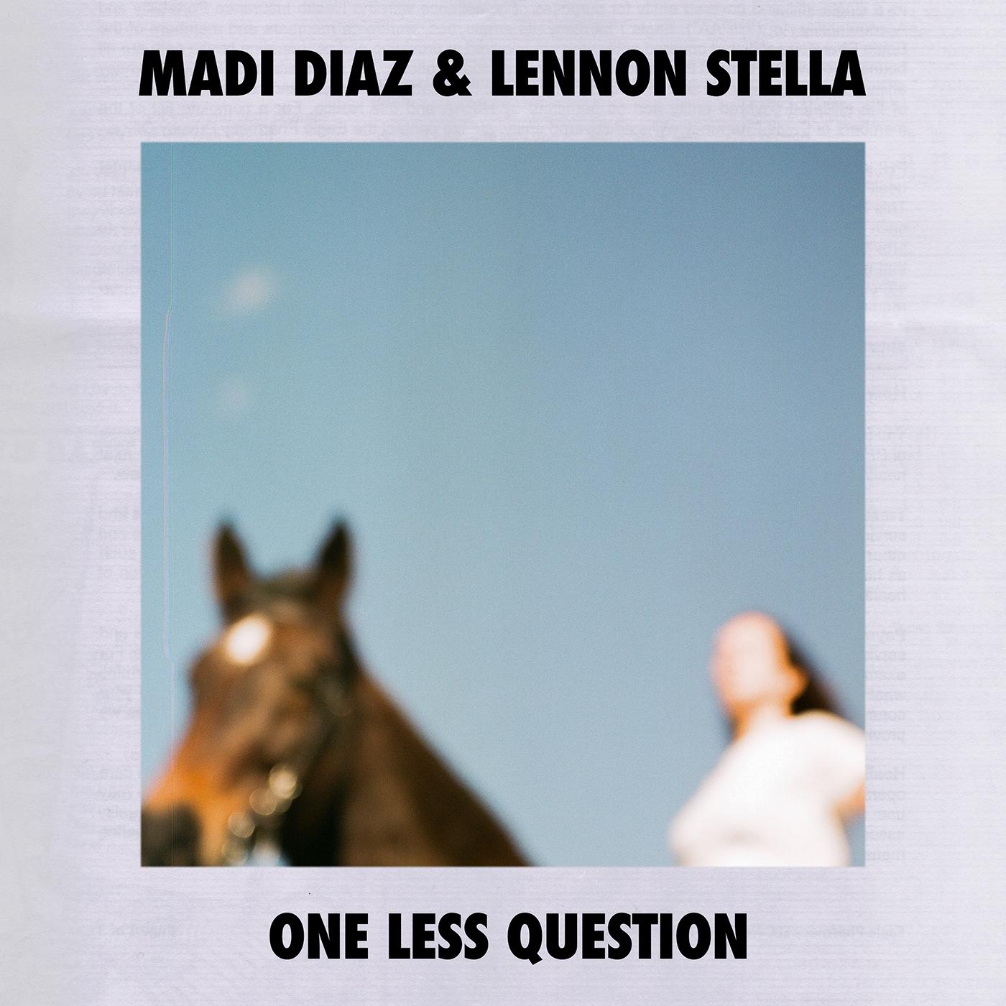
(“One Less Question” Single Artwork)

Madi Diaz Online:
Website | Instagram | Facebook | Twitter

For more information, contact:
Jessica Linker & Jaycee Rockhold | Pitch Perfect PR –
jessica@pitchperfectpr.com, jaycee@pitchperfectpr.com, 773-942-6954

