July 28, 2021
For Immediate Release

Madi Diaz Reveals New Single/Video, “Resentment,”

And Announces 2021 Tour

New Album, History Of A Feeling, Out August 27th via ANTI-

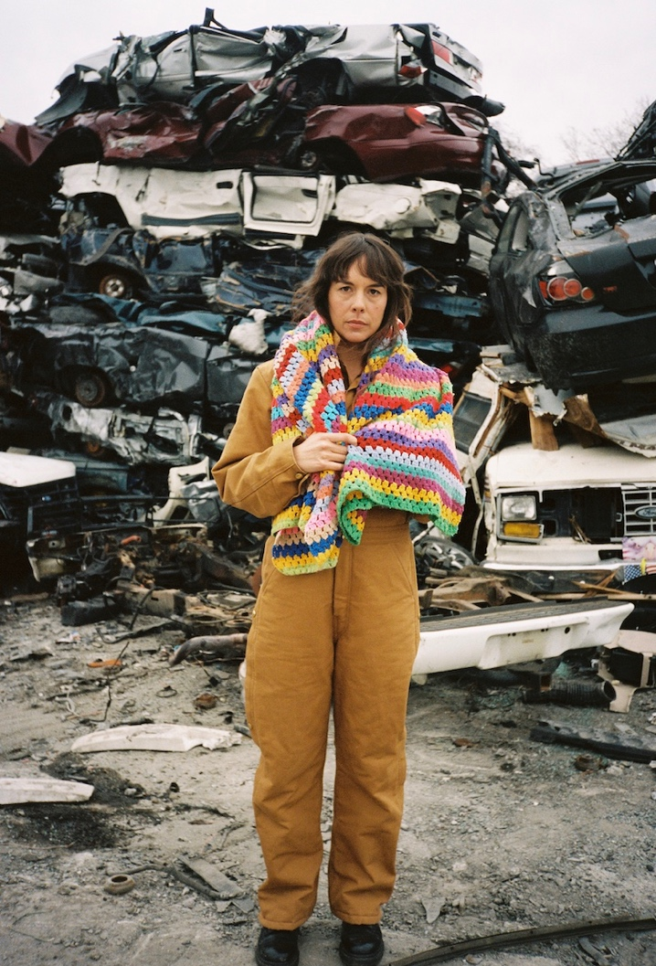
Photo Credit: Natalie Osborne

“Madi Diaz has a voice that erupts like a geyser.’” - NYLON

“A slow burning, passionate ballad...It certainly has a lot of heart to it.” - The Needle Drop

“[‘Woman In My Heart’ is] a saccharine blend of guitars and building percussion, with Diaz’s vocals resonating through it all.” - Paste

Nashville-based songwriter Madi Diaz reveals the final pre-release single/video, “Resentment,” from her forthcoming album, History Of A Feeling, out August 27th via ANTI-, and announces a 2021 tour. Diaz has released a string of powerful singles, and today’s “Resentment” is resonant and heartbreakingly honest. The song, written by Diaz, Wrabel, and Jamie Floyd, originally appeared on Kesha’s last album and featured Sturgill Simpson and Brian Wilson. In Diaz's version of the song, the rawness of the emotional reaction she is singing about matches the recording - stripped back to only vocals and guitar: “I don’t hate you babe it’s worse than that // Cause you hurt me and I’m more than sad // I’ve been building up this thing for months // Resentment.” The accompanying video directed by $ECK at the Four Lane Auto Salvage in Nashville picks up where the video for “New Person, Old Place” left off. Diaz wanders around the junkyard, letting her emotions out on the surrounding wreckage.

“It felt completely and strangely cathartic walking around ruin and wreckage in the salvage yard making the ‘Resentment’ video,” says Diaz. “It was somehow representative of all the feelings I’ve let sit and rot and rust, probably becoming more hazardous with time and neglect. It was almost a kind of joyful act smashing up cars like maybe I was crushing and compounding my own resentments. Basically it’s cheap therapy and I highly recommend it. I loved making this video and I think Seck has such a beautiful eye…somehow he made poetry out of something pretty brutal.”

Watch Madi Diaz’s Video for “Resentment”

History Of A Feeling undeniably marks Diaz’s status as a first-rate songwriter, a craft she’s spent years refining. Across the album, she cycles through the full spectrum of emotions of coming to terms with the dissolution of a meaningful relationship. She plays the line between the personal and the general with dexterity: in Diaz’s hands, quiet moments of self-pity are transformed into grand meditations on heartbreak, and unwieldy knots of big existential feelings are smoothed out with a sense of clear-eyed precision.

The seedlings of History Of A Feeling first sprouted three years ago, before beginning collaborations with co-producer Andrew Sarlo (Big Thief, Bon Iver). Pulling from a range of folk, country and pop leanings, as much influenced by Patty Griffin and Lori McKenna as PJ Harvey and Kathleen Hanna, History Of A Feeling is comprised of the most direct and introspective songs Diaz has ever written. Throughout, she seamlessly weaves a profound sense of intimacy and camaraderie as her lyrics are relatable to anyone who has experienced heartbreak and great change in some manner. These universals are shaded by the fact that the relationship breakdown Diaz is chronicling coincided with her former partner transitioning, a complex reckoning Diaz approaches with empathy, candor, and care.

Diaz, performing at times solo or as a three-piece (Diaz on guitar, Sarab Singh on drums, Matt Chancey on bass), will support The Tallest Man On Earth, Little Big Town, and Caamp this summer and fall. She’ll celebrate History Of A Feeling’s release in her hometown of Nashville on Friday, August 27th. All dates are below.

Pre-order History Of A Feeling

Watch Madi Diaz Videos:
“Nervous”
“New Person, Old Place”
“Man In Me”
“Woman In My Heart”

Madi Diaz Tour Dates
Fri. July 30 - Paso Robles, CA @ California Mid-State Fair *
Sat. July 31 - Saratoga, CA @ Mountain Winery *
Sun. Aug. 1 - Modesto, CA @ The Fruit Yard *
Sun. Aug. 8 - Evanston, IL @ Canal Shores Golf Course ^
Fri. Aug. 27 - Nashville, TN @ Soft Junk - Record Release Show %
Wed. Oct. 6 - Austin, TX @ Scoot Inn #
Mon. Oct. 11 - Knoxville, TN @ Bijou Theatre #
Wed. Oct. 13 - Asheville, NC @ Asheville Masonic Temple #
Thu. Oct. 14 - Saxapahaw, NC @ Haw River Ballroom #
Sat. Oct. 16 - Westerly, RI @ The Knickerbocker Music Center #
Sun. Oct. 17 - Woodstock, NY @ Levon Helm Studios #
Mon. Oct. 18 - Charlton, MA @ Tree House Brewing Company #

* = w/ Little Big Town
^ = w/ Caamp
% = w/ Bre Kennedy, Jonathan Childers & DJ Set by Jeremy Todd
# = The Tallest Man on Earth (solo)

Download hi-res images and jpegs of Madi Diaz
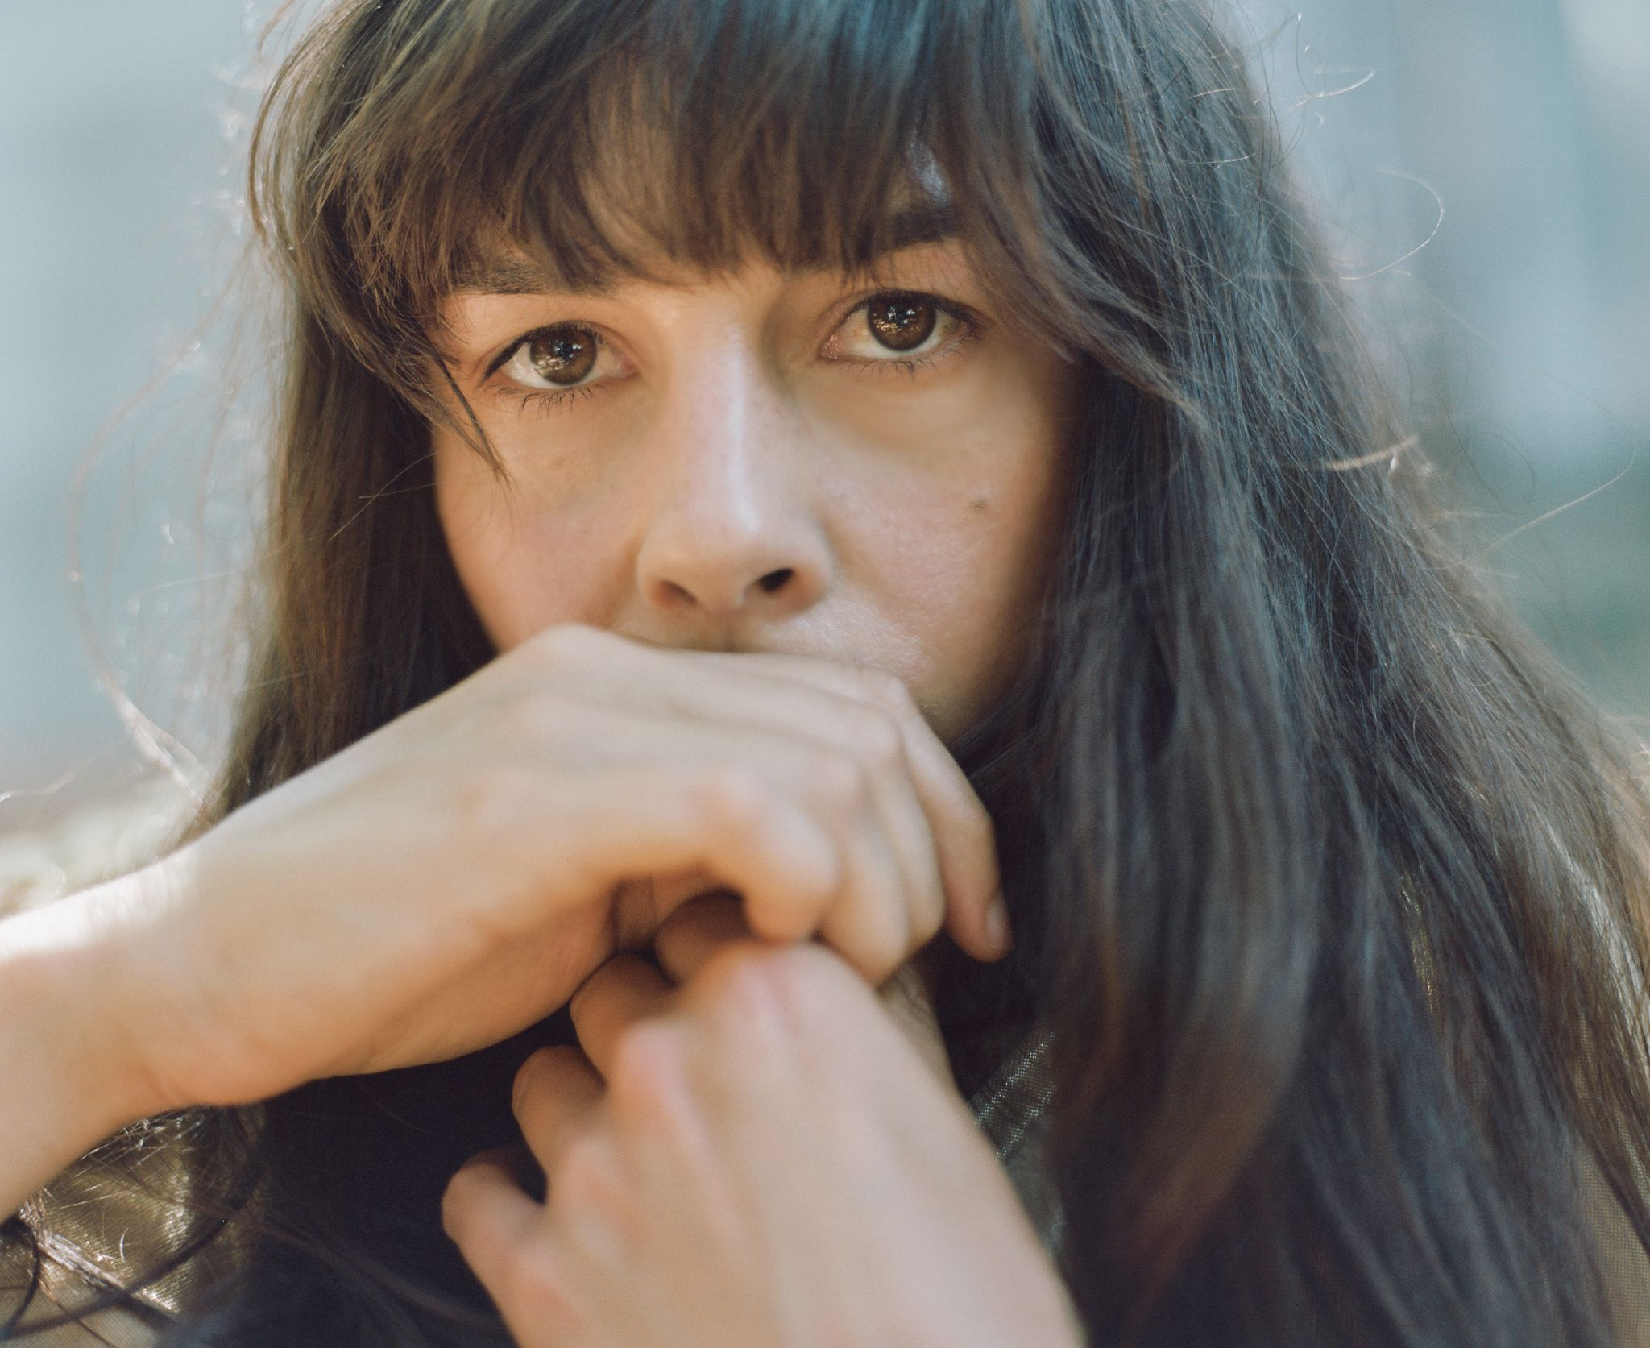
History Of A Feeling Cover Artwork (photo by Lili Pepper)

Website | Instagram | Facebook | Twitter

For more information, contact:
Jessica Linker | Pitch Perfect PR – jessica@pitchperfectpr.com, 773-942-6954

