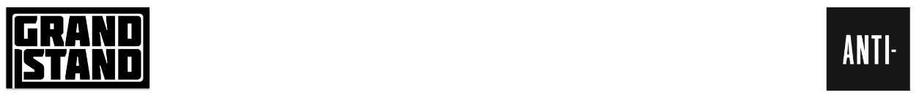
.
SNOCAPS

MAKE TELEVISION DEBUT PERFORMING “COAST”
ON THE TONIGHT SHOW STARRING JIMMY FALLON

SOLD OUT TOUR KICKS OFF NOV 30

SELF-TITLED DEBUT ALBUM OUT NOW VIA ANTI- RECORDS

Photo Credit: Todd Owyoung/NBC | Download Hi-Res

“Pure sibling-rock bliss"
– Rolling Stone

"Wise, revelatory songs with simple materials and expert vision"
– Associated Press

"This album is rich. There’s no fluff here, every song is a real winner.”
– NPR Music

"A spirited new project that plays to their strengths and embraces all the miles they’ve traveled."
– Pitchfork

“This is what well-rooted and courageous music sounds like."
– Paste Magazine

"The Crutchfields’ complementary songwriting styles are in excellent form."
– Consequence

"Their debut collaborative project juxtaposes sweet melodies with dark stories."
– The FADER

"Music from Katie is always welcome and, these days, not so rare. Which makes the return of Allison to the forefront on half these tracks the most wonderful of Snocaps’ surprises"
– Under the Radar

"It's a testament to the hot streak these musicians have been on that, despite the effortlessness that Snocaps exude, they can still casually break your heart with a tossed-off lyric or melodic turn"
– Exclaim!

Snocaps, the new band by Allison and Katie Crutchfield that surprise-released their acclaimed debut album last month via ANTI- Records, made their television debut last night, performing the album’s opening track “Coast” on The Tonight Show starring Jimmy Fallon.
The band’s tour in support of the record sold out within hours of its announcement. It kicks off Nov 30th in Chicago and wraps Dec 8th in New York. All dates below.
Snocaps self-titled album is an indie-rock record that recalls Allison’s band Swearin’ and Katie’s early records as Waxahatchee. The project was born out of the twin sisters’ desire to work on music together as they had in their teens and twenties in their legendary band P.S. Eliot. The Crutchfields are backed by friends and close collaborators MJ Lenderman and Brad Cook, who produced and almost entirely engineered the record at Sonic Ranch Studios. All four musicians play multiple instruments across the record.

WATCH THE “COAST” PERFORMANCE
[Embed: https://www.youtube.com/watch?v=_aUJO7y998A]
Tour Dates:
11/30 - Chicago, IL @ Thalia Hall w/ Bonny Doon - SOLD OUT
12/1 - Chicago, IL @ Thalia Hall w/ Cloakroom - SOLD OUT
12/2 - Chicago, IL @ Thalia Hall w/ Graham Hunt - SOLD OUT
12/4 - Los Angeles, CA @ Teragram Ballroom w/ Slippers - SOLD OUT
12/5 - Los Angeles, CA @ Teragram Ballroom w/ Mike Krol - SOLD OUT
12/7 - New York, NY @ Bowery Ballroom w/ Brennan Wedl - SOLD OUT
12/8 - New York, NY @ Bowery Ballroom w/ Ryan Davis & The Roadhouse Band - SOLD OUT
LISTEN TO SNOCAPS
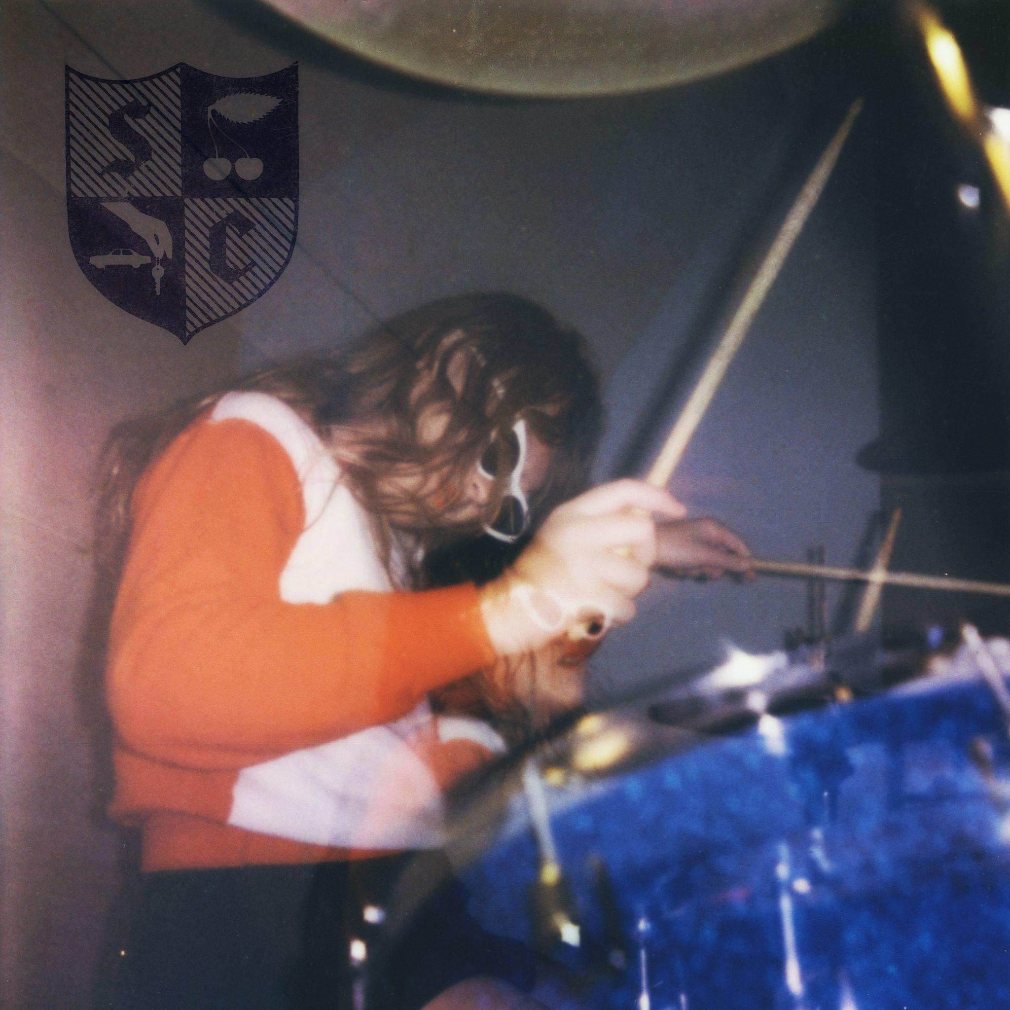
Album Art | Download Hi-Res

1. Coast
2. Heathcliff
3. Wasteland
4. Brand New City
5. Hide
6. Cherry Hard Candy
7. Avalanche
8. Doom
9. Over Our Heads
10. Angel Wings
11. I Don’t Want To
12. You In Rehab
13. Coast II

