October 11, 2019
For Immediate Release

Stream Son Little’s New EP, invisible, Out Today On ANTI-
https://sonlittle.ffm.to/invisible

Touring North America In November/December

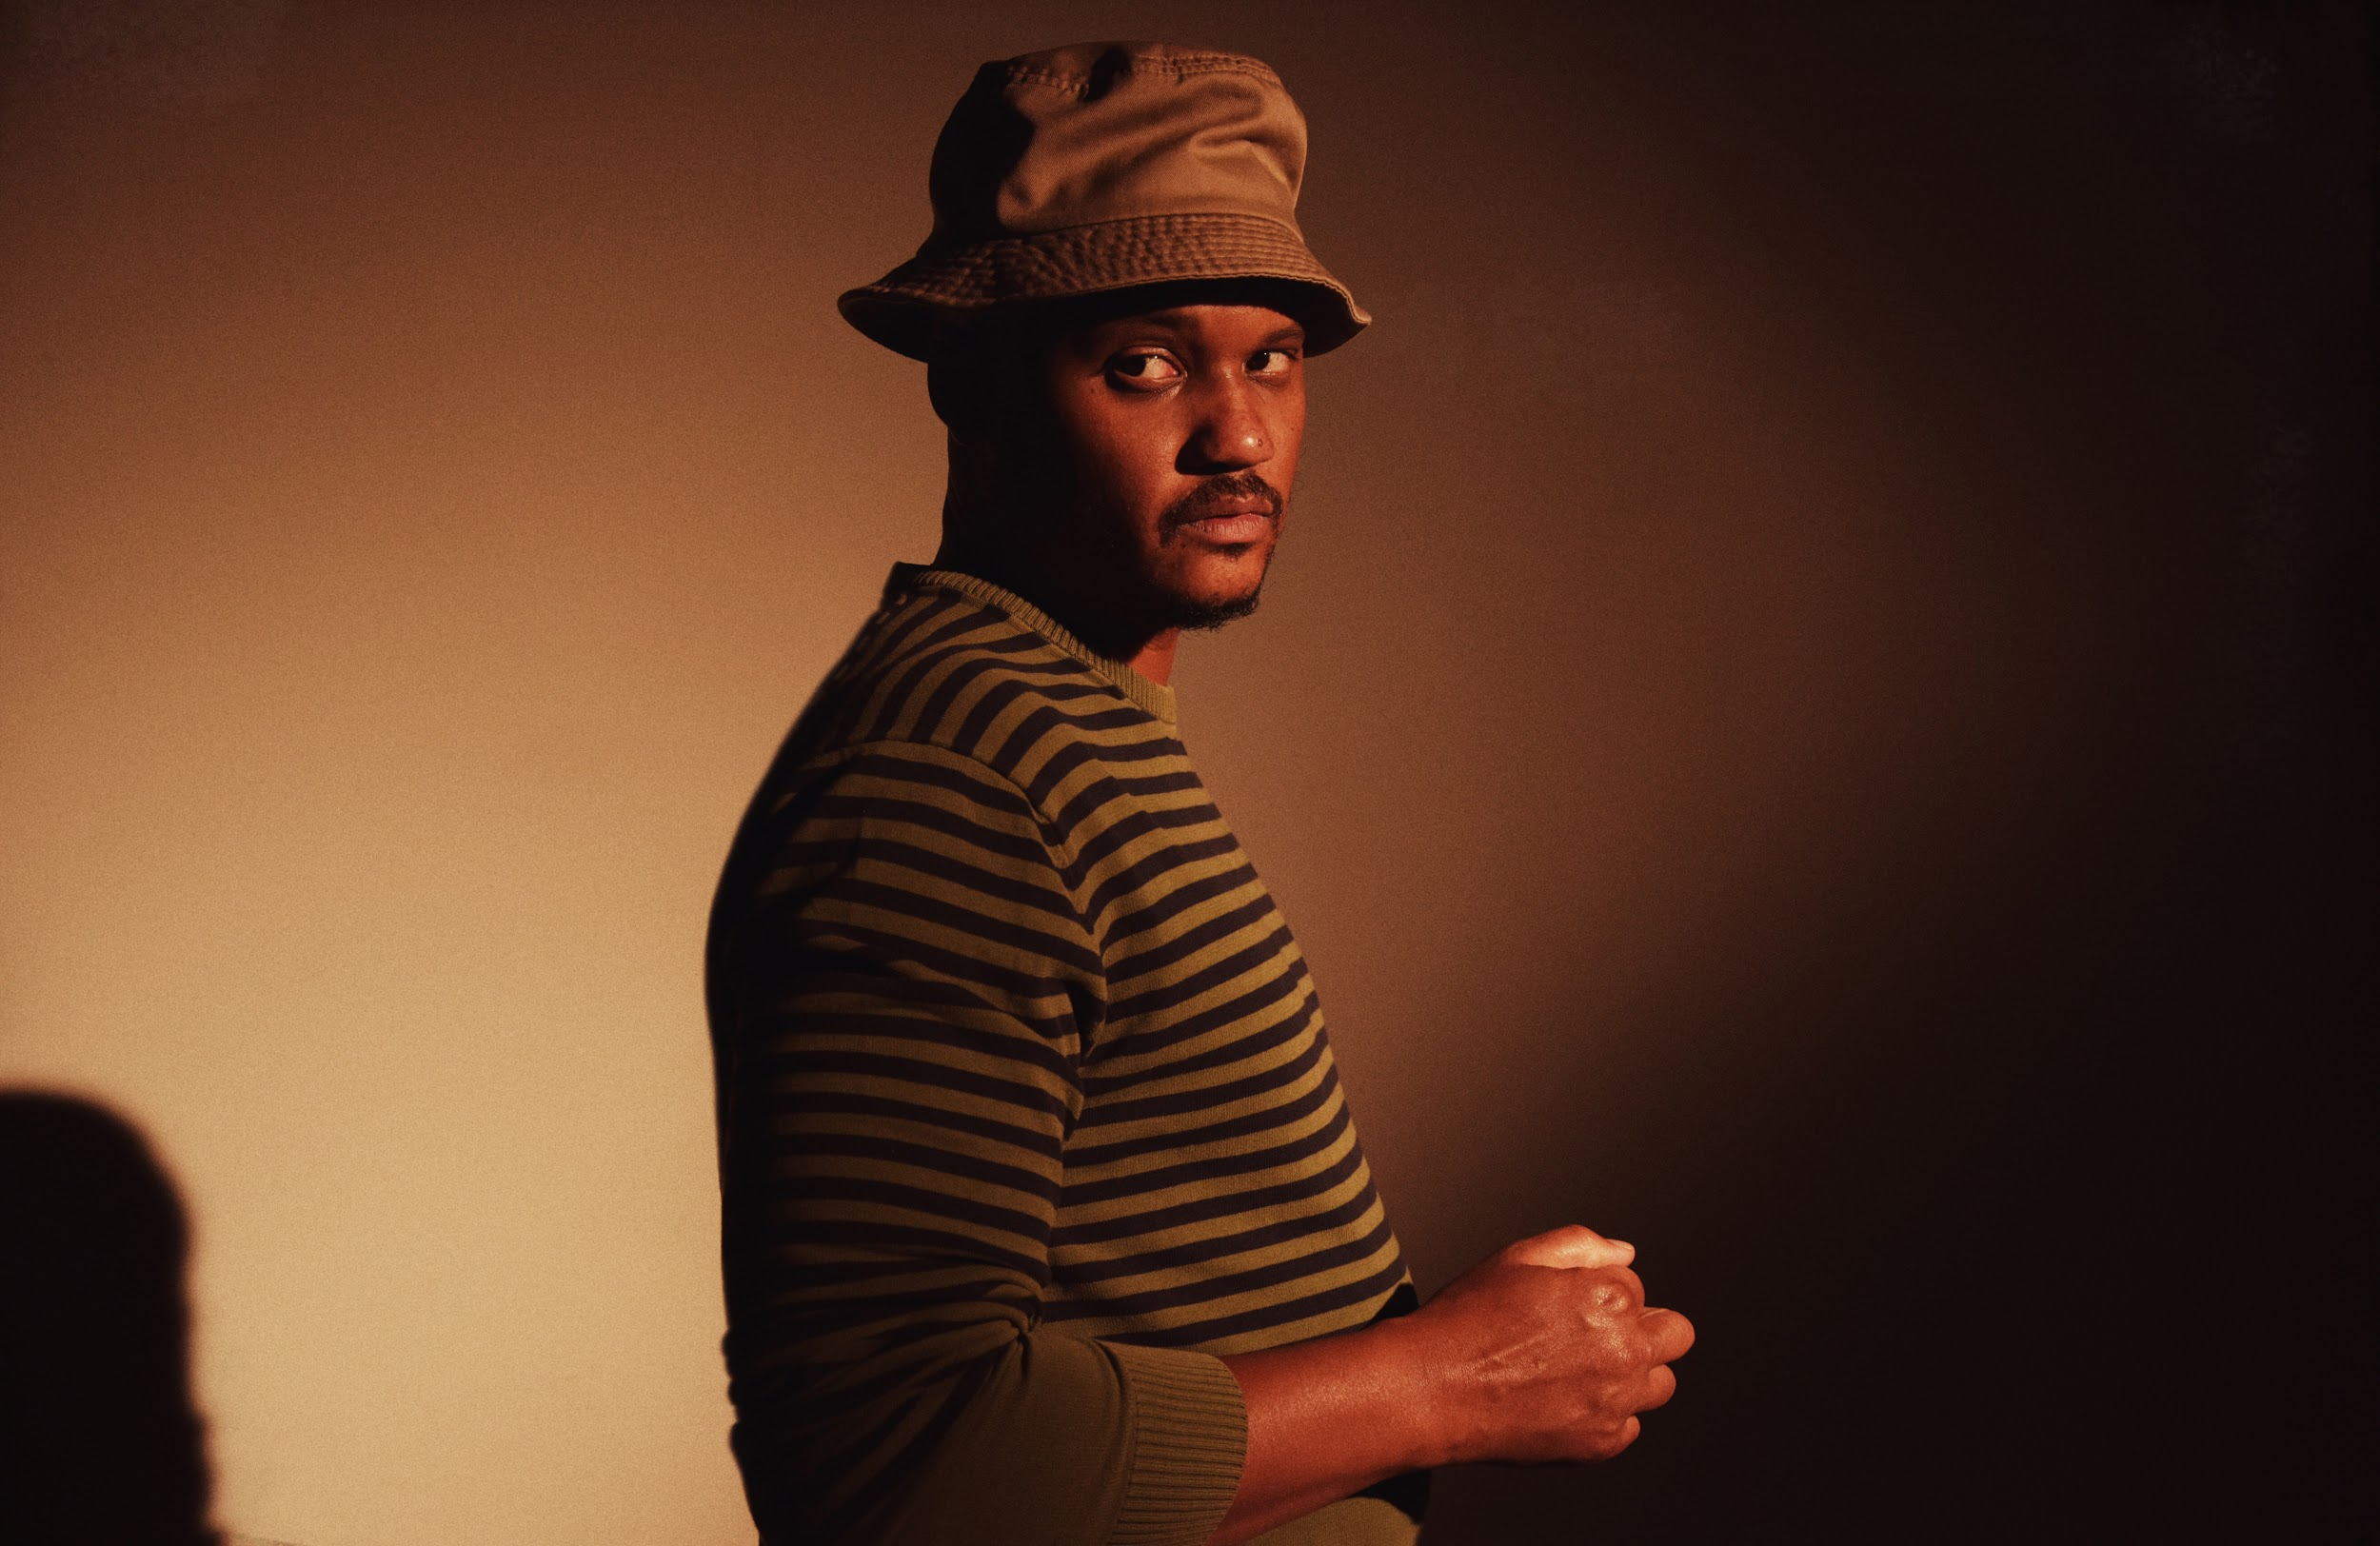
(photo by Shervin Lainez)

“Son Little has long excelled at making music that nods to retro style without sounding like a recreation and ‘hey rose’ is a natural evolution, using the building blocks of the past to make something totally new.” -- Afropunk

“As a vocalist, Livingston brings the heartbreak — his voice feels real and rough around the edges — while his impeccably crafted songs are honest and unpretentious.” -- NPR Music

Today, Son Little is pleased to share his new EP, invisible, out today on ANTI-. Recorded at Paris’s iconic Studios Ferber, the EP sees Little putting his songs in the hands of an outside producer -- Renaud Letang (Feist, Manu Chao) -- for the first time, offering up a tantalizing preview of Little’s third full-length album, set for release early next year.

Equal parts vintage and modern, invisible blends classic soul and old-school R&B into a timeless swirl fueled by gritty instrumental virtuosity and raw, raspy vocals. EP opener and lead single, “hey rose”, marries distorted, jittery guitar with smooth, sinuous vocals, while the slow-burning “about her. again.” injects trippy psychedelia into Sam Cooke soul, and a cover of “Skid” from Love’s long lost masterpiece Black Beauty uses a 1973 meditation on homelessness to make a pointed statement about our indifference to suffering in modern America. invisible closes with a remixed version of “hey rose” by English musician and DJ, Quantic. “For this remix I wanted to bring in a different mood to the song, it’s always good to bring the song to a different place,” the producer says. “The original is very happy and bouncy, so I wanted to lead into a bit more of a vibey space. I’m a fan of Son Little’s voice and this proves its versatility.”

Stream Son Little’s invisible EP -
https://sonlittle.ffm.to/invisible

Born to a preacher and a teacher in Los Angeles, Little first came to international prominence with his self-titled 2015 debut, following collaborations with hip-hop legends The Roots and electronic pioneer RJD2. In 2016, Little showed off his production chops, earning a GRAMMY Award for his work helming Mavis Staples’ acclaimed See That My Grave Is Kept Clean, and in 2017, he released a critically lauded sophomore album, New Magic.

Little will tour in support of invisible through November and December. A full list of dates are below, with tickets on-sale now.

Stream “about her. again.” -
https://youtu.be/RKyR-kOMLNY

“hey rose” Video -
https://youtu.be/KTzEVH4f434

invisible EP Tracklist:
01. hey rose
02. about her. again.
03. i’m a builder
04. skid
05. hey rose (quantic remix)

Son Little Tour Dates:
Mon. Nov. 11 - San Francisco, CA @ Swedish American Hall
Wed. Nov. 13 - Portland, OR @ The Old Church
Thu. Nov. 14 - Seattle, WA @ The Crocodile
Sat. Nov. 16 - Salt Lake City, UT @ The State Room
Sun. Nov. 17 - Denver, CO @ Daniels Hall
Tue. Nov. 19 - Minneapolis, MN @ Cedar Cultural Center
Wed. Nov. 20 - Chicago, IL @ Old Town School of Folk Music
Thu. Nov. 21 - Ferndale, MI @ Magic Bag
Fri. Nov. 22 - Pittsburgh, PA @ Thunderbird Café & Music Hall
Sat. Nov. 23 - Lancaster, PA @ Chameleon Club
Mon. Nov. 25 - Cambridge, MA @ The Sinclair
Tue. Nov. 26 - New York, NY @ Bowery Ballroom
Fri. Nov. 29 - Philadelphia, PA @ World Cafe Live
Sat. Nov. 30 - Washington, DC @ Rock & Roll Hotel
Sun. Dec. 1 - Asheville, NC @ The Grey Eagle
Tue. Dec. 3 - Nashville, TN @ WMOT Finally Friday - 3rd & Lindsley
Wed. Dec. 4 - Atlanta, GA @ The Earl
Thu. Dec. 5 - New Orleans, LA @ Gasa Gasa
Fri. Dec. 6 - Austin, TX @ 3TEN ACL Live
Sat. Dec. 7 - Dallas, TX @ The Blue Light Dallas
Tue. Dec. 10 - Phoenix, AZ @ Valley Bar
Wed. Dec. 11 - San Diego, CA @ Soda Bar
Thu. Dec. 12 - Los Angeles, CA @ Lodge Room

Purchase Son Little’s invisible EP (digital only) -
https://sonlittle.ffm.to/invisible

Download album art & hi-res images of Son Little -
http://pitchperfectpr.com/son-little

(invisible EP Cover Art)

Artist Site | Facebook | Twitter | Instagram | Youtube | ANTI-

For more information, contact:
Sam McAllister | Pitch Perfect PR - sam@pitchperfectpr.com, 773-271-6844

