THE DRUMS RELEASE TWO NEW SONGS “PLASTIC ENVELOPE” AND “PROTECT HIM ALWAYS”

LISTEN NOW HERE

FULL-LENGTH NORTH AMERICAN TOUR
KICKS OFF IN JULY

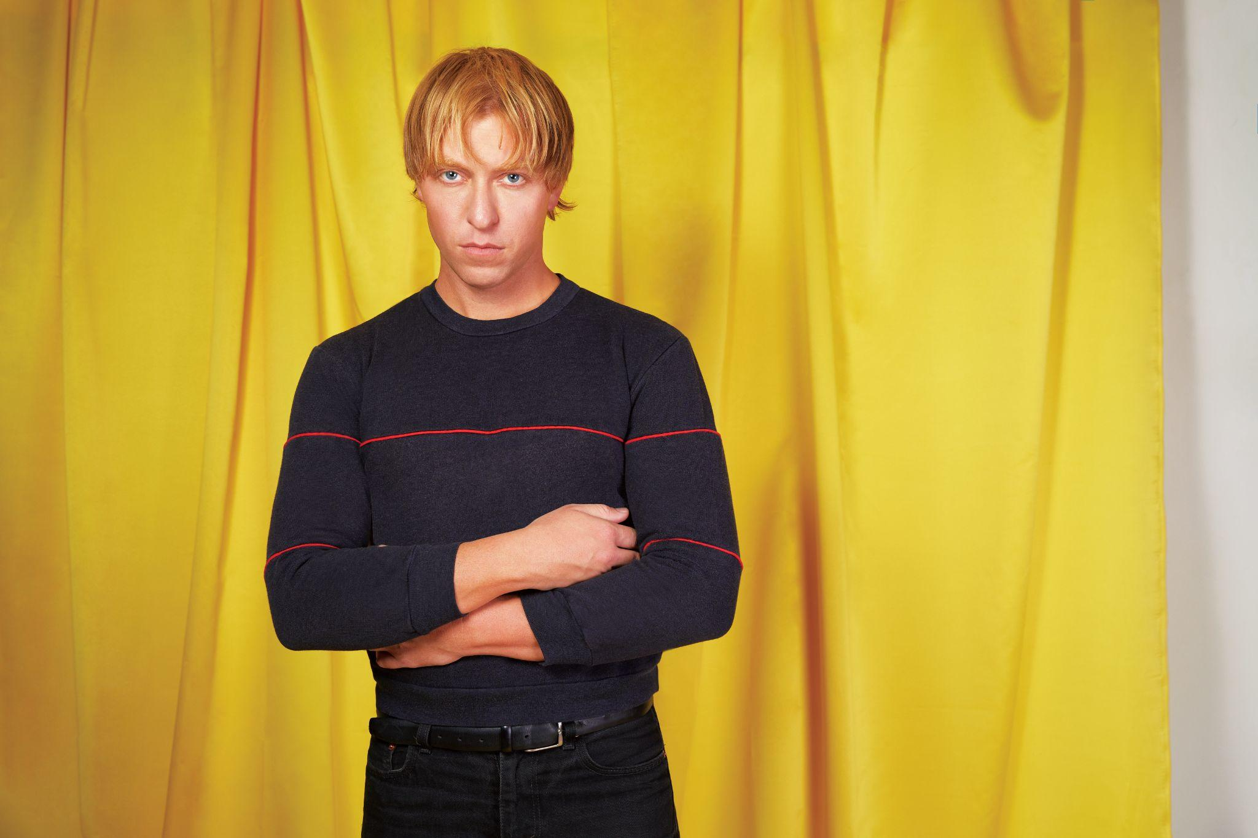
The Drums (Photo Credit: Qiao Meng)

May 11, 2023 (LOS ANGELES, CA) - Fresh off the release of last month’s comeback single “I Want It All,” The Drums have debuted a symbiotic duo of brand new songs today: “Plastic Envelope” and the accompanying vignette “Protect Him Always.” Ripe with introspection, the pair of tracks find Jonny Pierce – founder of The Drums – accepting and nurturing each version of his younger self against a backdrop of gently-fluttering guitars. Listen to “Plastic Envelope” and “Protect Him Always” now below via ANTI-.

“Plastic Envelope” and “Protect Him Always”:
https://www.youtube.com/watch?v=1OPblLW7M8E

“Plastic Envelope is about the pain that comes when your trust has been violated and the dread of not knowing if you could open your heart again the same way,” says Pierce. “The second song, Protect Him Always is an apology to the young boy in me, who I try my best to protect, knowing that when I get hurt, he gets hurt all over again.”

With The Drums’ forthcoming album and first studio project since 2019’s Brutalism on the horizon, Pierce initially teased the record with “I Want It All” in April. A work of art that’s as exposed as it is triumphant, the song weaves together a tapestry of soul-searching ruminations, confrontations of childhood trauma and epiphanies of self-acceptance. Since its release, “I Want It All” swiftly eclipsed 1 million streams with placements on dozens of playlists and coverage from the likes of Rolling Stone, Stereogum, FLOOD Magazine, Brooklyn Vegan and more.

Pierce will bring the new trio of songs to life on the stage for the first time ever on The Drums’ forthcoming full-length North American tour. Kicking July 12th in San Diego, CA, the run will stop in various cities nationwide including The Shrine in Los Angeles and Webster Hall in New York. For complete ticketing information, visit HERE.

Soaring to alt-pop prestige nearly fifteen years ago with a renowned self-titled debut, The Drums continue to thrive, influence and reinvent with every project. Pierce initially conceived of the band back in 2008 and what resulted was worldwide acclaim and a string of five studio albums that deftly walk the line of aching melancholy and irresistible pop sensibilities, presented through a kaleidoscope of pastel guitars, reverb, modular synthesizers and drum machines. It’s a sound that’s wholly unique, and unmistakably The Drums.

The Drums’ music remains timeless, as evidenced by the recent explosion of their song “Money,” which first appeared on their breakout sophomore album Portamento. Transforming into a viral sensation earlier this year – over a decade since it was first released – the song has since bloomed with a second life, eclipsing over 230 million streams on Spotify alone, achieving RIAA Gold-certification, and reaching #1 on the Alternative Global Shazam chart and the #2 TikTok Global Hashtag.

THE DRUMS 2023 TOUR DATES
July 12, 2023 - San Diego, CA - House of Blues
July 14, 2023 - Los Angeles, CA - The Shrine
July 15, 2023 - Las Vegas, NV - Area 15
July 16, 2023 - Phoenix, AZ - Van Buren
July 17, 2023 - El Paso, TX - Lowbrow Palace
July 19, 2023 - Dallas, TX - Granada Theatre
July 20, 2023 - Austin, TX - Mohawk
July 21, 2023 - Houston, TX - White Oak Music Hall
July 22, 2023 - New Orleans, LA - House of Blues
July 24, 2023 - Atlanta, GA - Terminal West
July 25, 2023 - Nashville, TN - Basement East
July 27, 2023 - Carrboro, NC - Cat’s Cradle
July 28, 2023 - Washington, DC - 9:30 Club
July 29, 2023 - Philadelphia, PA - Theatre of Living Arts
July 31, 2023 - Boston, MA - Royale
August 3, 2023 - New York, NY - Webster Hall
August 5, 2023 - Detroit, MI - St. Andrew’s Hall
August 6, 2023 - Toronto, ON - Danforth Music Hall
August 8, 2023 - Chicago, IL - Metro
August 9, 2023 - Minneapolis, MN - Varsity
August 11, 2023 - Denver, CO - Bluebird
August 12, 2023 - Salt Lake City, UT - Psych Lake City at Urban Lounge
August 14, 2023 - Seattle, WA - The Showbox
August 15, 2023 - Vancouver, BC - Fortune Sound Club
August 16, 2023 - Portland, OR - Wonder Ballroom
August 18, 2023 - San Francisco, CA - The Regency Ballroom

###

For More Information:

Jaime Rosenberg / 2b Entertainment
jaime@2bentertainment.net

Peter Quinn / 2b Entertainment
peter@2bentertainment.net

Kelly Kettering / ANTI- Records
kelly@epitaph.com

