



**PERFORMS “MUCH ADO ABOUT NOTHING” ON *THE TONIGHT SHOW STARRING JIMMY FALLON***

**2025 TOUR DATES ANNOUNCED**

**GRAMMY® NOMINATED ALBUM *TIGERS BLOOD***

**OUT NOW ON ANTI- RECORDS**

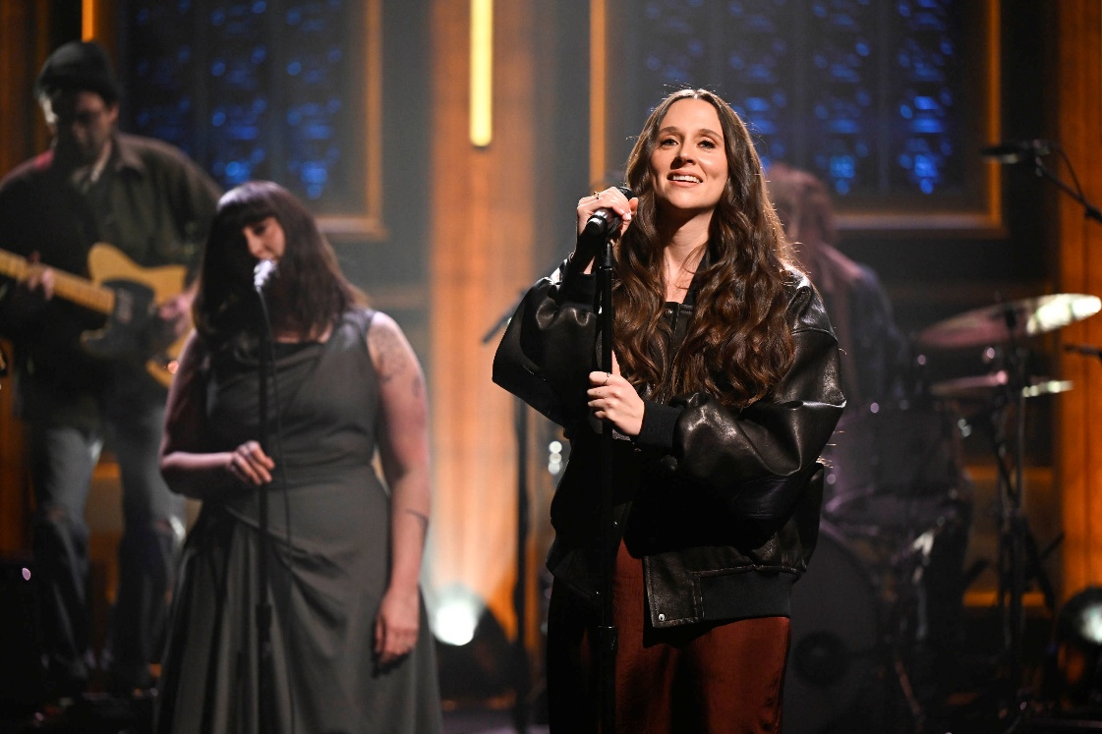

Last night, **Waxahatchee** performed the acclaimed song “[**Much Ado About Nothing**](https://www.youtube.com/watch?v=TFvQOjAOBQ0)” on *The Tonight Show Starring Jimmy Fallon*. Watch the incredible performance [here](https://youtu.be/-0fNP7vzcac?si=IEdOAiqkGadP3YfJ).

The track, released this fall, was the first new release following her **GRAMMY®-nominated** album ***Tigers Blood***, out now on **ANTI- Records**. Crutchfield also released a lively new single, an outtake from the ***Tigers Blood*** sessions titled “[**Mud**](https://youtu.be/aBQE1HTQpGY)” earlier this month.

Waxahatchee will continue her tour in support of *Tigers Blood* this year, with newly announced tour dates at **Outlaw Fest** with **Willie Nelson & Family**, **Bob Dylan** and **Sheryl Crow** in September in addition to the previously announced show she curated at **Willie Nelson’s Luck Ranch** on **March 14th** featuring **Lucinda Williams and her band**, **Futurebirds**, **Bill Callahan** and more, a run with **Wilco** in the spring and additional dates with **Lord Huron, Kevin Morby, MJ Lenderman,** **Hurray For The Riff Raff** and more**.** Tickets to all shows available at [**waxahatchee.com/shows**](http://waxahatchee.com/shows).

**PRAISE FOR *TIGERS BLOOD*:**

*"Katie Crutchfield has one of those voices-rich, effortless, so perfectly suited to her songs-that make it easy to forget just how remarkable it is. Yet her vocals, which swing from earthy to spectral, contain enormous amounts of pathos, boredom, joy, anxiety, resignation, hope."*

***-The New Yorker, Best Albums of 2024***

*"A stunning set of easygoing downhome tunes cataloging the travails and charms of mid-30s living"*

***-TIME Magazine, Best Albums of 2024***

*“The casual confidence, lived-in wisdom and patiently unfurling melodies of Tigers Blood offer a more laid-back kind of gratification that keeps on giving throughout her sixth album."*

***-New York Times, Best Albums of 2024***

*"Crutchfield sings with the self-recrimination of a perfectionist, a bearer of high standards who believes her potential is limitless-with each subsequent entry in the Waxahatchee canon, it’s hard not to believe her."*

***-Pitchfork, Best Albums of 2024***

*“A master storyteller fully aware she’s on a hot streak. She sings about adult romance, struggling for sobriety, the day-to-day work of holding it together — in the poetic voice of a Lucinda Williams who came of age playing DIY punk-house basement shows."*

***-Rolling Stone, Best Albums of 2024***

*"Crutchfield frees herself completely in these rambling yet tightly executed songs.”*

*-****NPR, Best Albums of 2024***

*"In her long, gradual journey into country and folk, Crutchfield has discovered new shades of her already-spectacular voice and new ways to convey serene yearning."*

***-Stereogum, Best Albums of 2024***

*"Katie Crutchfield has found a home making glistening, easygoing country music."*

*-****Vulture, Best Songs of 2024***

*“Such viscerally aching songwriting paired with heartbroken harmonies is a potent combination – and yet, there’s a comfort to ‘Right Back to It’ that keeps listeners, well, coming back to it."*

***-Billboard, Best Songs of 2024***

*“If there were a cheat code for creating a modern classic Americana song, Katie Crutchfield found it”*

*-****Consequence, Best Albums of 2024***

*"When the dust settles on the best album of Katie Crutchfield’s career, what we’re left with is the deeply human beauty of Tigers Blood."*

*-****Paste, Best Albums of 2024***

*“Dizzyingly vulnerable and dazzlingly intimate, Tigers Blood is a staggering release, full of heart, wisdom and freedom”*

*-****Holler, Best Albums of 2024***

*"It’s the kind of song you know you’ll want to play again immediately within the first 60 seconds, and again and again after that."*

*-****UPROXX, Best Songs of 2024***

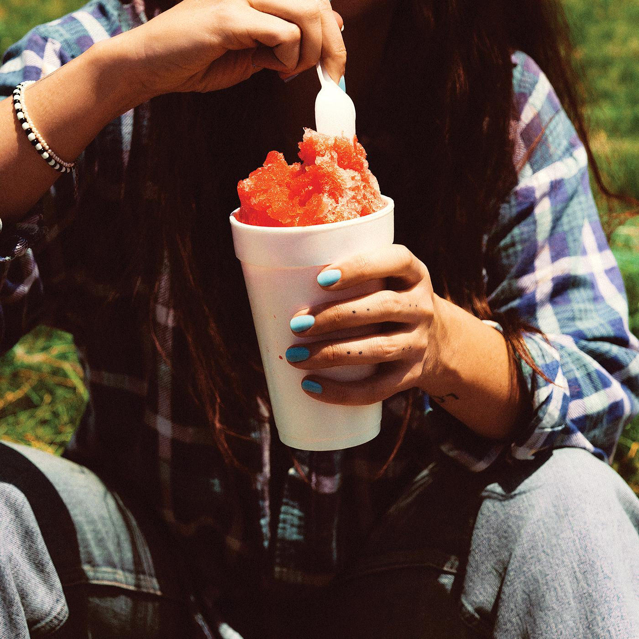

**Single Art Credit: Molly Matalon | download hi-res** [**here**](https://drive.google.com/file/d/1jHvEdBA_doM_i0tTtEerw7wavktxnrfx/view?usp=sharing)

**Follow Waxahatchee:**

[Website](http://waxahatchee.com) | [Instagram](http://instagram.com/waxa_katie) | [Facebook](http://facebook.com/waxahatchee) | [Twitter](http://twitter.com/k_crutchfield)

**For more information please contact Grandstand Media & Management:**

[Eloy Lugo](mailto:eloyl@grandstandhq.com)