



**RELEASES NEW SINGLE “**[**MUD**](https://youtu.be/aBQE1HTQpGY)**”**

**JOINS OUTLAW FEST FEAT. WILLIE NELSON & FAMILY**

**BOB DYLAN AND SHERYL CROW**

**2025 TOUR DATES ANNOUNCED**

**GRAMMY® NOMINATED ALBUM *TIGERS BLOOD***

**OUT NOW ON ANTI- RECORDS**

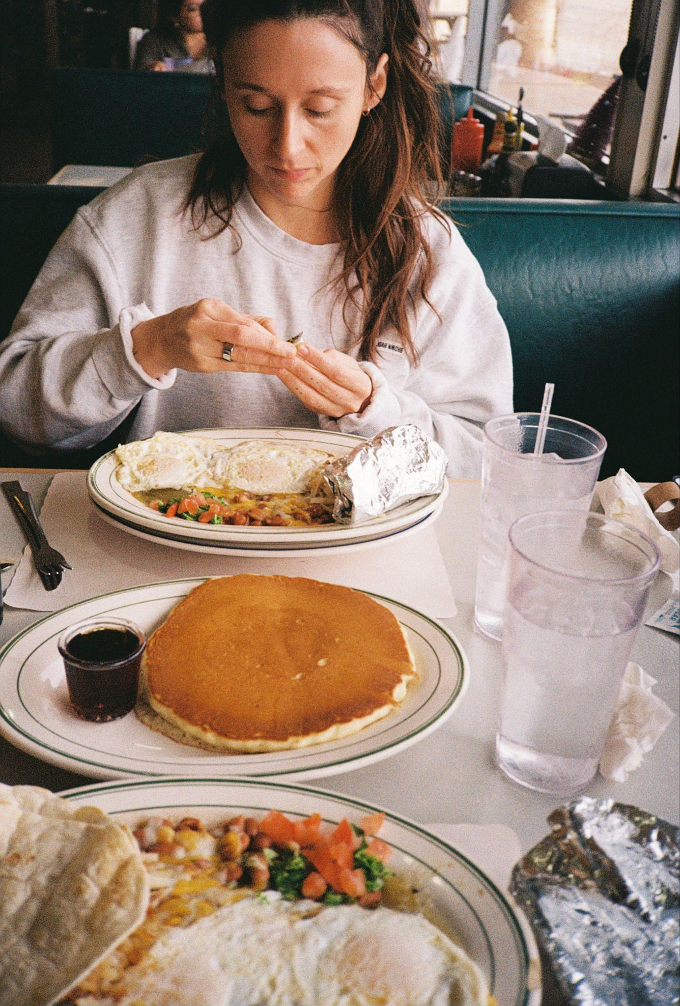

**Photo Credit: Kevin Morby | download hi-res** [**here**](https://drive.google.com/file/d/1x4Z-dkIuHaMZ_BFXQ-61fVFSmno27Xzj/view?usp=drive_link)

Today, **Waxahatchee** releases a lively new single, an outtake from the ***Tigers Blood*** sessions titled “[**Mud**](https://youtu.be/aBQE1HTQpGY).” The song, follows the release of the acclaimed “[**Much Ado About Nothing**](https://www.youtube.com/watch?v=TFvQOjAOBQ0)” single and her **GRAMMY®-nominated** album ***Tigers Blood***, out now on **ANTI- Records**.

Crutchfield continues her tour in support of *Tigers Blood* this year, with newly announced tour dates at **Outlaw Fest** with **Willie Nelson & Family**, **Bob Dylan** and **Sheryl Crow** in September in addition to the previously announced show she curated at **Willie Nelson’s Luck Ranch** on **March 14th** featuring **Lucinda Williams and her band**, **Futurebirds**, **Bill Callahan** and more, a run with **Wilco** in the spring and additional dates with **Nathaniel Rateliff & The Night Sweats, Iron & Wine, Lord Huron, Kevin Morby, MJ Lenderman,** **Hurray For The Riff Raff** and more**.** Pre-sale tickets for Outlaw Fest go on sale today at 10 am local time, with general on-sale starting Friday February 7th at 10 am local time. Tickets to all shows available at [**waxahatchee.com/shows**](http://waxahatchee.com/shows).

**Tour Dates:**

2/21 - Inglewood, CA @ Kia Forum *

3/14 - Spicewood, TX @ Willie Nelson’s Luck Ranch #

3/29 - Knoxville, TN @ Big Ears Festival

4/26 - Tallahassee, FL @ Adderley Amphitheater at Cascades Park ^

4/27 - North Charleston, SC @ High Water Festival

4/29 - Miami Beach, FL @ The Fillmore ^

4/30 - St. Augustine, FL @ The St. Augustine Amphitheater ^

5/2 - Birmingham, AL @ Avondale Brewing Company ^

5/3 - New Orleans, LA @ Saenger Theatre ^

5/4 - Houston, TX @ White Oak Music Hall (Lawn) ^

5/6 - San Antonio, TX @ The Espee ^

5/7 - Irving, TX @ The Pavilion at Toyota Music Factory ^

5/9 - Nashville, TN @ The Pinnacle ^

5/10 - Atlanta, GA @ Cadence Bank Amphitheatre at Chastain Park ^

5/11 - Chattanooga, TN @ Soldiers and Sailors Memorial Auditorium ^

5/13 - Wilmington, NC @ Live Oak Bank Pavilion ^

5/14 - Durham, NC @ Durham Performing Arts Center &

5/15 - Charlotte, NC @ The Amp Ballantyne ^

5/16 - Asheville, NC @ Asheville Yards Amphitheater ^

6/1 - Denver, CO @ Outside Festival

6/6 - Barcelona, ES @ Primavera Sound

6/8 - Glasgow, SCT @ Barrowland Ballroom $

6/9 - Manchester, UK @ Albert Hall $

6/10 - Bristol, UK @ SWX $

6/11 - London, UK @ Hammersmith Apollo $

6/13 - Porto, PT @ Primavera Porto

6/20 - Nelsonville, OH @ Nelsonville Music Festival

6/21 - Lafayette. NY @ Beak & Skiff Apple Orchards %

6/22 - Greenfield, MA @ Green River Festival

6/23 - Shelburne, VT @ Shelburne Museum on The Green =

7/29 - Columbia, MD @ Merriweather Post Pavilion ~

7/30 - New York, NY @ Madison Square Garden ~

9/5 - Bangor, ME @ Maine Savings Amphitheatre +

9/6 - Hartford, CT @ Xfinity Theatre +

9/7 - Mansfield, MA @ Xfinity Center +

9/12 - Camden, NJ @ Freedom Mortgage Pavilion +

9/13 - Holmdel, NJ @ PNC Bank Arts Center +

9/19 - East Troy, WI @ Alpine Valley Music Theater +

* w/ Nathaniel Rateliff & The Night Sweats and Iron & Wine

# w/ Lucinda Williams & Special Guests

^ w/ Wilco

& w/ Cameron Winter

% w/ MJ Lenderman & Hurray For The Riff Raff

= w/ Kevin Morby

$ w/ Merce Lemon

~ w/ Lord Huron

+ w/ Willie Nelson & Family, Bob Dylan, Sheryl Crow & Madeline Edwards

**PRAISE FOR *TIGERS BLOOD*:**

*"Katie Crutchfield has one of those voices-rich, effortless, so perfectly suited to her songs-that make it easy to forget just how remarkable it is. Yet her vocals, which swing from earthy to spectral, contain enormous amounts of pathos, boredom, joy, anxiety, resignation, hope."*

***-The New Yorker, Best Albums of 2024***

*"A stunning set of easygoing downhome tunes cataloging the travails and charms of mid-30s living"*

***-TIME Magazine, Best Albums of 2024***

*“The casual confidence, lived-in wisdom and patiently unfurling melodies of Tigers Blood offer a more laid-back kind of gratification that keeps on giving throughout her sixth album."*

***-New York Times, Best Albums of 2024***

*"Crutchfield sings with the self-recrimination of a perfectionist, a bearer of high standards who believes her potential is limitless-with each subsequent entry in the Waxahatchee canon, it’s hard not to believe her."*

***-Pitchfork, Best Albums of 2024***

*“A master storyteller fully aware she’s on a hot streak. She sings about adult romance, struggling for sobriety, the day-to-day work of holding it together — in the poetic voice of a Lucinda Williams who came of age playing DIY punk-house basement shows."*

***-Rolling Stone, Best Albums of 2024***

*"Crutchfield frees herself completely in these rambling yet tightly executed songs.”*

*-****NPR, Best Albums of 2024***

*"In her long, gradual journey into country and folk, Crutchfield has discovered new shades of her already-spectacular voice and new ways to convey serene yearning."*

***-Stereogum, Best Albums of 2024***

*"Katie Crutchfield has found a home making glistening, easygoing country music."*

*-****Vulture, Best Songs of 2024***

*“Such viscerally aching songwriting paired with heartbroken harmonies is a potent combination – and yet, there’s a comfort to ‘Right Back to It’ that keeps listeners, well, coming back to it."*

***-Billboard, Best Songs of 2024***

*“If there were a cheat code for creating a modern classic Americana song, Katie Crutchfield found it”*

*-****Consequence, Best Albums of 2024***

*"When the dust settles on the best album of Katie Crutchfield’s career, what we’re left with is the deeply human beauty of Tigers Blood."*

*-****Paste, Best Albums of 2024***

*“Dizzyingly vulnerable and dazzlingly intimate, Tigers Blood is a staggering release, full of heart, wisdom and freedom”*

*-****Holler, Best Albums of 2024***

*"It’s the kind of song you know you’ll want to play again immediately within the first 60 seconds, and again and again after that."*

*-****UPROXX, Best Songs of 2024***

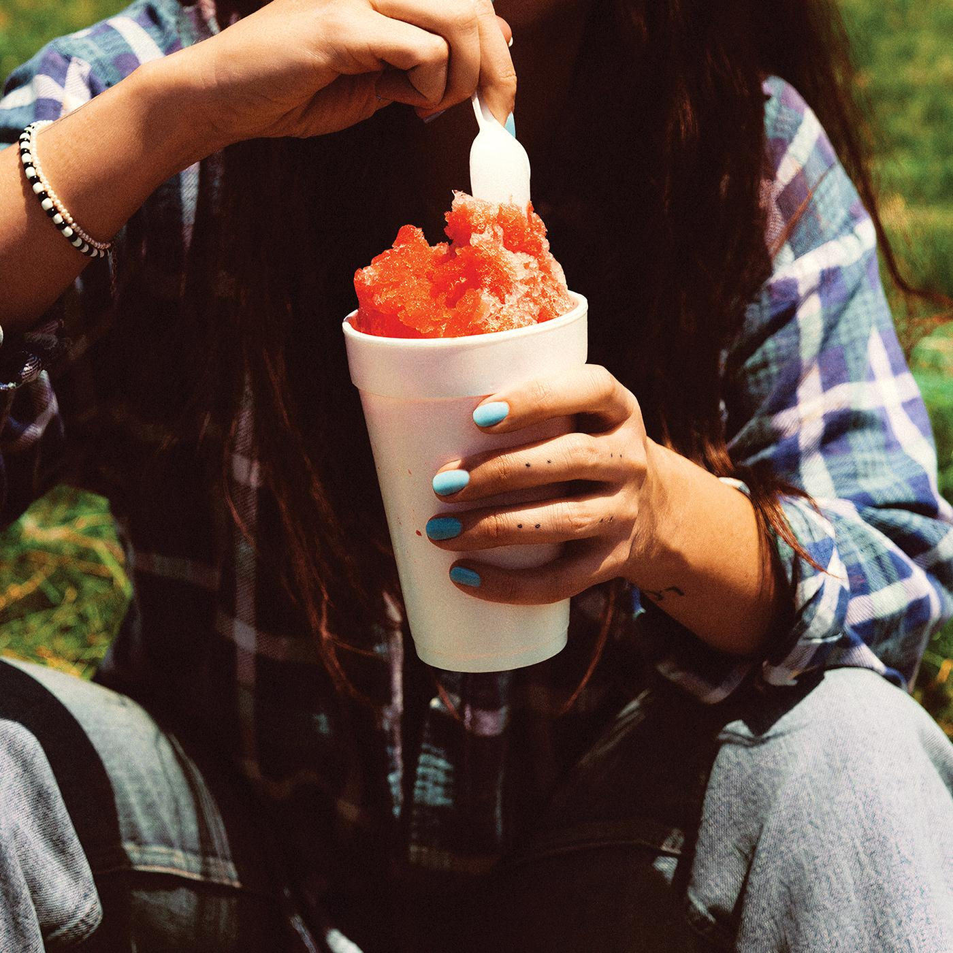

**Single Art Credit: Molly Matalon | download hi-res** [**here**](https://drive.google.com/file/d/1jHvEdBA_doM_i0tTtEerw7wavktxnrfx/view?usp=sharing)

**Follow Waxahatchee:**

[Website](http://waxahatchee.com) | [Instagram](http://instagram.com/waxa_katie) | [Facebook](http://facebook.com/waxahatchee) | [Twitter](http://twitter.com/k_crutchfield)

**For more information please contact Grandstand Media & Management:**

[Eloy Lugo](mailto:eloyl@grandstandhq.com)