Sentinel Installation Troubleshooting 2

Hi Daniel,

The S-Box and your PC communicate because the communication via TCP/IP
was established .

If your sentinels are flashing red two times and green two times?
(Embedded image moved to file: pic18467.gif)

If yes , That means that all the id of the sentinel were reset :
Unplug all the sentinels
Do the procedure on user guide Chapiter 5.2.4.

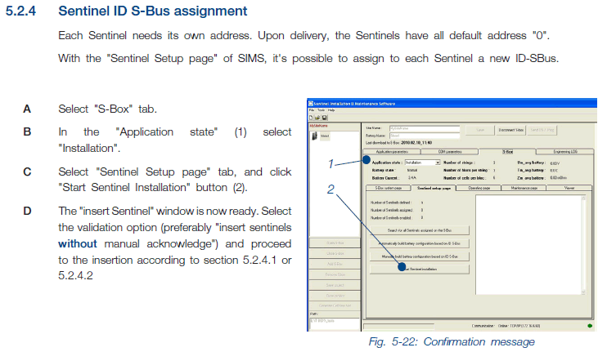

(Embedded image moved to file: pic06334.gif)

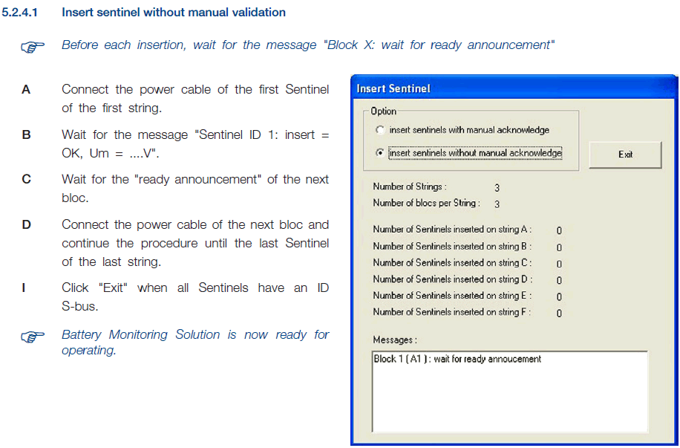

(Embedded image moved to file: pic26500.gif)

If no, but the sentinels are flashing green =>



(Embedded image moved to file: pic19169.gif)

Plug all the sentinels
Do the procedure below

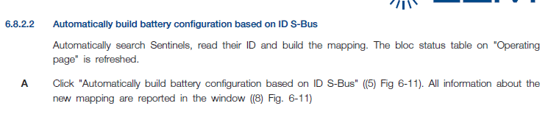
(Embedded image moved to file: pic15724.gif)

If after you have the problem yet , you must check some points below :

Please check the external power supply 24V DC is connected to the Bus
converter?
Please check that the S-BUS converter is connected like the schematic
below please ?

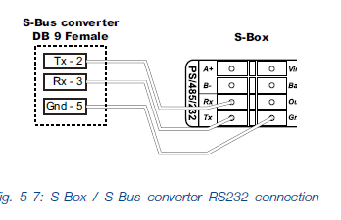

(Embedded image moved to file: pic11478.gif)

I wait your feedback please

Best Regards
EL HAJJI Nacim

