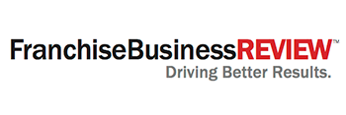

**Employee Survey Reminder Template**

Once the survey is underway, we encourage you to send out a reminder from the corporate team to everyone to complete the survey if they haven’t already. This will help boost participation numbers.

Below is sample language you can use. Feel free to personalize the message as you see fit.

**IMPORTANT REMINDER: SURVEY DEADLINE**

*[Insert brand name] is working with Franchise Business Review to gather feedback on how well we’re supporting our employees.*

*Thank you to everyone who has already completed the survey. If you have not yet completed your survey, you’ll be receiving another email from survey@franchisebusinessreview.com shortly.*

*The survey only takes 5-10 minutes to complete.* ***Please submit your responses no later than DATE*** *[insert survey close date] to ensure that your opinions are reflected in the overall results.*

*The more employees who participate in the survey, the better we can understand your needs and guide our corporate priorities for the coming year.*

*If you have any questions, please contact me at (corporate phone number).*

*Thank you for your assistance. Your feedback is extremely valuable to us.*