 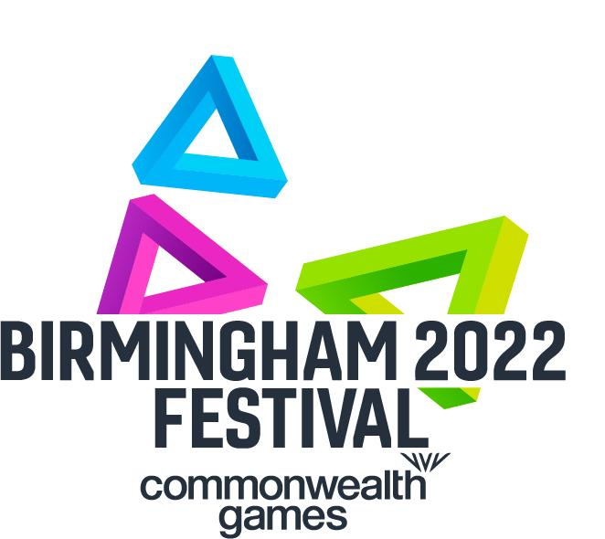 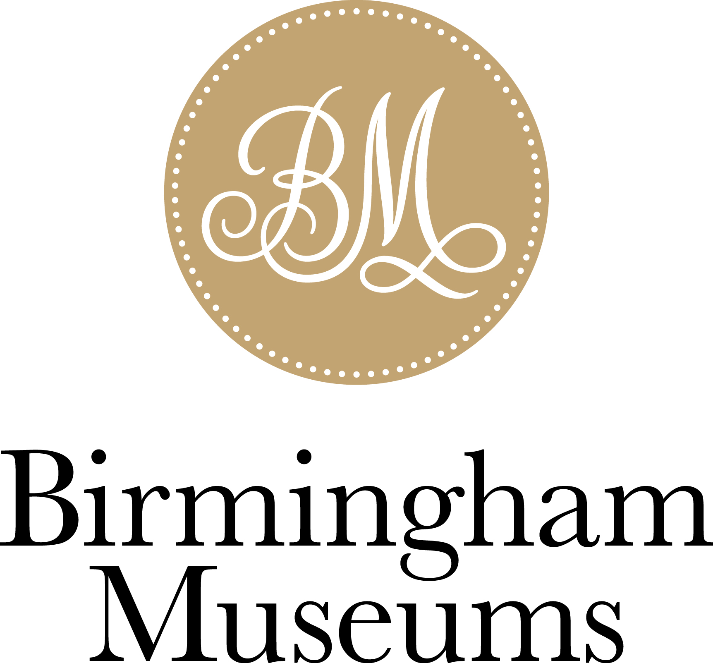

**Press Release** 17 March 2022

Exhibition dates: Thurs 28 April - Sun 30 October 2022

**Unmissable exhibition ‘Wonderland’ will explore how cinema has shaped the streets, social lives and dreams of Brummies over the past 125 years, presented by Flatpack Projects and Birmingham 2022 Festival**

Wonderland opens as part of the Birmingham 2022 Festival at Birmingham Museum & Art Gallery (BMAG) when it partially reopens on Thursday 28 April. Birmingham's unique cinema history will be revealed through photographs, cinema memorabilia and a collection of magic lanterns and optical toys. Through exploring this history, Wonderland inspires us to imagine what the cinemas of the future might look like. Wonderland is curated by Ian Francis from Flatpack Projects.

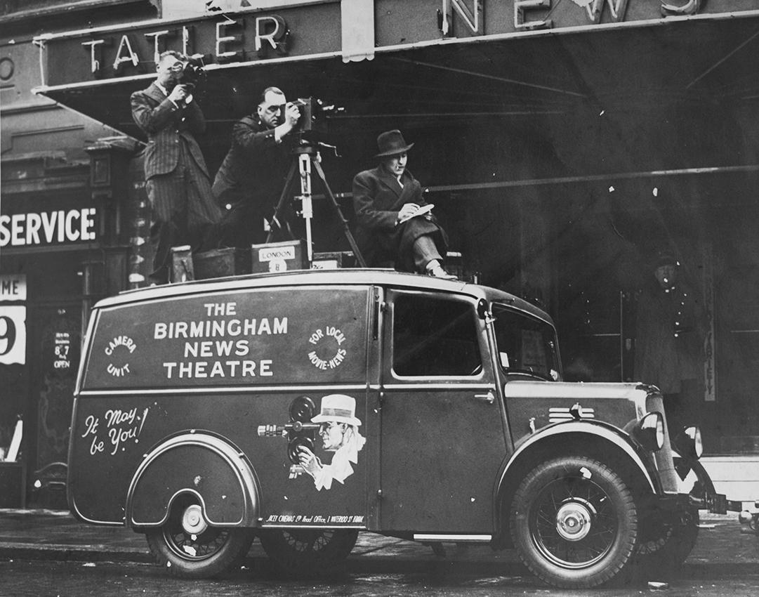 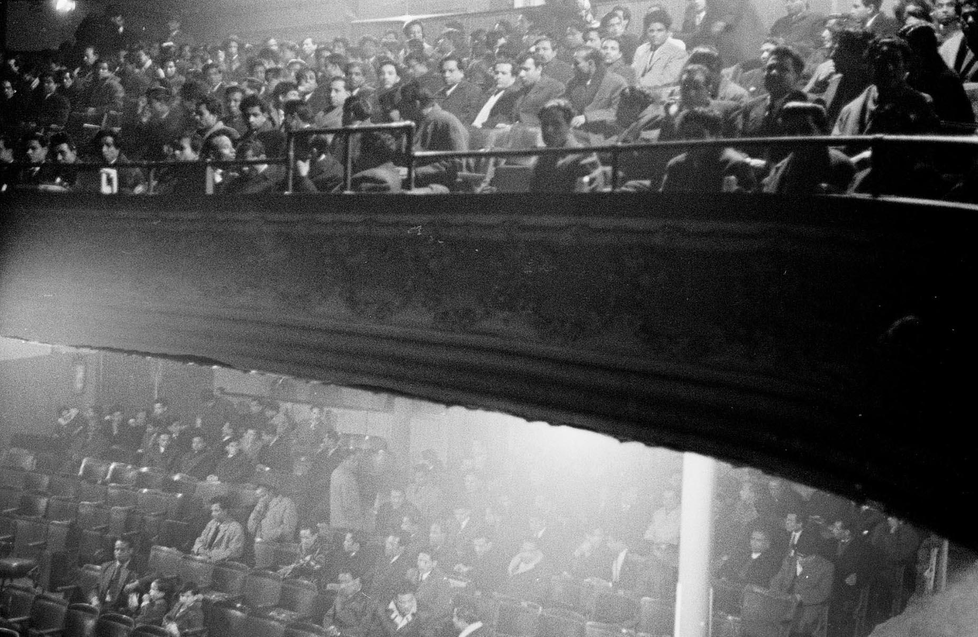

Based in Digbeth, Flatpack Projects is known for its annual Flatpack Festival and for creating unique film and cinema-inspired events and experiences.

The birthplace of celluloid and the Odeon circuit, Birmingham has been a cinema city since the very first flickering images astonished audiences in the late 19th century. Wonderland leads visitors on a voyage through 125 years of movie-going and over 150 cinemas, from early fairground bioscopes to 1930s super cinemas. It will also look at the vital role of film for South Asian communities and explore the pop-ups and boutique picture houses that exist today.

A centrepiece of the exhibition is the remarkable **Odeon story** which began in 1930 when the son of a Hungarian scrap metal dealer Oscar Deutsch opened his first cinema in Perry Barr. Born in Balsall Heath, Oscar created a chain of over 250 Odeon cinemas by the time he died in 1941. The Odeon cinemas include many iconic art deco venues designed by Birmingham architecture practice Harry Weedons.

There will be a talk by cinema expert **Allen Eyles** about the rapid rise of Oscar Deutsch's Odeon chain in the 1930s and a walking tour exploring key cinema sites in Birmingham city centre.

Wonderland features 91 year-old Joan Pearson and her husband Bill who were both projectionists at a number of different Birmingham cinemas and documented their working lives in a series of scrapbooks. Some of this material will be on show for the first time, giving a glimpse behind the scenes of much-loved local picture houses including the Orient, the Robin Hood and the Bristol.

The exhibition explores the development of **South Asian cinema** in the city through venues like the Imperial and the Waldorf, bringing to light material from the private collection of the Randhawa family. From the 50s onwards three generations of Randhawas brought Indian films and stars to local audiences, creating an important gathering place for communities still finding their feet in the UK.

**The Electric Cinema** on Station Street neatly encapsulates the whole story of cinema in one building, its 112-year existence encompassing everything from silent movies and newsreels to 70s erotica and the boutique sofa experience on offer today. Recently relaunched under new management, Wonderland will share some archival treasures from the cinema's basement.

**Raidene Carter, Executive Producer, Birmingham 2022 Festival said:**

“The Birmingham 2022 Festival will put the region’s creativity, ambition, heritage and diversity on a global stage and what better way to mark that than with Flatpack’s exciting and ambitious look at Birmingham’s rich cinema history at Birmingham Museum & Art Gallery. We’re looking forward to the many layers that Wonderland will reveal from curious cinema memorabilia to fascinating anecdotes.”

The exhibition sits around a unique 3D map created by Birmingham makers **Space_Play**, known for creating miniatures of landmark buildings that illustrate the city's film history landscape. Space_Play's Adam Carthy and Habib Ali are also devising a city-wide treasure hunt, with trading cards and cinema miniatures on offer for intrepid Wonderland explorers.

At BMAG there will be drop-in optical toy and magic lantern workshops, including a chance to try out a massive zoetrope.

**Sara Wajid and Zak Mensah, co-CEOs of Birmingham Museums Trust, said:**

“For this partial reopening of BMAG we wanted to tell stories that haven’t been told in the museum before and truly hand the space over to the people of the city. We’re thrilled that the team at Flatpack are part of this and Wonderland will offer a fascinating insight into the history of cinema and Birmingham’s own unique connection to it. We invite visitors to delve into this cinematic treasure trove and to contribute their own experiences and memories to add to the story of Birmingham cinema.”

Alongside the exhibition, Flatpack will launch an online Wonderland resource where people can navigate through Birmingham’s past and present film landscape, as well as share their own cinema stories. Throughout the summer there will also be a chance to explore different parts of the story with a programme of walks, events and special screenings across the city, kicking off with the Flatpack Festival in May.

**Ian Francis, Director of Flatpack Festival said:** “for Wonderland we were inspired to start a conversation about Birmingham’s rich cinema history. Birmingham's Odeon story completely changed how cinema was experienced as a grand and opulent form of escape. We are creating a legacy and the exhibition will live on and grow through the website where we are inviting people to share their cinema stories. We've also got a team of 25 volunteers from all across the city who have their own personal interests to research and share whether it's kung fu movies, cinema upholstery, or the South Asian story. All this combined with the design of the space will make for a unique experience to look back and also reflect on the future."

Flatpack Festival is back with over 60 live events this year, including an in-conversation with DJ and entrepreneur **Cecil Morris** about the legendary blaxploitation and kung fu nights he hosted in the 70s and 80s. A **Wonderland Pecha Kucha** evening at the festival hub will host a range of guests who will share their cinema stories.

Members of the public are encouraged to share their cinema stories by visiting <https://flatpackfestival.org.uk/news/share-your-cinema-stories/>

**NOTES TO EDITORS:**

**Listings Info:**

Wonderland

Thurs 28 April to Sun 30 October 2022

Birmingham Museum and Art Gallery, Chamberlain Sq, B3 3DH

Wonderland Website link: <https://flatpackfestival.org.uk/projects/wonderland>

**Images:** [Google Drive Link](https://drive.google.com/drive/folders/1fAOSwgtP2rbY1ueNYWH9_ZMWCbyMyADi?usp=sharing)

**PR rep:** Binita Walia 07734 507799 [binita@thespaceinbetween.co.uk](mailto:binita@thespaceinbetween.co.uk)

**Wonderland exhibition credit:**

Wonderland is presented by the Birmingham 2022 Festival, produced by Flatpack Festival with Birmingham Museum and Art Gallery. It is supported by Arts Council England and the National Lottery Heritage Fund.

**About Flatpack Festival**

Flatpack Festival is produced by Birmingham-based charitable organisation Flatpack Projects, a mobile arts organisation that shows amazing work, brings people together and develops new ideas. Since 2006, the festival (which began life as a monthly mixed-media night at the Rainbow pub in Digbeth) has shown over 3,000 films to over 100,000 people and is a vital fixture in Birmingham’s cultural calendar. Stirring together a colourful stew of screenings and performances, walks and installations, the Flatpack programme boasts a mind-boggling range of international talent with an emphasis on the playful, surprising and indefinable. <https://flatpackfestival.org.uk/>

Flatpack Festival is funded by the National Lottery via Arts Council England and the British Film Institute.

**About the Birmingham 2022 Festival**

The Birmingham 2022 Festival unites people from around the Commonwealth through a celebration of creativity, in a six-month long programme, shining a spotlight on the West Midland’s culture sector.

Running from March to beyond the conclusion of the Birmingham 2022 Commonwealth Games in September, the festival aims to entertain and engage over 2.5 million people in person and online.

Delivering over 200 projects across the region including art, photography, dance, theatre, digital art and more the festival will embrace local culture and generate lasting change and a creative legacy beyond the games with funding to community led projects from Birmingham City Council’s Creative City Grants scheme.

Major support has been dedicated by Arts Council England, The National Lottery Heritage Fund, Birmingham City Council and Spirit of 2012. The Birmingham 2022 Festival is grateful for further support from British Council, Paul Hamlyn Foundation, Esmée Fairbairn Foundation, National Lottery Community Fund, Canada Council for the Arts, the High Commission of Canada in the UK, Department for Digital, Culture, Media and Sport, Create Central, Creative New Zealand, UK/Australia Season 2021/2022, and Birmingham 2022 Organising Committee.

To learn more, view the full programme of events or get involved visit: [birmingham2022.com/festival](https://www.birmingham2022.com/festival)

**About Birmingham Museums Trust**

Birmingham Museums Trust is an independent charity formed in 2012 that manages the city’s museum collection and venues on behalf of Birmingham City Council. It uses the collection of around 1 million objects to provide a wide range of arts, cultural and historical experiences, events and activities that deliver accessible learning, creativity and enjoyment for citizens and visitors to the city.

The collection reflects the city’s historic and continuing position as a major international centre for manufacturing, commerce, education and culture. Most areas of the collection are designated as being of national importance, including the finest public collection of Pre-Raphaelite art in the world.

Attracting over one million visits a year, Birmingham Museums venues are Aston Hall, Birmingham Museum & Art Gallery, Blakesley Hall, Museum Collection Centre, Museum of the Jewellery Quarter, Sarehole Mill, Soho House, Thinktank and Weoley Castle. [birminghammuseums.org.uk](http://www.birminghammuseums.org.uk)

In June 2019 Birmingham Museums Trust was crowned Overall Winner of Excellence at The Charity Awards 2019 for its Collecting Birmingham project, which empowered the people of Birmingham to take an active role in developing the collection. Find out more [here](https://www.birminghammuseums.org.uk/blog/posts/national-charity-award-win-for-birmingham-museums-trust).

Birmingham Museums is a charity (no. 1147014).

