Gameday #1 Findings & Next Steps

Date:

Attendees:

**Top 3 Gameday Key Findings**

1. Missing alerts for x
2. Lack of failover when
3. x

**Top 3 Next Steps Post-Gameday**

1. X  team will build out alerts for x
2. X team has plans to build out other alerts such as memory usage, cpu usage, latency, and error rates
3. We need to further investigate x

[Stretch Goal] Plan out an automated way to run Chaos Engineering experiments on a regular basis for potential <Application> deploys.

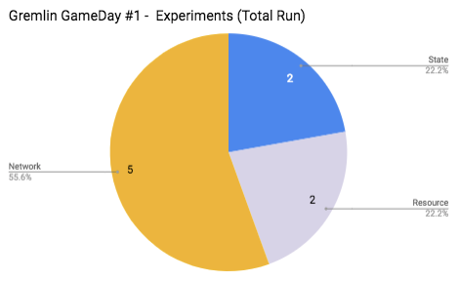

**App / System Overview**

<Application> is owned by <Team>. It has been in production since <year/month>.

*[insert whiteboard diagram of system - include upstream and downstream dependencies]*

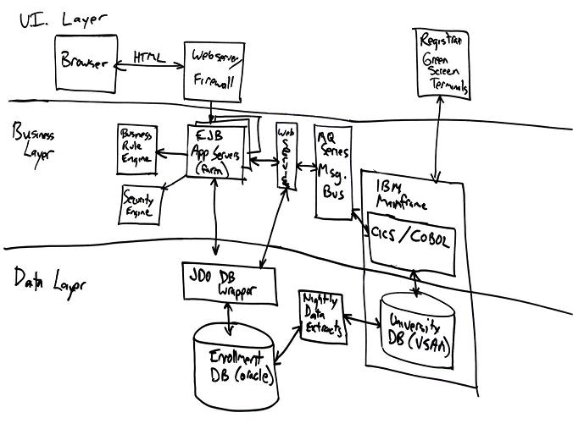

**Key App/System Metrics**

**<Application> high severity incidents in 2018**

*[insert chart - example below]*

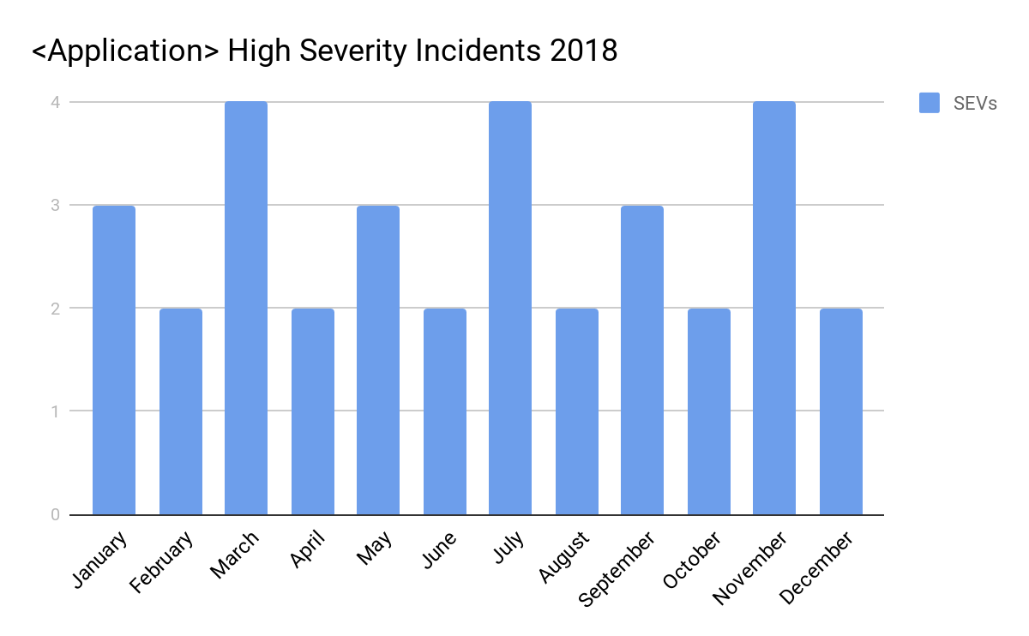

**<Application> alerts the last 3 months**

*[insert chart - obtain alert data from alerting system, e.g. pagerduty]*

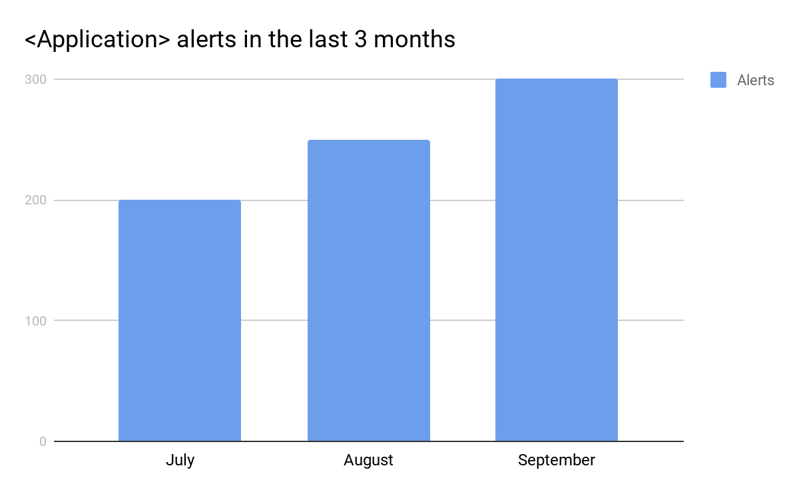

**Detailed Gremlin Chaos Engineering Experiments**

Here is a list of the gremlin scenarios that were ran, and the outcomes of running them

|  |  |  |  |  |
| --- | --- | --- | --- | --- |
| **Experiment** | **Gremlin Type** | **Outcome** | **Experiment**  **Results As Expected?** | **Experiment Grade** |
| Shutdown primary node to verify secondary node is promoted to primary | State - Shutdown |  |  | 🔴✅ |
| Blackhole’d ports | Network - Blackhole |  |  |  |
| Simulate High disk usage 99% | Resource - Disk |  |  |  |
| Simulate high IO | Resource - IO |  |  |  |
| Time traveled request coming in to simulate possible Daylight Savings | State - Time Travel |  |  |  |
| Blackhole’d AWS | Network - Blackhole |  |  |  |
| Packet Loss between <Application> and AWS | Network - Packet Loss |  |  |  |
| Latency injection between <Application> and AWS | Network - Latency |  |  |  |

**Where To Learn More ?**

* Read Gameday reports: [insert link]
* Watch this video on Chaos Engineering: [insert link]
* Read this paper on failure injection: [insert link]

Date:

Team:

Contact: